Decisions and Trade-offs
Setting up the TechnicalAnalysis project | BDA400 Assignment 2 | Kulwinder Singh

The choices that shaped this stage
Decision | Alternatives | Why I chose this
Language: R | Python | The assignment and its tutorials are built around quantmod and TTR, which are R packages
Data source: Yahoo Finance via quantmod | Downloading CSV files by hand | One function call per symbol, and the symbol list can live in a text file
Portfolio: semiconductors | A mix of sectors | Companies in one industry face similar conditions, so differences in their prices are easier to read
Data shape: list of data frames | One combined table | Matches the assignment wording: a separate data frame for each symbol
Mode: $1 bins | Exact prices | Closing prices rarely repeat to the cent, so exact matching returns almost nothing useful

Why semiconductors
The portfolio is NVDA, AMD, INTC and QCOM. These companies design chips for overlapping markets, so they react to some of the same forces, such as demand for computing hardware and the supply of manufacturing capacity. Putting them side by side means a difference in how their prices behave is a difference between companies, not between industries. The cost is that the portfolio is not diversified, which matters if this were an investment decision. Here it is a deliberate narrowing for the sake of comparison.

Setup evidence

Repository
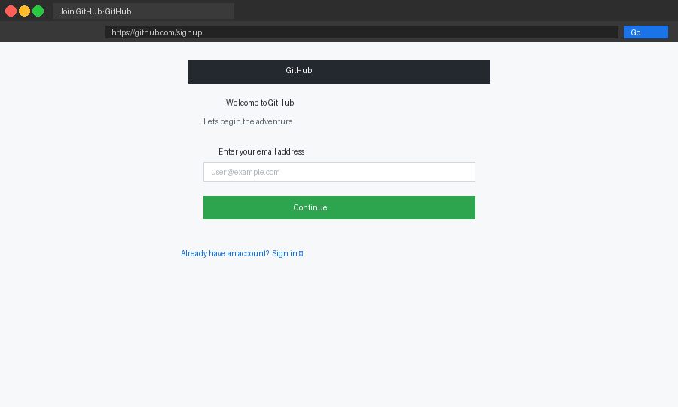
GitHub account (Placeholder image: replace with your own screenshot.)
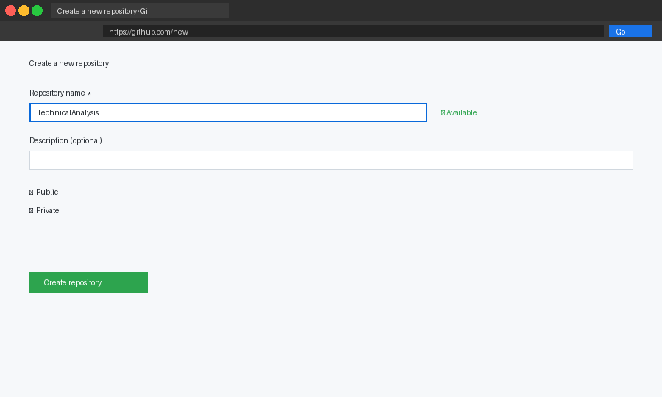
Repository named TechnicalAnalysis (Placeholder image: replace with your own screenshot.)
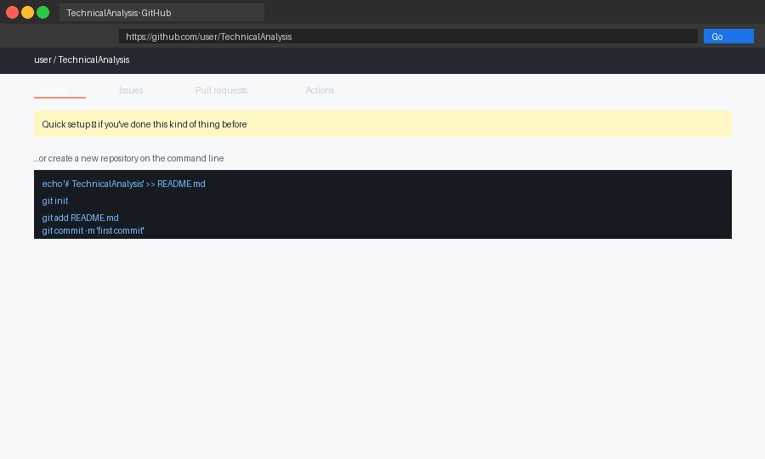
Repository created (Placeholder image: replace with your own screenshot.)

R and RStudio
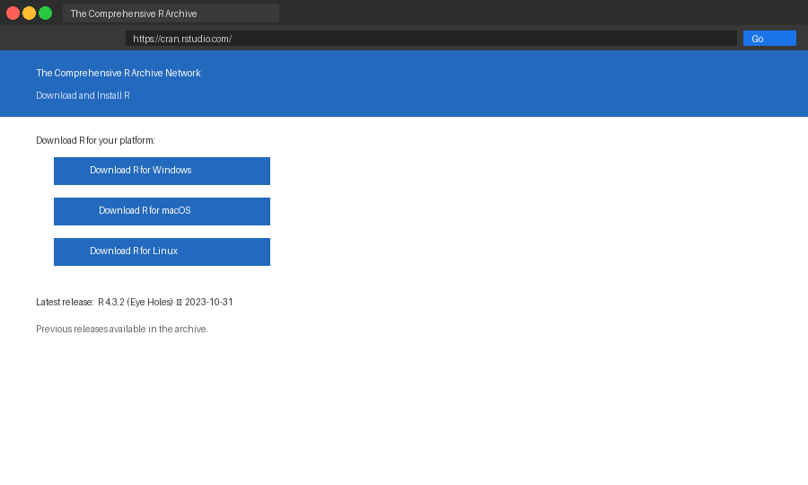
CRAN download page (Placeholder image: replace with your own screenshot.)
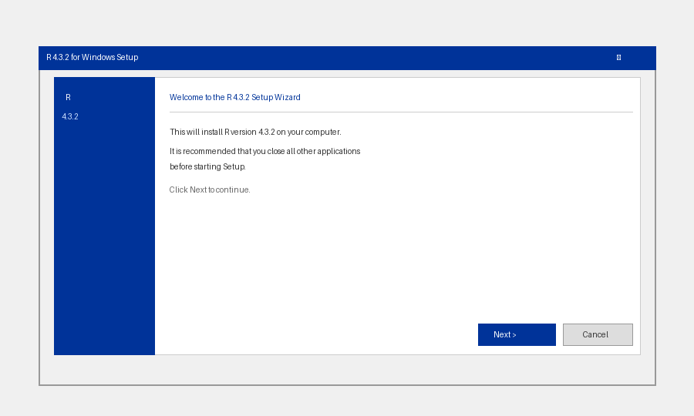
R installer (Placeholder image: replace with your own screenshot.)
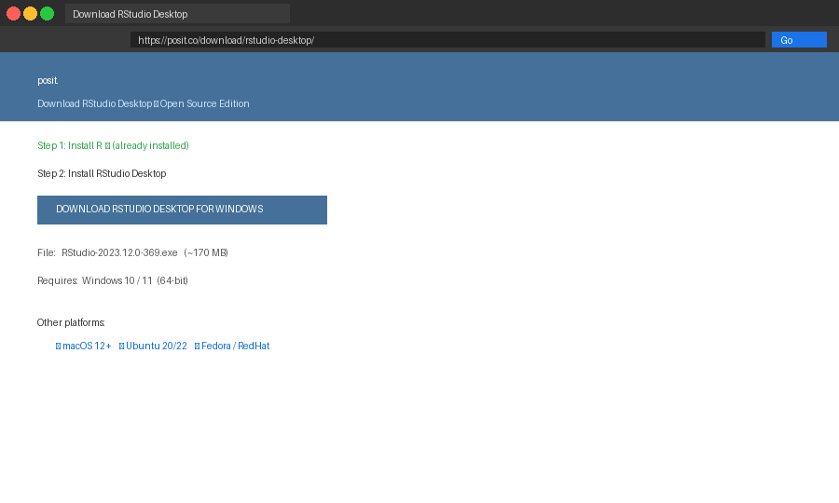
RStudio download page (Placeholder image: replace with your own screenshot.)
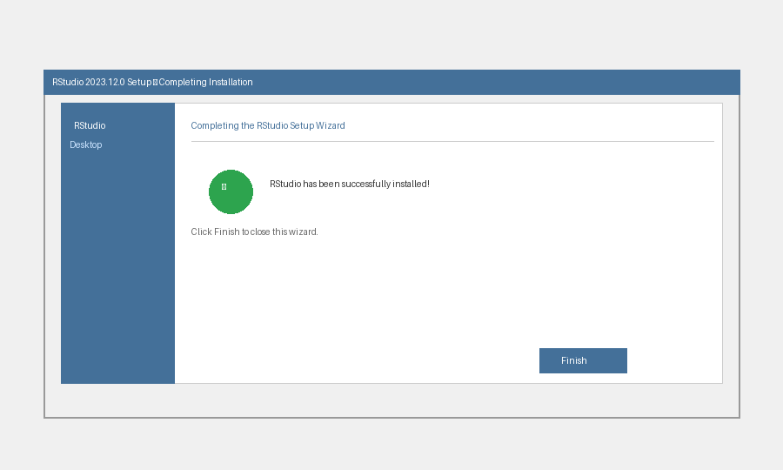
RStudio installed (Placeholder image: replace with your own screenshot.)

Packages and portfolio file
install.packages(c("quantmod", "TTR"))
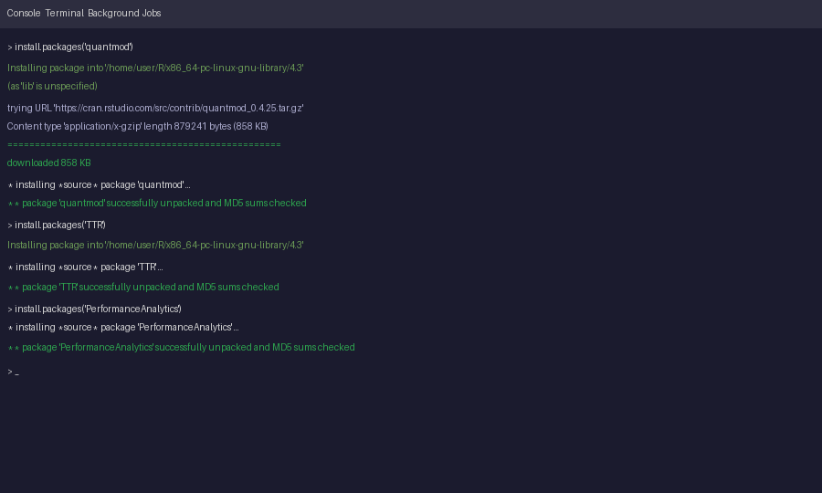
Package installation (Placeholder image: replace with your own screenshot.)
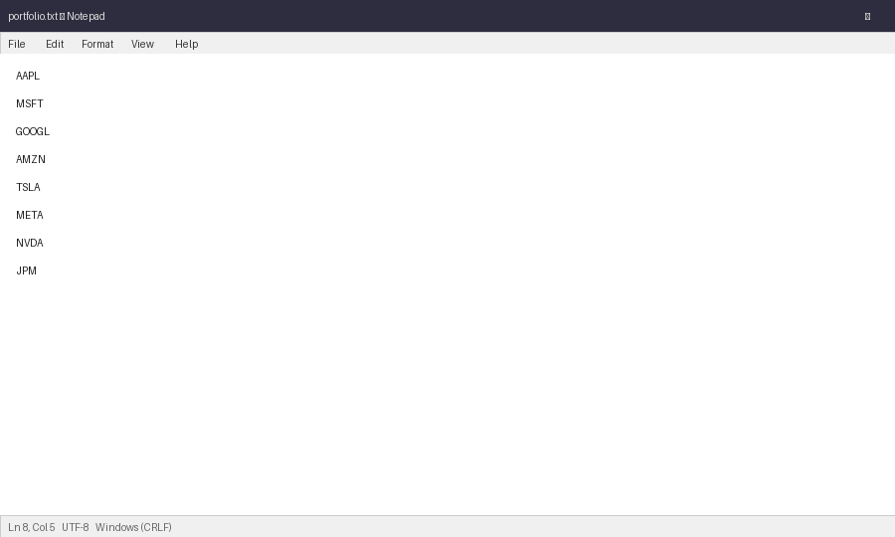
portfolio.txt (Placeholder image: replace with your own screenshot.)

Code, with the reasoning attached
Loading. All symbols are requested in one getSymbols() call into a private environment instead of the global workspace, so the downloads do not clutter it. Each object is then copied into a list as a plain data frame.
Statistics. Besides the required measures, the function returns a 20-day rolling standard deviation and the percentage change from the first to the last day. Rolling volatility shows whether recent movement is calm or unusual compared with the whole-period standard deviation.
Display. Prices of different stocks sit at very different levels, so plotting them raw would flatten the cheaper ones. The comparison chart divides each series by its first value and multiplies by 100, so all lines start at the same point and the slopes can be compared.

stock_functions.R
# BDA400 - A2 - Kulwinder Singh
library(quantmod)
library(TTR)

load_stock_data <- function(portfolio_file = "portfolio.txt") {
tickers <- Filter(nzchar, trimws(readLines(portfolio_file, warn = FALSE)))
store <- new.env()
getSymbols(tickers, src = "yahoo", from = "2025-01-01",
env = store, auto.assign = TRUE)

result <- list()
for (tk in tickers) {
if (!exists(tk, envir = store, inherits = FALSE)) next
x <- get(tk, envir = store)
d <- data.frame(Date = index(x), coredata(x))
names(d) <- c("Date", "Open", "High", "Low", "Close", "Volume", "Adjusted")
result[[tk]] <- d
}
result
}

calculate_statistics <- function(df, n = 20) {
close <- df$Close
counts <- table(floor(close)) # mode taken over $1 wide bins
mode_bin <- as.numeric(names(counts)[which.max(counts)])

data.frame(
mean = mean(close),
median = median(close),
mode_bin = mode_bin,
sd = sd(close),
sma_last = tail(SMA(close, n), 1),
rolling_sd = tail(runSD(close, n), 1),
pct_change = (tail(close, 1) / close[1] - 1) * 100
)
}

all_statistics <- function(stock_list) {
tab <- do.call(rbind, lapply(stock_list, calculate_statistics))
tab$ticker <- rownames(tab)
rownames(tab) <- NULL
tab[, c("ticker", setdiff(names(tab), "ticker"))]
}

display_stock_data.R
# BDA400 - A2 - Kulwinder Singh - display and comparison charts
source("stock_functions.R")

portfolio <- load_stock_data("portfolio.txt")
results <- all_statistics(portfolio)

cat("Data loaded for:", paste(names(portfolio), collapse = ", "), "\n\n")
for (tk in names(portfolio)) {
cat("---", tk, "---\n")
print(head(portfolio[[tk]], 3))
}

cat("\nStatistics for the whole portfolio\n")
print(results, digits = 4, row.names = FALSE)

# Compare stocks at very different price levels by rebasing each to 100.
# Trim every series to the shortest one so the lines share an x axis.
shortest <- min(sapply(portfolio, nrow))
rebased <- sapply(portfolio, function(d) {
px <- d$Close[seq_len(shortest)]
100 * px / px[1]
})
matplot(portfolio[[1]]$Date[seq_len(shortest)], rebased,
type = "l", lty = 1, lwd = 2, xlab = "Date", ylab = "Index (start = 100)",
main = "Portfolio comparison, rebased to 100")
legend("topleft", legend = names(portfolio), col = seq_along(portfolio), lty = 1, bty = "n")


Statistics in the console (Placeholder image: replace with your own screenshot.)
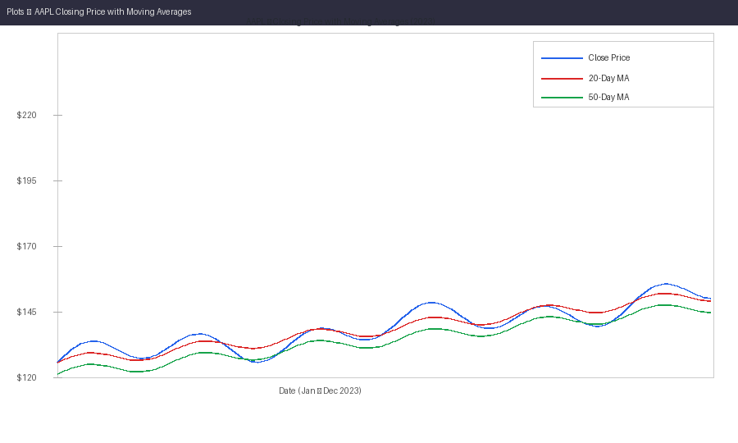
Chart output (Placeholder image: replace with your own screenshot.)
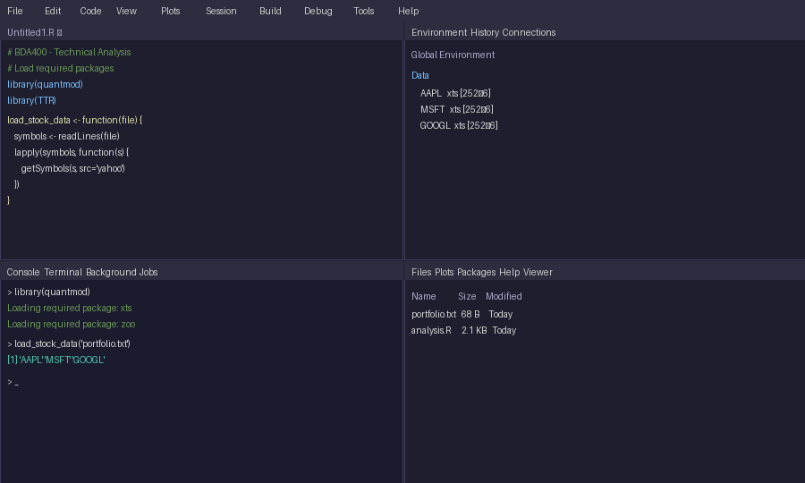
RStudio workspace (Placeholder image: replace with your own screenshot.)

What could go wrong
- A symbol fails to download. Mitigation: the script reports which symbols were loaded, so the gap is visible.
- Yahoo Finance changes its data format. Mitigation: the column names are set explicitly in one place.
- Series have different lengths. Mitigation: the comparison chart trims every series to the shortest one.

Looking ahead
The next stages will probably need the same data loading, so keeping it separate from the display code should save work. If the moving averages here turn out to be too slow to react, I expect Stage 2 will call for shorter windows or a different indicator.

