AHB – WISHBONE BRIDGE

Table of Contents

Authors 2
Copyright & License 2
Revision No. 2
Disclaimer 2
Introduction 3
Limitations of Design 3
Synthesizability 3
Port Definitions 4
Block Representation 5
Reset operation 6
Write Cycle 7
Read Cycle 8
Write with Wait states 9
Inserted by Wishbone Slave 9
Inserted by AHB Master 10
Read with wait states 12
Inserted by Wishbone Slave 12
Inserted by AHB Master 13
Read after Write 15
Write after Read 16

Authors
TooMuch Semiconductor Solutions (info@toomuchsemi.com)

Copyright & License
Copyright (c) 2007 TooMuch Semiconductor Solutions Pvt Ltd.

Revision No.
1.0

Disclaimer
This source file may be used and distributed without restriction provided that this copyright statement is not removed from the file and that any derivative work contains the original copyright notice and the associated disclaimer.
This software is provided “as is” and without any express or implied warranties, including, but not limited to, the implied warranties of merchantability and fitness for a particular purpose. in no event shall the author or contributors be liable for any direct, indirect, incidental, special, exemplary, or consequential damages (including, but not limited to, procurement of substitute goods or services; loss of use, data, or profits; or business interruption) however caused and on any theory of liability, whether in contract, strict liability, or tort (including negligence or otherwise) arising in any way out of the use of this software, even if advised of the possibility of such damage.

Introduction
AHB-Wishbone 桥接器是可综合桥接器的 RTL 实现，用于将 AHB 主设备互连到 Wishbone 从设备。

Limitations of Design
- 这种设计不适用于Sequential transfers（即wrap和incremental类型的传输）。
- 设计中没有考虑错误、重试和拆分情况
- 字长为 32 位。 可以根据需要进行修改。
- 所有传输都被视为non-sequential类型。

Synthesizability
这段代码是完全可综合的。 唯一需要注意的是wishbone 总线的clock (clk_i) 和复位 (rst_i) 信号在设计内部未连接。 整个设计正在处理应由 AHB 主机提供的 AHB 时钟和复位信号。

Port Definitions

Port Name | Direction | Size | Source | Description
Hclk | in | 1 | AHB Master | Bus Clock
Hresetn | in | 1 | AHB Master | Active Low Sync. Reset
Hwdata | in | 32 | AHB Master | Write data bus
Hwrite | in | 1 | AHB Master | Read/Write enable
Hburst | in | 3 | AHB Master | Burst Type
Hsize | in | 3 | AHB Master | not used
Htrans | in | 2 | AHB Master | Transfer Type
Hsel | in | 1 | AHB Decoder | Slave select signal
Haddr | in | 16 | AHB Master | Address bus
dat_i | in | 32 | WB Slave | Data Bus
ack_i | in | 1 | WB Slave | To indicate current transfer status
clk_i | in | 1 | WB Slave | unconnected
rst_i | in | 1 | WB Slave | unconnected
adr_o | out | 16 | Bridge | Address bus
dat_o | out | 32 | Bridge | Data bus
cyc_o | out | 1 | Bridge | To indicate valid bus cycle
we_o | out | 1 | Bridge | Read/Write enable
stb_o | out | 1 | Bridge | To indicate valid data transfer cycle
Hrdata | out | 32 | Bridge | Read Data Bus
Hresp | out | 2 | Bridge | Response
Hready | out | 1 | Bridge | To indicate bridge is ready.

Block Representation
AHB
WISHBONE
BRIDGE
Hclk adr_o

Hresetn
we_o
Hwrite
stb_o
Haddr
cyc_o
Hwdata
dat_o
Hsel

Htrans dat_i

Hburst clk_i

Hready ack_i

Hresp rst_i

Hrdata

Reset operation
AHB 复位信号低电平有效，用于复位系统和总线。 在 Hclk 的上升沿之后，此复位已同步置位和置低。 复位至少需要一个时钟周期（AHB 时钟）。
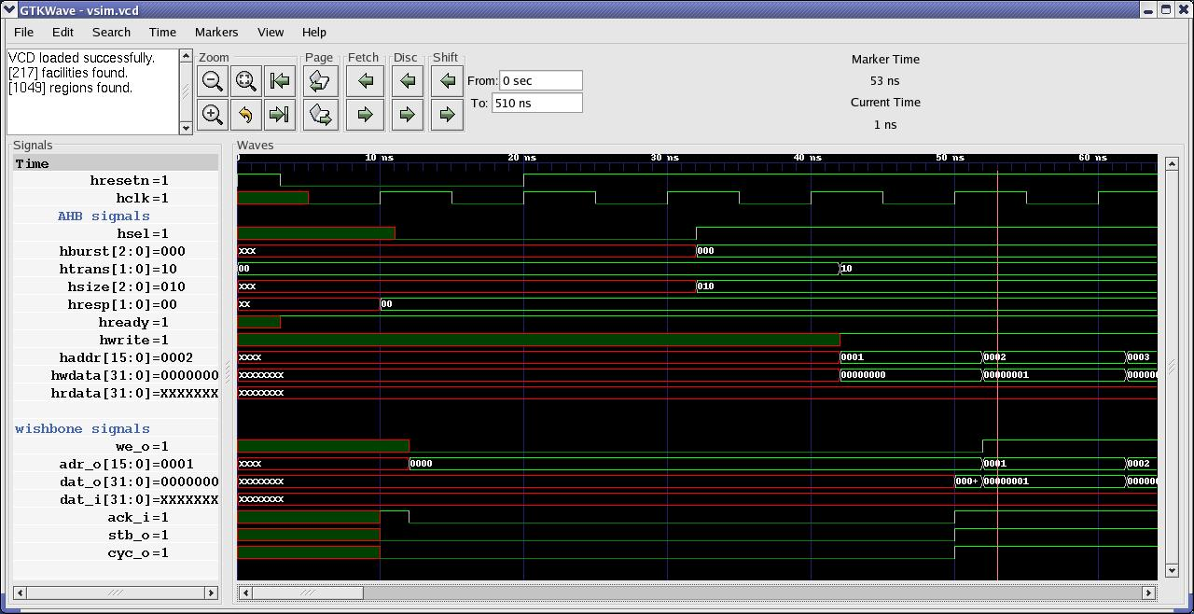

Fig. 1 : Reset operation

Write Cycle
当 Hwrite 为 HIGH 时，该信号表示写传输，当 Hready 信号为 HIGH 时，Master 将在写数据总线（Hwdata）上广播数据。
- 在第一个时钟沿，地址 (A1) 由 Haddr 上的 AHB 从设备采样。
- 这个采样的地址被同步传输到wishbone Slave的adr_o 上。
- 此地址的数据(D1) 由 AHB Slave对 Hwdata 进行异步采样。
- 该数据在 dat_o 总线上异步写入 WISHBONE Slave。
- 在下一次传输的第二个时钟边沿地址 (A2) 由 Haddr 上的 AHB Slave 采样。
- 在第 2 个时钟沿地址 (A1) 和数据 (D1) 分别由 adr_o 和 dat_o 总线上的 WISHBONE Slave 采样。
- 在第二个时钟沿 ack_i 也被使能。
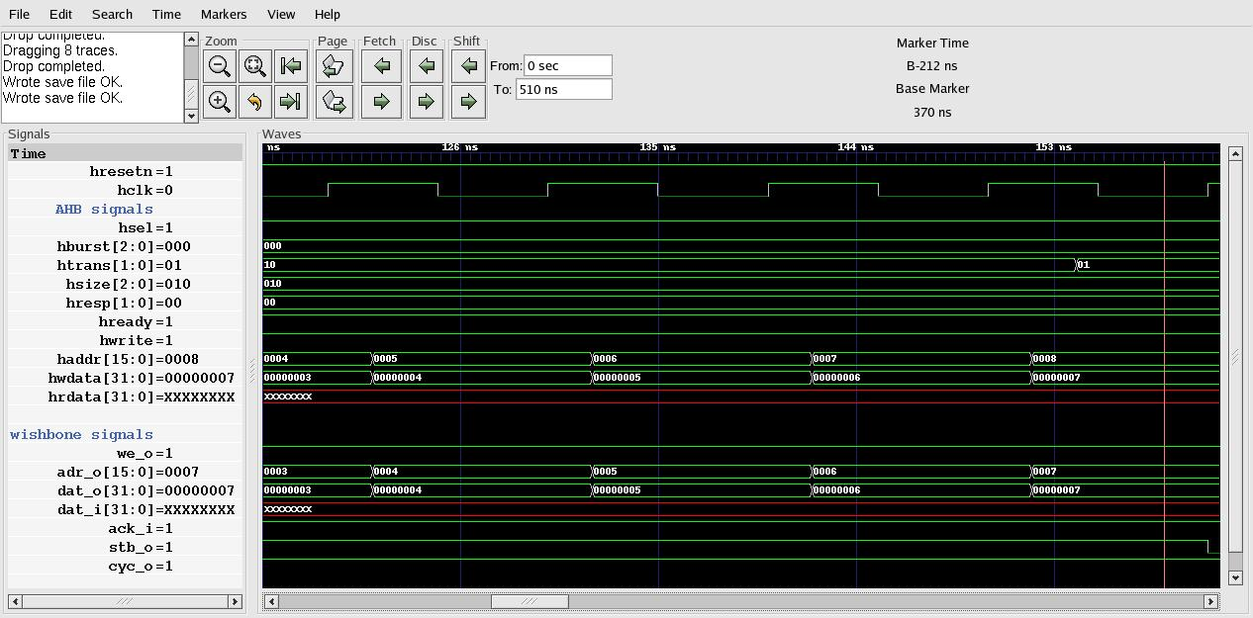

Fig 2 : Write Cycle

Read Cycle
When Hwrite is LOW, this signal indicates a read transfer and the Master will receive data on the read data bus (Hrdata) provided the Hready signal is HIGH.
- At 1st clock edge the address(A1) is sampled by the AHB Slave on Haddr.
- This address will be transfered synchronously to WISHBONE Slave on adr_o.
- Data(D1) for this address is sampled asynchronously by WISHBONE Master on dat_i.
- This data is transfered asynchronously to AHB Master on Hrdata.
- This data (D1) is sampled by AHB Master on 2nd clock edge.
- At 2nd clock edge address(A2) for next transfer is sampled by AHB Slave on Haddr.
- At 2nd clock edge ack_i is asserted.

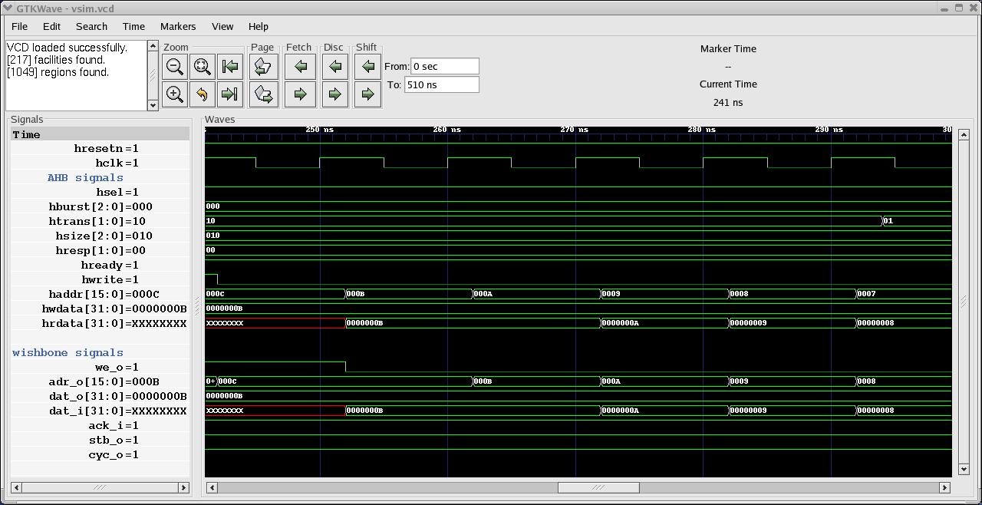
Fig. 3 : Read Cycle

Write with Wait states

Inserted by Wishbone Slave
- At 1st clock edge the address(A1) is sampled by the AHB Slave on Haddr
- This address sampled is transfered synchronously to the wishbone Slave on adr_o.
- Data(D1) for this address is taken asynchronously by AHB Slave after 1st clock edge on Hwdata.
- This data is latched asynchronously on dat_o bus.
- Address (A2) is sampled at 2nd clock edge.
- Ack_i signal is pulled LOW by the wishbone Slave after 2nd clock edge.
- Hready signal is pulled down asynchronously, to indicate that the AHB Slave and hence wishbone Slave is not ready to complete its current transfer.
- Address(A3) at next rising clock edge is sampled by AHB Slave when ack_i and hence Hready is asserted again.
- Data (D2) is latched on dat_o bus when Hready is asserted.

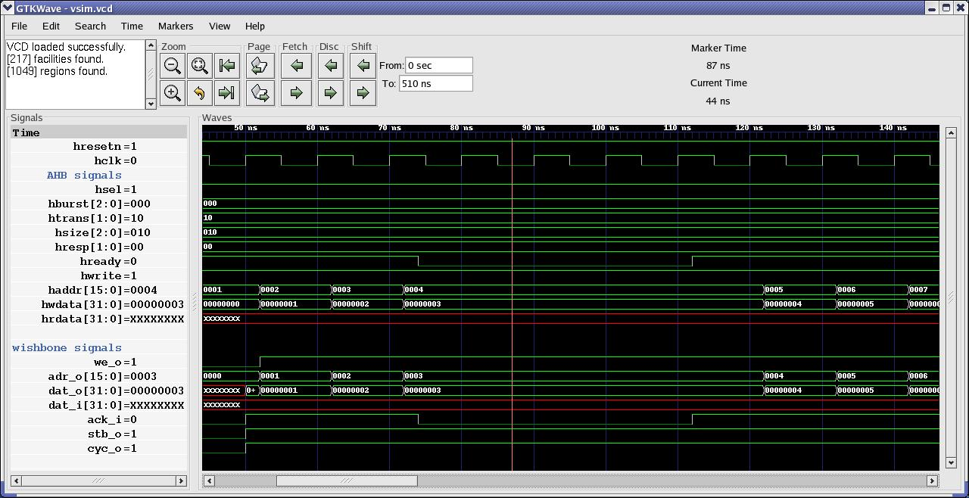
Fig. 4 : Write cycle with wait state inserted by wishbone Slave

Inserted by AHB Master
This is when AHB Master is busy, so that it can not continue its next bus transfer operation.
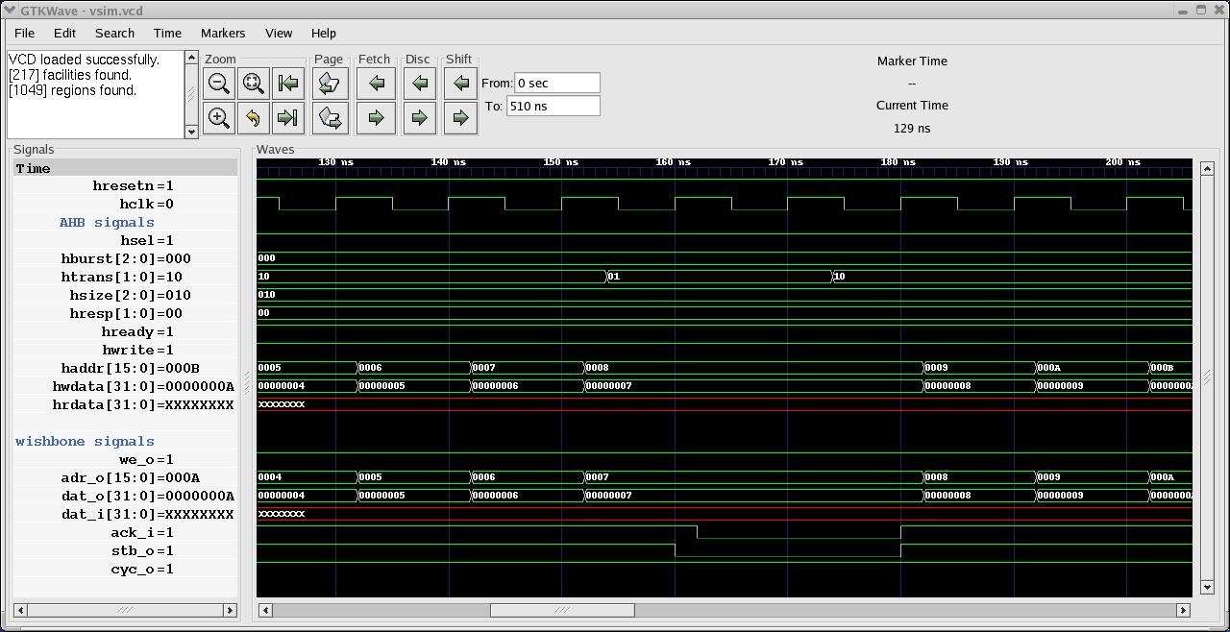
Fig. 5 : Write Cycle with wait state inserted by AHB Master

- At 1st clock edge the address(A1) is sampled by the AHB Slave on Haddr
- This address sampled is transfered synchronously to the wishbone Slave on adr_o.
- Data(D1) for this address is taken asynchronously by AHB Slave after 1st clock edge on Hwdata.
- This data is latched asynchronously on dat_o bus.
- Address (A2) is sampled at 2nd clock edge.
- Assert Htrans to “busy(01)” after 1st clock edge.
- At 2nd clock edge the bridge will sample the Htrans signal.
- Deassert “stb_o” signal synchronously.
- Ack_i signal will also be deasserted asynchronously by Wishbone Slave in response to stb_o signal.
- Htrans is asserted to “Non – Seq (10)” transfer type at clock edge after clock edge 4
- At 4th clock edge the bridge will sample the Htrans signal.
- Stb_o is asserted synchronously at clock edge 4
- Ack_i is asserted asynchronously with response to stb_o.
- Data (D2) is latched asynchronously on dat_o bus .
- Address(A3) at 5th clock edge is sampled by AHB Slave

Read with wait states

Inserted by Wishbone Slave
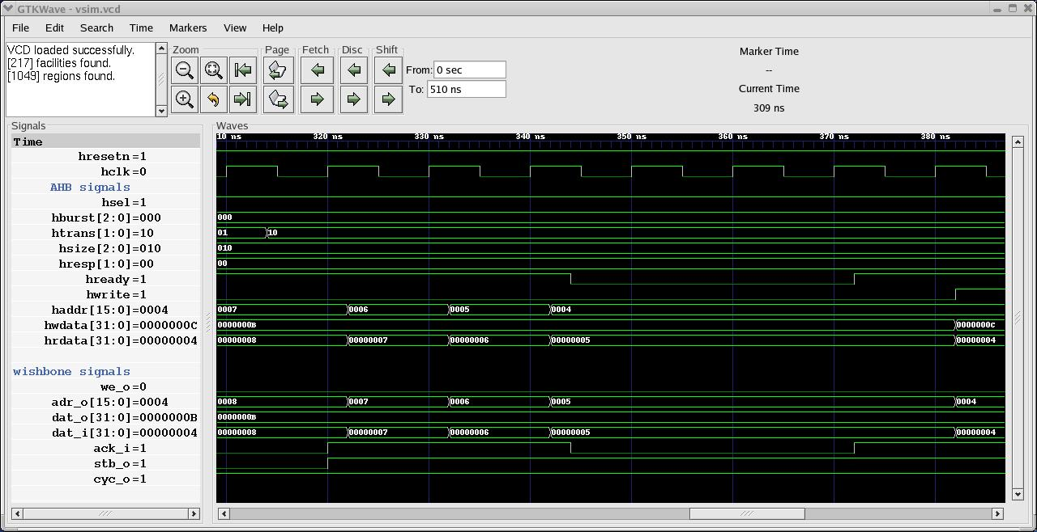
Fig. 6 : Read cycle with wait state inserted by wishbone Slave
- At 1st clock edge the address(A1) is sampled by the AHB Slave on Haddr
- This address sampled is transfered synchronously to the wishbone Slave on adr_o.
- Data(D1) for this address is latched asynchronously by wishbone Slave after 1st clock edge on dat_i.
- This data is latched asynchronously on Hrdata bus.
- Address (A2) is sampled at 2nd clock edge.
- Ack_i signal is pulled LOW by the wishbone Slave after 2nd clock edge.
- Hready signal is pulled down asynchronously, to indicate that the AHB Slave and hence wishbone Slave is not ready to complete its current transfer.
- Address(A3) at next rising clock edge (6th ) is sampled by AHB Slave when ack_i and hence Hready is asserted again.
- Data (D2) is latched on dat_i bus asynchronously when Hready is asserted.
- Data (D2) is latched on Hrdata asynchronously at the same time.

Inserted by AHB Master
This is when AHB Master is busy, so that it can not continue its next bus transfer operation.
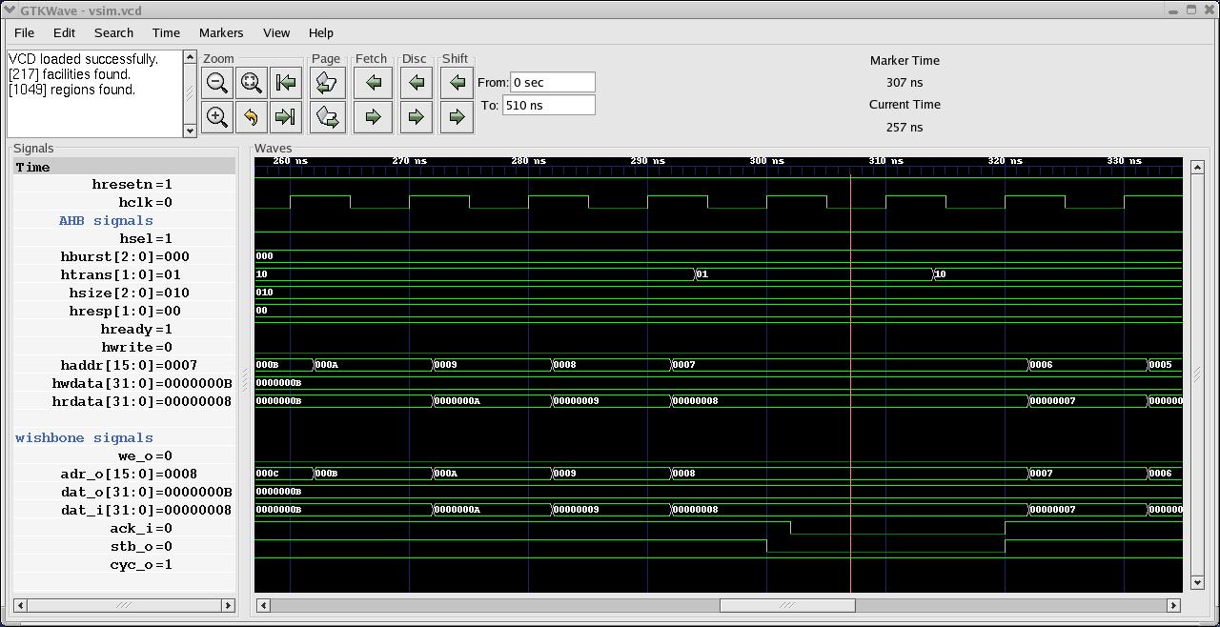
Fig. 7: Read cycle with wait state inserted by AHB Master
- At 1st clock edge the address(A1) is sampled by the AHB Slave on Haddr
- This address sampled is transfered synchronously to the wishbone Slave on adr_o.
- Data(D1) for this address is latched asynchronously by wishbone Slave after 1st clock edge on dat_i.
- This data is latched asynchronously on Hrdata bus.
- Address (A2) is sampled at 2nd clock edge.
- Assert Htrans to “busy(01)” after 1st clock edge.
- At 2nd clock edge the bridge will sample the Htrans signal.
- Deassert “stb_o” signal synchronously.
- Ack_i signal will also be deasserted asynchronously by Wishbone Slave in response to stb_o signal.
- Htrans is asserted to “Non – Seq (10)” transfer type at clock edge after clock edge 4
- At 4th clock edge the bridge will sample the Htrans signal.
- ] Stb_o is asserted synchronously at clock edge 4
- Ack_i is asserted asynchronously in response to stb_o.
- Address(A3) at 5th clock edge is sampled by AHB Slave
- Data (D2) is latched asynchronously on dat_i bus
- Data (D2) is latched asynchronously at the same time on Hrdata bus.

Read after Write
- At 1st clock edge the address(A1) is sampled by the AHB Slave on Haddr along with Hwrite signal and other control signals.
- This address sampled is transfered synchronously to the wishbone Slave on adr_o.
- Data(D1) for this address is sampled asynchronously by AHB Slave on Hwdata.
- Hwrite signal is pulled down to LOW (for read operation) after clock edge 1.
- Data(D1) is latched into the WISHBONE Slave asynchronously on dat_o bus.
- At 2nd clock edge address(A2) for next transfer is sampled by AHB Slave on Haddr along with Hwrite signal and is latched synchronously on adr_o bus.
- we_o signal is pulled LOW synchronously at 2nd clock edge.
- At 2nd clock edge address(A1) and data (D1) is sampled by WISHBONE Slave on adr_o and dat_o bus respectively.
- Wishbone Slave will latch data(D2) for address (A2) asynchronously on dat_i bus
- Bridge will latch data(D2) asynchronously on Hrdata at the same time.
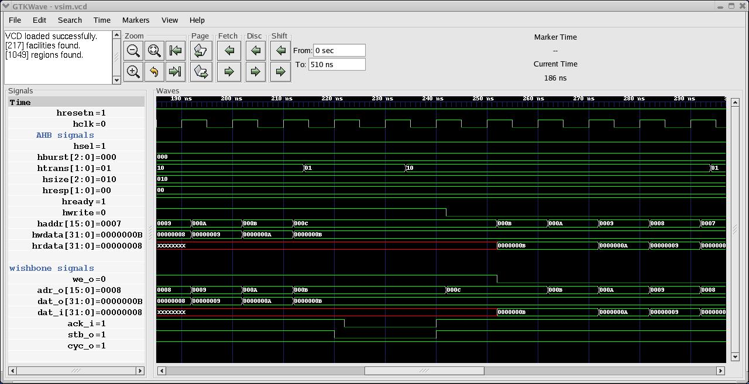
Fig. 8: Read after write cycle with wait state inserted by AHB Master during write operation

Write after Read
- At 1st clock edge the address(A1) is sampled by the AHB Slave on Haddr .
- This address will be transfered synchronously to WISHBONE Slave on adr_o.
- Data(D1) for this address is sampled asynchronously by WISHBONE Master on dat_i.
- D1 is transfered asynchronously to AHB Master on Hrdata
- Hwrite signal is pulled to HIGH logic(for write operation) after 1st rising edge of clock.
- Hwrite logic is transfered synchronously on we_o port.
- At 2nd clock edge address(A2) is sampled by AHB Slave along with Hwrite signal.
- A2 is transfered synchronously from Haddr to adr_o.
- Bridge transfers data (D2) asynchronously after 2nd clock edge from Hwdata to dat_o.

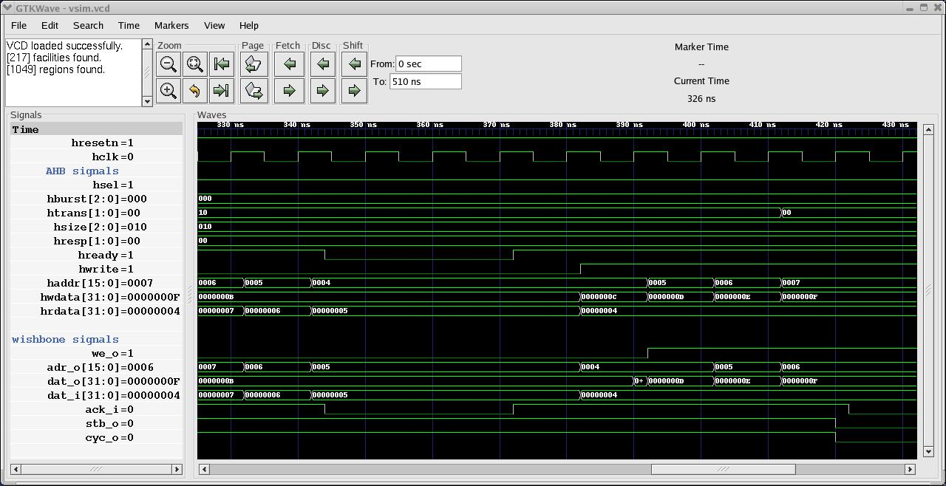
Fig. 9: Write after Read cycle with wait state inserted by wishbone Slave during read operation

