**ENSF-381**: **Full Stack Web Development Laboratory Lab02**

**Section: B02**

**Group information:**

Name 1 (UCID#): **Nitin kumar (30230030)** Name 2 (UCID#): **Natinael Nega (30228957)**

**GITHUB REPOSITORY LINK:**<https://github.com/kum-nitin-cell/ENSF381-LAB2.git>

**Exercise 1**

**O**

**utput:**

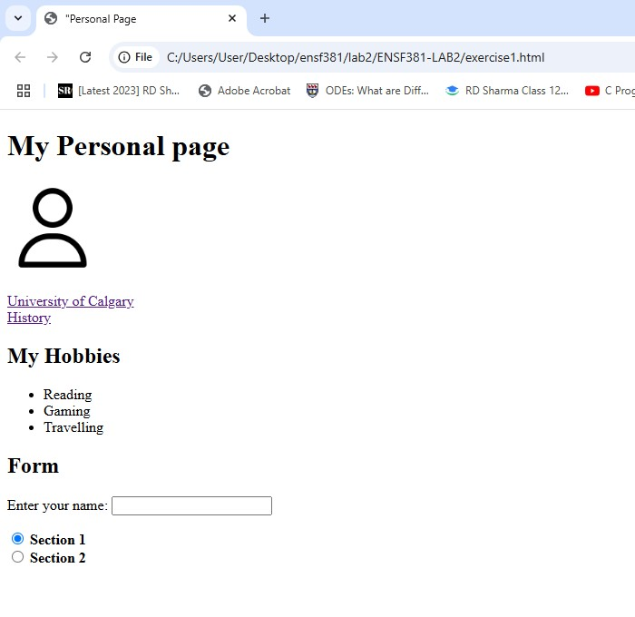

**Exercise 2 Answer:**

1. **The answer to Question 2.1:**

**Ans:** The main difference between setting the table width to a fixed width(eg 150px) compared to a percentage (eg 100%) lie out in layout behaviour and responsiveness.

* + **Fixed width (150px):**

Setting the fixed width makes the table always 150pxls wide regardless of screen size causing layout issues when tried to open on a small screen. Also, if the content inside the table is wider than 150pixels it might cause overflow causing layout distortion.

* + **Percentage width (100%)**

Setting the percentage width makes the table adjusts accordingly. Also, it is more responsive since it resizes dynamically when the viewpoint or screen has changed. Also prevents, scrolling issues on smaller screen.

So fixed width is good in case we want to use consistent size, but in case if we need flexible responsive design according to the different screen size percentage width is better.

1. **Output:**





