Mobile Application Development

(Assignment 1)

**team members:**

17309003 Cho Manki

17309004 Kim Seonghyeon

17309005 Kum Seungwon

17309006 Min Siwan

**Technical features:**

**-Intro ui**

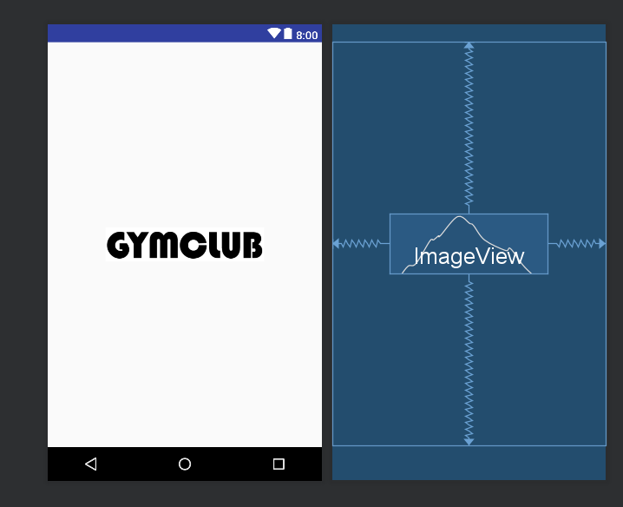

Intro UI is used to launch an app logo on the first screen for three seconds.

So, we set the manifest file to load intro.java first.

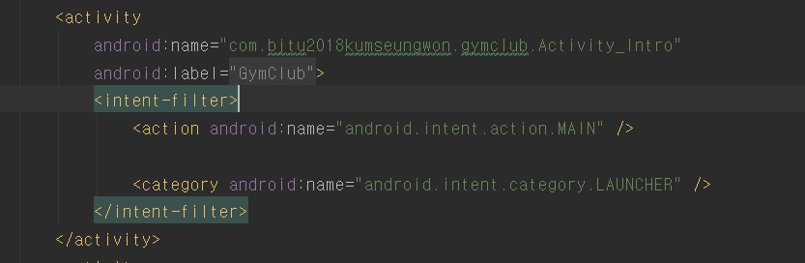

therefore, we set the intro ui to appear on the screen first and then the main ui to appear 3 seconds later.

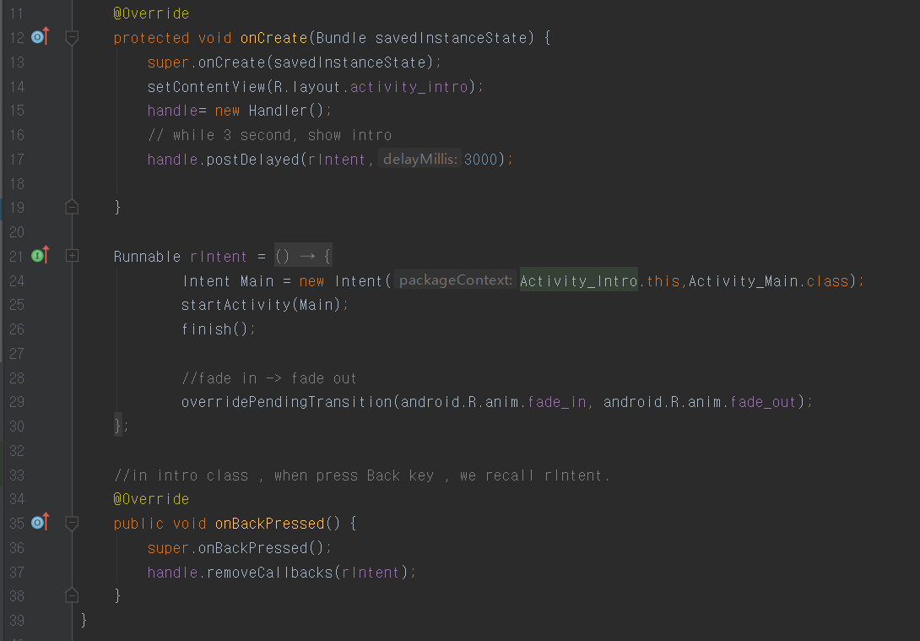

**-Dashboard UI :**

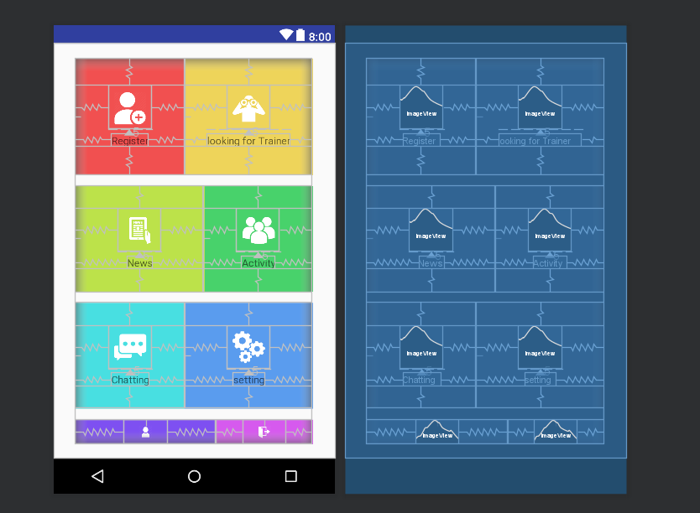

using linear layout, we make dashboard., and using icon we make UI friendly.

if we click on each chapter, dashboard jump to each screen. using intent

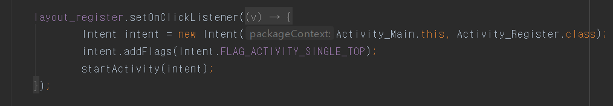

**-Registering as club member UI:**

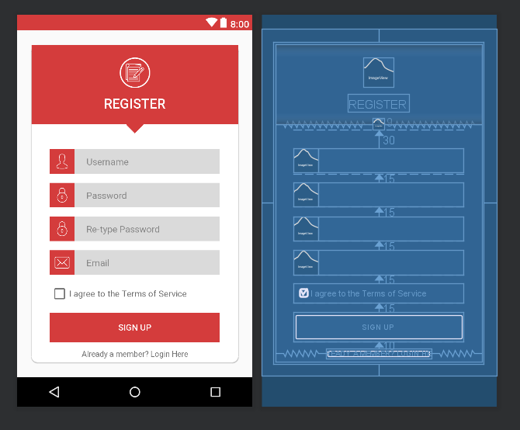

using card view Layout, we made register UI because of making layout roundly

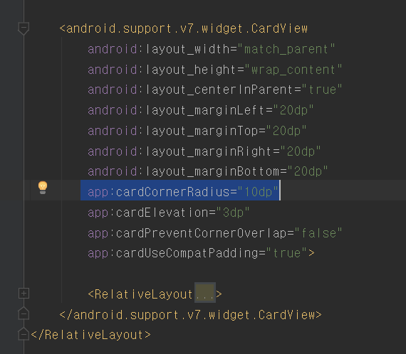

before making register ui, in gradle we should typing cardview implementation.

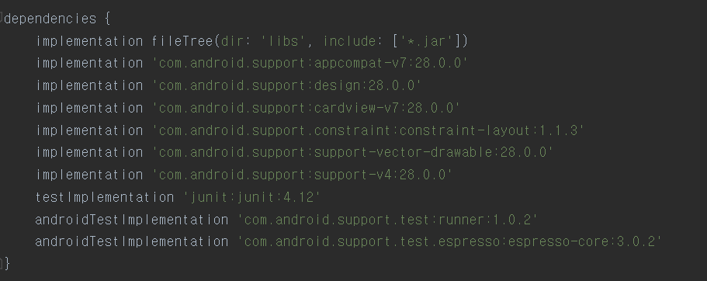

**-Looking for and booking trainers and training classes**

**/ activity posters :**

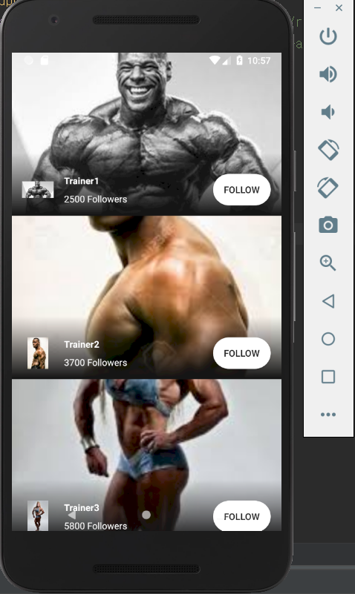 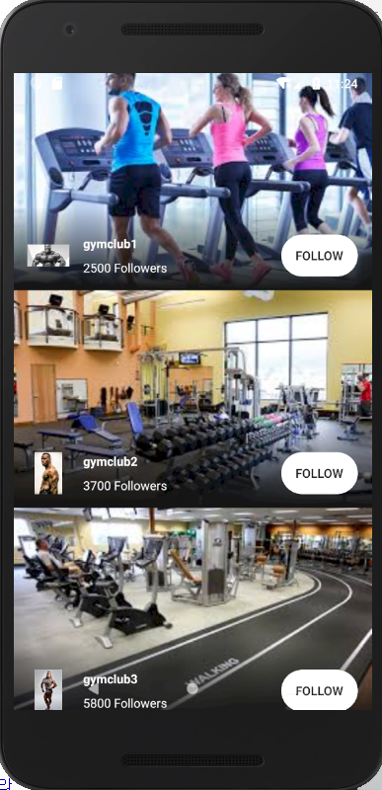

**Source code associated with**

**Looking for and booking trainers and training classes**

layout : activity_looking.xml activity_card_item.xml

java code : Activity_Looking.java , Adapter.java, item.java

**source code associated with activity posters**

layout : activity_acitivity.xml activity_card_item.xml

java code : Activity_Activity.java , Adapter.java, item.java

first we made card_item like this in activity_card_item.xml

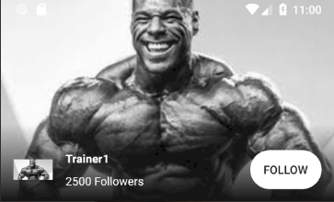

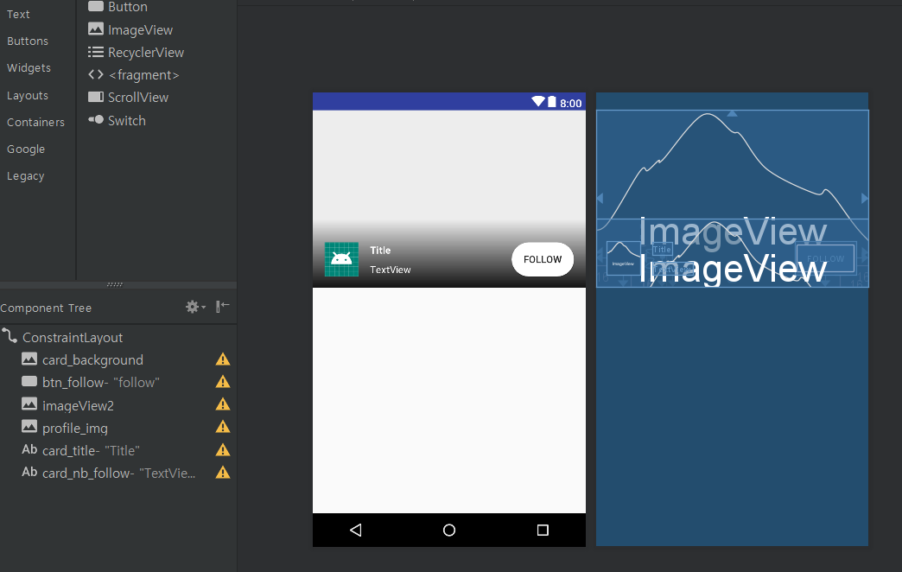

and next we made Recyclerview in activity_looking.xml

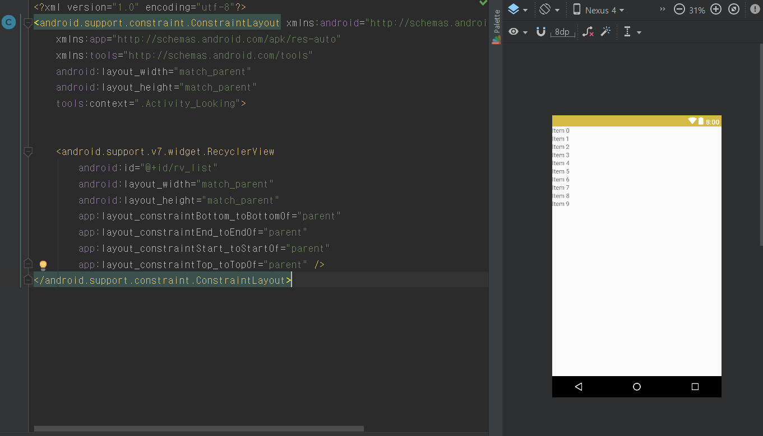

we should make item class.

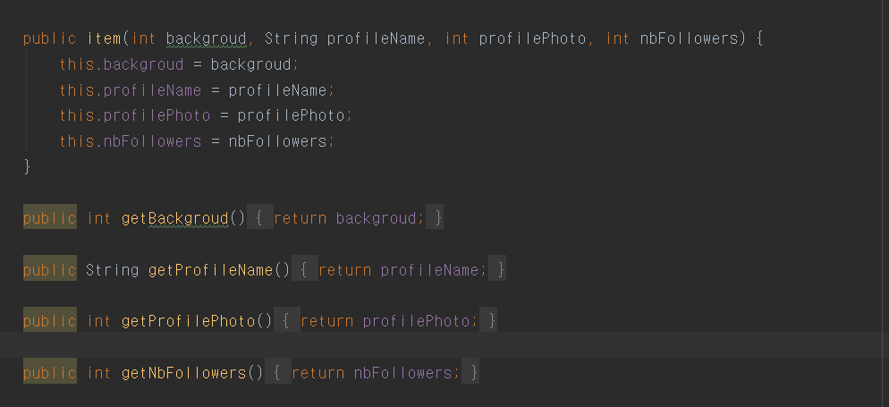

and make Adapter.java

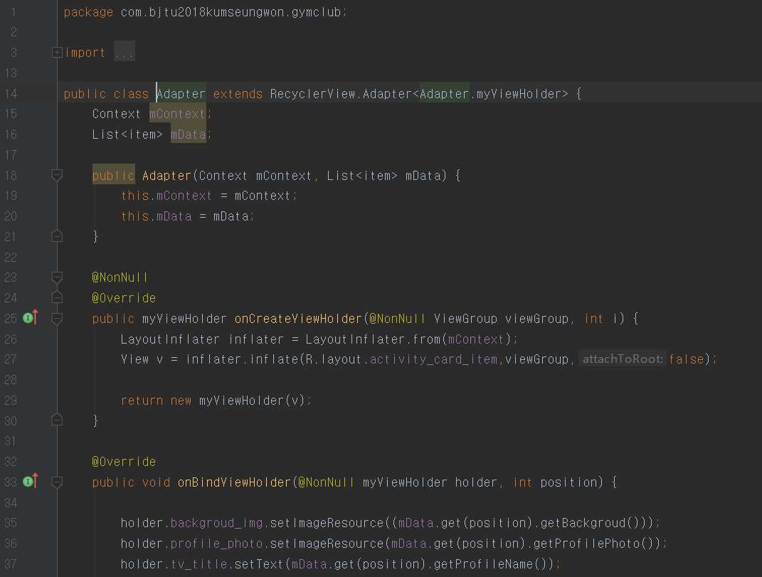

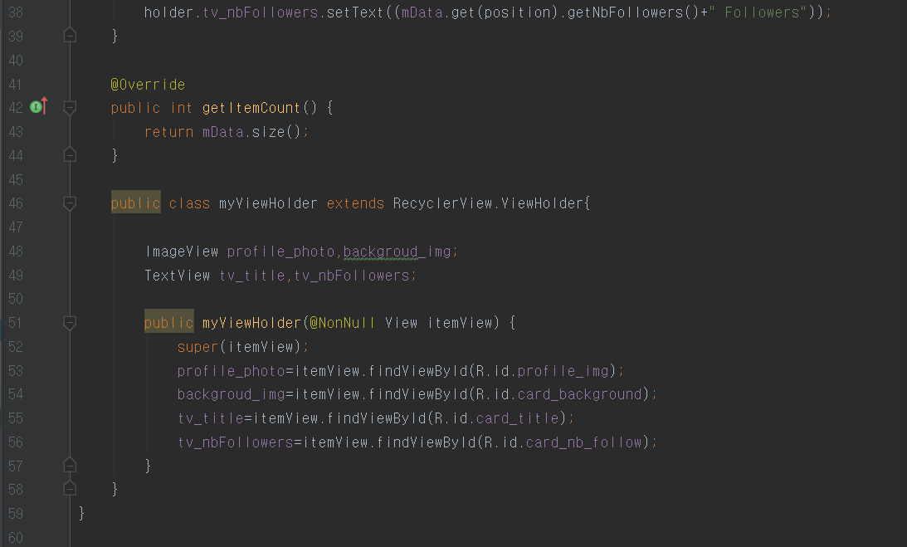

and make Activity_Looking because of adding item list.

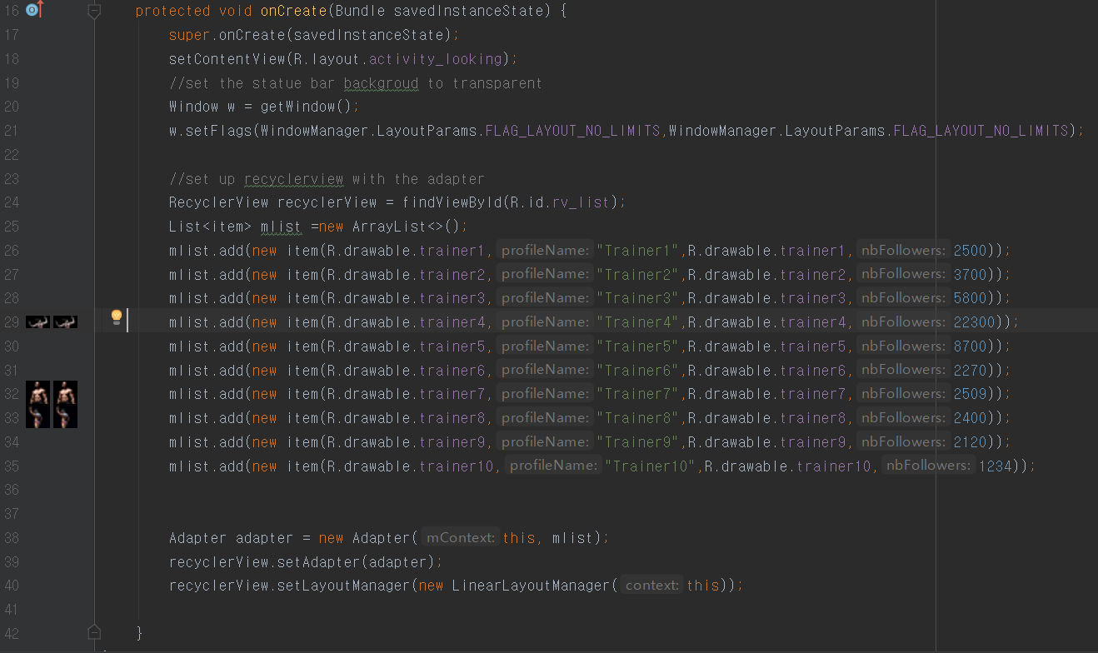

**-Sign-up UI**

using cardview, we made login UI

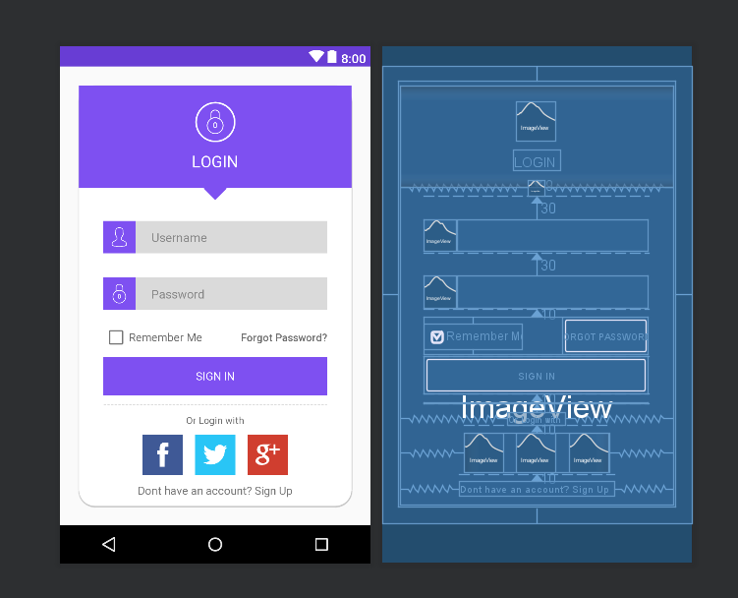

**-Logout UI**

we use dialog Layout to make Logout UI

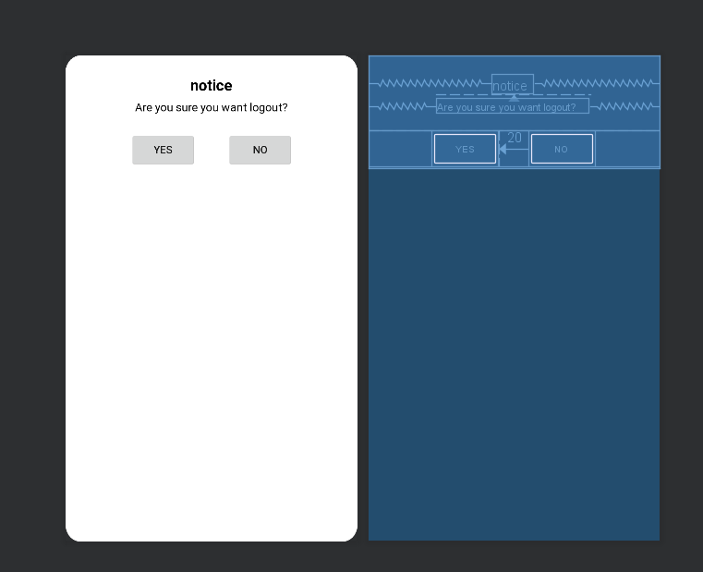

**-Home UI(profile ui)**

In the home chapter we put a profile.

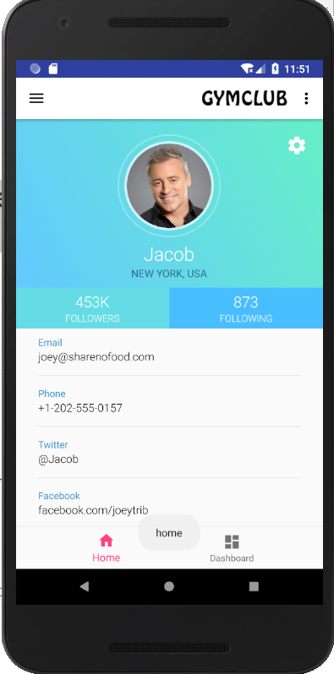

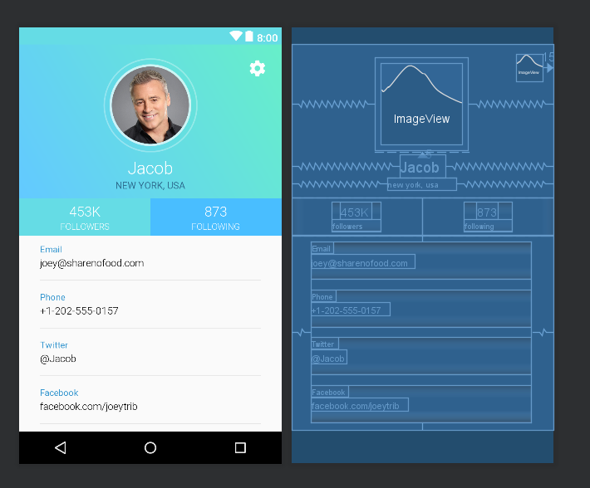

**-Club news UI, Chat UI**

we yet can’t club news UI, and chat UI because for making these UI, we should make perfect interface in java code and layout. Later we will make news ui and chat ui.

only thinking appearance.

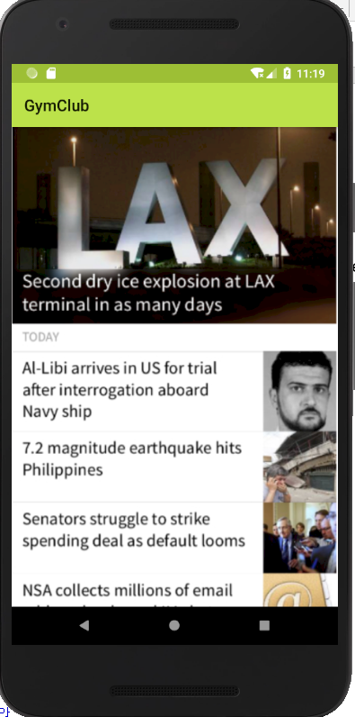 

-news UI-

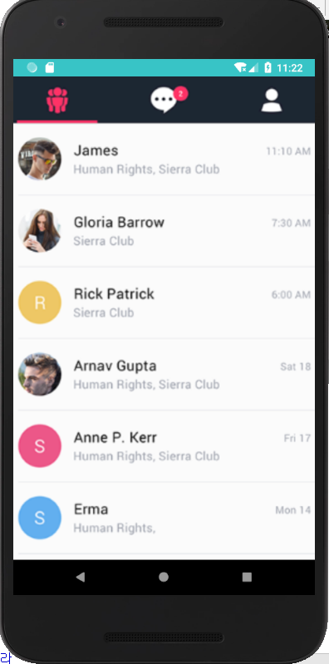 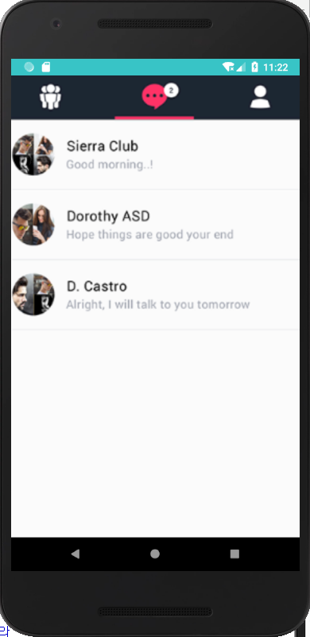

-chat UI-

-Setting UI

We have just created the default setting activity.

I will add more features.

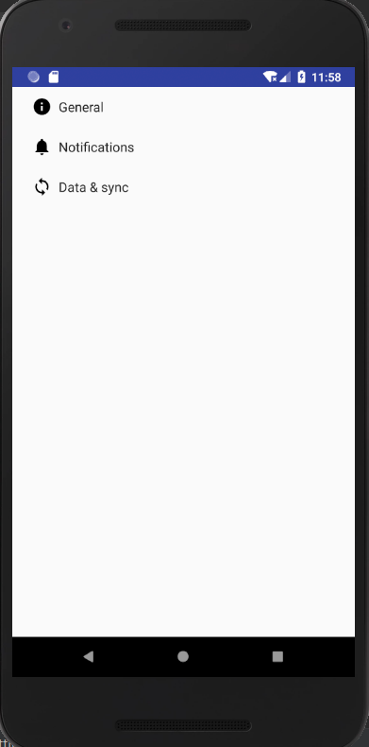

**-navigations through each screens**

We used the default navigation activity and made it go to each screen using intent.

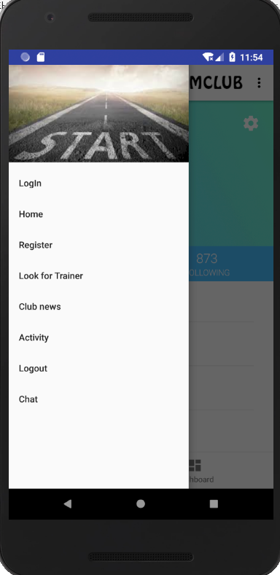

example using intent

