Mobile Application Development

(Assignment 3)

**team members:**

17309003 Cho Manki

17309004 Kim Seonghyeon

17309005 Kum Seungwon

17309006 Min Siwan

**Technical features:**

**Function1**

As a gym club app user, he/she can watch the training video online. Primary needs for this function include a video list where each video item consists of a picture as well as short explanation and/or may be click through rate, and a video player that can be opened by click each video item on list.

Implementation of this function needs to be online, you can either install a stream server or simply make use of web server that accept video download.

**Used programs :** android studio, mysql, php, apache server

**running result :**

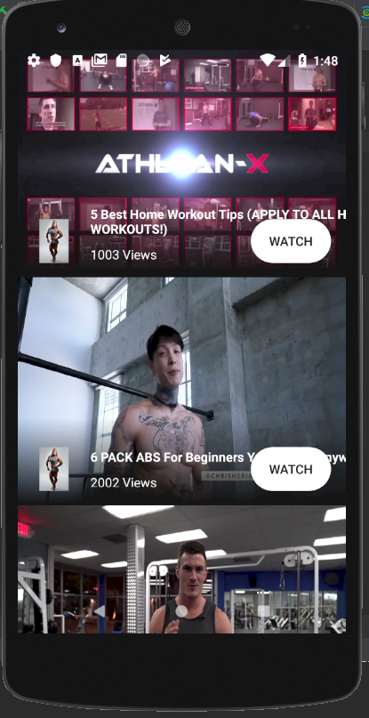 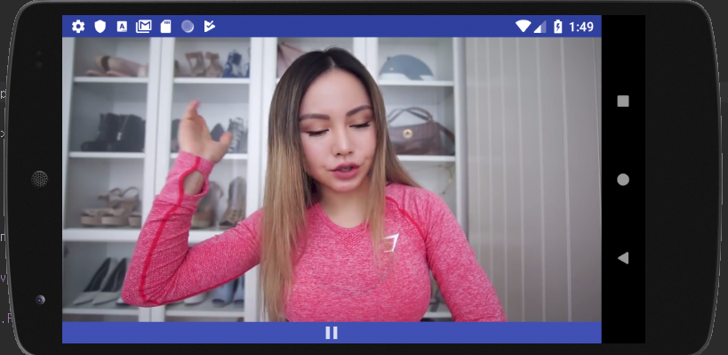

**class diagram:**

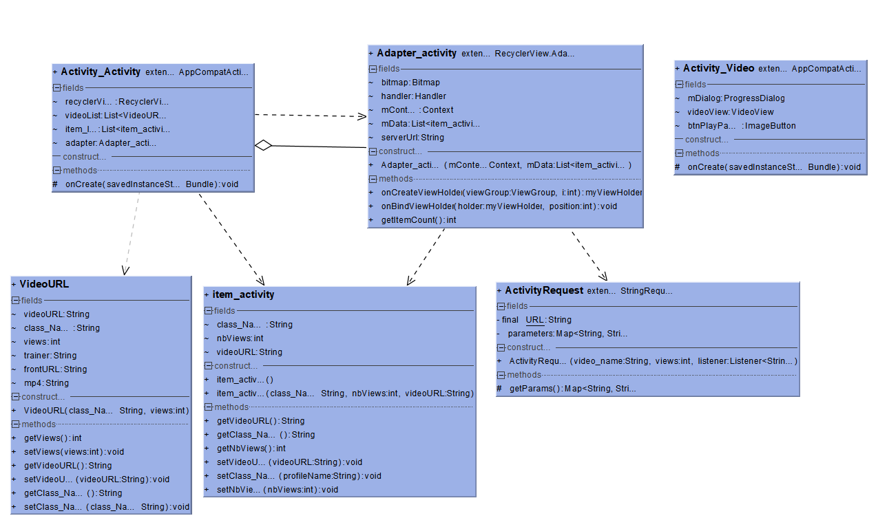

Once we saved the video to the server, I was able to watch the video in a stream.

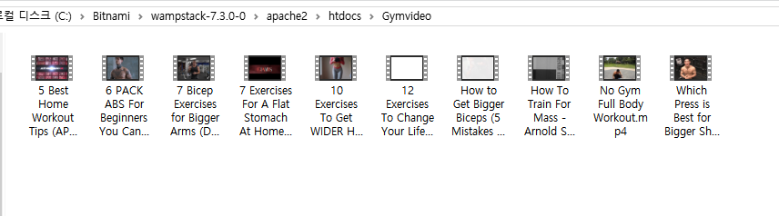

And we defined the server address where video is stored in "videoURL" class.

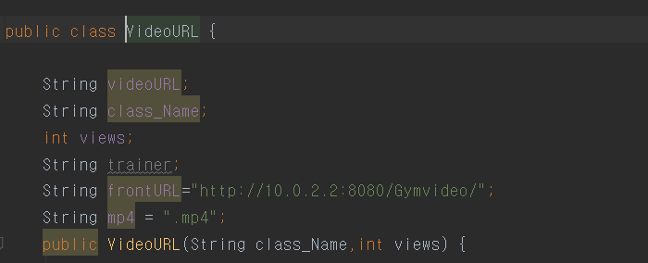

Then, the video was played using the stored server address and "videoView".

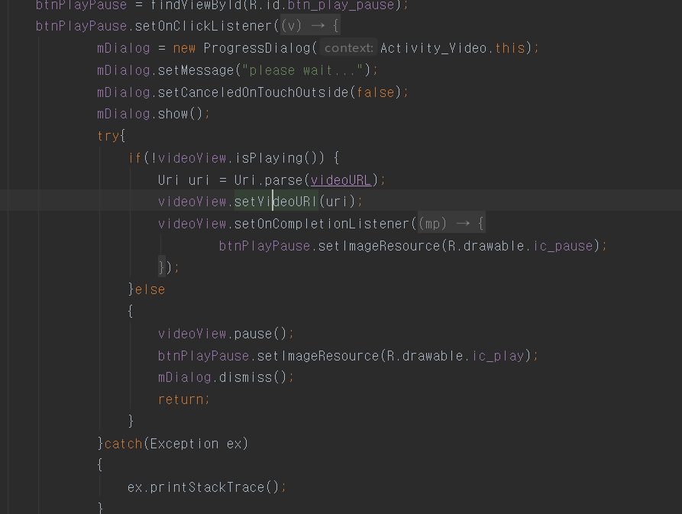

for showing video image(thumbnail),we used setVideoPath method.

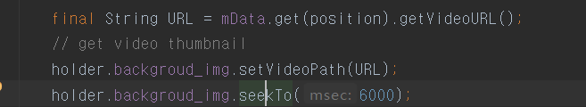

A brief description of the video should be set to the video file name and the url is fetched and the file name is printed on each "recyclerview" item.

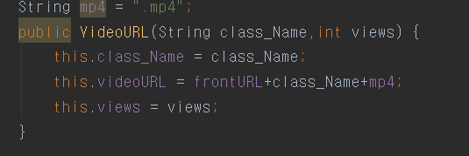

We also stored the video name and click rate in the database.

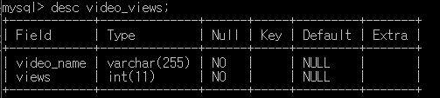

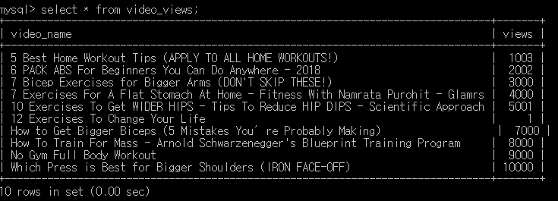

we also wrote a php file to get information from the database.

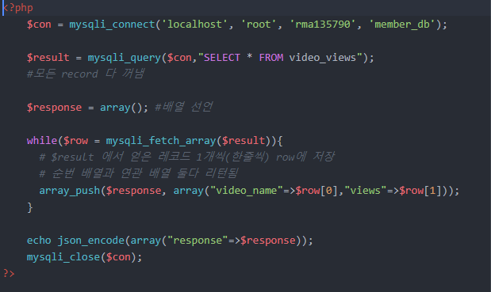

in java code, http connection

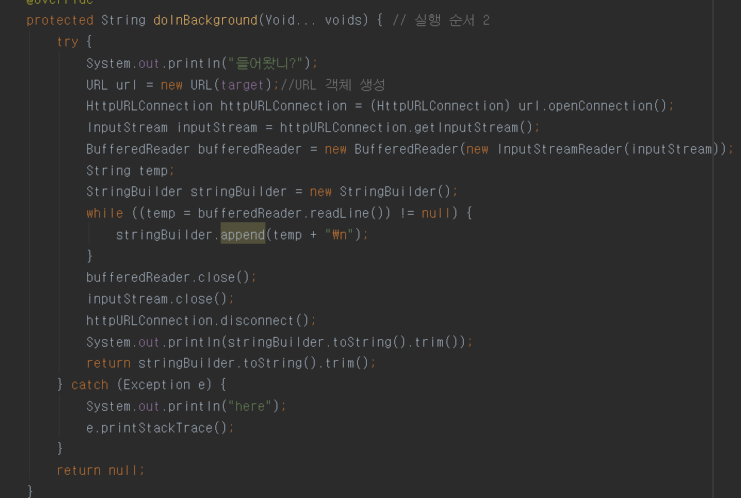

in java code, parsing json.

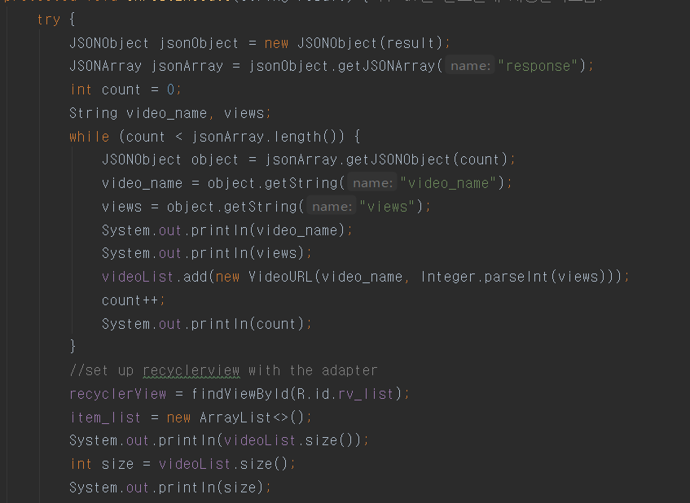

The click rate is stored in the database so that it can be saved even when the application is terminated. I created a php file to update each click rate on the database.

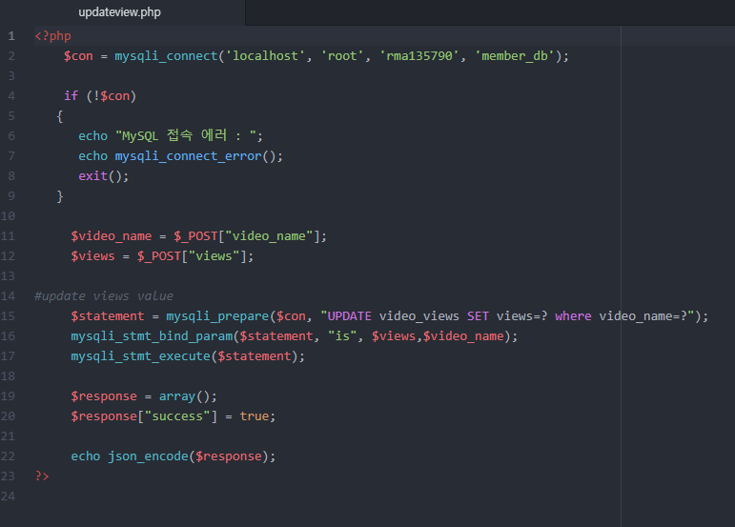

in java code http connection, we used volley api.

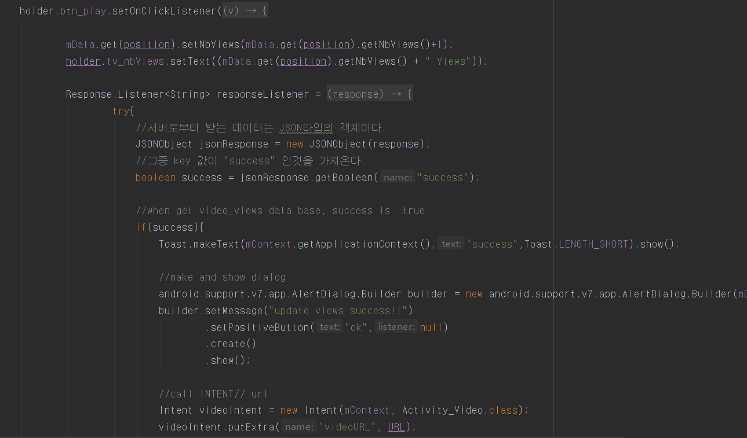

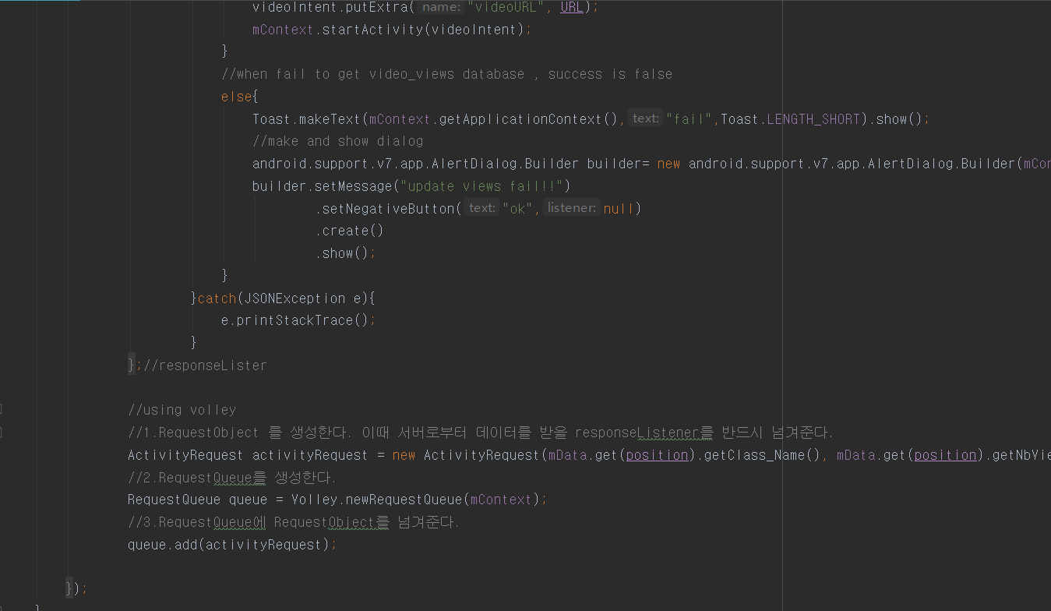

in ActivityRequest.java

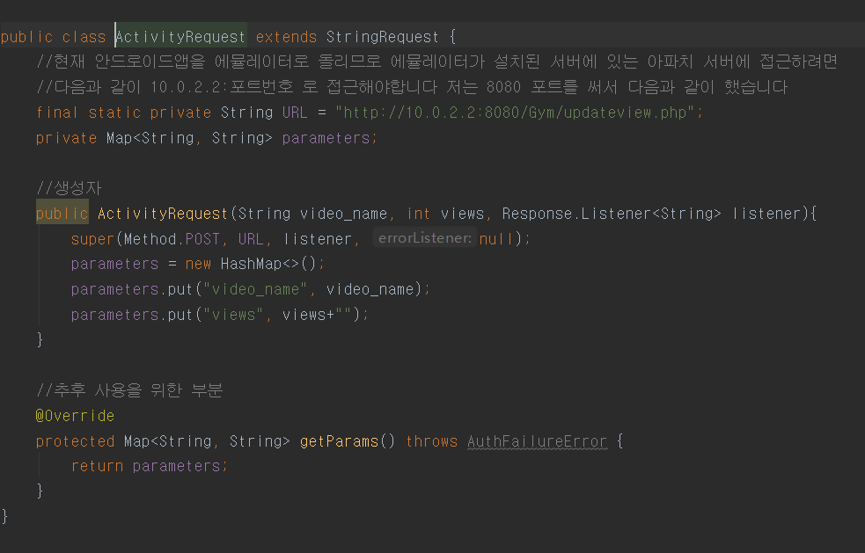

To get a profile picture from the server, I stored the profile picture on the server and I used the server url to store the profile picture in the application's imageview using the bitmap.

we used a thread because we needed to get a profile picture from the server for each item. 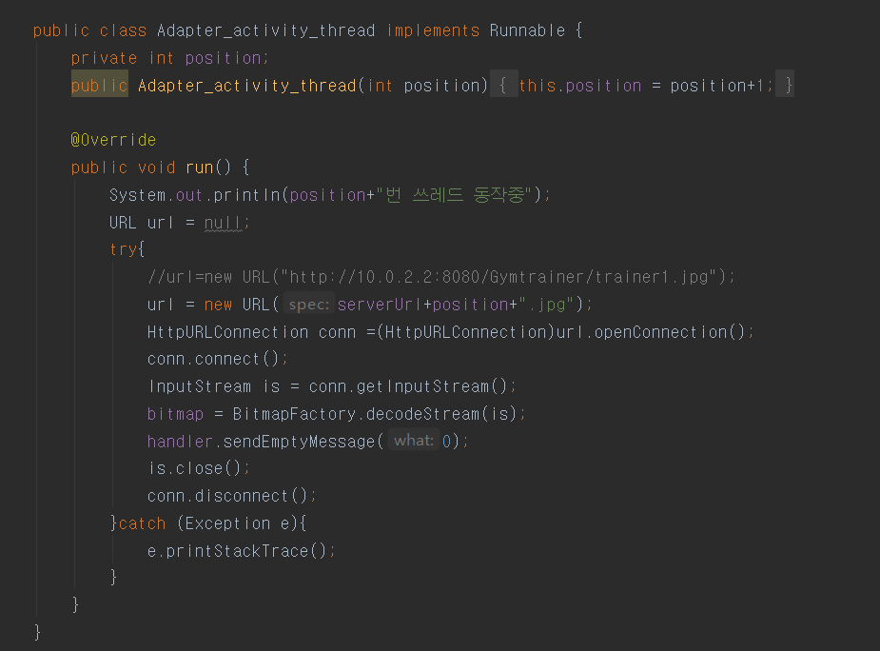

and using handler , we save profile image to each item.

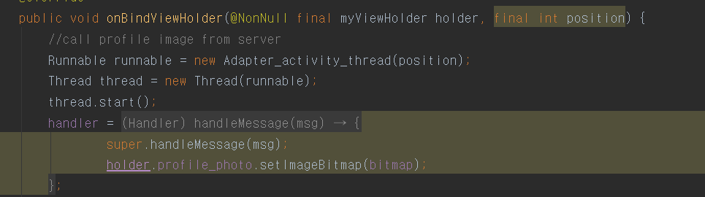

**Function 2,**

As an app user, when he/she is browsing the private trainer list, he/she may want to send a email or leave a SMS message or take a call according to the contacts provided in the list.

**Used programs :** android studio, mysql, php, apache server

**running result :**

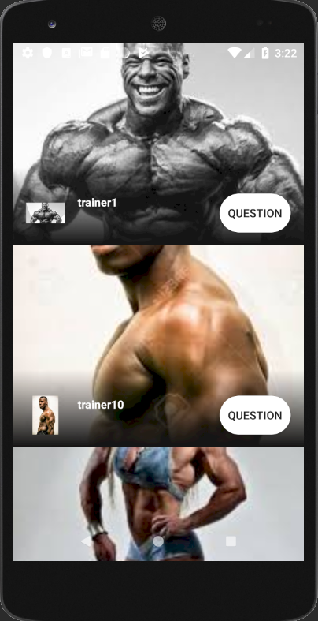 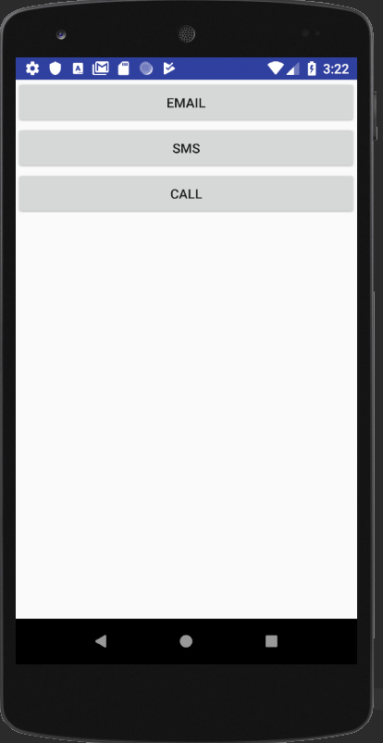

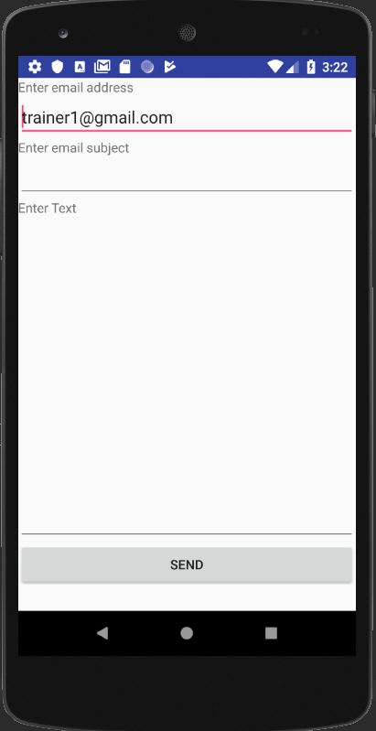 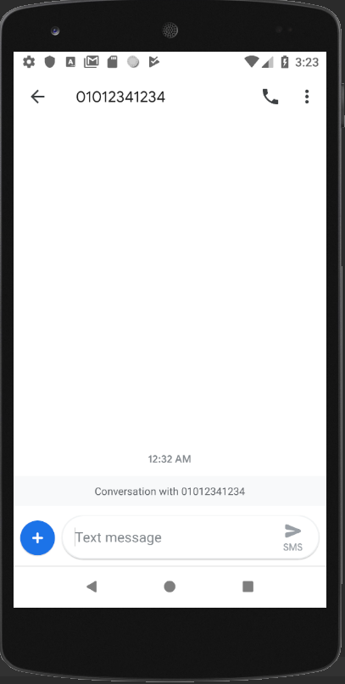 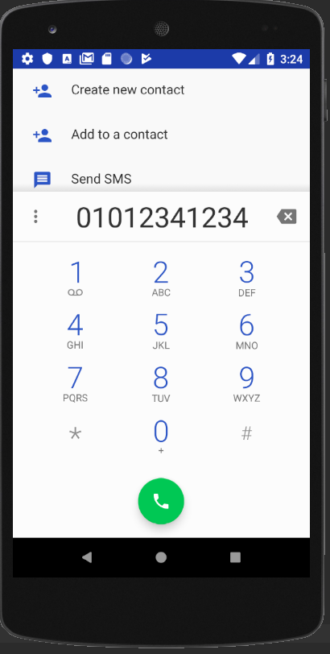

-send email- -send sms- -call-

**class diagram:**

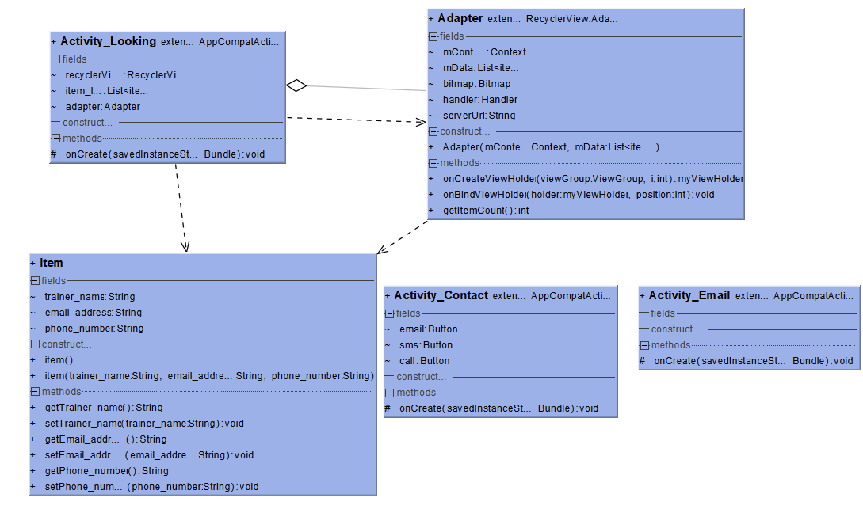

We created a database that stores each trainer contact, email, and name.

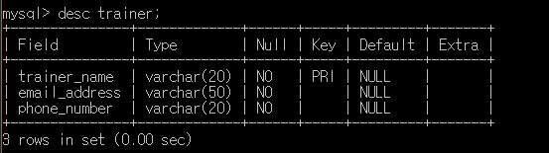

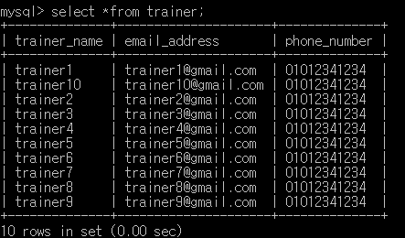

we wrote a php file to get a list of trainer in the database.

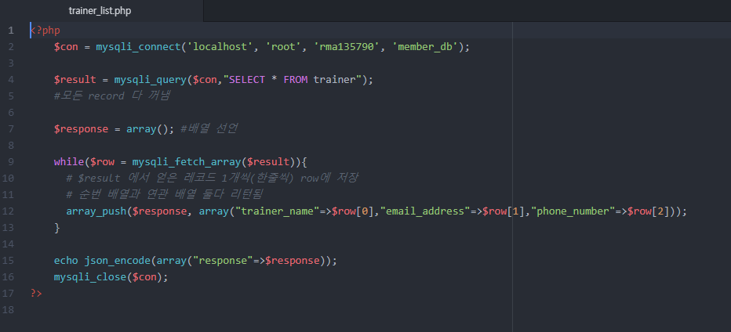

I created an item class to receive the list.

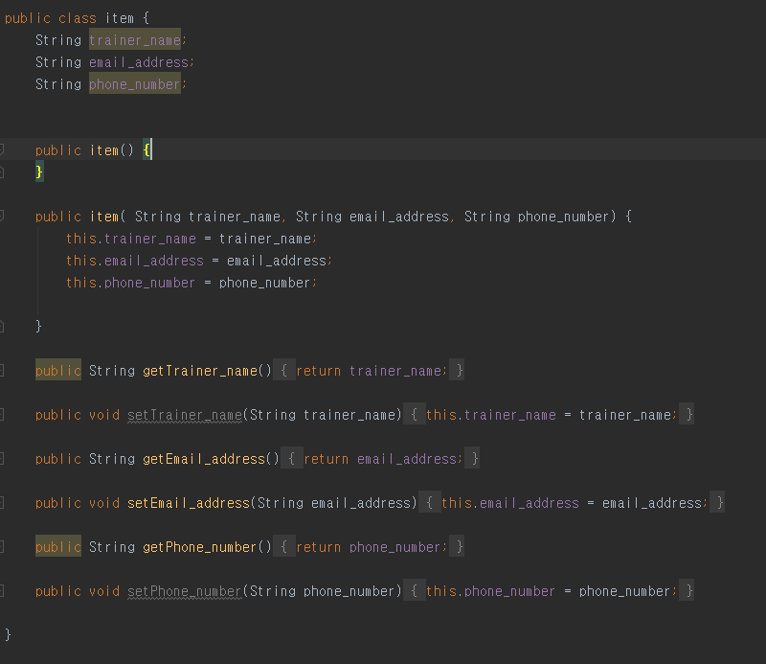

for connecting http server, we wrote network connection code.

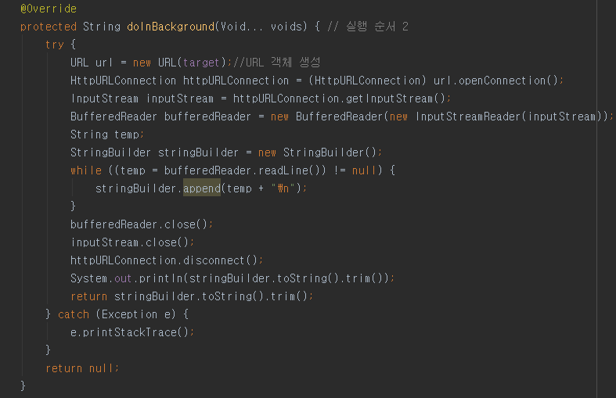

and parsing json. and input json data in item class.

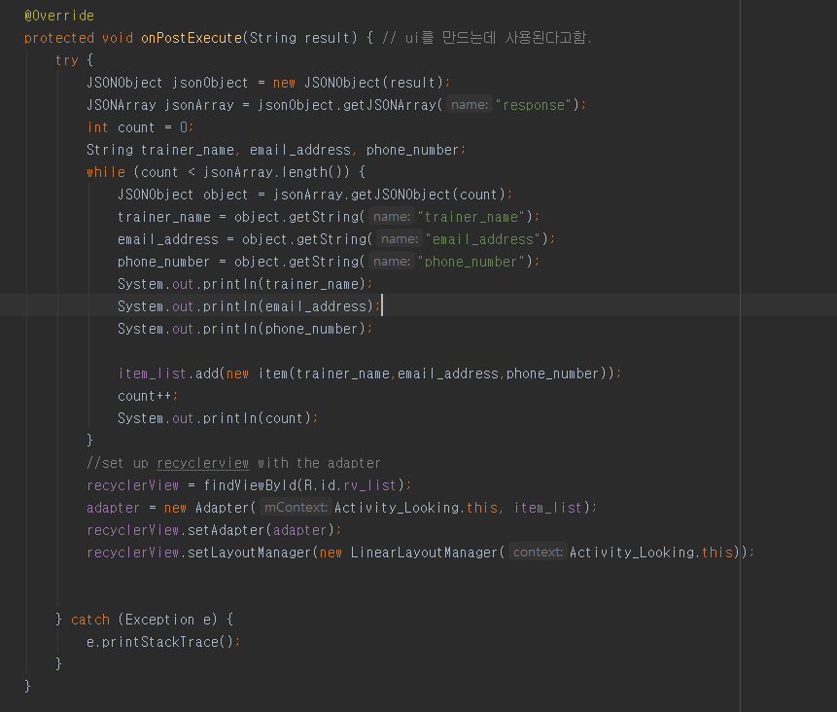

And we saved the trainer photo on the server.

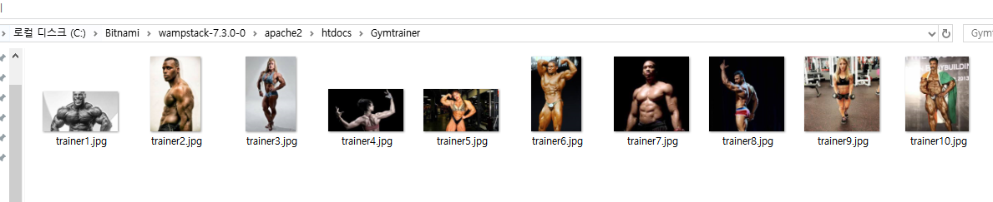

And I made a thread to get those pictures.

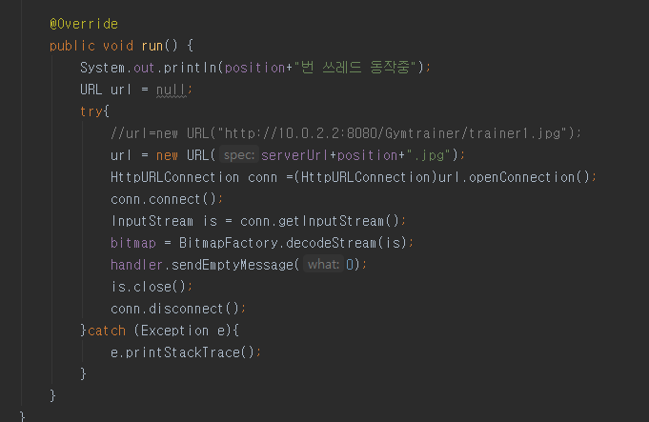

We used handlers to store them in each imageview.

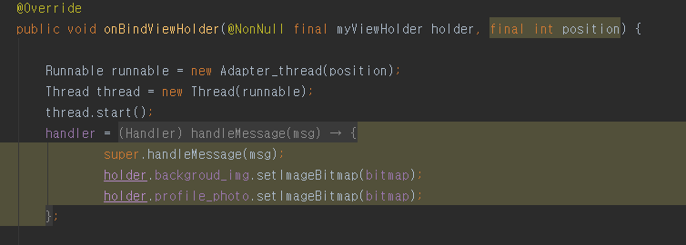

When we press the question button, we move on to the "Activity_Contact" class, and when we move on, we hand over each trainer email and cell phone number as "extra data".

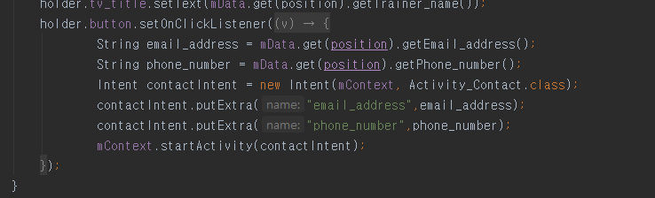

in Activity_contact, we make each button to send an email, send an SMS, and make a call.

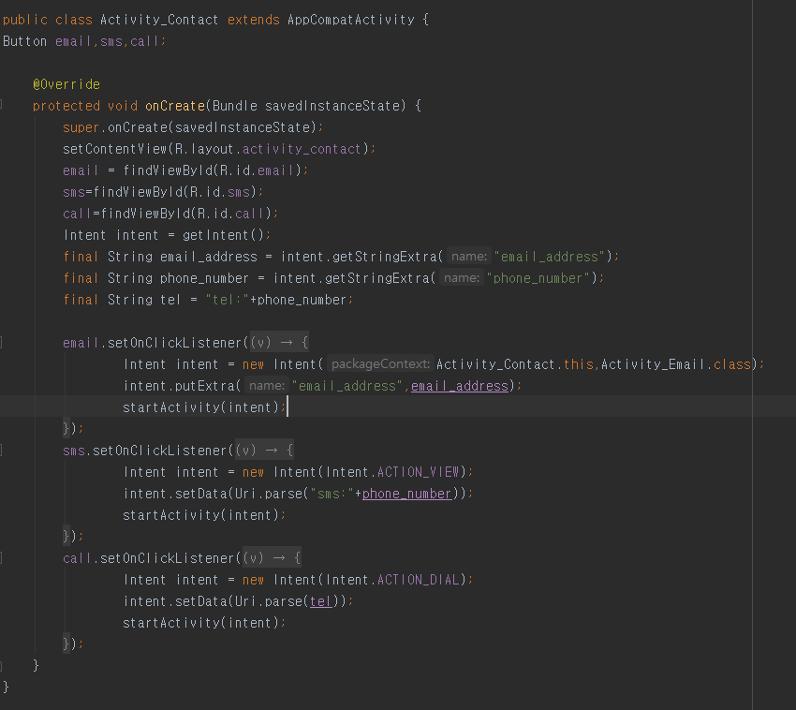

to send email, we should go to the Activity_Email.

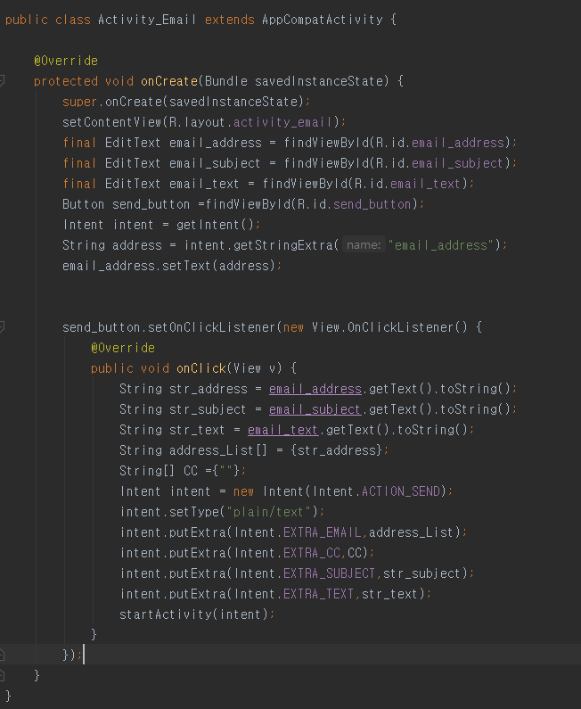

to send sms , we should add <uses-permission android:name="android.permission.SEND_SMS" />in AndroidManifest.xml

to call trainer, we should add <uses-permission android:name="android.permission.CALL_PHONE" /> in AndroidManifest.xml

**Optional Function3,**

As an app user, he/she likes to use a geolocation service (e.g, Google map or Baidu map) so that he/she can find the place of a specified gym, user hopes the map function can be integrated to the gym club app.

**Used programs :** android studio, google api

**running result :**

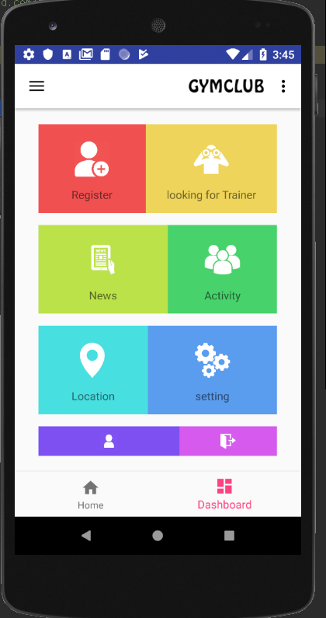 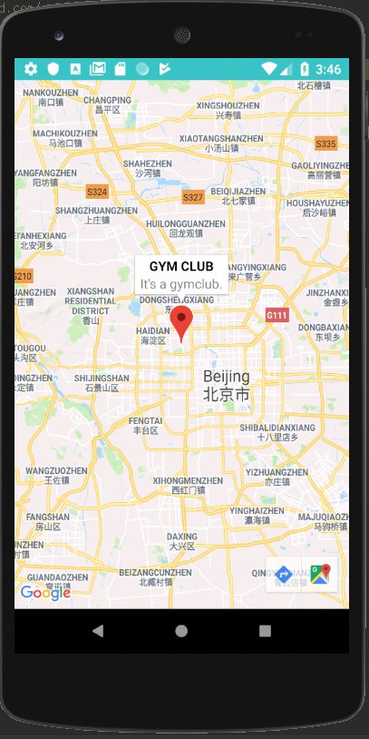

we used google api to make geolocation service.

We visited this site to use Google Maps. (https://console.developers.google.com/apis/dashboard )

and make project, using Maps SDK for Android .

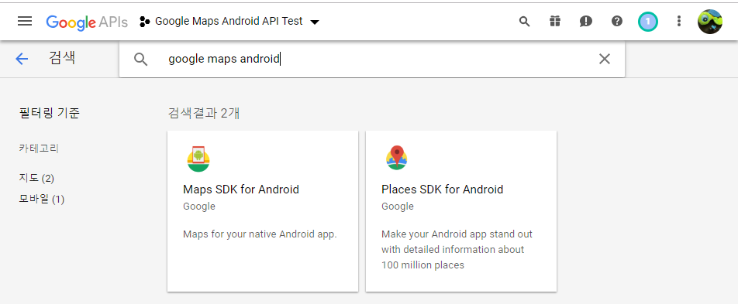

and get SHA key

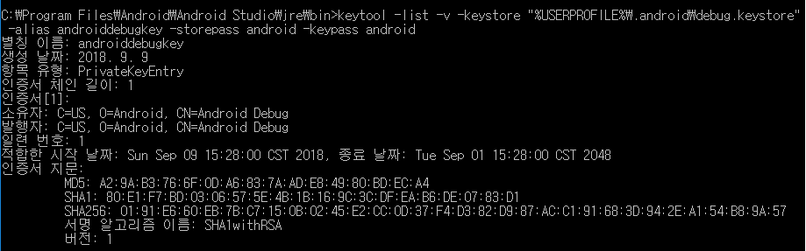

and get API key in that site.

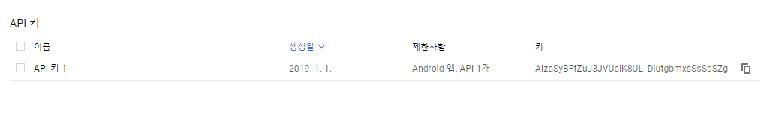

Enter the API key we copied using the <meta-data> tag in the <application> tag subelement of AndroidManifest.xml.

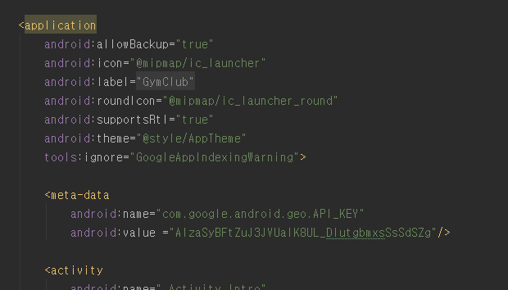

we need to add the Google Play Services library to your project in the build.gradle of your module app.

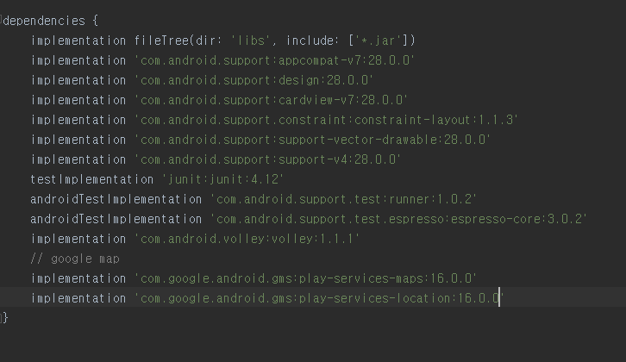

in layout file, we add fragment tag to use google map.

MapFragment is a component used to display a map in your app, which automatically handles related processing. In order to use it in your app, you need to add it to your layout's activities using the <fragment> tag.

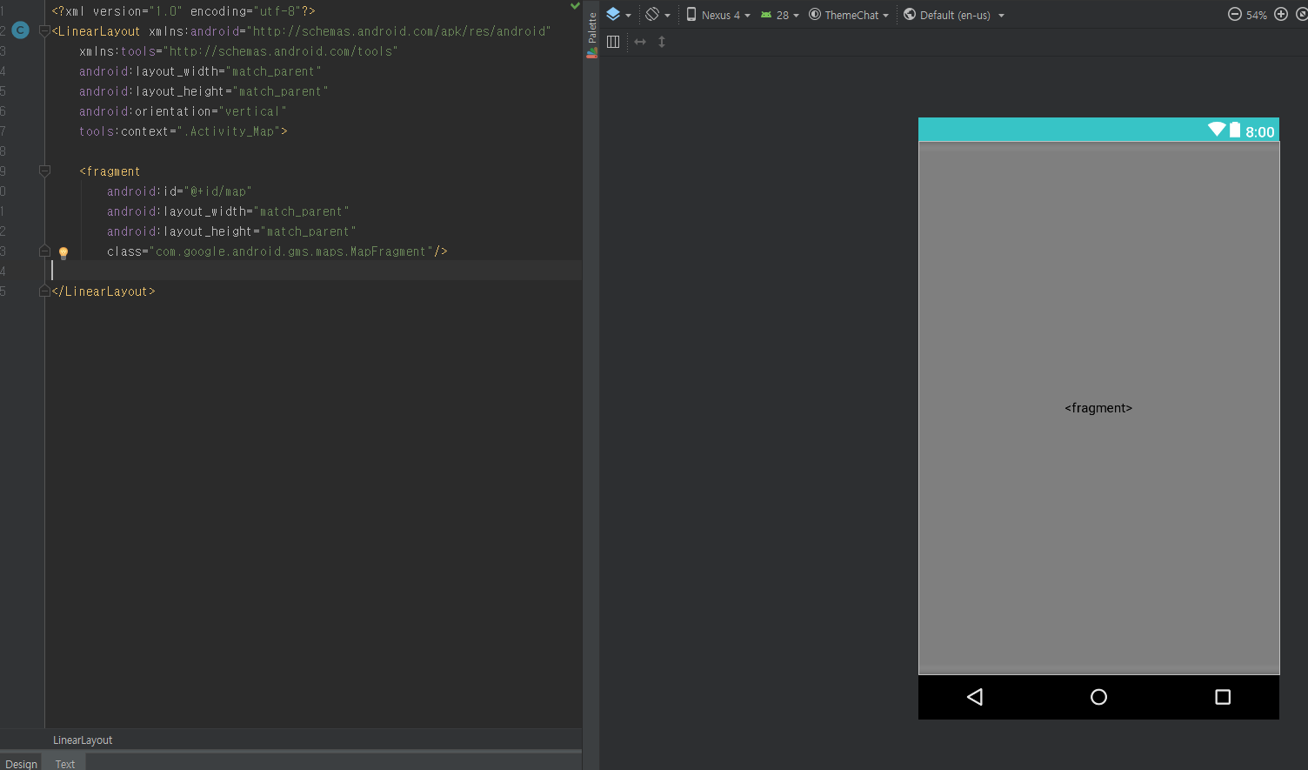

in java code , We designated the location of the virtual gymclub as jiaotong university.

