Mobile Application Development

(Assignment 4)

**team members:**

17309003 Cho Manki

17309004 Kim Seonghyeon

17309005 Kum Seungwon

17309006 Min Siwan

**Technical features:**

As per requirements from our client, users hope the app will enable them to query the private trainer information as well as the training material offline.

**Function1,***As a User, I hope to* Access private trainer information offline.

**running result:**

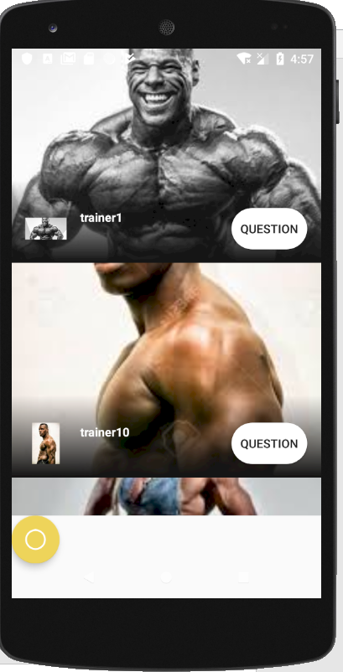 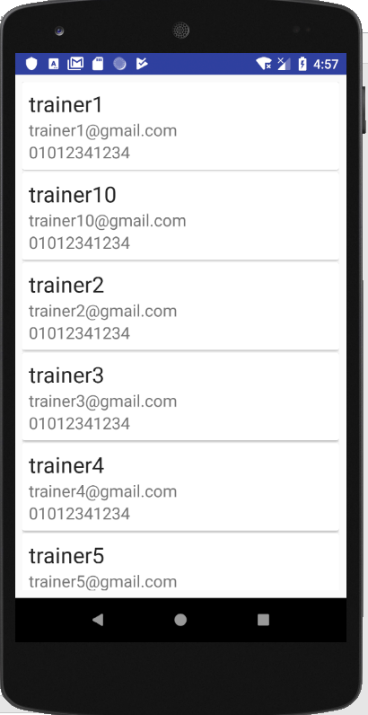

We decided to use room api. So we added the library to build.grade (app).

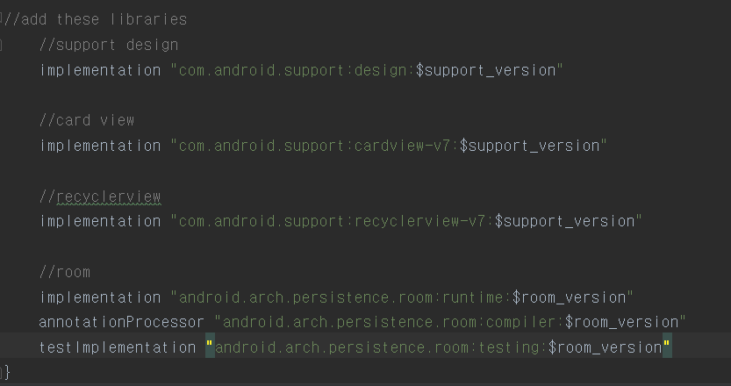

And we added permission to the Manifest file to check offline.

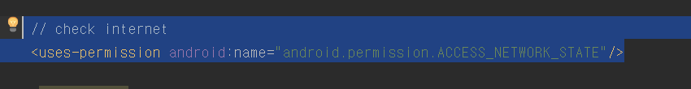

we have defined several classes to use sqlite.

item.java

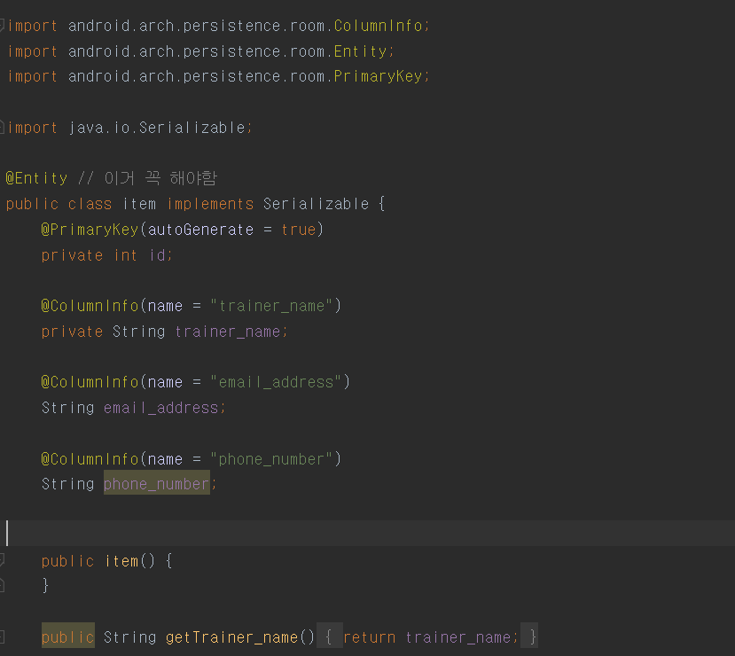

itemDao.java

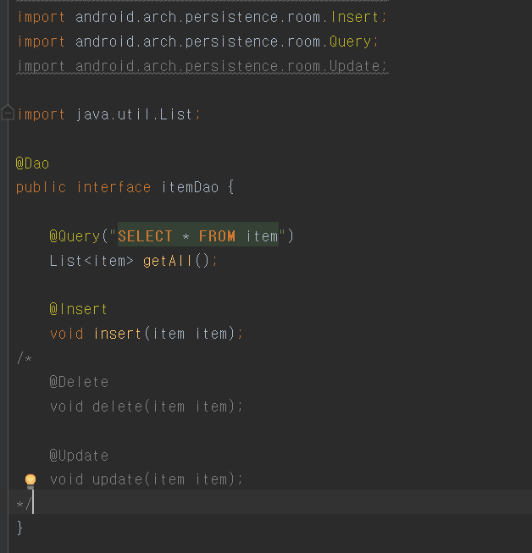

databaseclient

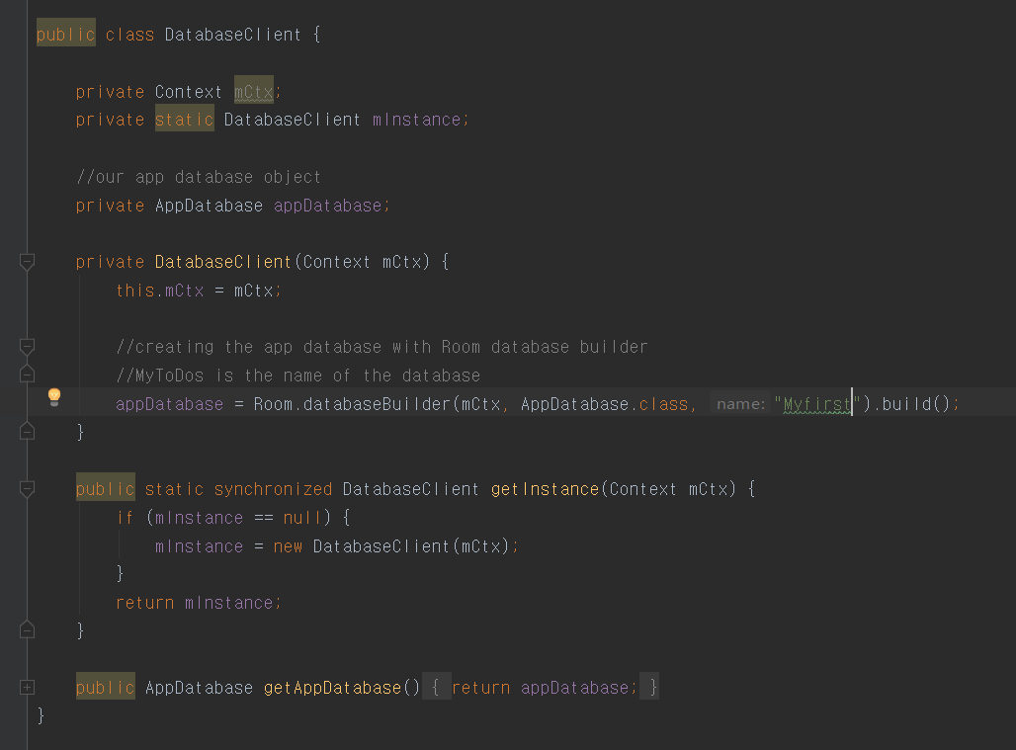

appdatabase

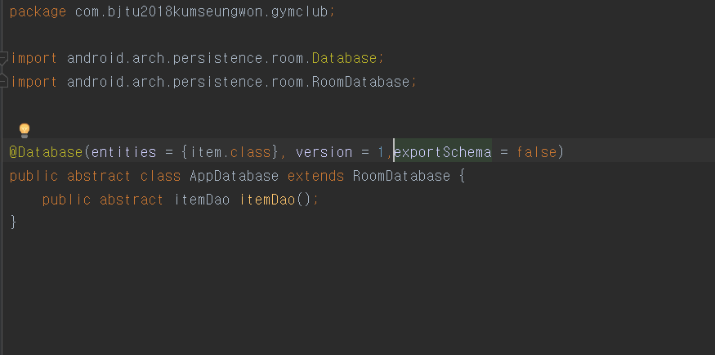

and add the code to add to database

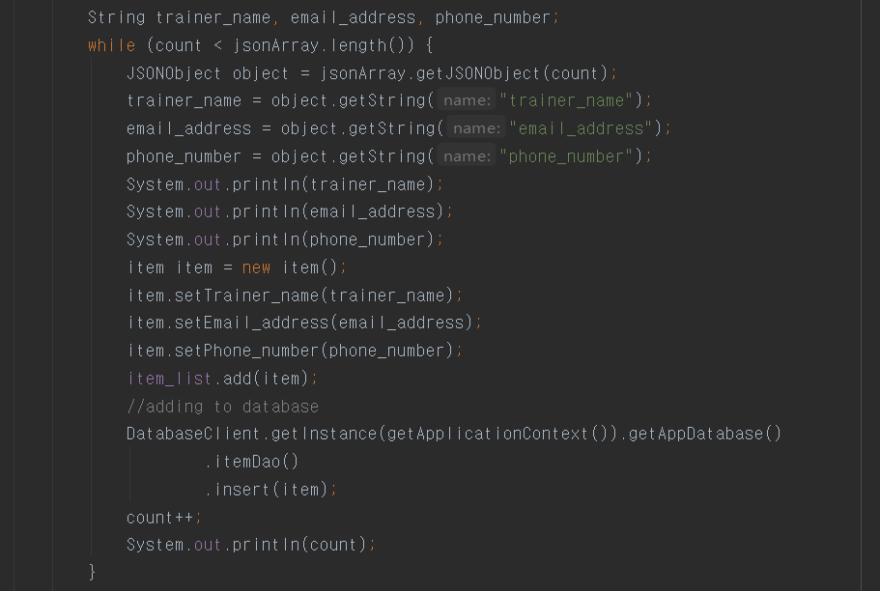

we checked that the internet works well and works well.

**Function 2**

As a User, I hope to Access training articles offline.

**running result:**

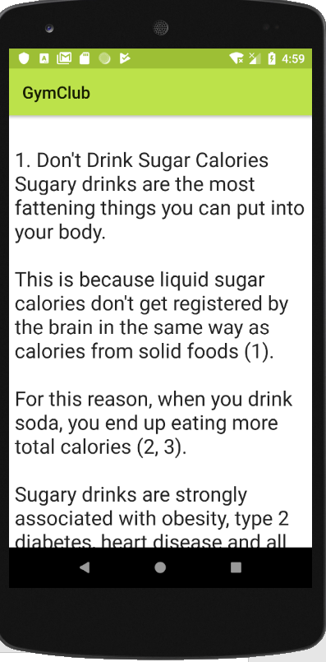

I did not have the data so I saved the text document to the server.

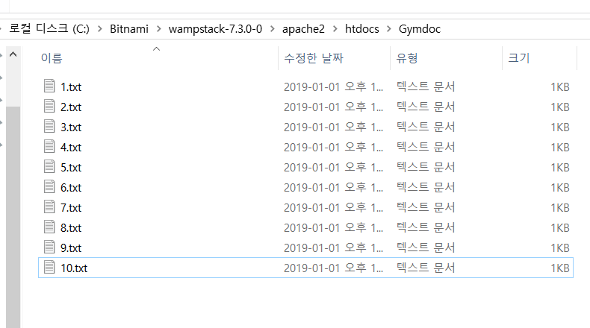

I then parsed it and put it in the news activity.

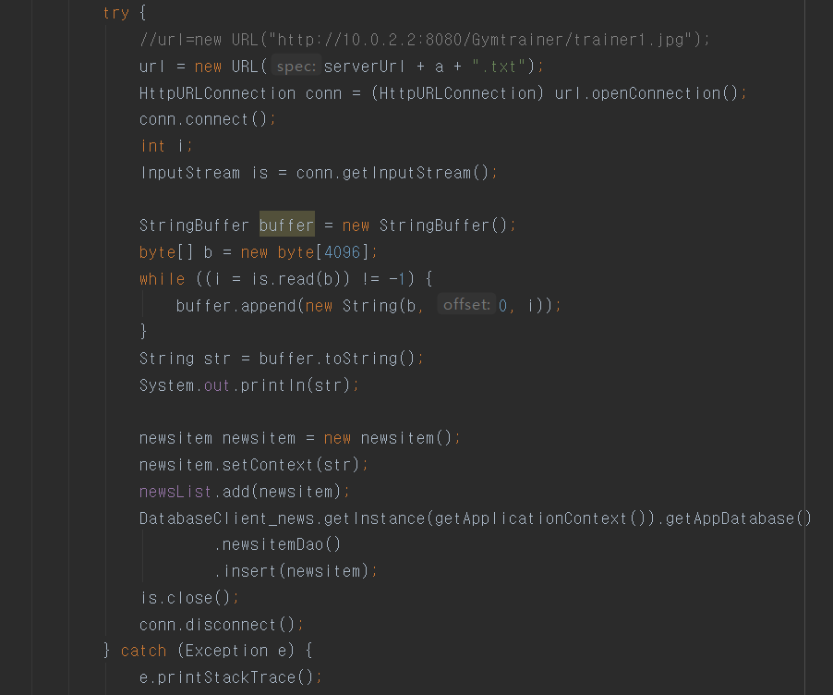

I also put in code to check if the internet is down.

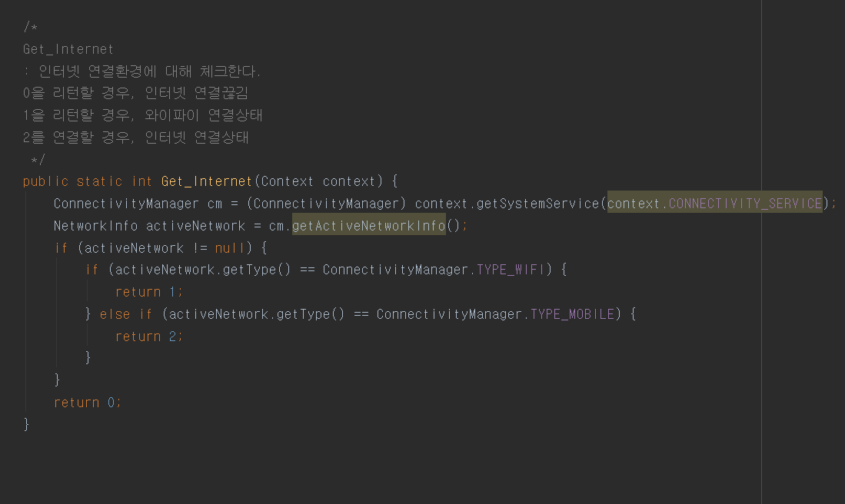

The definition of the class that manages the database is as in function1.

newsitem.java

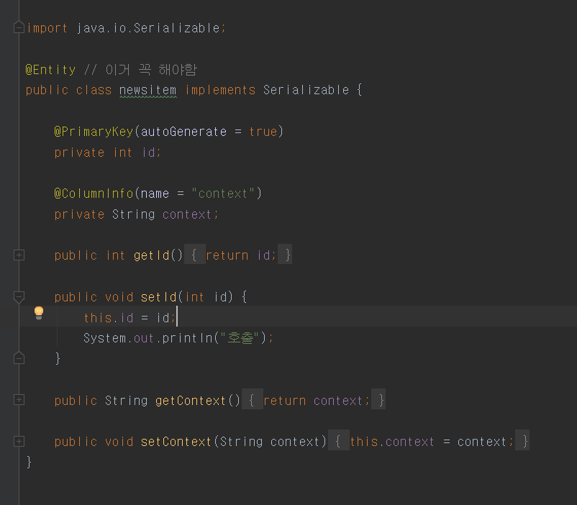

newitemAdapter.java

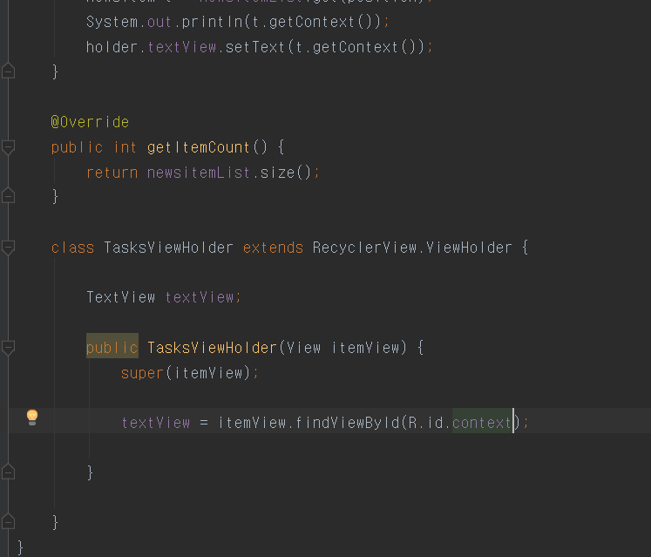

appdatabase_news

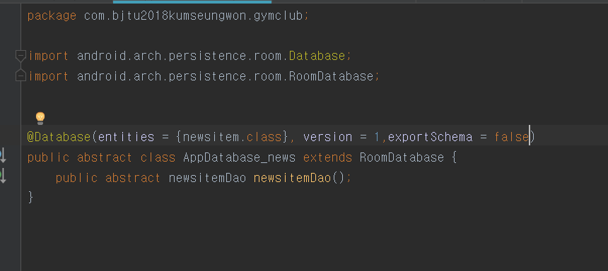

databaseClient_news

