Mobile Application Development

(Assignment 5)

**team members:**

17309003 Cho Manki

17309004 Kim Seonghyeon

17309005 Kum Seungwon

17309006 Min Siwan

**Technical features:**

As per requirements from our client, users hope the app will enable them to login to the gymclub app with their social account in QQ, Wechat, Facebook and etc.

**Function1,**

As a User, I hope to be able to sign in the app with my Wechat/QQ/other social account .

**running result:**

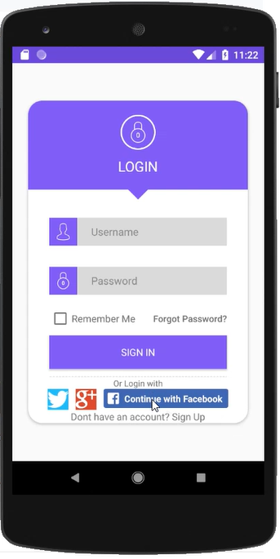 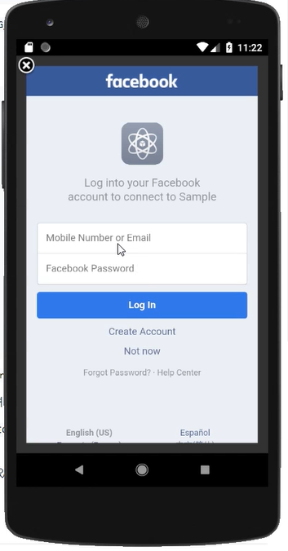 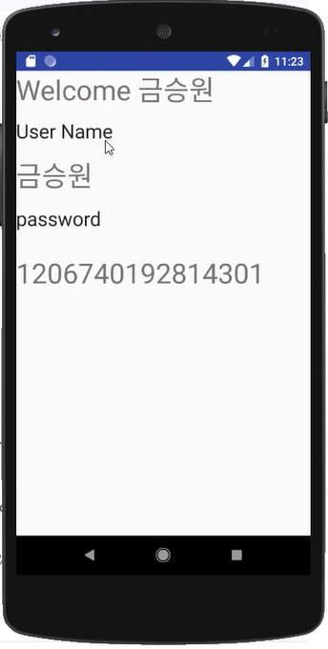

once we signed up facebook for developer to use facebook login api.

https://developers.facebook.com/

and in build.gradle(project) enter this code.



and in build.gradle(app) we entered this code.



and in manifest.xml file , we entered this meta data



And implements the callback function.



And we added the function to the Java file which had the original login function.

When we log in as facebook, it receives the automatically generated ID and name and prints the ID and name on the output layout, which is the layout that comes out when login is successful.

