Journal4

1

public class trydemo

{

public static void main(String args[])

{

try

{

int array[]=new int[-5];

System.out.println(array[0]);

}

catch(NegativeArraySizeException ne)

{

System.out.println("problem info="+ne);

}

}

}

Output

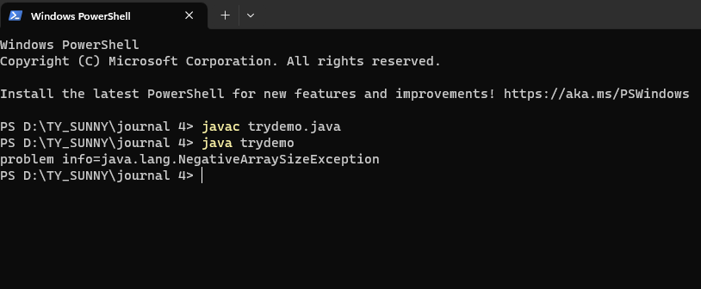

2

class multipletrycatch

{

public static void main(String args[])

{

try

{

int a[]=new int[5];

a[2]=10;

a[4]=0;

a[3]=a[2]/a[4];

}

catch(ArithmeticException ae)

{

System.out.println("error:value of divisor cannot be 0");

}

catch(ArrayIndexOutOfBoundsException ar)

{

System.out.println("error:array index more than size");

}

catch(Exception e)

{

System.out.println("unknown exception has occur");

}

}

}

Output

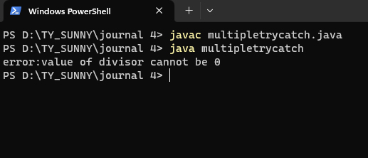

3

class trycatchfinally

{

public static void main(String args[])

{

try

{

int a[]=new int[5];

a[2]=10;

a[4]=0;

a[3]=a[2]/a[4];

}

catch(Exception e)

{

System.out.println("division by zero is not possible");

}

finally

{

System.out.println("the finally block always executes");

}

}

}

Output

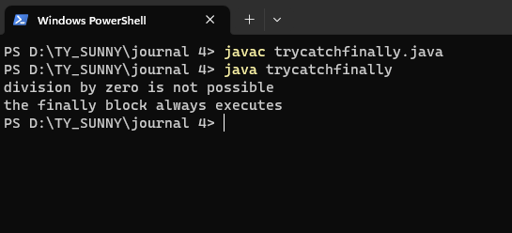

4

public class throwsex

{

public static void main(String args[])throws InterruptedException

{

System.out.println("hello java");

Thread.sleep(1000);

}

}

Output

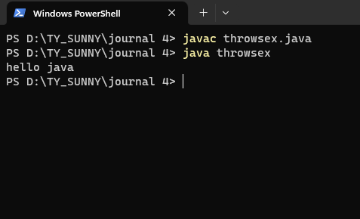

5

public class throwtest

{

public static void main(String args[])

{

int num=7;

for(num=1;num<=10;num++)

{

try

{

if(num==5)

throw new ArithmeticException("arithmetic exception");

else if(num<2)

throw new RuntimeException("runtime exception");

else if(num>9)

throw new NullPointerException("null pointer exception");

}

catch(Exception e)

{

System.out.println("caught an exception");

System.out.println(e.getMessage());

}

}

}

}

Output

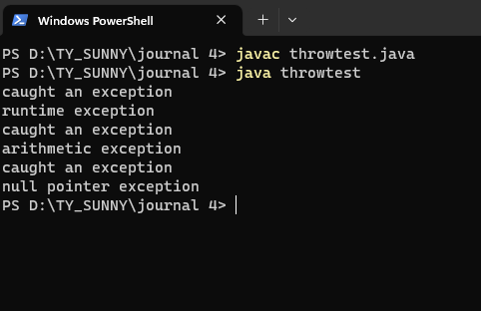

5

import java.util.\*;

class NotEligibleException extends Exception

{

NotEligibleException(String msg)

{

super(msg);

}

}

class voterlist

{

int age;

voterlist(int age)

{

this.age=age;

}

void checkeligibility()

{

try

{

if(age<18)

{

throw new NotEligibleException("error:not eligible for vote due to under age");

}

System.out.println("you are eligible for vote");

}

catch(NotEligibleException ne)

{

System.out.println(ne.getMessage());

}

}

public static void main(String args[])

{

Scanner s=new Scanner(System.in);

System.out.println("enter your age=");

int age=s.nextInt();

voterlist v=new voterlist(age);

v.checkeligibility();

}

}

Output

