LAB ASSIGNMENT 04
OPERATING SYSTEM
NAME: DIYA KUMAL
ROLL NO: 2501720001
PROGRAM: BSC (H) COMPUTER SCIENCE
COURSE CODE: ETCCOS204
Assignment: Producer–Consumer Problem Using Semaphores
1. Introduction:
The Producer–Consumer Problem is a classic problem in Operating Systems that deals with synchronization between processes.
- Producer → produces data and adds it to buffer
- Consumer → consumes data from buffer
- Buffer → shared memory (fixed size)
Problem:
- Producer should not add data if buffer is full .
- Consumer should not remove data if buffer is empty .
2. Concept of Semaphore:
A Semaphore is a synchronization tool used to control access to shared resources.
Types:
- Counting Semaphore → controls multiple resources .
- Binary Semaphore (Mutex) → ensures mutual exclusion.
3. Semaphores Used in This Problem:
We use 3 semaphores:
- mutex = 1 → ensures only one process accesses buffer at a time .
- empty = n → counts empty slots in buffer .
- full = 0 → counts filled slots .
4. Algorithm:
Producer:
- Wait(empty)
- Wait(mutex)
- Add item to buffer
- Signal(mutex)
- Signal(full)
Consumer:
- Wait(full)
- Wait(mutex)
- Remove item from buffer
- Signal(mutex)
- Signal(empty)
5. Input:
No manual input required.
Program automatically:
- Generates random items (Producer) .
- Consumes them (Consumer).
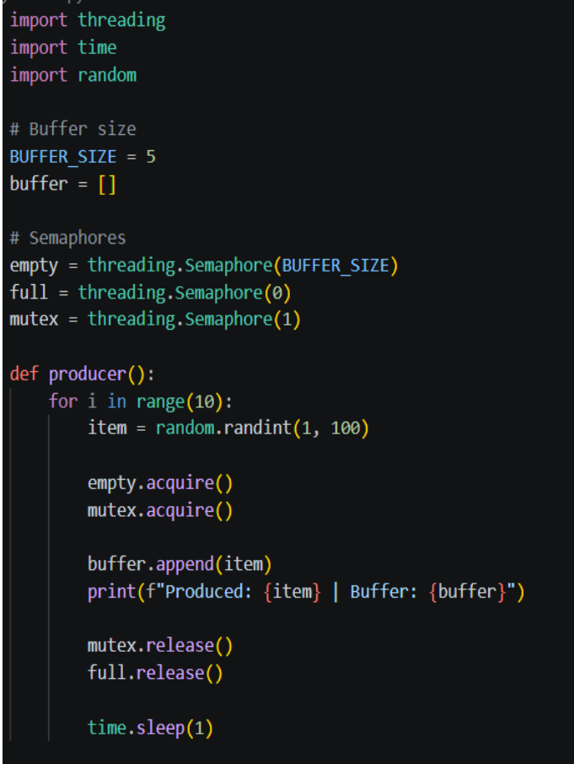

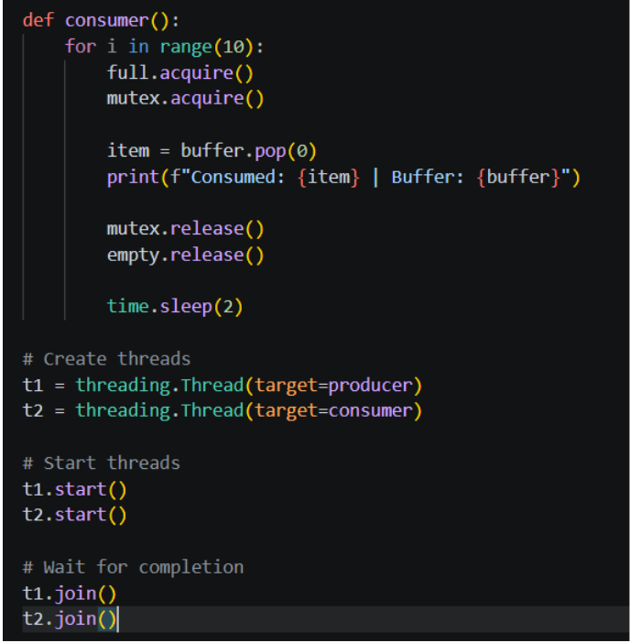
6. Explanation of Output:
- Producer adds items to buffer .
- Consumer removes items .
- Buffer never:
- Overflows (due to empty)
- Underflows (due to full)
- mutex ensures only one thread accesses buffer at a time .

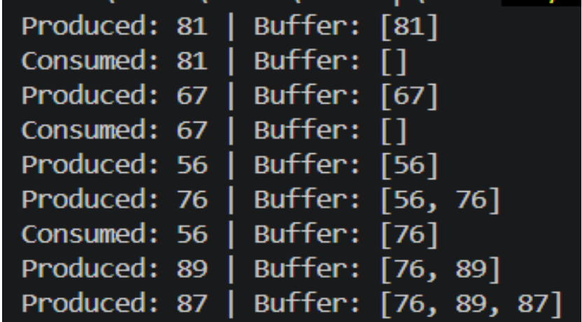

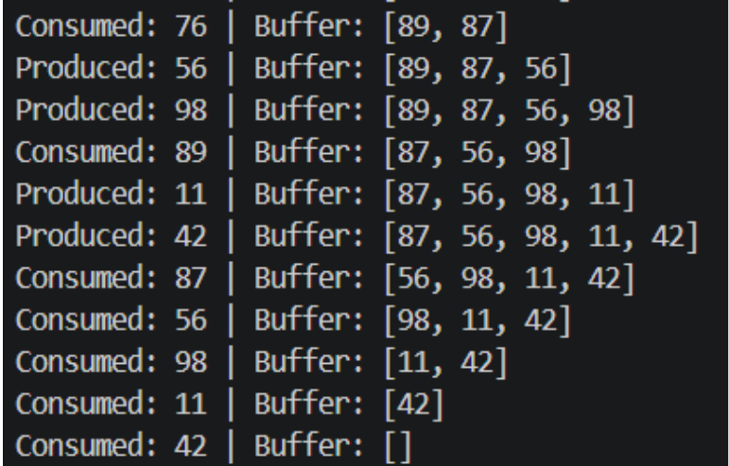

7. Advantages:
- Prevents race conditions .
- Ensures data consistency .
- Efficient use of shared resources .
8. Conclusion:
The Producer–Consumer problem demonstrates how semaphores help in process synchronization.
Using mutex, empty, and full, we ensure safe and efficient communication between producer and consumer processes.

