LAB ASSIGNMENT 03
OPERATING SYSTEM
NAME: DIYA KUMAL
PROGRAM: BSC (H) COMPUTER SCIENCE
ROLL NO: 2501720001
TITLE: Round Robin Scheduling.
OBJECTIVE: Round Robin scheduling aims to allocate CPU time equally to each process using a fixed time quantum.

Example Data:
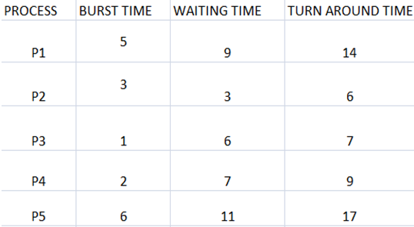

OUTPUT:
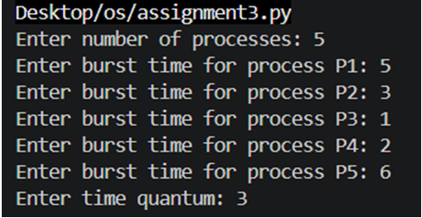
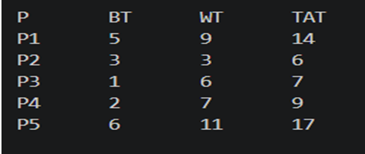
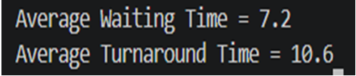
Why this example is good
Shows fair CPU sharing.
Includes both short & long processes.
Easy to understand and calculate.
Conclusion :
Round Robin scheduling gives equal CPU time to all processes and prevents starvation.

