BUG REPORT 02
Bug ID: BUG_002
Bug Title: Password Reset page displays 504 Gateway Timeout after clicking Reset Password
Module: Forgot Password
Reported By: Kumar Suraj
Reported Date: 12-07-2026
Environment
- Application: OrangeHRM Demo
- Browser: Google Chrome
- Operating System: Windows 11
Severity: Critical
Priority: High
Status: Open

Description
The application fails to process the password reset request. After entering a valid username (Admin) and clicking the Reset Password button, the application displays a 504 Gateway Timeout (nginx/1.18.0 Ubuntu) error page instead of completing the password reset process.

Steps to Reproduce
- Launch the OrangeHRM application.
- Click on Forgot your password?
- Enter the username: Admin.
- Click the Reset Password button.

Expected Result
The application should successfully process the password reset request and display a confirmation message such as:
"Password reset instructions have been sent to your registered email."
or redirect the user to a password reset confirmation page without any errors.

Actual Result
The application fails to process the request and displays a 504 Gateway Timeout (nginx/1.18.0 Ubuntu) error page, preventing the password reset operation.

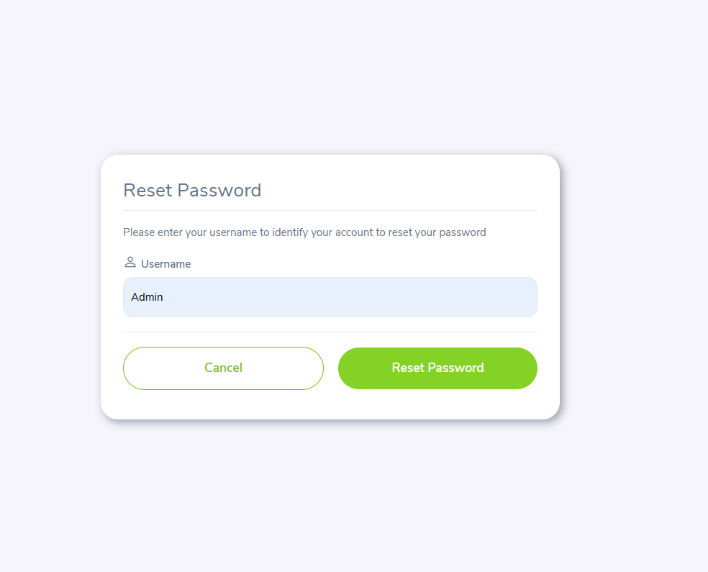

Attachment
- Screenshot showing the 504 Gateway Timeout error page after clicking Reset Password.
