Travel Memory Application – AWS Deployment Guide
This guide documents the end-to-end deployment of the MERN-based Travel Memory application on AWS EC2 with scalability, security hardening, and a custom domain via Cloudflare. It includes architecture, step-by-step procedures, sample configurations, and best practices.

1. Architecture Overview
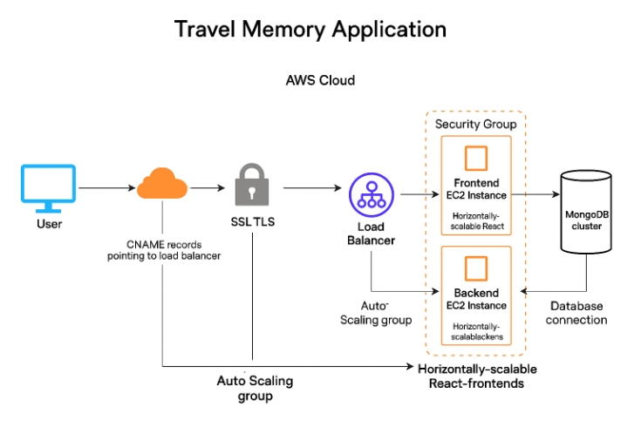

- Key Components:
- Cloudflare: DNS, SSL/TLS, WAF/DDoS protection.
- AWS Application Load Balancer (ALB): HTTPS termination and path-based routing.
- Auto Scaling Groups (ASG): Separate groups for frontend and backend EC2.
- Security Groups (SG): Least-privilege network controls across tiers.
- Frontend EC2 (Nginx serving React): Horizontally scalable.
- Backend EC2 (Node.js behind Nginx): Horizontally scalable.
- MongoDB cluster (Atlas or EC2-hosted): Restricted to backend only.

2. Prerequisites
- - AWS account with IAM permissions to create EC2, ALB, Target Groups, ASG, ACM certificates, and Security Groups.
- - Cloudflare account with your domain added.
- - MongoDB Atlas project (or alternative) ready for connection.
- - Ubuntu 22.04 AMIs for EC2, SSH key pair, and a bastion or allow-listed office IP for administration.

3. Repository Setup
Clone the application repository:
$ git clone https://github.com/UnpredictablePrashant/TravelMemory.git
$ cd TravelMemory

4. Backend Configuration
Navigate to the backend directory and configure environment variables:
# .env (example)
MONGODB_URI=mongodb+srv://<user>:<pass>@<cluster>/<db>?retryWrites=true&w=majority
PORT=3000
JWT_SECRET=change_me
$ cd backend
$ npm install
$ npm run start

5. Frontend Configuration
Update the frontend API base URL (e.g., in urls.js) to point to the backend through ALB.
// frontend/src/urls.js (example)
export const API_BASE = "https://api.yourdomain.com";
$ cd ../frontend
$ npm install
$ npm run build

6. EC2 Instance Setup
Provision EC2 instances for frontend and backend (recommend t3.micro or t3.small for initial tests). Install Nginx and Node.js.
# Common setup
sudo apt update && sudo apt install -y nginx git nodejs npm
Nginx reverse proxy for backend (Node.js on port 3000):
# /etc/nginx/conf.d/backend.conf
server {
listen 80;
server_name _;
location /api/ {
proxy_pass http://127.0.0.1:3000/;
proxy_http_version 1.1;
proxy_set_header Host $host;
proxy_set_header X-Real-IP $remote_addr;
proxy_set_header X-Forwarded-Proto $scheme;
proxy_set_header X-Forwarded-For $proxy_add_x_forwarded_for;
proxy_set_header Connection "";
}
location = /health { return 200 "OK"; add_header Content-Type text/plain; }
}
Nginx static hosting for frontend (React build):
# /etc/nginx/conf.d/frontend.conf
server {
listen 80;
server_name _;
root /var/www/travelmemory/build;
index index.html;
location / {
try_files $uri /index.html;
}
location = /health { return 200 "OK"; add_header Content-Type text/plain; }
}

7. Load Balancer & Target Groups
Create an Application Load Balancer (ALB) with an HTTPS listener (port 443) using an ACM certificate for your domain. Configure two target groups:
- - Frontend TG: HTTP port 80, health check /health
- - Backend TG: HTTP port 3000 (or 80 via Nginx), health check /health
Add path-based rules: /api* -> Backend TG; default -> Frontend TG.

8. Auto Scaling
Create two Auto Scaling Groups (ASGs) – one for frontend and one for backend. Use target tracking scaling on ALB RequestCountPerTarget or CPU. Set min=1, desired=2, max=4 for initial tests.

9. Security Groups (Least Privilege)
Define four SGs and attach accordingly:
- sg-alb: Inbound 443 from 0.0.0.0/0 (or Cloudflare IP ranges); Outbound to sg-frontend:80 and sg-backend:3000.
- sg-frontend: Inbound 80 from sg-alb; SSH 22 from your office IP; No DB access.
- sg-backend: Inbound 3000 (or 80/443) from sg-alb; SSH 22 from office IP; Outbound 27017 to sg-db.
- sg-db: Inbound 27017 from sg-backend only.

10. SSL/TLS Configuration
Request an ACM certificate for your domain (e.g., app.example.com) and attach it to the ALB HTTPS listener. In Cloudflare, set SSL/TLS mode to Full (Strict). Optionally enable HSTS and Automatic HTTPS Rewrites.

11. Cloudflare DNS
Create a CNAME record for your app hostname pointing to the ALB DNS name (e.g., my-alb-123.us-east-1.elb.amazonaws.com) with proxy enabled (orange cloud). Optionally create an A record to a frontend EC2 for direct access if required by the assignment.

12. MongoDB Connectivity
Use MongoDB Atlas IP Access List to allow only backend EC2 public IPs or VPC peering/private endpoints. Store the connection string in the backend .env and avoid hardcoding credentials.

13. Validation & Testing
- - Frontend loads over HTTPS and passes health checks in ALB.
- - /api routes are reachable and return expected data.
- - ALB distributes traffic across instances; simulate load to observe ASG scaling.
- - Security groups block unintended access paths (e.g., DB not reachable from internet).

14. Best Practices
- - Use IAM roles for EC2 instead of embedding credentials.
- - Restrict SSH to your static IP and disable password auth.
- - Enable CloudWatch metrics/alarms and ALB access logs.
- - Regularly patch OS and rotate secrets.

Appendix A: Useful Commands
# Nginx reload
sudo nginx -t && sudo systemctl reload nginx
# Enable services
sudo systemctl enable nginx
# Node.js as a service (PM2 example)
sudo npm install -g pm2
pm2 start server.js --name travelmemory-api
pm2 startup systemd
pm2 save

