

**C Programming Basic Notes**

* **Programming Language**

**What is a programming language?**

A programming language is the language that we developers use for communicating to a computer. We communicate through our computer through a set of instructions that are called **“programs”.** These set of instructions are used to perform some specific tasks .

For example – C,C++,Java, Python, Fortan, Cobol, Basic.

* **C Programming Language**

C is the first high-level programming language that is created to design system software. C language is considered as the mother language of all the modern programming languages because **most of the compilers, JVMs, Kernels, etc. are written in C language**, and most of the programming languages follow C syntax, for example, C++, Java, C#, etc.

* **Write your first C program**

Let’s first understand our first program before learning “abcd” of c programming. All C programs run in a compiler. This compiler can be online or offline both.

Open any c compiler and copy below code

#include <stdio.h>

**int** main(){

printf("Hello C Language");

**return** 0;

}

**#include <stdio.h>** includes the **standard input output** library functions. The printf() function is defined in stdio.h .

* **#include <stdio.h>** includes the **standard input output** library functions. The printf() function is defined in stdio.h .
* **int main()** The **main() function is the entry point of every program** in c language.
* **printf()** The printf() function is **used to print data** on the console.
* **return 0** The return 0 statement, returns execution status to the OS. The 0 value is used for successful execution and 1 for unsuccessful execution.

**Running the First C Program**

* Now **click on the compile menu then compile sub menu** to compile the c program.
* Then **click on the run menu then run sub menu** to run the c program.

**You will see the following output on user screen.**

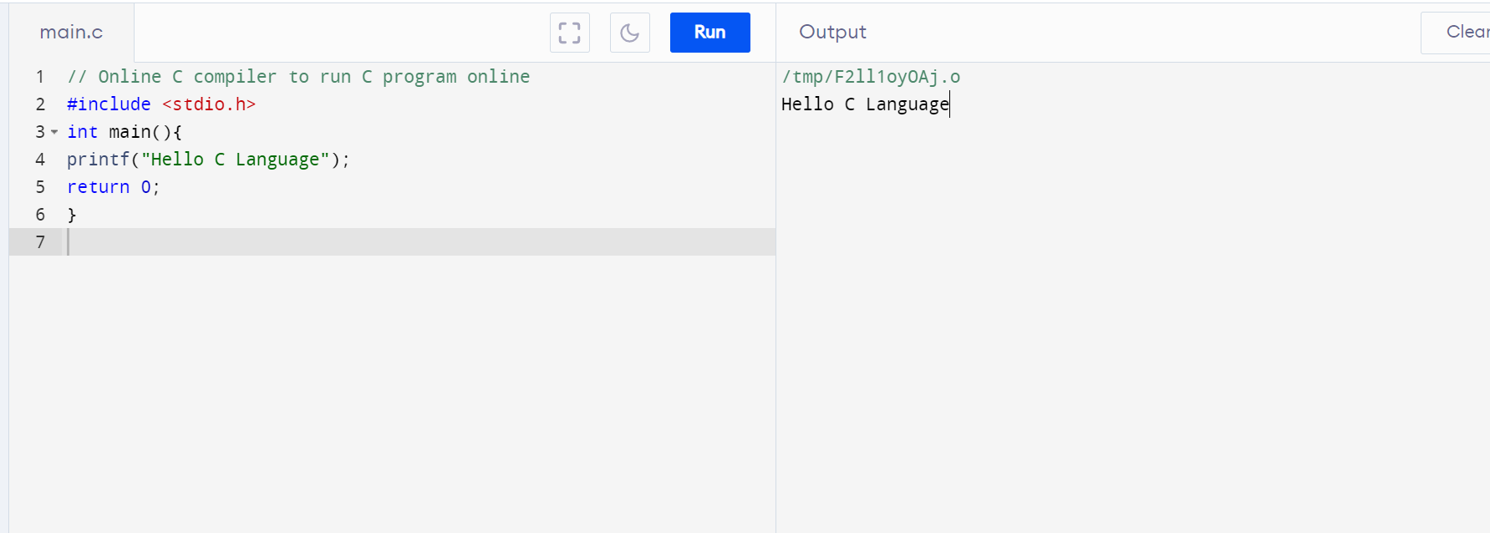

**Happy Learning. Please reach to us for any doubt.**

** 8084234955  https://www.facebook.com/learningpioneer**