

**Functions in C**

Functions are set of code that are written to perform a specific Function are used only when called. A function enables us to write a code and use it anytime in same program. A function increases the code reusability.

We have two types of functions in C language

* Standard library functions
* User-defined functions

**Standard library functions**

These are inbuilt functions in c which are given to us to use only. These functions are defined in the header files.

For example,

* The printf() is a standard library function to send formatted output to the screen (display output on the screen). This function is defined in the stdio.h header file.
* Hence, to use the printf()function, we need to include the stdio.h header file using #include <stdio.h>.
* The sqrt() function calculates the square root of a number. The function is defined in the math.h header file.

**User-defined function**

C Language Provide us the power to create your own function. Those function which are created by the user are known as user defined functions

Flow of program in functions

First the flow of code goes to the main function()

In main function we call our function that we have created. From this the code goes to function definition . After that function code is executed.

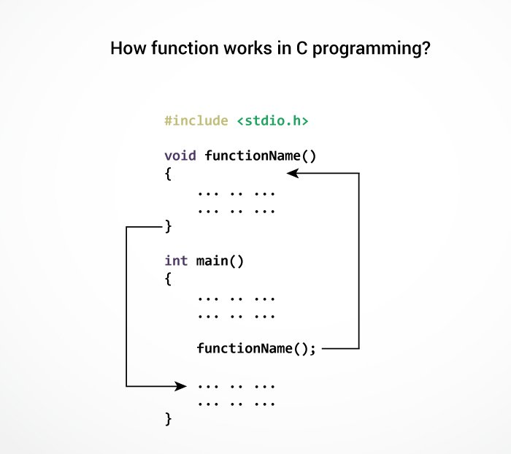

A function has following parts in C

* Return Type

Every function has a return type. This return type can be both Pre-defined variable such as int, char, double, long or User Defined Variables such as array and structure. Return Type is type of variable that function will give in output. If there are no function name then function name should be ***void.***

* Function Name

Every Functions must have a unique name same as variable name. In compiler function is known by its name only.

* Functions parameter

These are input parameters that function takes while we call the function in c. We defined the Function parameter while creating the function itself. These function parameters can be All the predefined and user defined variables. A function can have any number of parameters. We can also create a function without a parameter.

Lets understand it by a example

Suppose we have a function

int add(int a, int b)

Here int is the return , add is the function name and int a and int b are function parameters.

Every function must have a function body. Function body start with { and ends with }.

Every function should be declared before main function like below example

int add(int a, int b);

We can write the function definition either before main or after main function

Let’s understand by an example

We will create a function to print all the prime numbers between a given range

#include <stdio.h>

int isPrime (int a); // Here we are declaring the function. It is called function declaration

int main ()

{

int n;

printf ("Please enter the number\n");

scanf ("%d", &n);

int flag=0;

for(int i=1;i<=n;i++){

flag=isPrime(i); //We are calling our function here//our compiler know about function from this step only

if(flag==0){

printf("%d",i);

}

}

return 0;

}

int isPrime (int a) //This is the function Definition. We are writing the code what function should do.

{

int flag = 0;

if (a == 0 || a == 1)

{

flag = 1;

}

for (int i = 2; i < a; i++)

{

if (a % i == 0)

{

flag = 1;

break;

}

}

return flag; // We return the output of a function though return statement only. Here we are returning value of flag as output. This output will be used whenever function will be called

}

Advantages of using functions

* The program will be easier to understand, maintain and debug.
* Reusable codes that can be used in other programs
* A large program can be divided into smaller modules. Hence, a large project can be divided among many programmers.

Happy Leaning.