

What is SQL?

SQL is a short-form of the structured query language, and it is pronounced as S-Q-L or sometimes as See-Quell.

We use this data language mainly in **Relational Database Management System( RDBMS).**

Relational management System is a special type of database where we store data in form of rows and columns. Data is stored in rows and columns and this collection in known as table.

We use SQL for data insertion, manipulation and deletion.

SQL Syntax

The syntax of the structured query language is a unique set of rules and guidelines, which is not case-sensitive. We have to follow these specific rules while writing a SQL Query.

For Example if you want to fetch all the records of a table employee we have to write

Select * from employee;

## SQL Statement

## Sql statements tell the database what operation you want to perform on the structured data and what information you would like to access from the database.

## These are like normal English statement but with a particular syntax.

## For example

## SELECT "column_name" FROM "table_name";

Each SQL statement start with SQL keyword and ends with a semicolon (;)

Note: SQL statements are case sensitive which means You can write the keywords of SQL in both uppercase and lowercase.

Select * from Employee

SELECT * FROM Employee

These both statements will give same result.

## SQL Database

## In SQL, the 'Create Database' statement is a first step for storing the structured data in the database.

### Syntax of Create Database statement in SQL

### CREATE DATABASE Database_Name;

Suppose you want to create a database employee you have to write below statement

### CREATE DATABASE employee;

In MYSQL we have to select the database for performing any operation.

Please use the following syntax to see the list of all databases.

### SHOW DATABASES

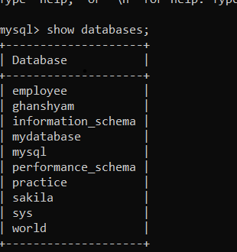

See in pic we can see a table with name employee created.

We have to select a particular database in order to use it.

Use the below syntax to select a database;

**USE employee;**

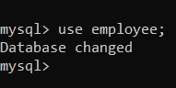

# SQL Table

Table is a collection of data, organized in terms of rows and columns. In DBMS term, table is known as relation and row as tuple.

Employee

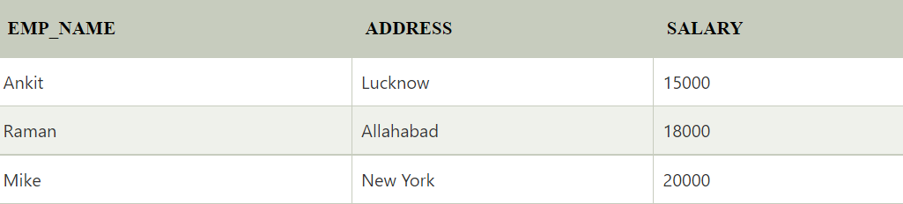

In the above table, "Employee" is the table name, "EMP_NAME", "ADDRESS" and "SALARY" are the column names. The combination of data of multiple columns forms a row e.g. "Ankit", "Lucknow" and 15000 are the data of one row.

# SQL CREATE TABLE

SQL CREATE TABLE statement is used to create table in a database.

If you want to create a table, you should name the table and define its column and each column's data type.

Lets see a simple syntax of creating table

**create** **table** "tablename"  ("column1" "data type",  "column2" "data type",  "column3" "data type",  "columnN" "data type");

We have to specify column name datatype for creating a table

Suppose you want to create a table Employeedata use the following syntax

**CREATE TABLE Employeedata**

**(**

**EmployeeID int,**

**FirstName varchar(255),**

**LastName varchar(255),**

**Email varchar(255),**

**AddressLine varchar(255),**

**City varchar(255)**

**);**

USE DESC Command to see the table structure.

