**CAPILLARY ASSIGNMENT**

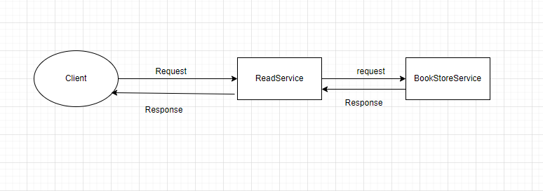

* Run the ReadService Application and BookStoreService Application.
* Send a get Request to the Api -> **http ://localhost:8080/recommended**.
* If the BookStoreService will be up it will send the response as “Service is up”, else it will send response as “Service is down” (Which is a fallback method implemented In ReadService Application).
* The configuration for Circuit Breaker is done in application.yml file of ReadService Application.
* The failure Rate threshold is set to **50**, which means if **50%** of request fails the state of circuit will change from **CLOSED** to **OPEN**.
* The minimum number of calls is set to **5,** wait duration in open state is set to **5sec** andautomatic Transition from Open to half-open is set to be **True,** which means that after the circuit breaker state has changed from **CLOSED** to **OPEN**. It will automatically change its state from **OPEN** to **HALF-OPEN** after 5 seconds.
* Failure rate in half open state is set to **3** which means if failure threshold is less than **50%** than the circuit breaker state will change to **CLOSED**, else it will again set its to **OPEN**.

Note : - I have also used actuator to monitor the application and to know what is the state of the circuit breaker ([**http://localhost:9080/actuator/health**](http://localhost:9080/actuator/health)).

* Initially The circuit breaker is in **CLOSED** State.

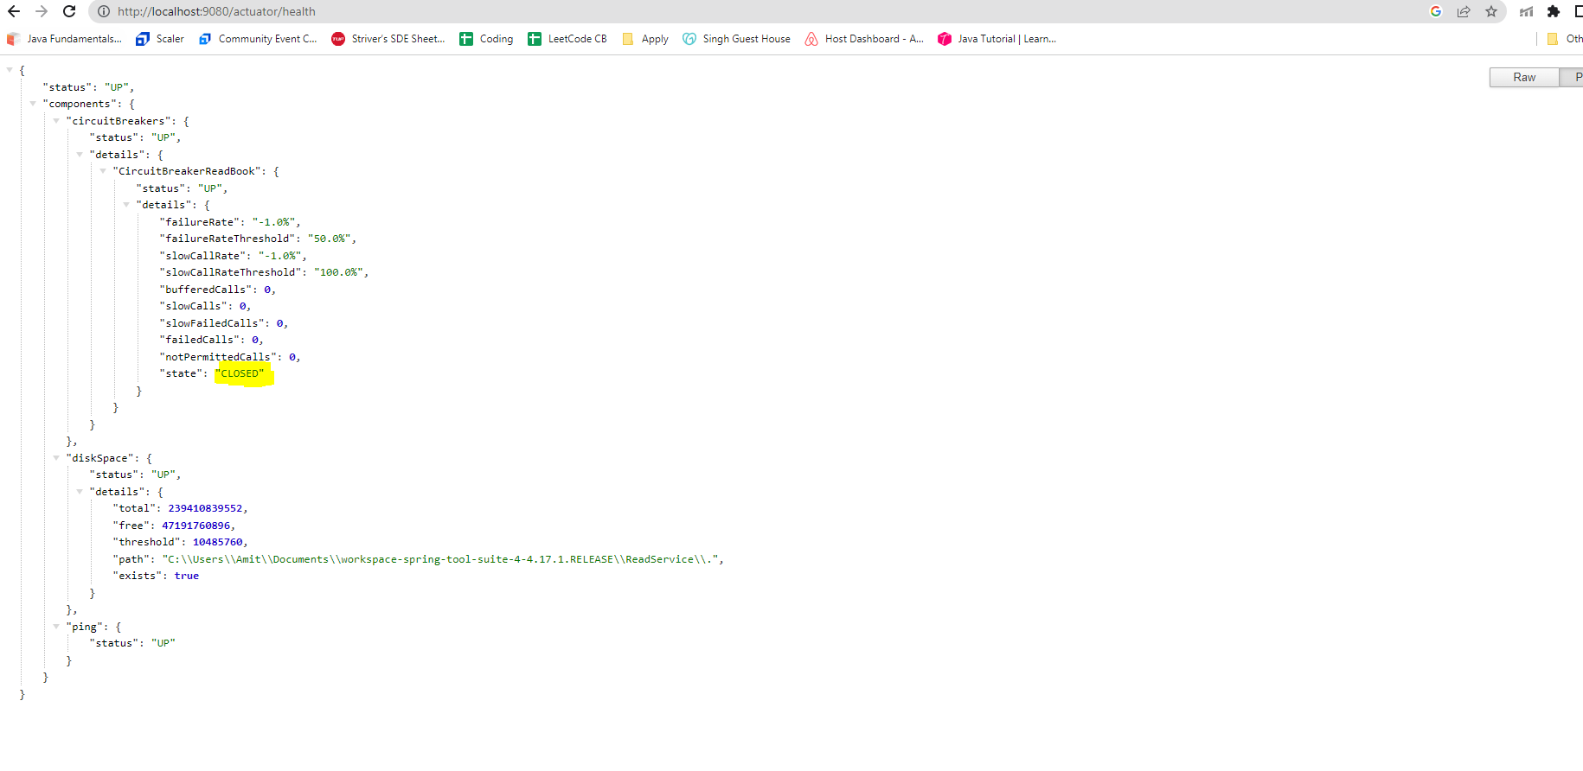

* When the service will be down and the threshold value reaches above 50% the circuit breaker state will change form **CLOSED** to **OPEN**.

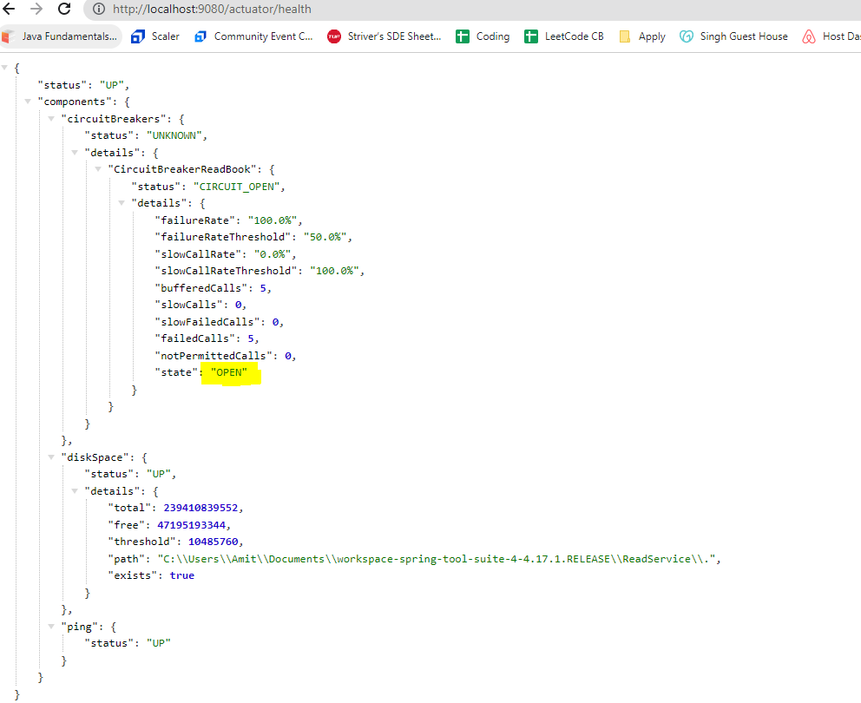

After 5 seconds the state will automatically change from **OPEN** to **HALF-OPEN**.

