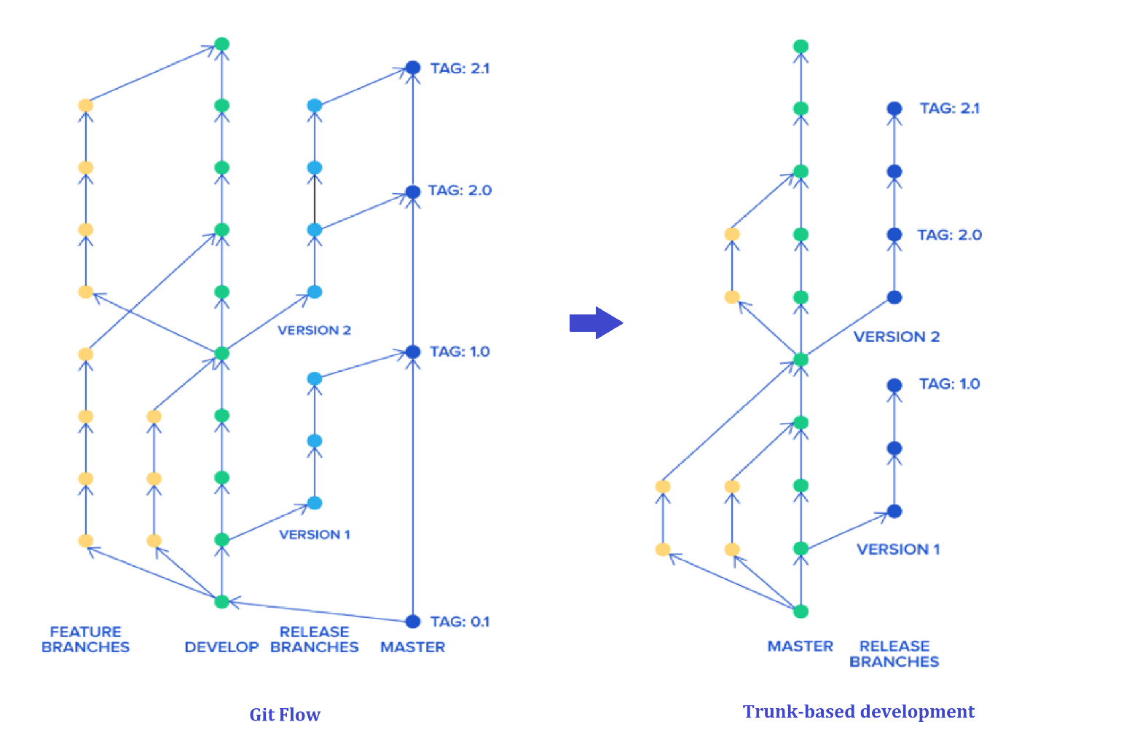 All developers work on a single branch simply the master branch and a release manager can create release branches and no one can commit on that branch

* There should be three or fewer active branches on the application's code repository.
* Developers commit small changes as often as they can, and frequency of merging branches and forks to master must be at least once per day.
* Find ways to make code review a synchronous activity that's performed as part of development.
* Prioritize fixing master if commit breaks the CI build