**Javascript-2021**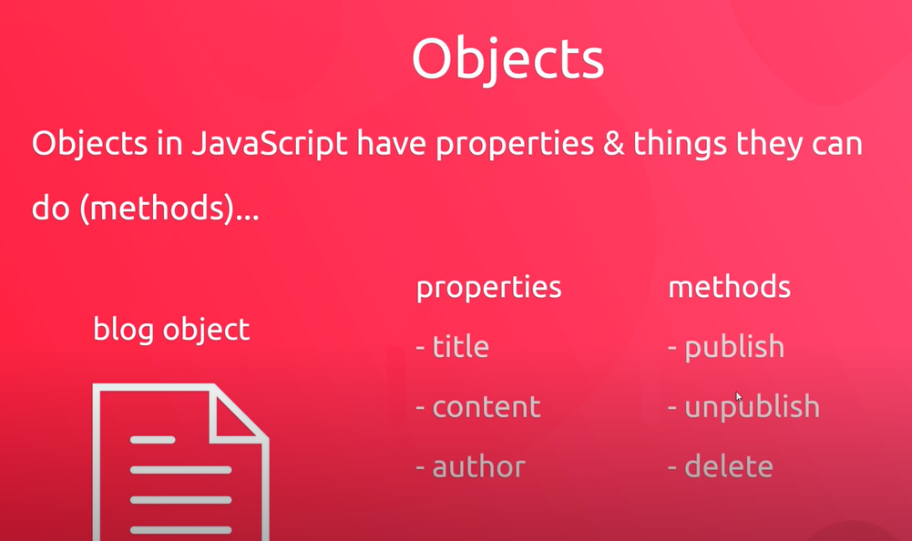

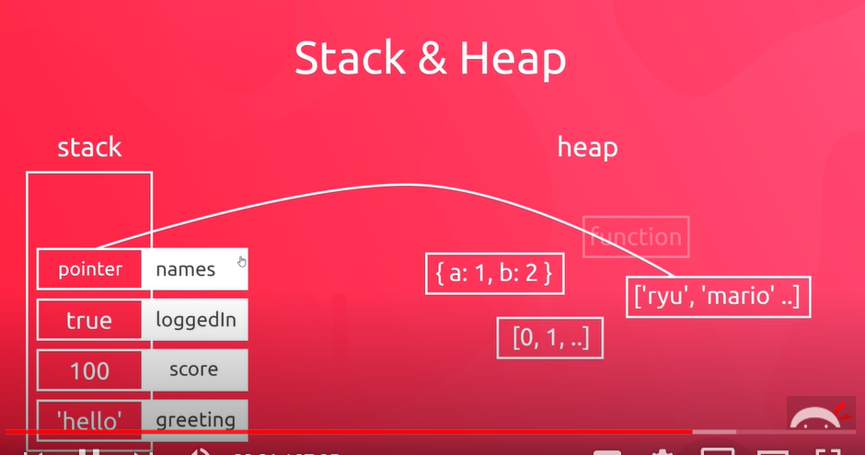

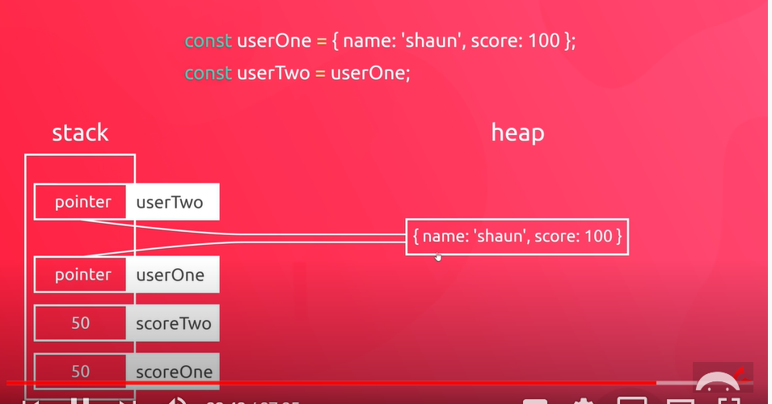

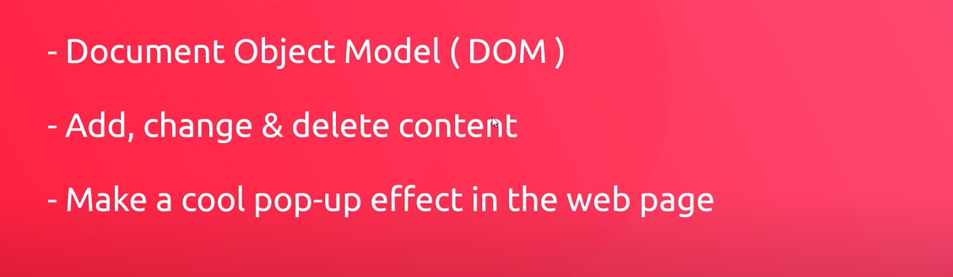

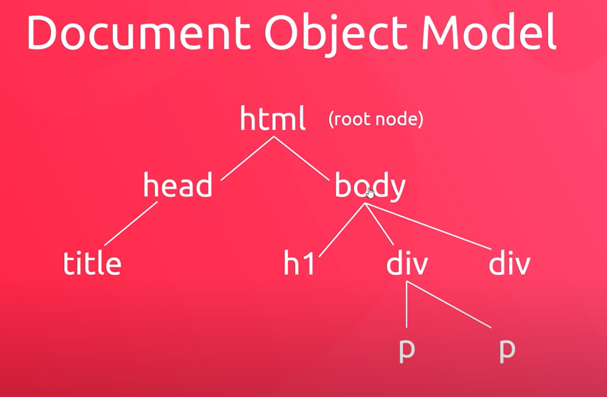

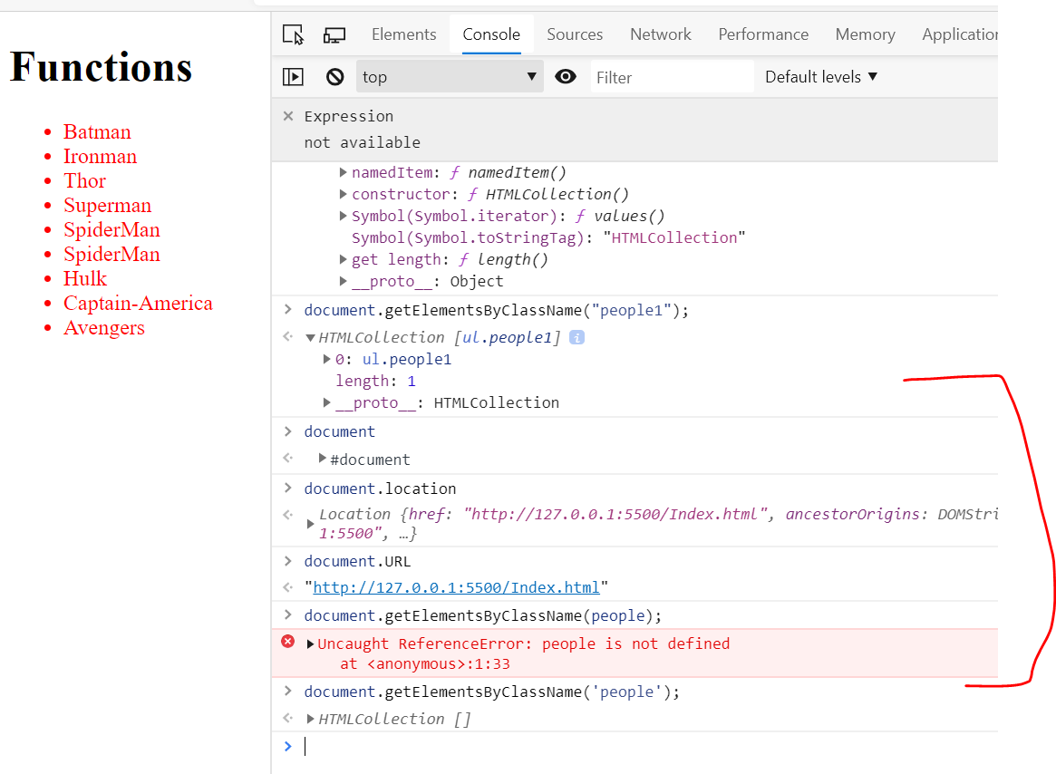

How to get the elements information from console  


