**Getting Started(Windows10)**

Below mentioned technologies needs to be installed:

1. Node.js (version: v6.9.4)
2. Npm (version: 4.5.0)
3. Yeoman (version: 1.8.5)
4. Bower (version: 1.8.0)
5. Git (version: 2.12.2.windows.2)
6. Grunt-cli (version: v1.2.0)

**How to install? (Environment Setup):**

1. Node.js: Install node.js windows installer(.msi): <https://nodejs.org/en/download/>
2. NPM: If already installed, then upgrade npm: npm install npm@latest -g.

Version check:

node -v

npm -v

1. Git: Install git: <https://git-scm.com/>

Version check: git –version

Install powershell/gitdesktop

*Powershell*: <https://www.microsoft.com/en-in/download/details.aspx?id=2560>

*Gitdesktop*: <https://desktop.github.com/>

git clone <https://github.com/kumar-rahul/kumar-rahul.github.io.git>

1. Yeoman: Install yeoman toolset: npm install –global yo

Version check: yo –version

1. Bower: Install bower: npm install -g bower

Version check: bower –version

1. Grunt-cli: Install grunt-cli: npm install -g grunt -cli

Version check: grunt –version

**To build & run application:**

* cd to project directory.
* run this command on cmd: grunt serve

**Fig1: Full Screen**

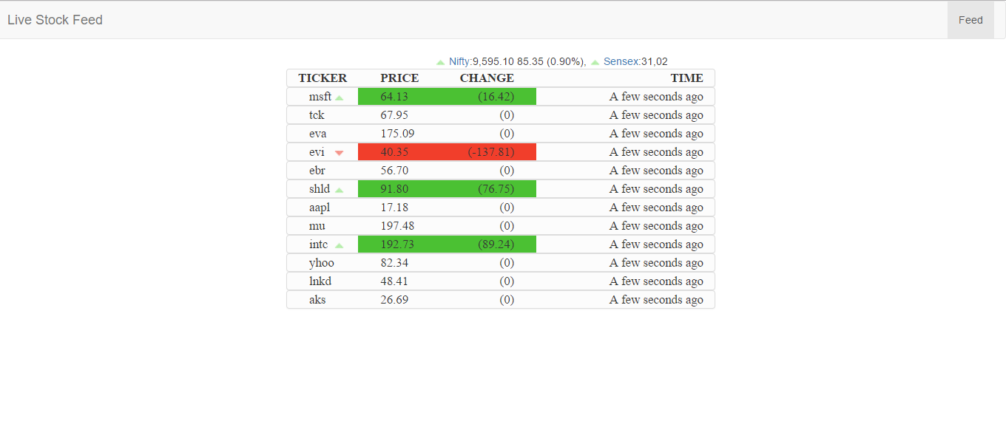

**Fig2: Live Stock Feed Table**

