**Getting Started(Windows10)**

Below mentioned technologies needs to be installed:

1. Node.js (v6.9.4)
2. Npm (4.5.0)
3. Yeoman
4. Bower
5. Git
6. Grunt

**Environment Setup:**

* make sure you have [**Node**](https://nodejs.org/) and [**NPM**](https://www.npmjs.com/) installed (and updated!)
* install Yeoman, Bower, the Angular generator plugin which you can do by running the following command: npm install -g grunt-cli bower yo generator-karma generator-angular
* install git: https://git-for-windows.github.io/

**To build & run application:**

* cd to project directory.
* run this command on cmd: grunt serve

**Below are the output screens:**

* Home

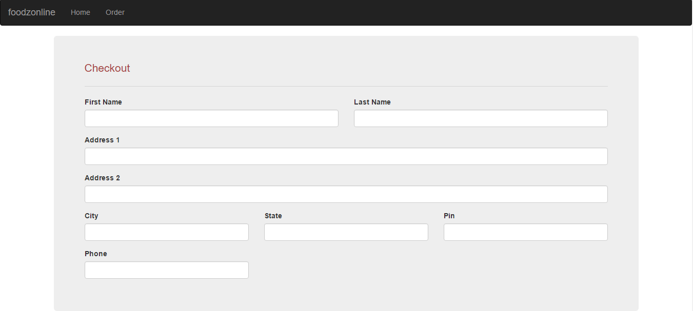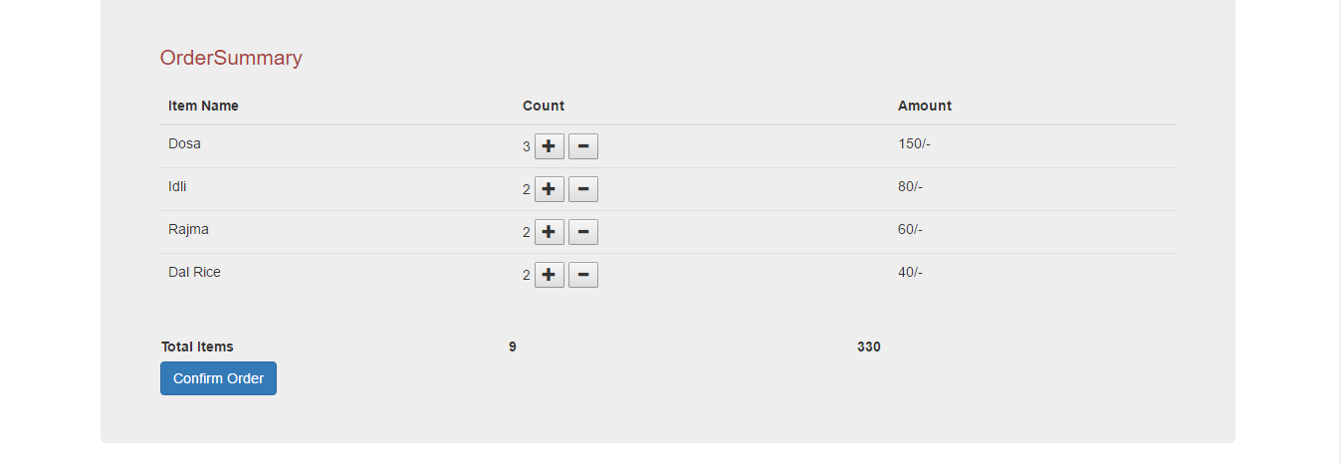

* Order

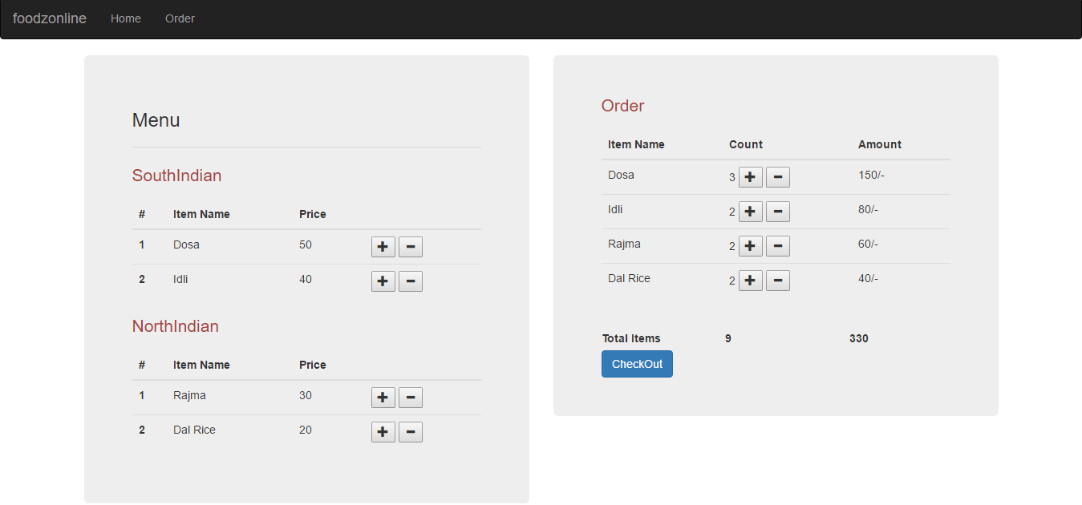

* Thank You

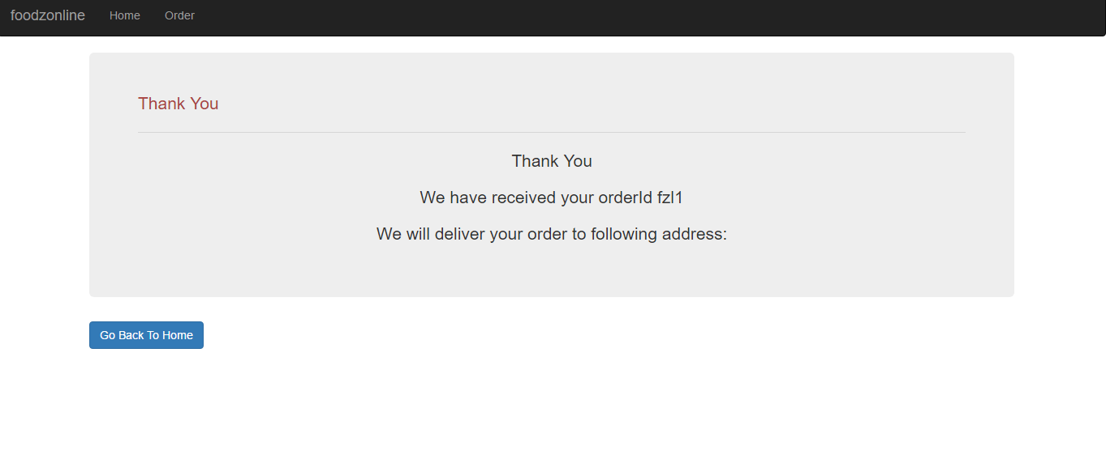

**Below is the Json data used in the project**

{

"menu" : [{"menuType":"SouthIndian",

"menuItems":[{"sno":"1","name":"Dosa","price":"50","availqty":"10"},

{"sno":"2","name":"Idli","price":"40","availqty":"10"}

]

},

{"menuType":"NorthIndian",

"menuItems":[{"sno":"1","name":"Rajma","price":"30","availqty":"10"},

{"sno":"2","name":"Dal Rice","price":"20","availqty":"10"}]

}]

}