Machine Learning Operations (MLOps)
AIMLCZG523 — Assignment 01
Heart Disease Risk Prediction
An End-to-End, Reproducible, Cloud-Ready ML Pipeline
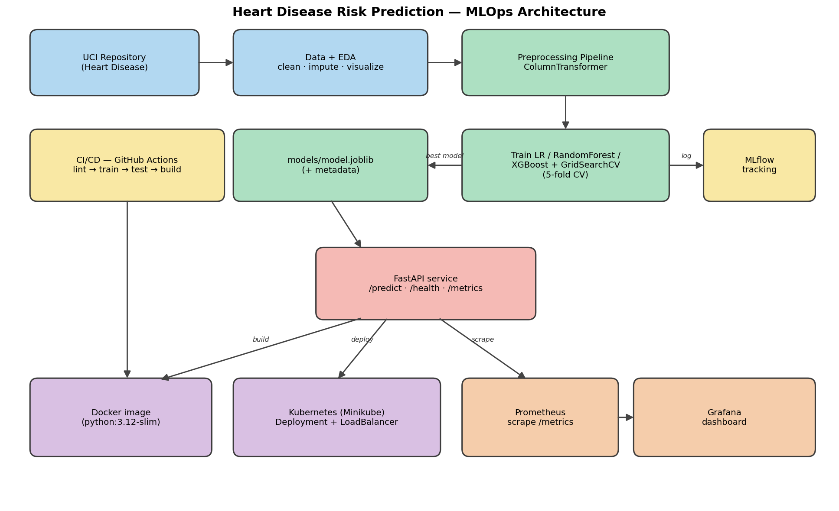
System architecture overview
Data → EDA → Modelling → MLflow → API → Docker → Kubernetes → Monitoring

Table of Contents
Table of Contents 2
1. Project Overview 3
2. Setup & Installation 3
3. Data Acquisition & Exploratory Data Analysis 3
3.1 Class balance 4
3.2 Missing-value analysis 4
3.3 Feature distributions 4
3.4 Correlation analysis 5
3.5 Feature-vs-target relationships 6
4. Feature Engineering & Model Development 6
4.1 Preprocessing pipeline 6
4.2 Models, tuning & validation 6
4.3 Results & model selection 6
5. Experiment Tracking (MLflow) 7
6. Model Packaging & Reproducibility 8
7. CI/CD Pipeline & Automated Testing 8
7.1 Test suite 8
7.2 GitHub Actions pipeline 8
8. Model Containerization (Docker) 9
9. Production Deployment (Kubernetes / Minikube) 9
10. Monitoring & Logging 10
11. Conclusion & Repository 10

1. Project Overview
This project delivers a complete Machine Learning Operations (MLOps) solution that predicts the risk of heart disease from patient health data and serves the model as a monitored REST API. It follows modern production practices end-to-end: automated data acquisition, reproducible preprocessing, experiment tracking, containerisation, continuous integration/continuous delivery (CI/CD), Kubernetes deployment, and observability.
Problem statement.
Given 13 clinical attributes (age, sex, chest-pain type, resting blood pressure, cholesterol, etc.), predict a binary outcome: presence (1) or absence (0) of heart disease. This is a supervised binary-classification problem with a healthcare screening use-case, where recall (sensitivity) is especially important.
Dataset.
- Source: UCI Machine Learning Repository — Heart Disease (Cleveland), dataset id 45.
- Size: 303 records, 13 features + 1 binary target.
- Class balance: 164 no-disease (54%) vs 139 disease (46%) — reasonably balanced.
- Missing values: only 6 cells (in `ca` and `thal`), handled by imputation.
Tooling.
Python 3.12, pandas / NumPy, scikit-learn, XGBoost, MLflow, FastAPI, Prometheus & Grafana, Docker, Kubernetes (Minikube), and GitHub Actions.

2. Setup & Installation
The entire project runs from a clean environment using the pinned requirements file, satisfying the production-readiness requirement.
- Create and activate a virtual environment: `python -m venv venv` then `venv\Scripts\Activate.ps1`.
- Install dependencies: `pip install -r requirements.txt`.
- Download & clean the data: `python data/download_data.py`.
- Train models (logs to MLflow, saves best model): `python -m src.train`.
- Run the test suite: `pytest -v` (15 tests).
- Serve the API: `uvicorn api.main:app --port 8000` then open `/docs`.
Docker, Kubernetes, CI/CD and monitoring steps are documented in the repository's PENDING.md with exact commands.

3. Data Acquisition & Exploratory Data Analysis
A download script (`data/download_data.py`) fetches the raw Cleveland data directly from the UCI file server, with a `ucimlrepo` fallback. It replaces the UCI missing-value marker `?` with NaN, coerces all columns to numeric, and binarises the raw 0–4 diagnosis into a 0/1 target. The cleaned dataset is written to `data/heart_disease_clean.csv`.

3.1 Class balance
The target is fairly balanced, so accuracy is meaningful — but we still report precision, recall, F1 and ROC-AUC because false negatives are costly in a screening context.
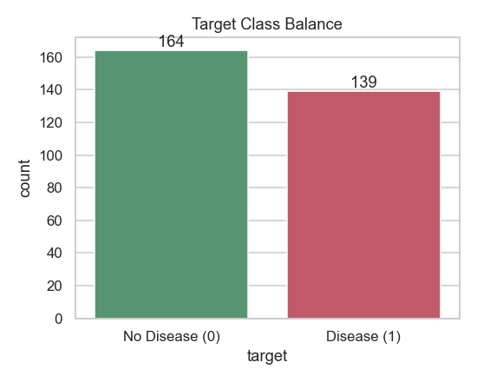
Figure 1 — Target class balance (164 vs 139)

3.2 Missing-value analysis
Only `ca` and `thal` contain missing values (6 cells total). These are handled inside the preprocessing pipeline (median imputation for numeric, most-frequent for categorical) so no rows are dropped.
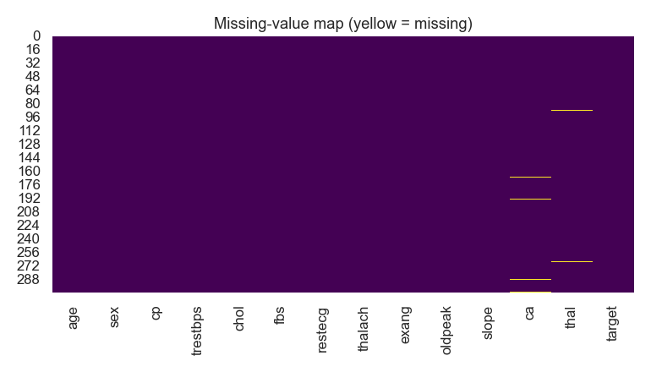
Figure 2 — Missing-value map

3.3 Feature distributions
Histograms of the five continuous features show approximately normal distributions for age, resting BP and max heart rate; cholesterol and ST-depression (oldpeak) are right-skewed.
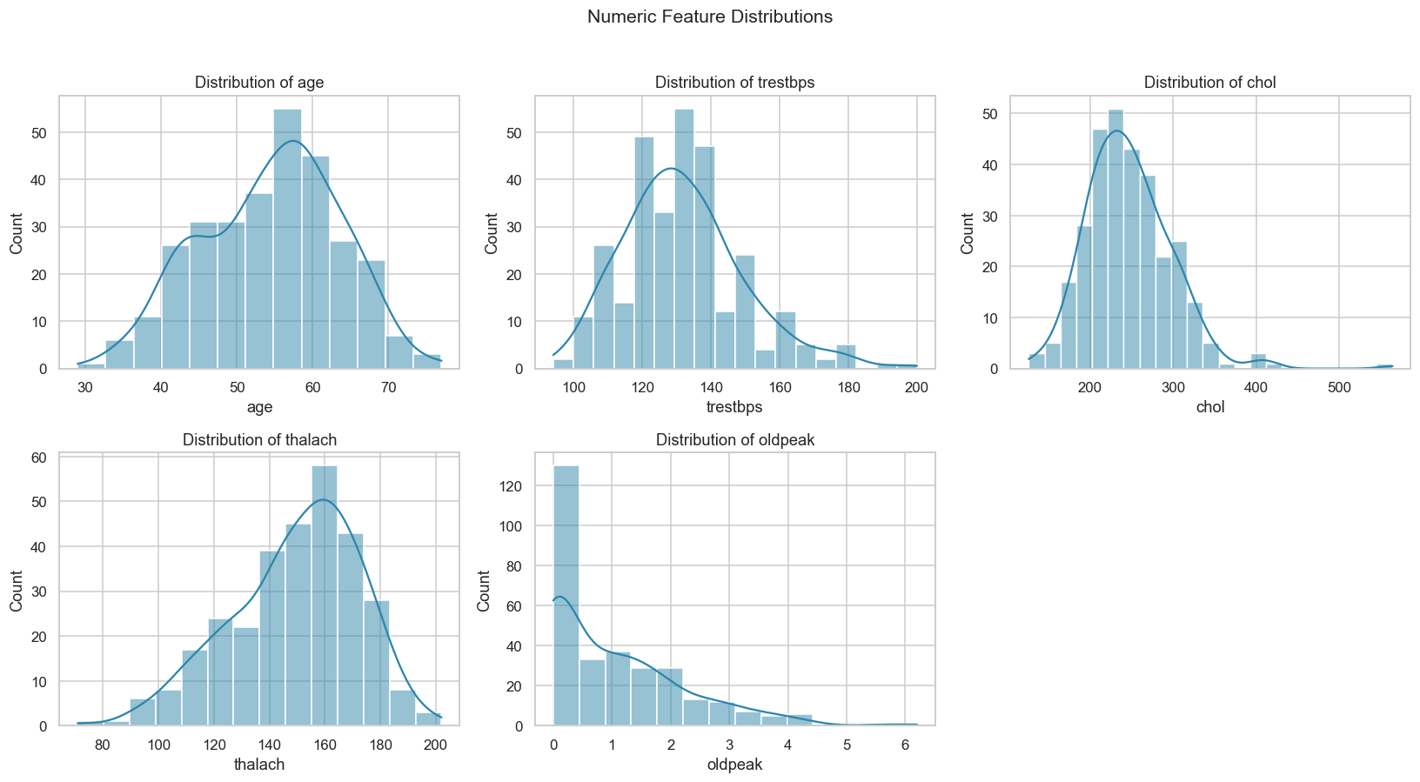
Figure 3 — Numeric feature distributions

3.4 Correlation analysis
The correlation heatmap identifies the strongest linear associations with the target: chest-pain type (`cp`), max heart rate (`thalach`, negative), ST-depression (`oldpeak`), number of major vessels (`ca`) and exercise-induced angina (`exang`).
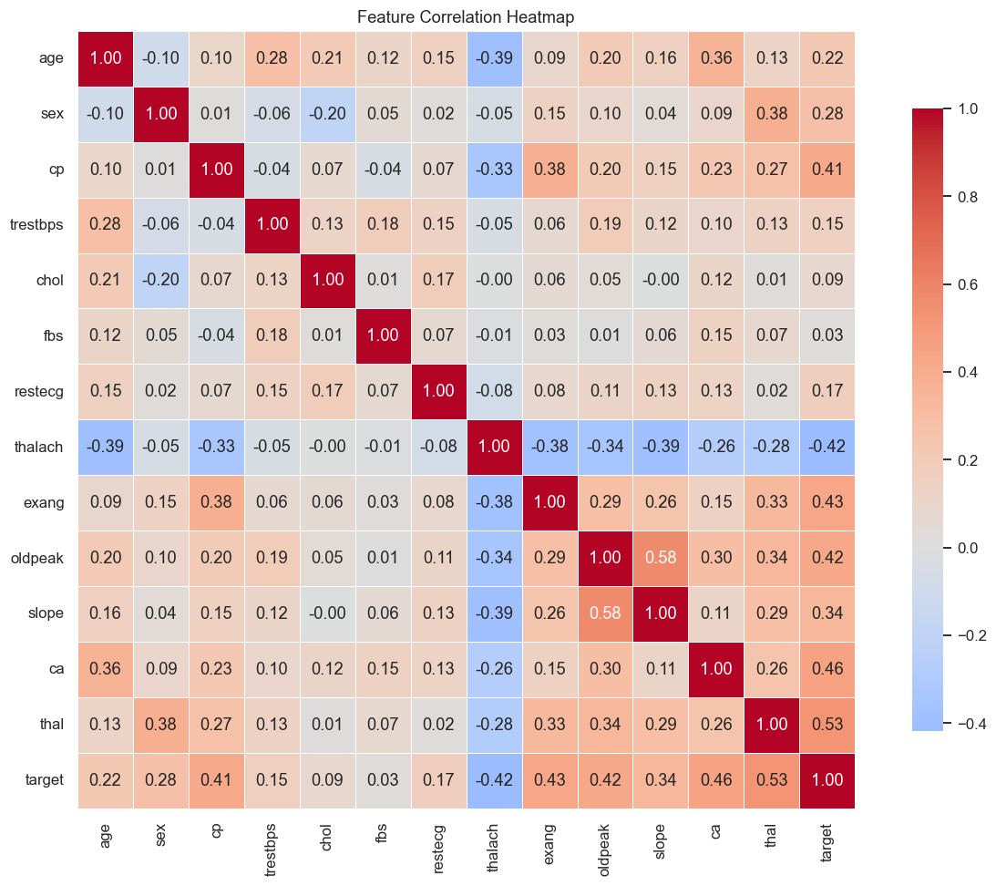
Figure 4 — Feature correlation heatmap

3.5 Feature-vs-target relationships
Boxplots confirm that patients with heart disease tend to have lower max heart rate and higher ST-depression, consistent with clinical expectation.
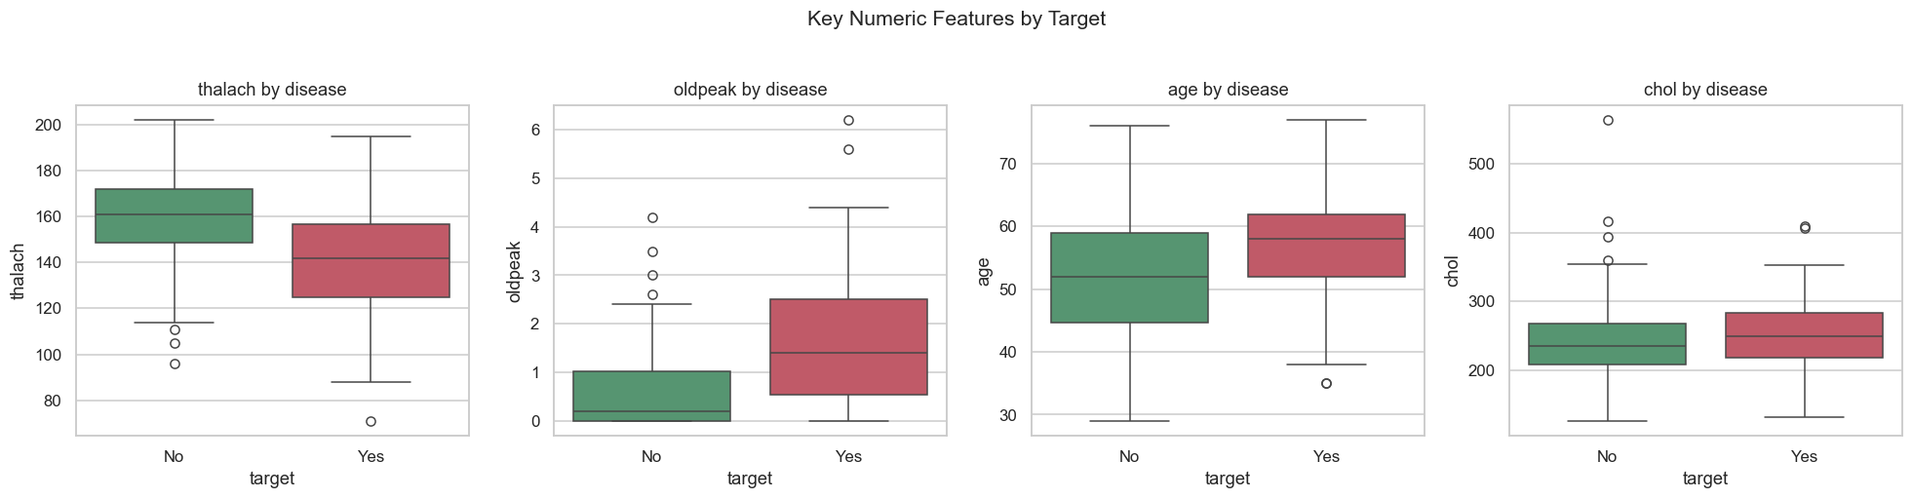
Figure 5 — Key numeric features by target

4. Feature Engineering & Model Development

4.1 Preprocessing pipeline
All feature transformations are encapsulated in a scikit-learn `ColumnTransformer`, guaranteeing that training and inference apply identical steps (a core reproducibility requirement):
- Numeric (age, trestbps, chol, thalach, oldpeak): median imputation → StandardScaler.
- Categorical (sex, cp, fbs, restecg, exang, slope, ca, thal): most-frequent imputation → OneHotEncoder.
The preprocessor and the classifier are combined into a single `Pipeline`, which is serialised as one artifact so the API needs no manual preprocessing.

4.2 Models, tuning & validation
Three classifiers were trained and tuned with `GridSearchCV` (5-fold cross-validation, scoring = ROC-AUC) on a stratified 80/20 train/test split with a fixed random seed (42):
- Logistic Regression — grid over C and penalty.
- Random Forest — grid over n_estimators, max_depth, min_samples_split.
- XGBoost — grid over n_estimators, max_depth, learning_rate.

4.3 Results & model selection
Evaluation on the held-out test set:
Model | Accuracy | Precision | Recall | F1 | ROC-AUC | CV AUC
Logistic Regression ⭐ | 0.885 | 0.839 | 0.929 | 0.881 | 0.965 | 0.898
Random Forest | 0.852 | 0.828 | 0.857 | 0.842 | 0.947 | 0.904
XGBoost | 0.885 | 0.862 | 0.893 | 0.877 | 0.949 | 0.882

Logistic Regression was selected as the production model — it achieved the highest test ROC-AUC (0.965) and the highest recall (0.929), which is the priority metric for a screening tool. Its simplicity also improves interpretability and inference speed.
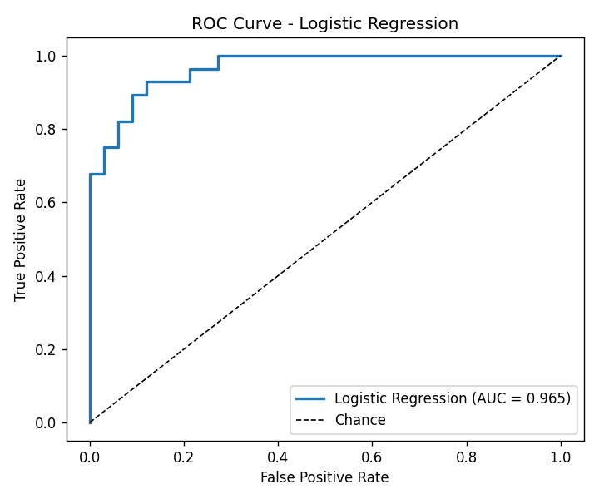
Figure 6 — ROC curve (Logistic Regression, AUC = 0.965)
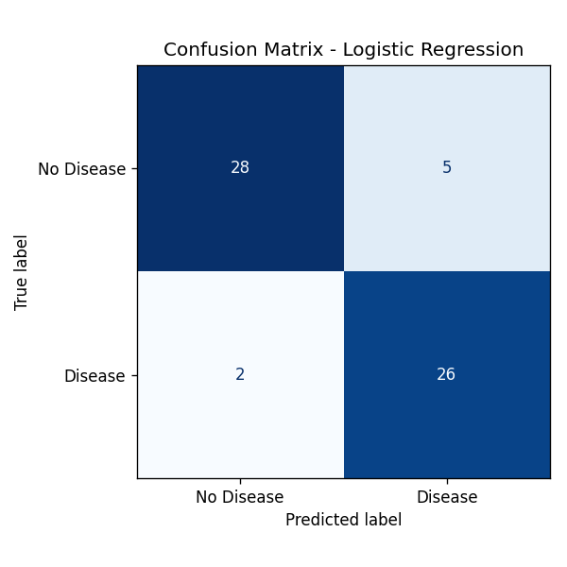
Figure 7 — Confusion matrix (Logistic Regression)

5. Experiment Tracking (MLflow)
Every training run is logged to MLflow (SQLite backend + local artifact store). For each model we log: the hyper-parameters chosen by GridSearchCV, all metrics (accuracy, precision, recall, F1, ROC-AUC, cross-validated AUC), the ROC-curve and confusion-matrix plots as artifacts, and the serialised model. This provides full experiment lineage and easy run comparison.
Launch the UI with: `mlflow ui --backend-store-uri sqlite:///mlflow.db --default-artifact-root ./mlartifacts`.
📸 INSERT SCREENSHOT: MLflow experiment runs table (3 runs with metrics columns)

📸 INSERT SCREENSHOT: MLflow run detail — Parameters & Metrics panels

📸 INSERT SCREENSHOT: MLflow artifacts tab — ROC / confusion-matrix plots + model folder

6. Model Packaging & Reproducibility
- Serialisation: the full pipeline (preprocessing + model) is saved with `joblib` to `models/model.joblib`, plus `model_metadata.json` recording the best model name, metrics and feature lists.
- Dependencies: `requirements.txt` pins exact versions; a slim `requirements-api.txt` is used for the serving container.
- Reproducibility: fixed seed, identical preprocessing at train and inference time, and a deterministic prediction path (verified by a unit test).
- Reusable transformers: because preprocessing is inside the pipeline, raw JSON can be scored directly by the API.

7. CI/CD Pipeline & Automated Testing

7.1 Test suite
A pytest suite (15 tests) covers data loading, the preprocessing pipeline (including missing-value handling and scaling), the trained model and inference helper, and the FastAPI endpoints (health, predict, validation errors, metrics).
📸 INSERT SCREENSHOT: Terminal output: pytest — 15 passed

7.2 GitHub Actions pipeline
The workflow `.github/workflows/ci.yml` runs on every push/PR and has two jobs:
- lint-test-train: flake8 linting → download data → train model → run pytest → upload the trained model and MLflow artifacts.
- docker-build: build the Docker image and smoke-test `/health` and `/predict` inside the container.
The pipeline fails fast and reports clear logs if linting or tests fail, satisfying the rubric's fail-on-error requirement.
📸 INSERT SCREENSHOT: GitHub Actions — green run with both jobs passing

📸 INSERT SCREENSHOT: GitHub Actions — a deliberately failing run (lint error) proving fail-fast

📸 INSERT SCREENSHOT: GitHub Actions — uploaded artifacts (trained-model, mlflow-artifacts)

8. Model Containerization (Docker)
A multi-stage-friendly Dockerfile builds a slim `python:3.12-slim` image containing the API code, the trained pipeline and the serving dependencies. It runs as a non-root user and defines a container HEALTHCHECK against `/health`.
Build & run: `docker build -t heart-api:1.0.0 .` then `docker run -p 8000:8000 heart-api:1.0.0`.
📸 INSERT SCREENSHOT: docker build — successful image build

📸 INSERT SCREENSHOT: docker ps — container running + /predict response from the container

📸 INSERT SCREENSHOT: Swagger UI (/docs) — /predict tried out with 200 response

9. Production Deployment (Kubernetes / Minikube)
The API is deployed to a local Kubernetes cluster (Minikube) using a Deployment (2 replicas, liveness/readiness probes, resource limits, Prometheus scrape annotations) and a LoadBalancer Service. An optional Helm chart parameterises the same resources.
Deploy: `kubectl apply -f k8s/deployment.yaml -f k8s/service.yaml` then `minikube service heart-api-service --url`.
📸 INSERT SCREENSHOT: kubectl get pods / svc / deployment — resources Running (2/2)

📸 INSERT SCREENSHOT: minikube service URL + /predict response through the LoadBalancer

10. Monitoring & Logging
The API instruments Prometheus metrics via middleware: total requests (by method/endpoint/status), request-latency histogram, and total predictions by predicted class. Every request is also logged with method, path, status and latency. A docker-compose stack runs the API alongside Prometheus and a pre-provisioned Grafana dashboard.
Why it matters: monitoring surfaces model failures, API downtime, latency regressions and shifts in prediction distribution (a proxy for data drift).
📸 INSERT SCREENSHOT: /metrics endpoint — Prometheus exposition format

📸 INSERT SCREENSHOT: Prometheus — heart-api target UP + a rate() query graph

📸 INSERT SCREENSHOT: Grafana — 'Heart Disease API - Monitoring' dashboard with live panels

11. Conclusion & Repository
This assignment implements a full production-style MLOps lifecycle for a healthcare classification problem: reproducible data and preprocessing, tracked experimentation, a well-tested and containerised serving API, automated CI/CD, Kubernetes deployment, and observability. The best model (Logistic Regression) achieves a strong test ROC-AUC of 0.965 with 0.93 recall.
Future work.
- Automated data-drift detection (e.g. Evidently) feeding Grafana alerts.
- Model registry with staged promotion (MLflow Model Registry).
- Push images to a registry and deploy to a managed cloud cluster (AKS/GKE/EKS).
Code repository: https://github.com/<YOUR_USERNAME>/heart-disease-mlops
(Replace the placeholder above with your actual repository URL before submission.)

