Machine Learning Operations (MLOps)
AIMLCZG523 — Assignment 01
Heart Disease Risk Prediction
An End-to-End, Reproducible, Cloud-Ready ML Pipeline
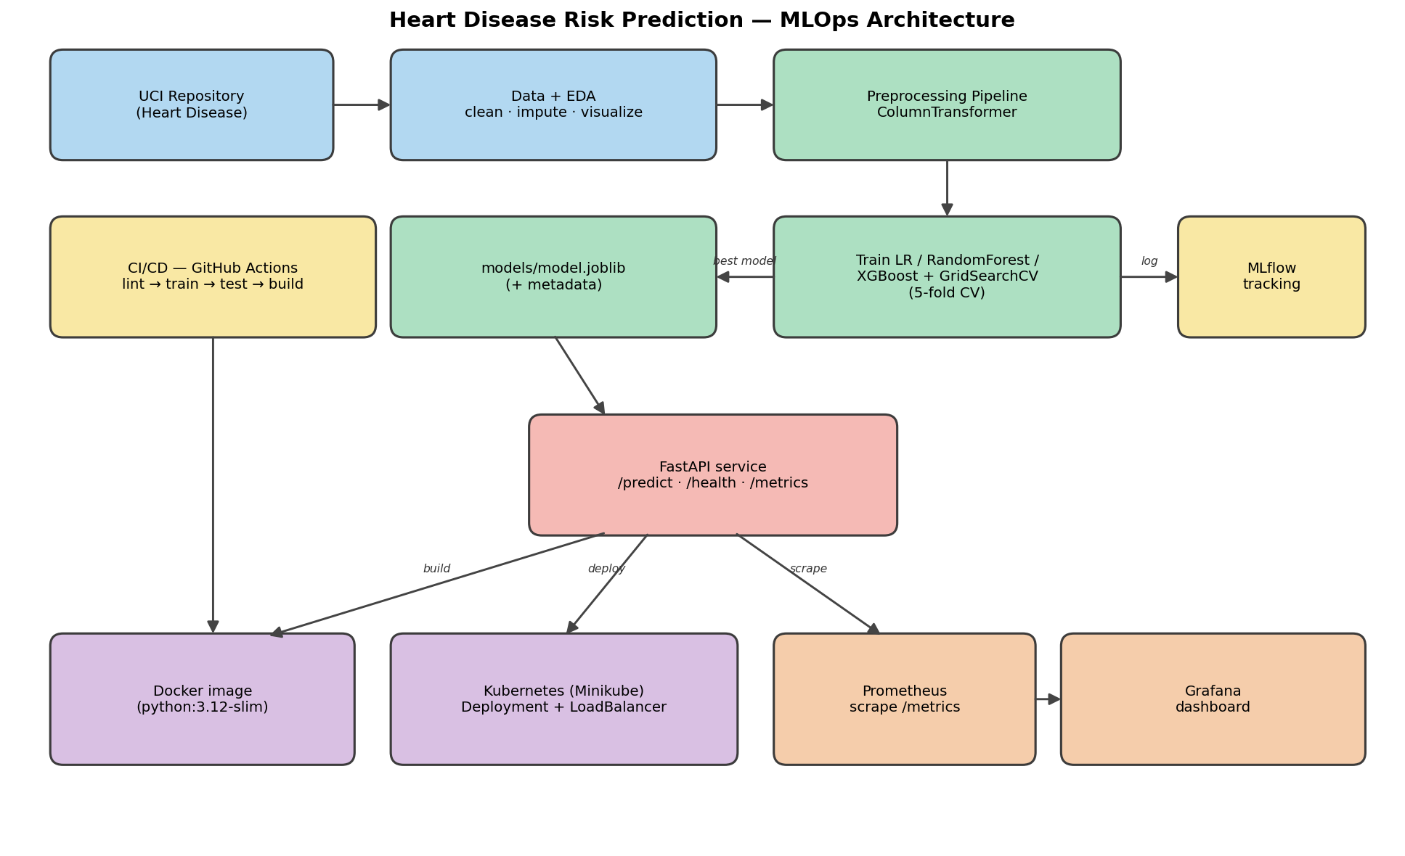
System architecture: Data → EDA → Modelling → MLflow → API → Docker → Kubernetes → Monitoring

Table of Contents

1. Project Overview
This project delivers a complete Machine Learning Operations (MLOps) solution that predicts the risk of heart disease from patient health data and serves the model as a monitored REST API. It follows modern production practices end-to-end: automated data acquisition, reproducible preprocessing, experiment tracking, containerisation, continuous integration/continuous delivery (CI/CD), Kubernetes deployment, and observability.
Problem statement. Given 13 clinical attributes (age, sex, chest-pain type, resting blood pressure, cholesterol, etc.), predict a binary outcome: presence (1) or absence (0) of heart disease. This is a supervised binary-classification problem with a healthcare screening use-case, where recall (sensitivity) is especially important.
Dataset. UCI Machine Learning Repository — Heart Disease (Cleveland), dataset id 45.
- Size: 303 records, 13 features + 1 binary target.
- Class balance: 164 no-disease (54%) vs 139 disease (46%) — reasonably balanced.
- Missing values: only 6 cells (in ca and thal), handled by imputation.
Tooling. Python 3.12, pandas / NumPy, scikit-learn, XGBoost, MLflow, FastAPI, Prometheus & Grafana, Docker, Kubernetes (Minikube), and GitHub Actions.

2. Setup & Installation
The entire project runs from a clean environment using the pinned requirements file, satisfying the production-readiness requirement.
- Create and activate a virtual environment: python -m venv venv then venv\Scripts\Activate.ps1.
- Install dependencies: pip install -r requirements.txt.
- Download & clean the data: python data/download_data.py.
- Train models (logs to MLflow, saves best model): python -m src.train.
- Run the test suite: pytest -v.
- Serve the API: uvicorn api.main:app --port 8000 then open /docs.
Docker, Kubernetes, CI/CD and monitoring commands are documented in the repository's README.md.

3. Data Acquisition & Exploratory Data Analysis
A download script (data/download_data.py) fetches the raw Cleveland data directly from the UCI file server, with a ucimlrepo fallback. It replaces the UCI missing-value marker ? with NaN, coerces all columns to numeric, and binarises the raw 0–4 diagnosis into a 0/1 target. The cleaned dataset is written to data/heart_disease_clean.csv.

3.1 Class balance
The target is fairly balanced, so accuracy is meaningful — but we still report precision, recall, F1 and ROC-AUC because false negatives are costly in a screening context.
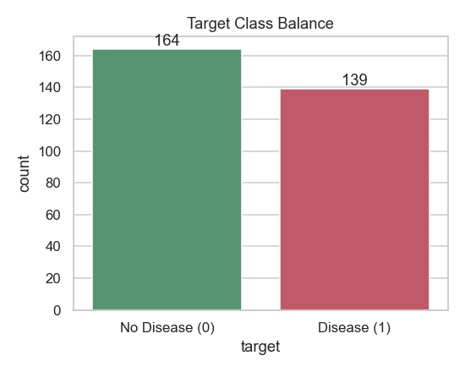
Figure 1 — Target class balance (164 vs 139)

3.2 Missing-value analysis
Only ca and thal contain missing values (6 cells total). These are handled inside the preprocessing pipeline (median imputation for numeric, most-frequent for categorical) so no rows are dropped.
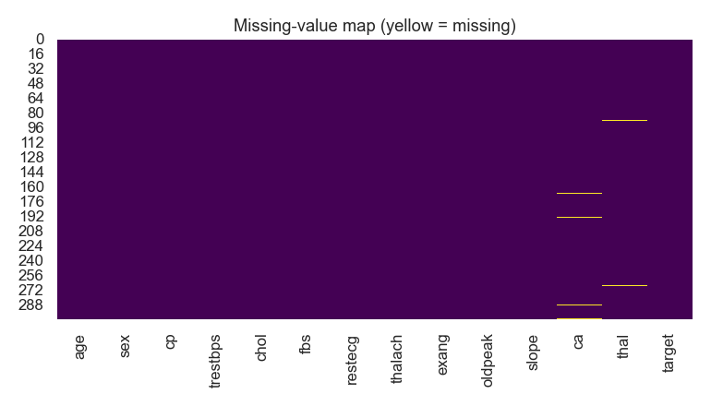
Figure 2 — Missing-value map

3.3 Feature distributions
Histograms of the five continuous features show approximately normal distributions for age, resting BP and max heart rate; cholesterol and ST-depression (oldpeak) are right-skewed.
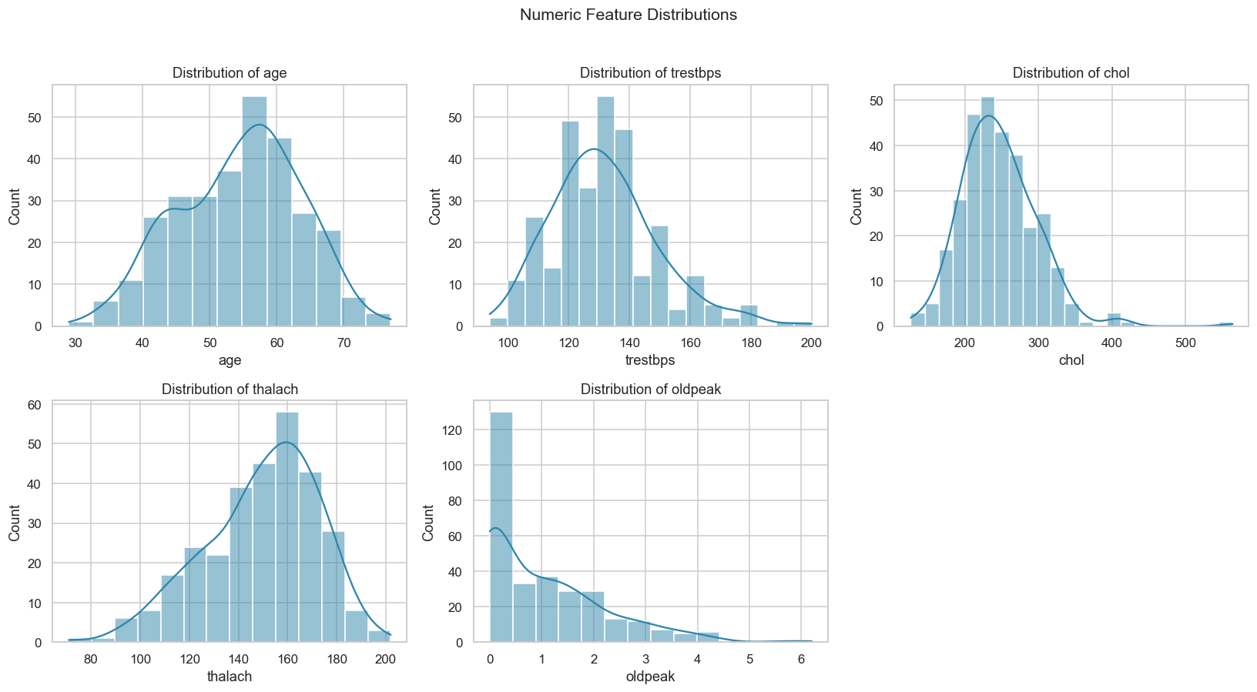
Figure 3 — Numeric feature distributions

3.4 Correlation analysis
The correlation heatmap identifies the strongest linear associations with the target: chest-pain type (cp), max heart rate (thalach, negative), ST-depression (oldpeak), number of major vessels (ca) and exercise-induced angina (exang).
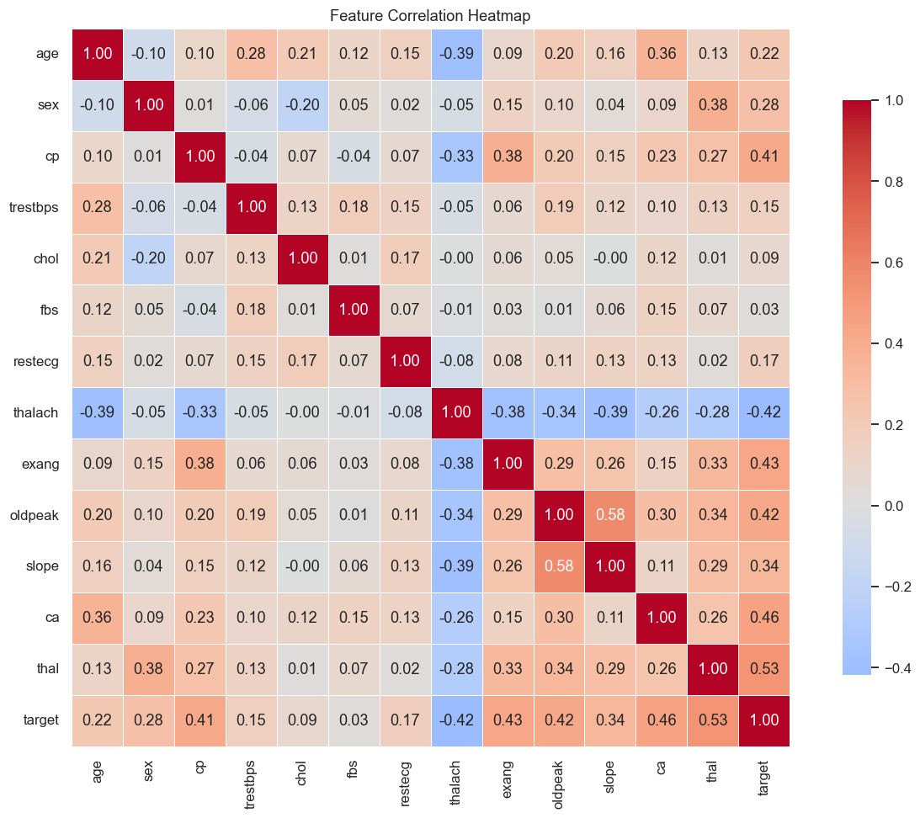
Figure 4 — Feature correlation heatmap

3.5 Feature-vs-target relationships
Boxplots confirm that patients with heart disease tend to have lower max heart rate and higher ST-depression, consistent with clinical expectation.
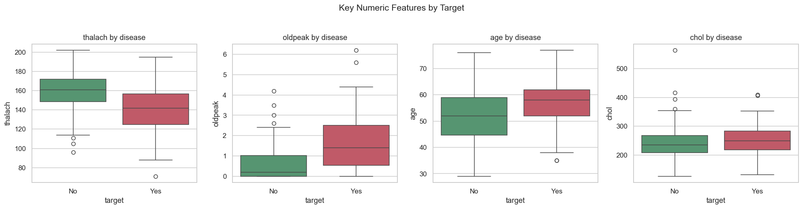
Figure 5 — Key numeric features by target

4. Feature Engineering & Model Development

4.1 Preprocessing pipeline
All feature transformations are encapsulated in a scikit-learn ColumnTransformer, guaranteeing that training and inference apply identical steps (a core reproducibility requirement):
- Numeric (age, trestbps, chol, thalach, oldpeak): median imputation → StandardScaler.
- Categorical (sex, cp, fbs, restecg, exang, slope, ca, thal): most-frequent imputation → OneHotEncoder.
The preprocessor and the classifier are combined into a single Pipeline, which is serialised as one artifact so the API needs no manual preprocessing.

4.2 Models, tuning & validation
Three classifiers were trained and tuned with GridSearchCV (5-fold cross-validation, scoring = ROC-AUC) on a stratified 80/20 train/test split with a fixed random seed (42):
- Logistic Regression — grid over C and penalty.
- Random Forest — grid over n_estimators, max_depth, min_samples_split.
- XGBoost — grid over n_estimators, max_depth, learning_rate.

4.3 Results & model selection
Evaluation on the held-out test set:
Model | Accuracy | Precision | Recall | F1 | ROC-AUC | CV AUC
Logistic Regression ⭐ | 0.885 | 0.839 | 0.929 | 0.881 | 0.965 | 0.898
Random Forest | 0.869 | 0.833 | 0.893 | 0.862 | 0.943 | 0.904
XGBoost | 0.885 | 0.862 | 0.893 | 0.877 | 0.949 | 0.882

Logistic Regression was selected as the production model — it achieved the highest test ROC-AUC (0.965) and the highest recall (0.929), which is the priority metric for a screening tool. Its simplicity also improves interpretability and inference speed.
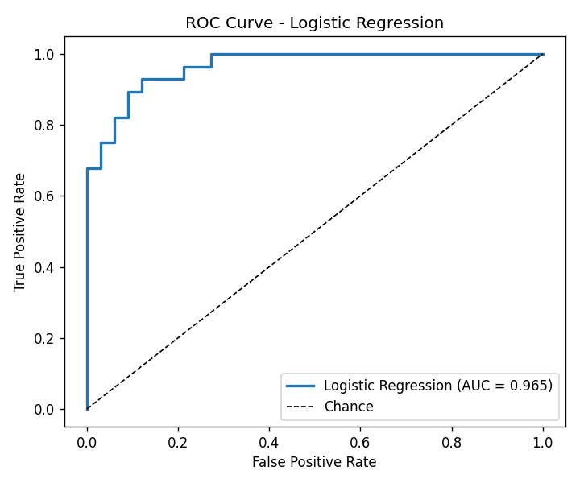
Figure 6 — ROC curve (Logistic Regression, AUC = 0.965)
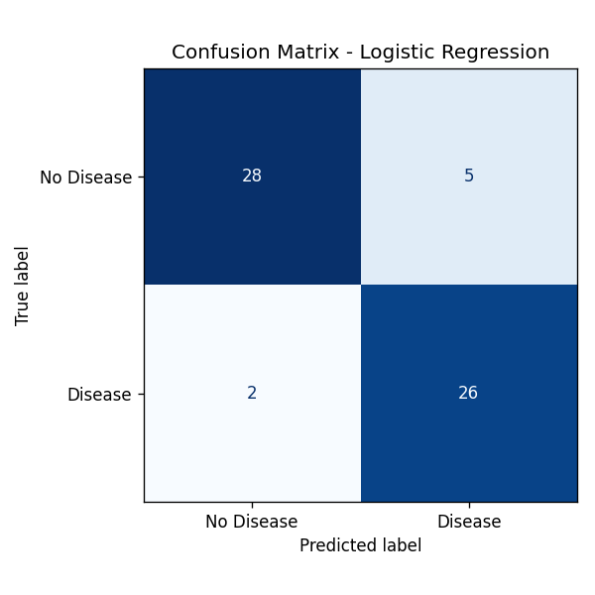
Figure 7 — Confusion matrix (Logistic Regression)

5. Experiment Tracking (MLflow)
Every training run is logged to MLflow (SQLite backend + local artifact store). For each model we log: the hyper-parameters chosen by GridSearchCV, all metrics (accuracy, precision, recall, F1, ROC-AUC, cross-validated AUC), the ROC-curve and confusion-matrix plots as artifacts, and the serialised model. This provides full experiment lineage and easy run comparison.
Launch the UI with: mlflow ui --backend-store-uri sqlite:///mlflow.db --default-artifact-root ./mlartifacts.
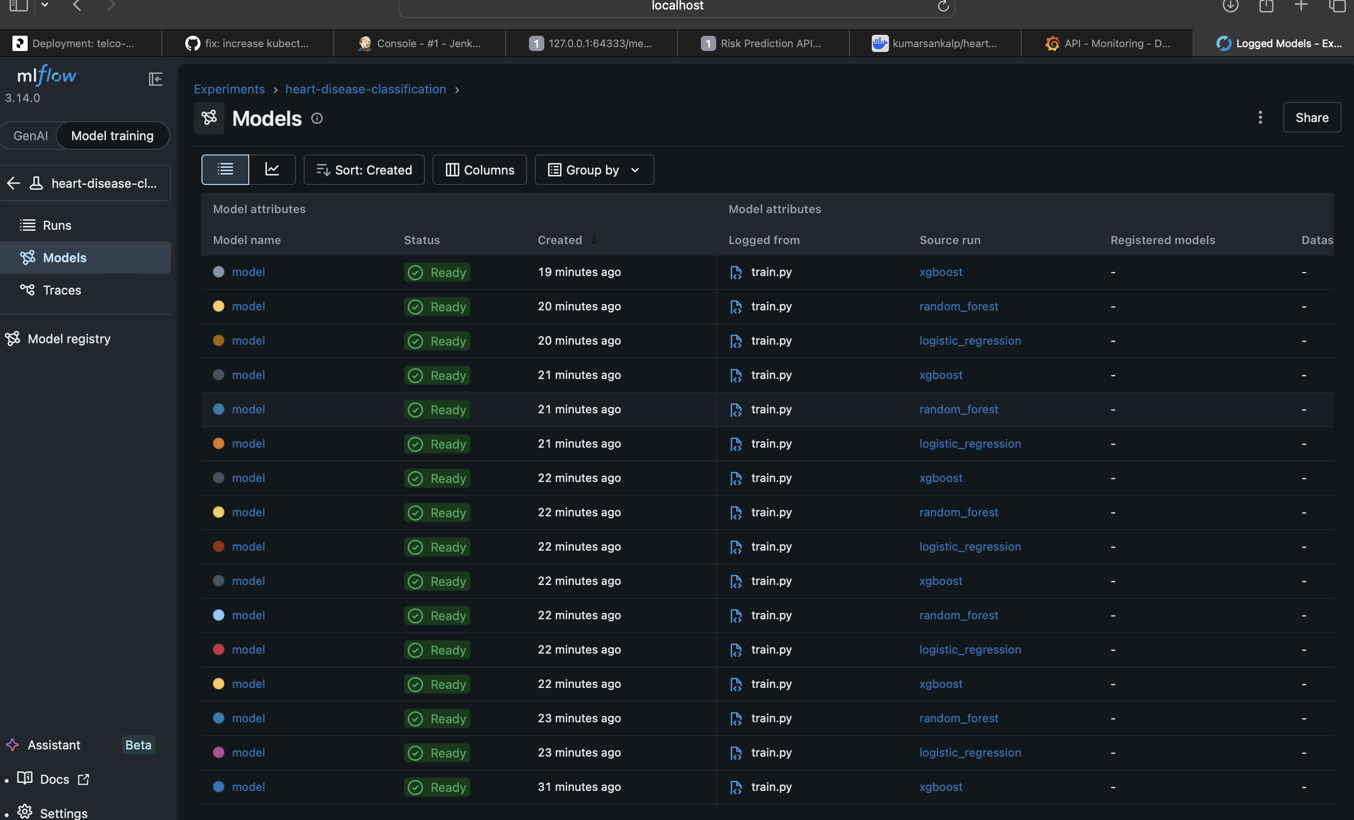
Figure 8 — MLflow experiment: all training runs with metric columns
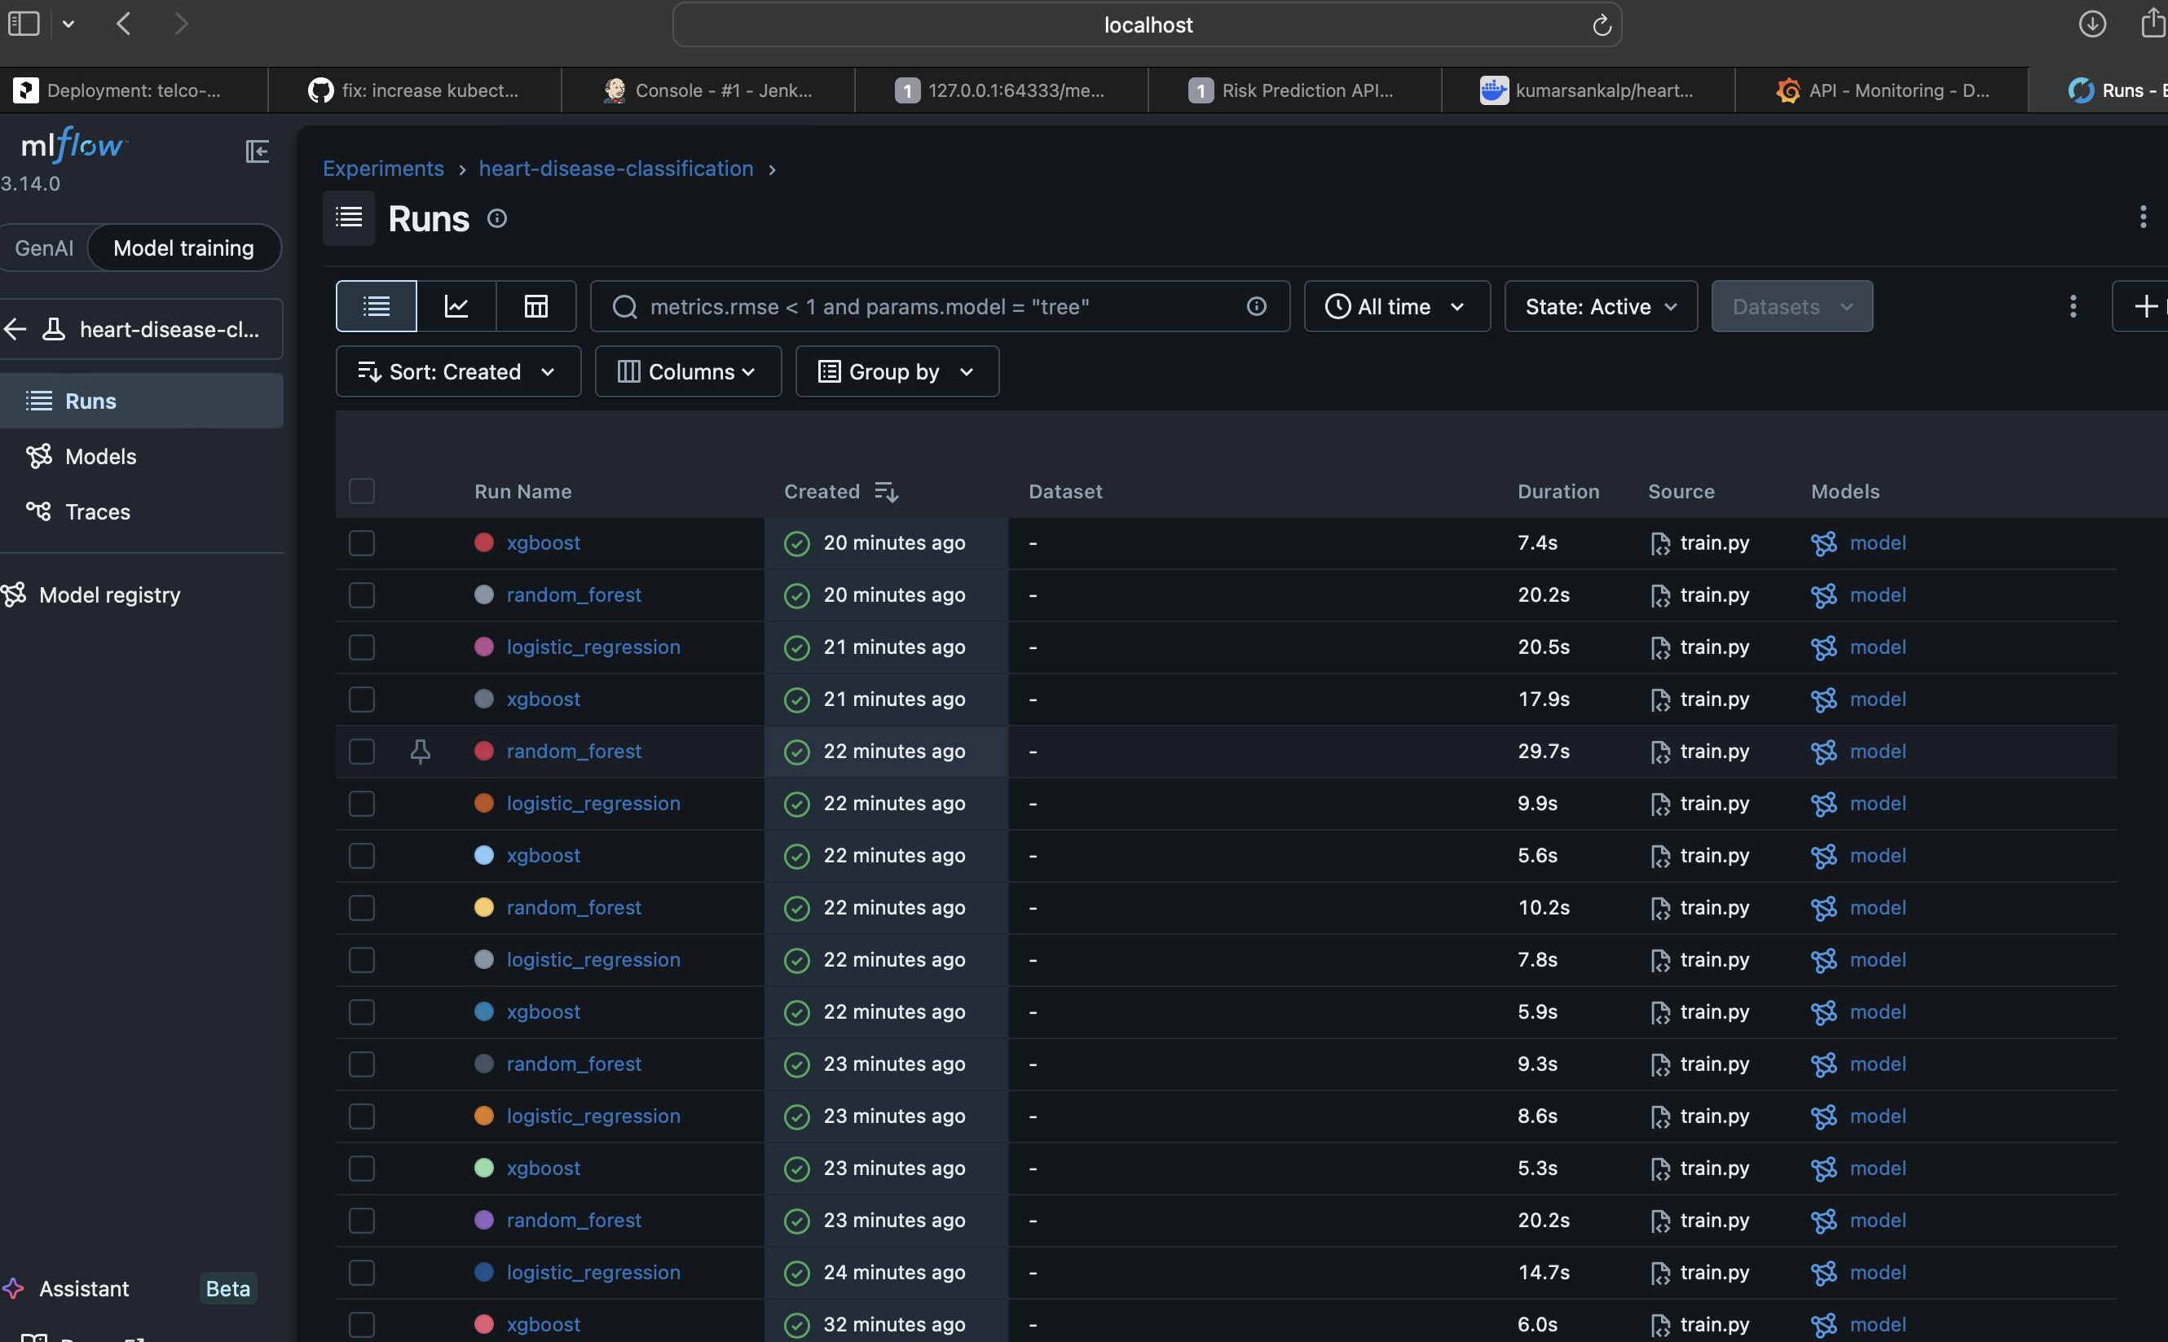
Figure 9 — MLflow run detail: logged parameters & metrics
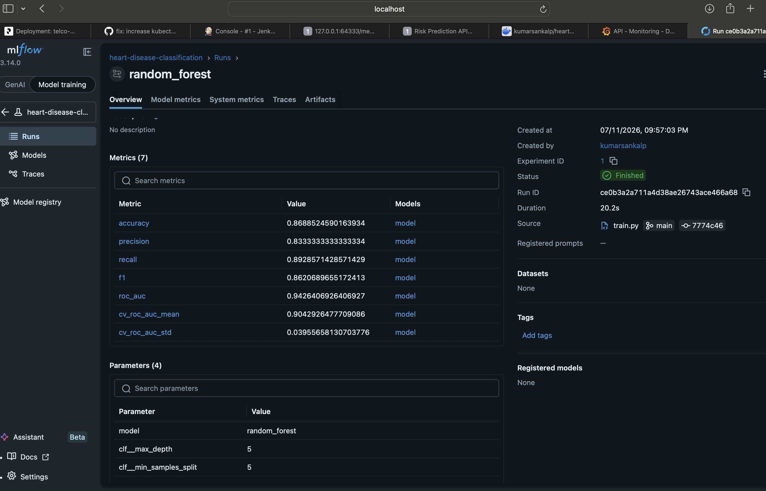
Figure 10 — MLflow run comparison / metric detail
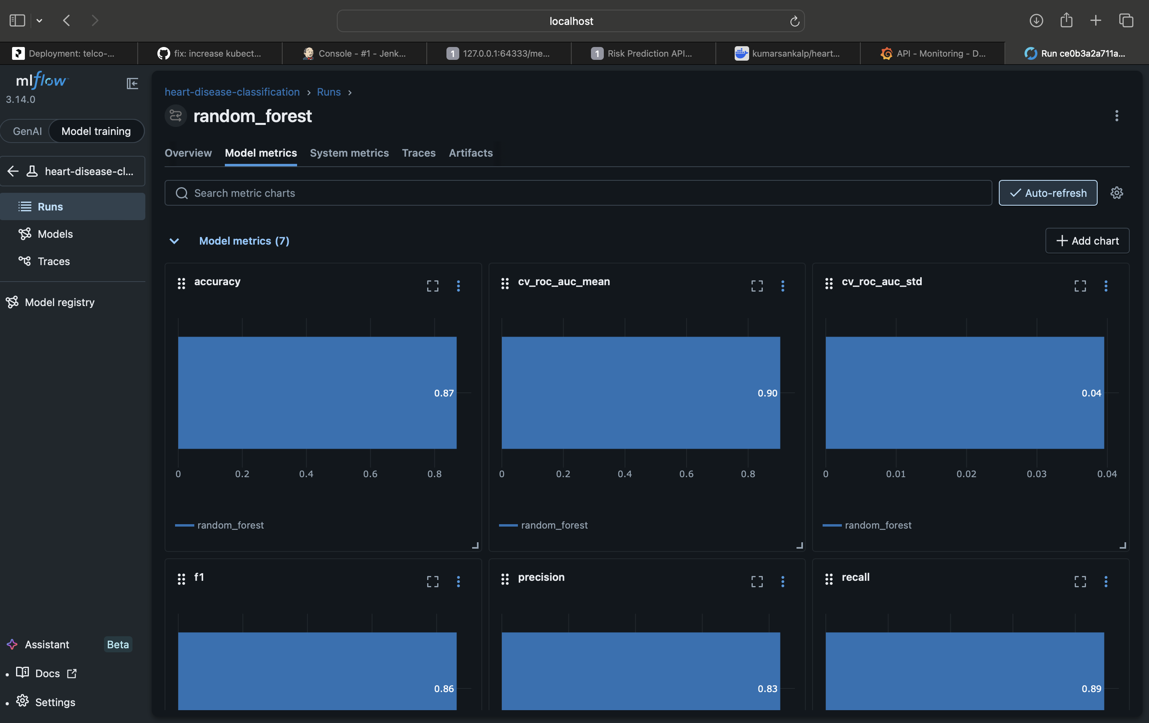
Figure 11 — MLflow artifacts: ROC / confusion-matrix plots + serialised model

6. Model Packaging & Reproducibility
Serialisation: the full pipeline (preprocessing + model) is saved with `joblib` to `models/model.joblib`, plus `model_metadata.json` recording the best model name, metrics and feature lists.
Dependencies: `requirements.txt` pins exact versions; a slim `requirements-api.txt` is used for the serving container.
Reproducibility: fixed seed, identical preprocessing at train and inference time, and a deterministic prediction path (verified by a unit test).
Reusable transformers: because preprocessing is inside the pipeline, raw JSON can be scored directly by the API.

7. CI/CD Pipeline & Automated Testing

7.1 Test suite
A pytest suite covers data loading, the preprocessing pipeline (including missing-value handling and scaling), the trained model and inference helper, and the FastAPI endpoints (health, predict, validation errors, metrics).
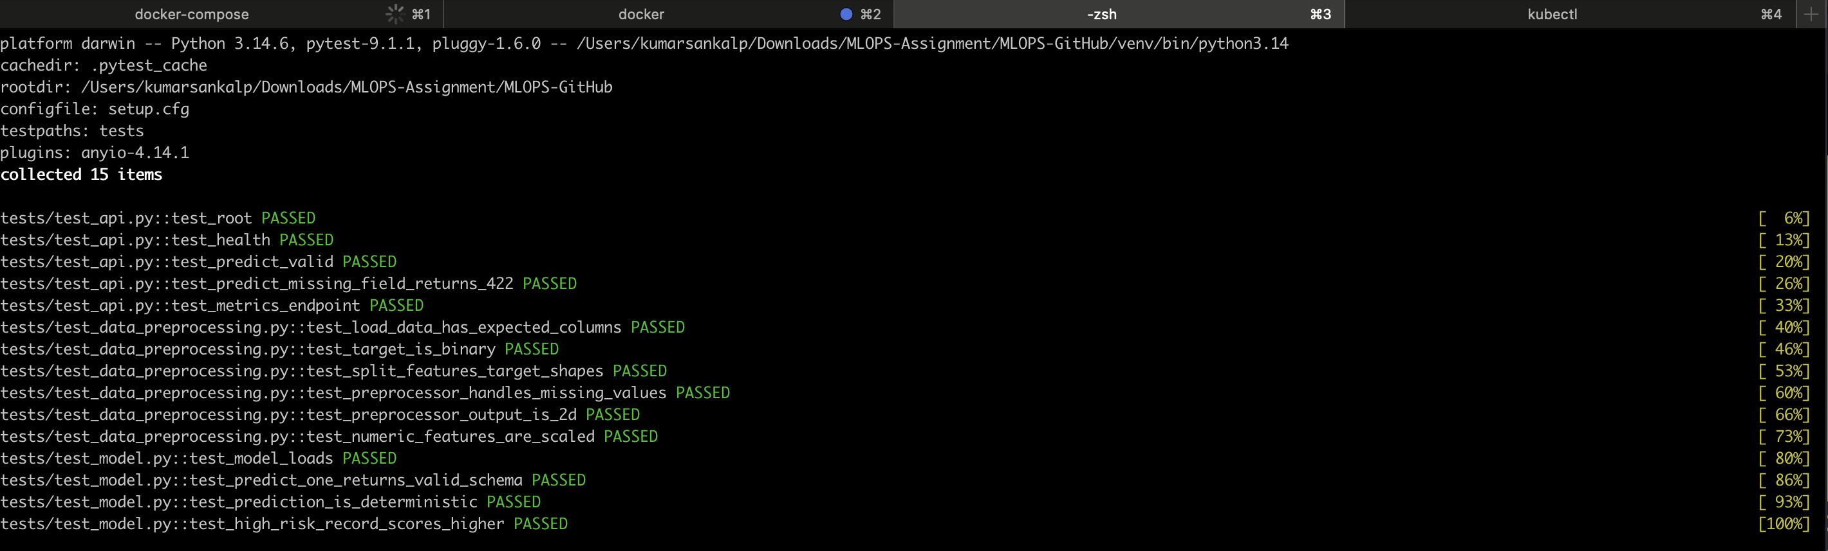
Figure 12 — pytest: all tests passing

7.2 GitHub Actions pipeline
The workflow .github/workflows/ci.yml runs on every push/PR and is organised as sequential, fail-fast jobs:
- lint — flake8 static checks on src, api and tests.
- train — download the dataset, train the models and upload the trained model + MLflow artifacts.
- test — download the trained model artifact and run the pytest suite.
- docker — build the image, smoke-test /health and /predict inside the container, then push to Docker Hub tagged with the commit SHA.
A separate cd.yml workflow triggers on successful CI completion and deploys the freshly-built image to the local Minikube cluster via a self-hosted runner. The pipeline fails fast and reports clear logs if linting or tests fail, satisfying the rubric's fail-on-error requirement.
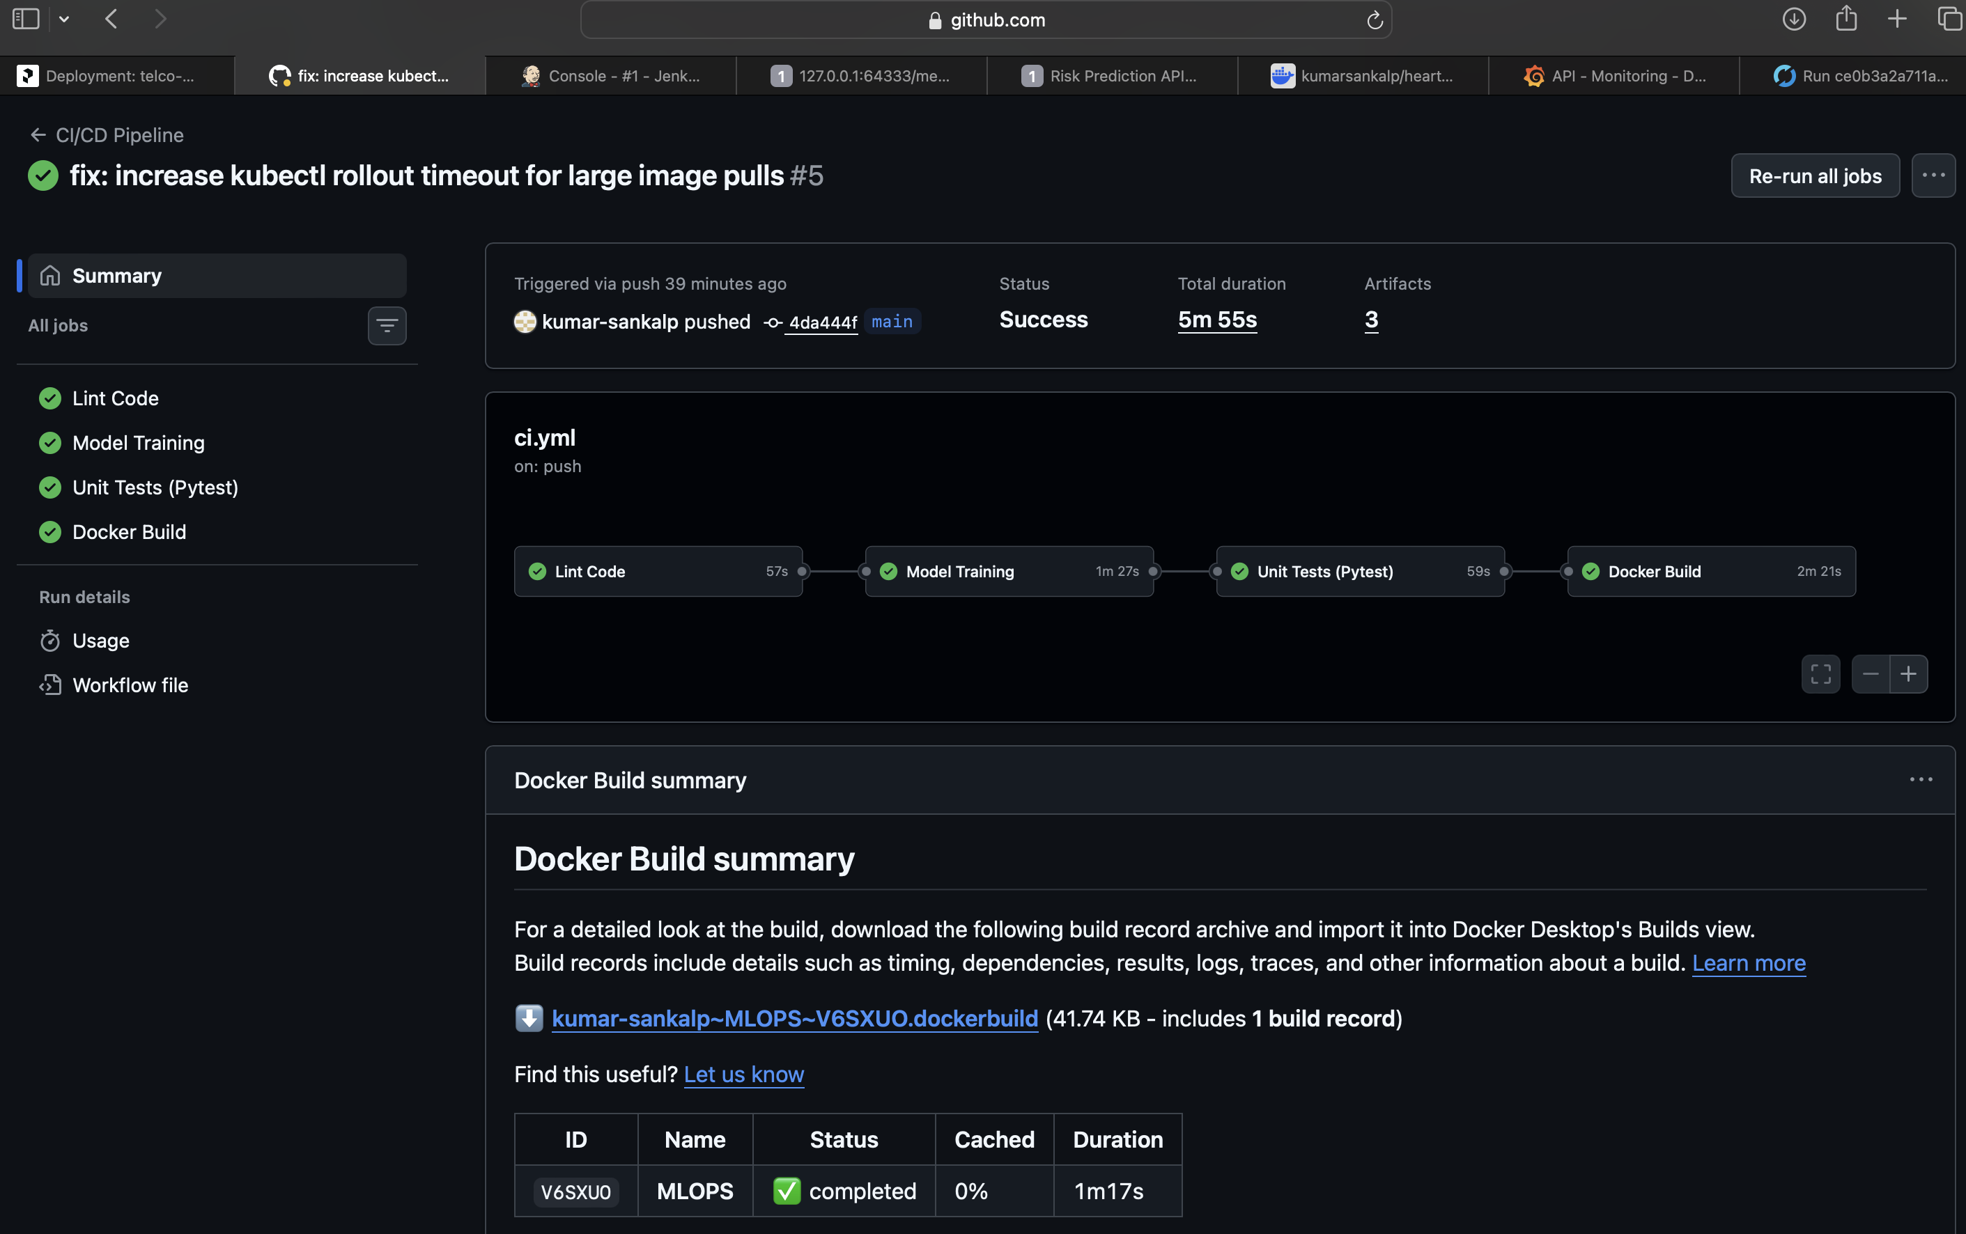
Figure 13 — GitHub Actions: CI/CD pipeline overview
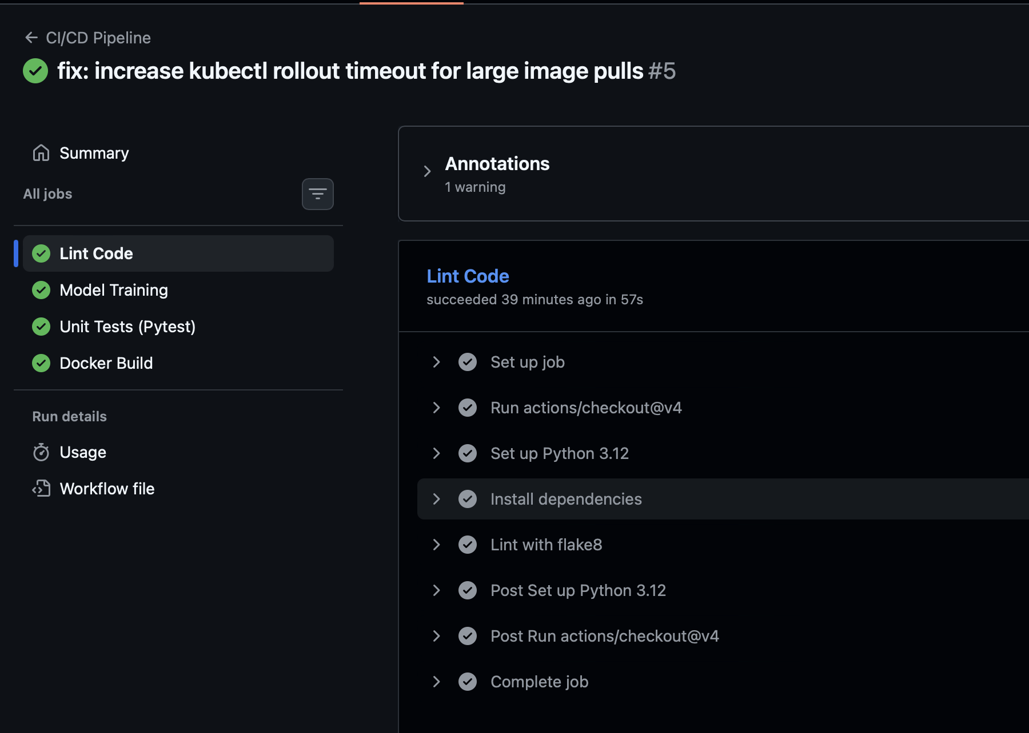
Figure 14 — GitHub Actions: lint & train job logs
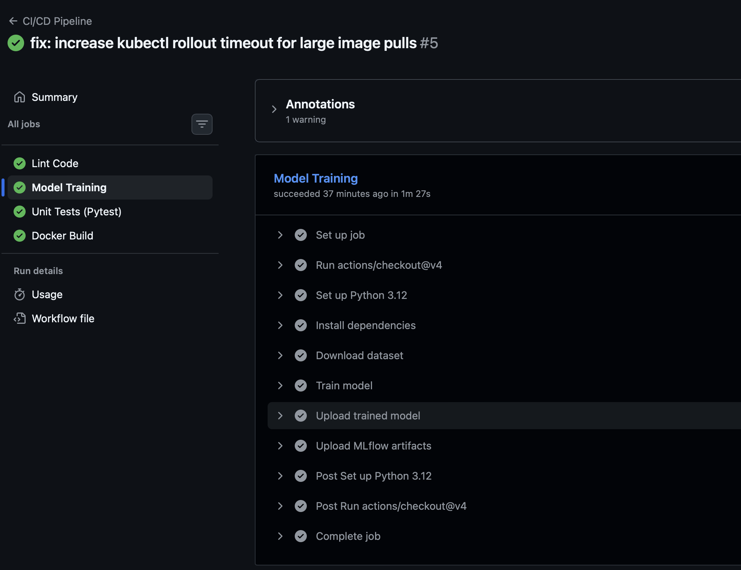
Figure 15 — GitHub Actions: test job (pytest) logs
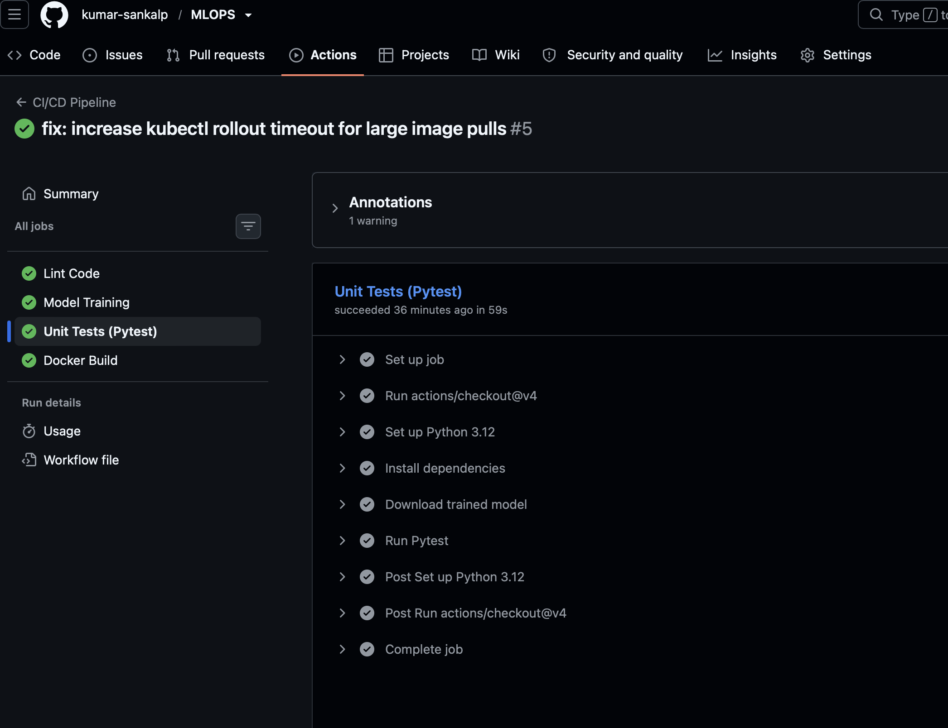
Figure 16 — GitHub Actions: Docker build & smoke-test logs
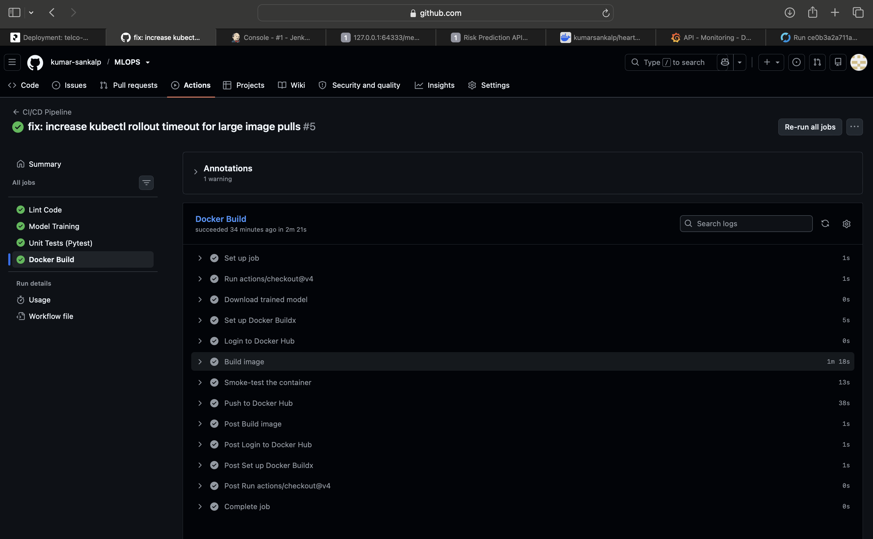
Figure 17 — GitHub Actions: green run with all jobs passing
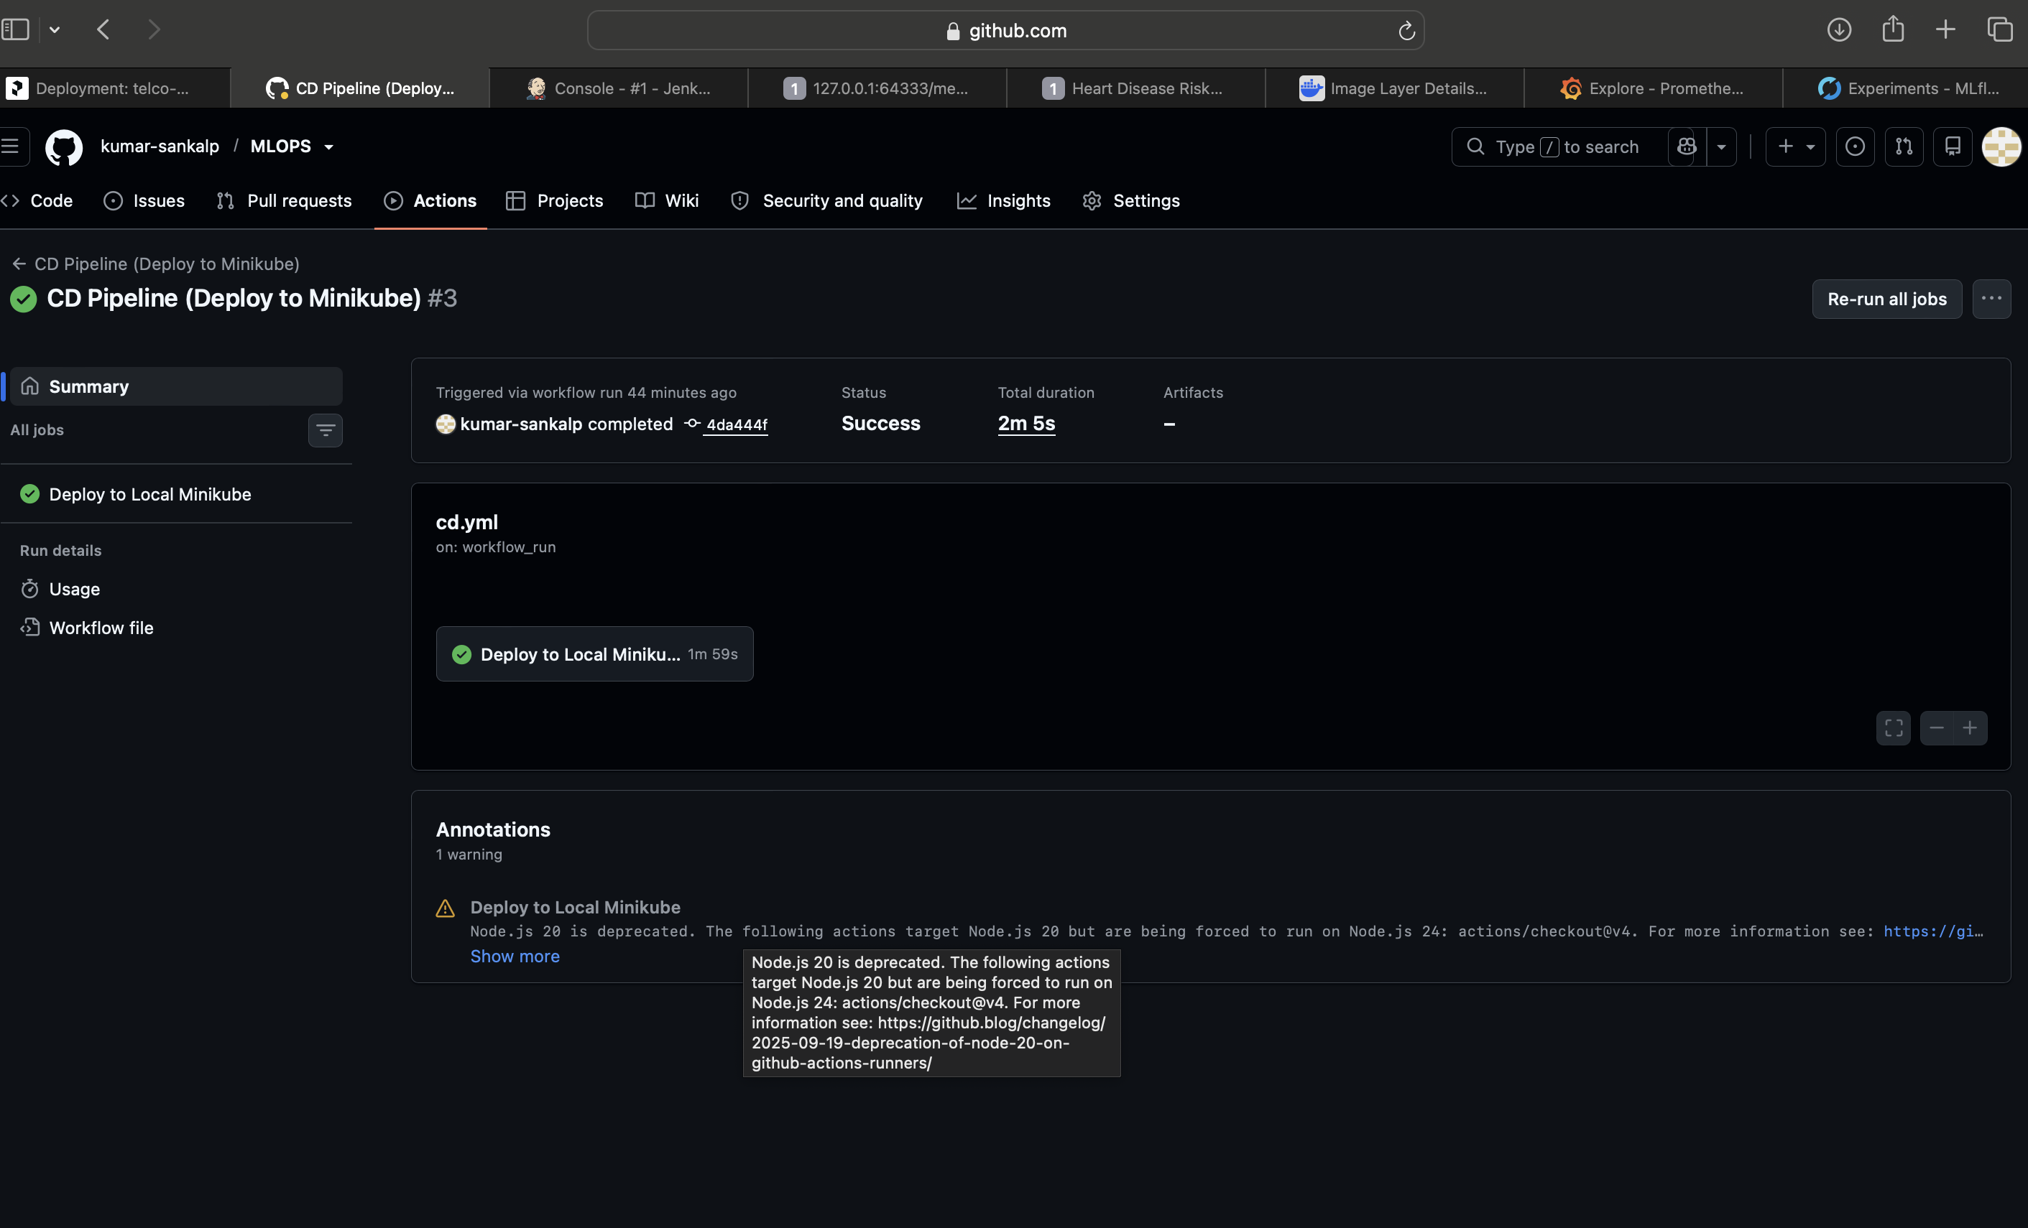
Figure 18 — GitHub Actions: CD workflow deploying to Minikube

8. Model Containerization (Docker)
A Dockerfile builds a slim python:3.12-slim image containing the API code, the trained pipeline and the serving dependencies. It runs as a non-root user and defines a container HEALTHCHECK against /health.
Build & run: docker build -t heart-api:1.0.0 . then docker run -p 8000:8000 heart-api:1.0.0. The CI pipeline publishes the image to Docker Hub.
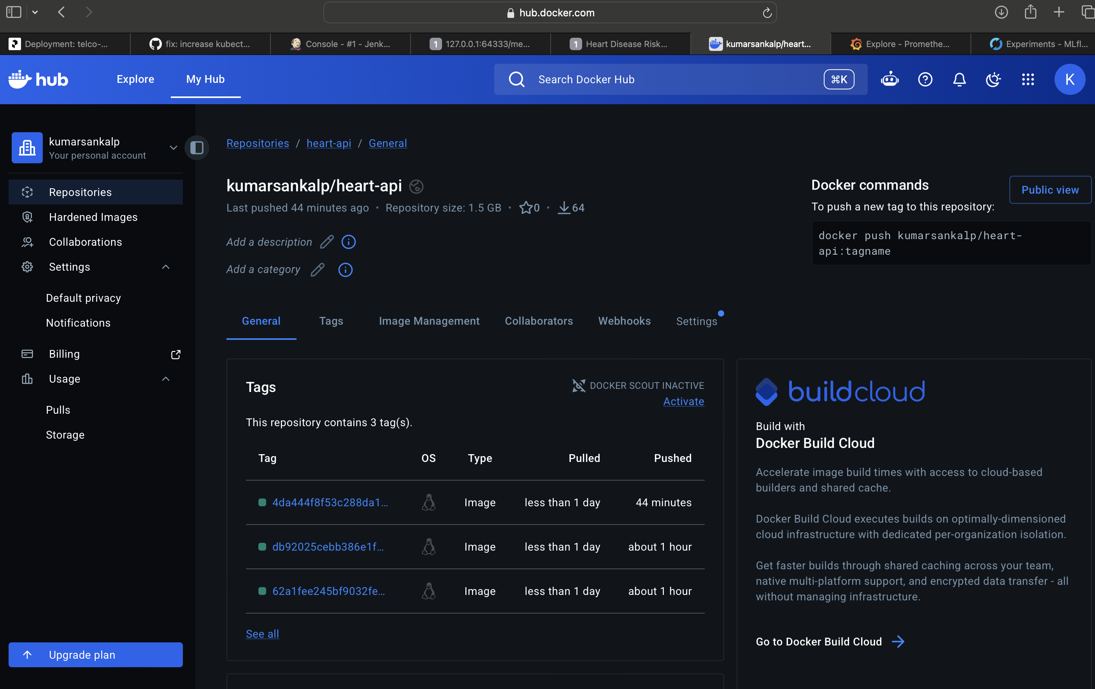
Figure 19 — Docker Hub: published heart-api image
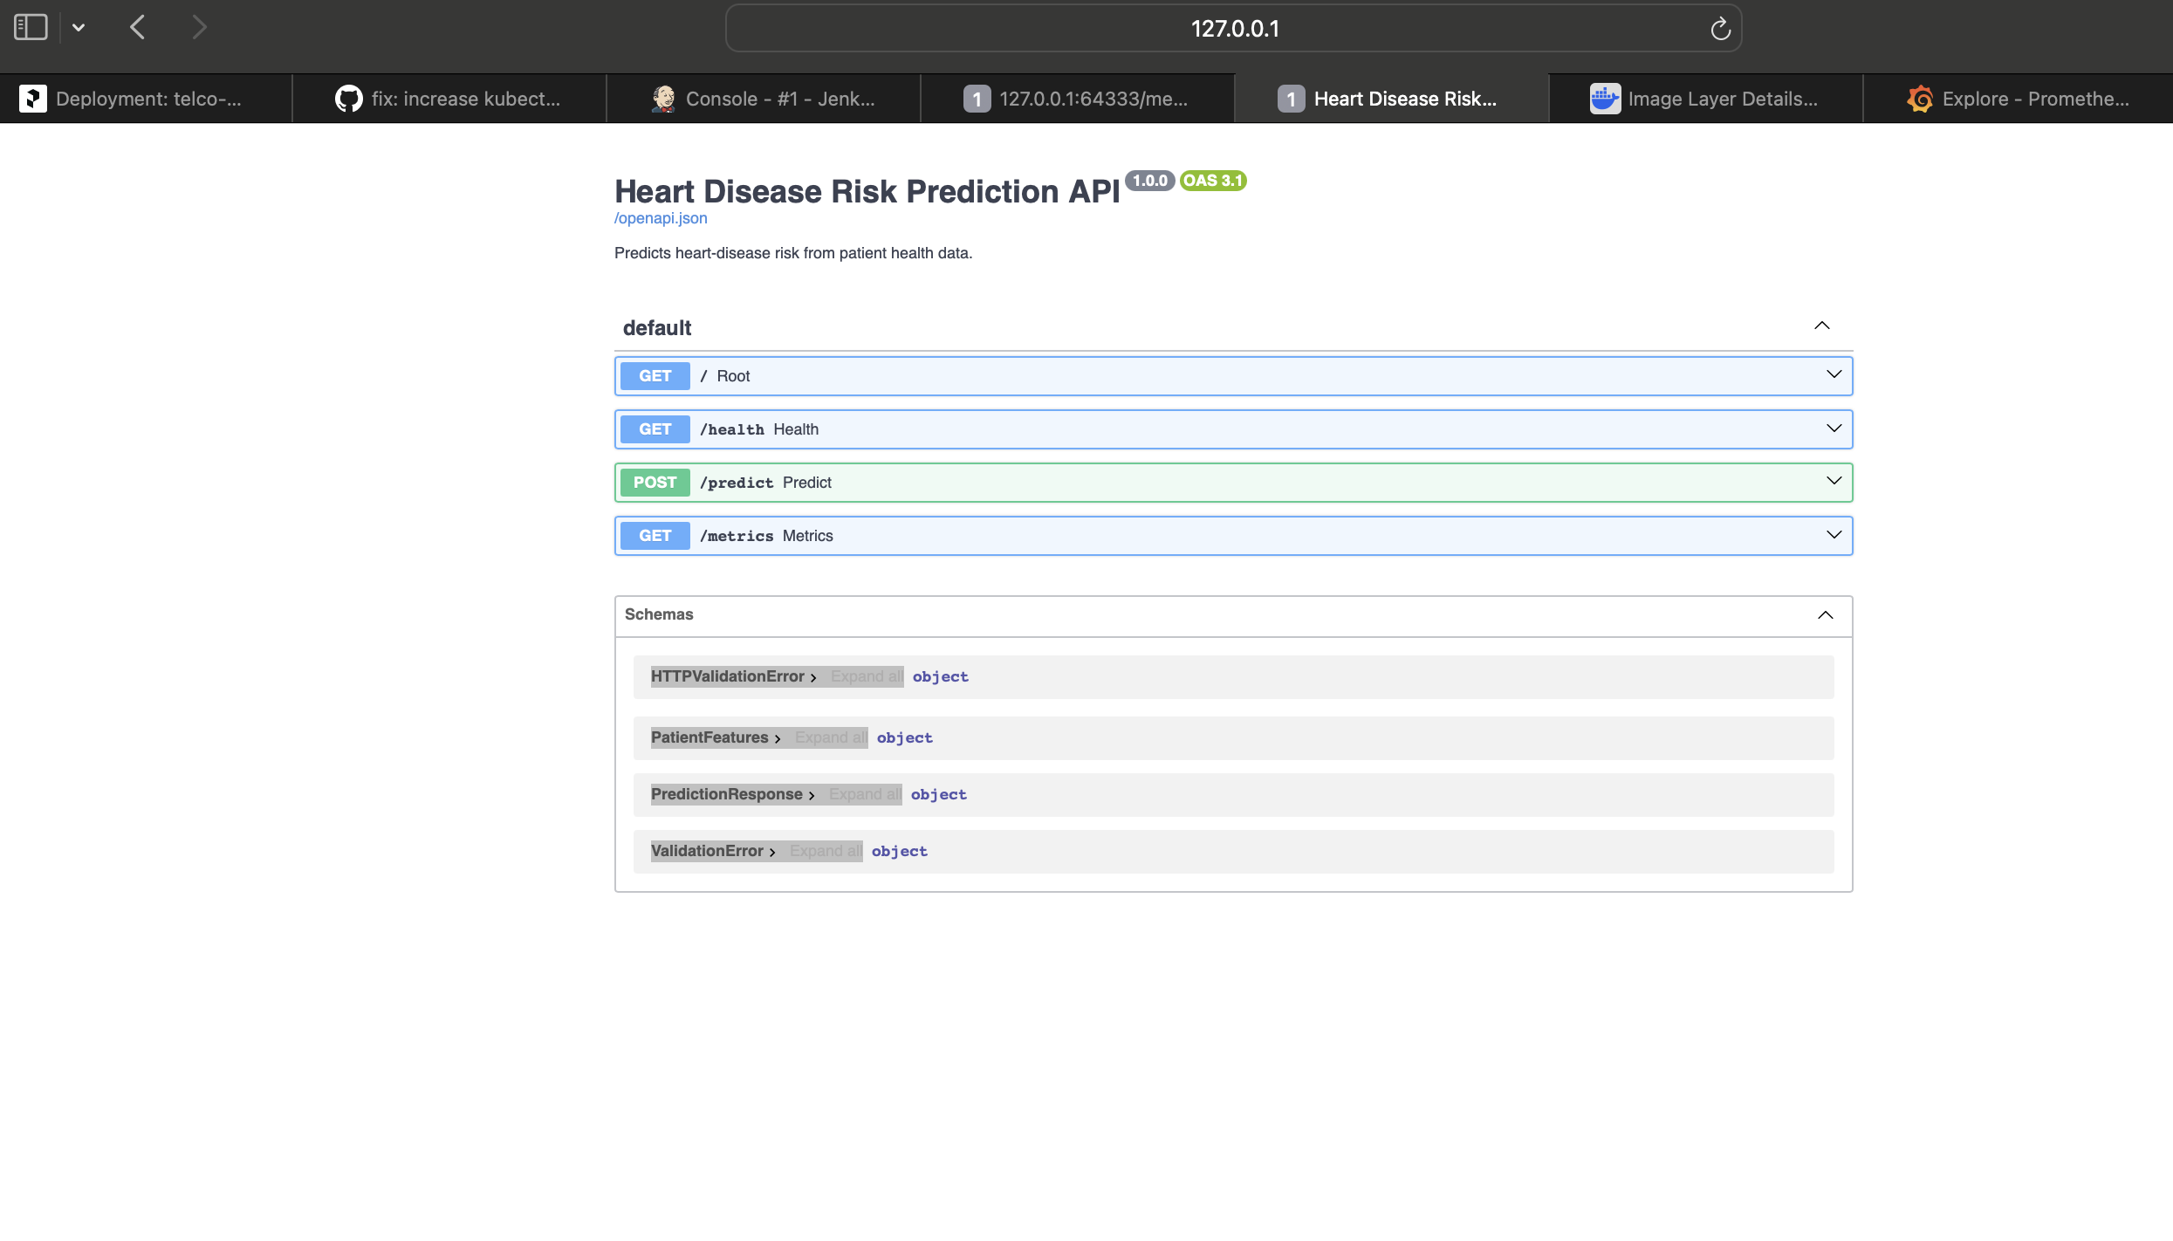
Figure 20 — Swagger UI (/docs): /predict tried out with a 200 response

9. Production Deployment (Kubernetes / Minikube)
The API is deployed to a local Kubernetes cluster (Minikube) using a Deployment (2 replicas, liveness/readiness probes, resource limits, Prometheus scrape annotations) and a LoadBalancer Service. An optional Helm chart parameterises the same resources.
Deploy: kubectl apply -f k8s/deployment.yaml -f k8s/service.yaml then minikube service heart-api-service --url.
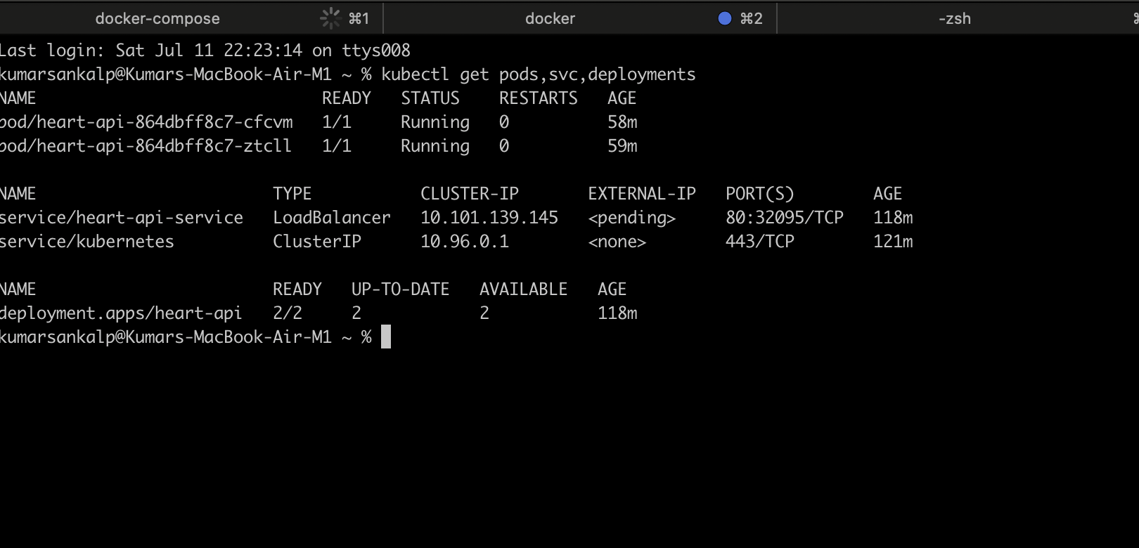
Figure 21 — kubectl: pods, service & deployment Running (2/2)
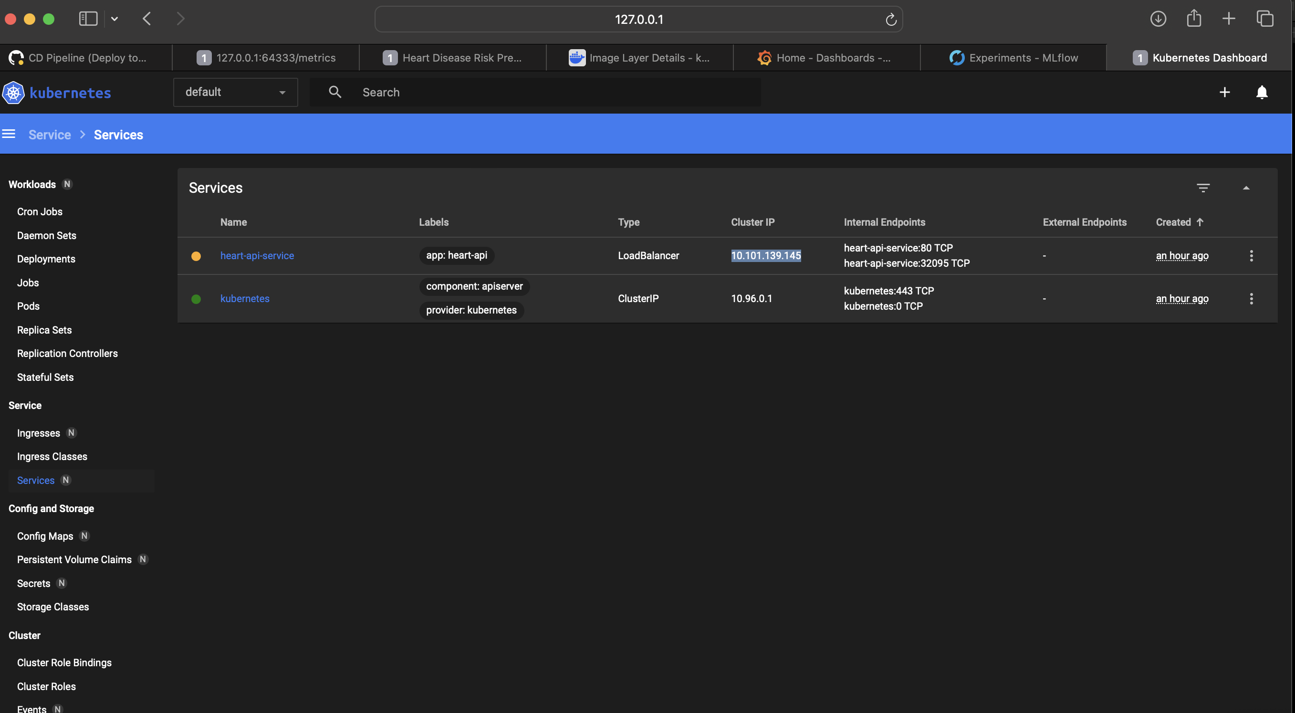
Figure 22 — Minikube dashboard: heart-api workload
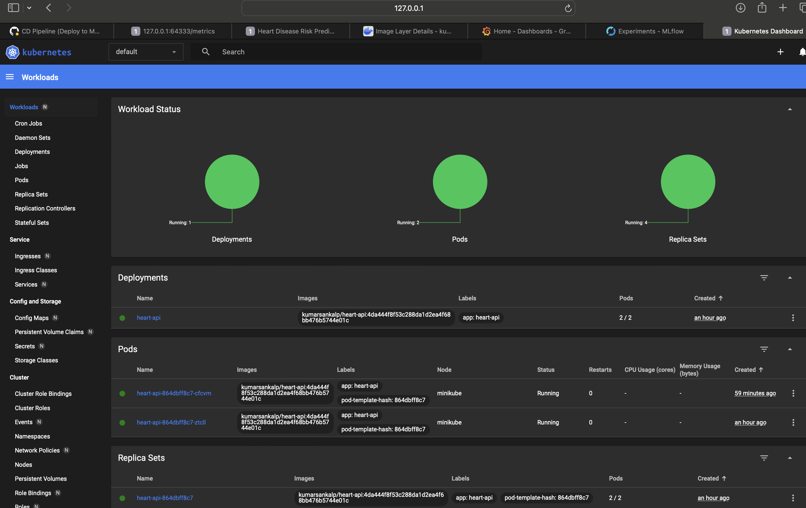
Figure 23 — Minikube: service exposed via LoadBalancer + /predict response

10. Monitoring & Logging
The API instruments Prometheus metrics via middleware: total requests (by method/endpoint/status), a request-latency histogram, and total predictions by predicted class. Every request is also logged with method, path, status and latency. A docker-compose stack runs the API alongside Prometheus and a pre-provisioned Grafana dashboard.
Why it matters: monitoring surfaces model failures, API downtime, latency regressions and shifts in prediction distribution (a proxy for data drift).
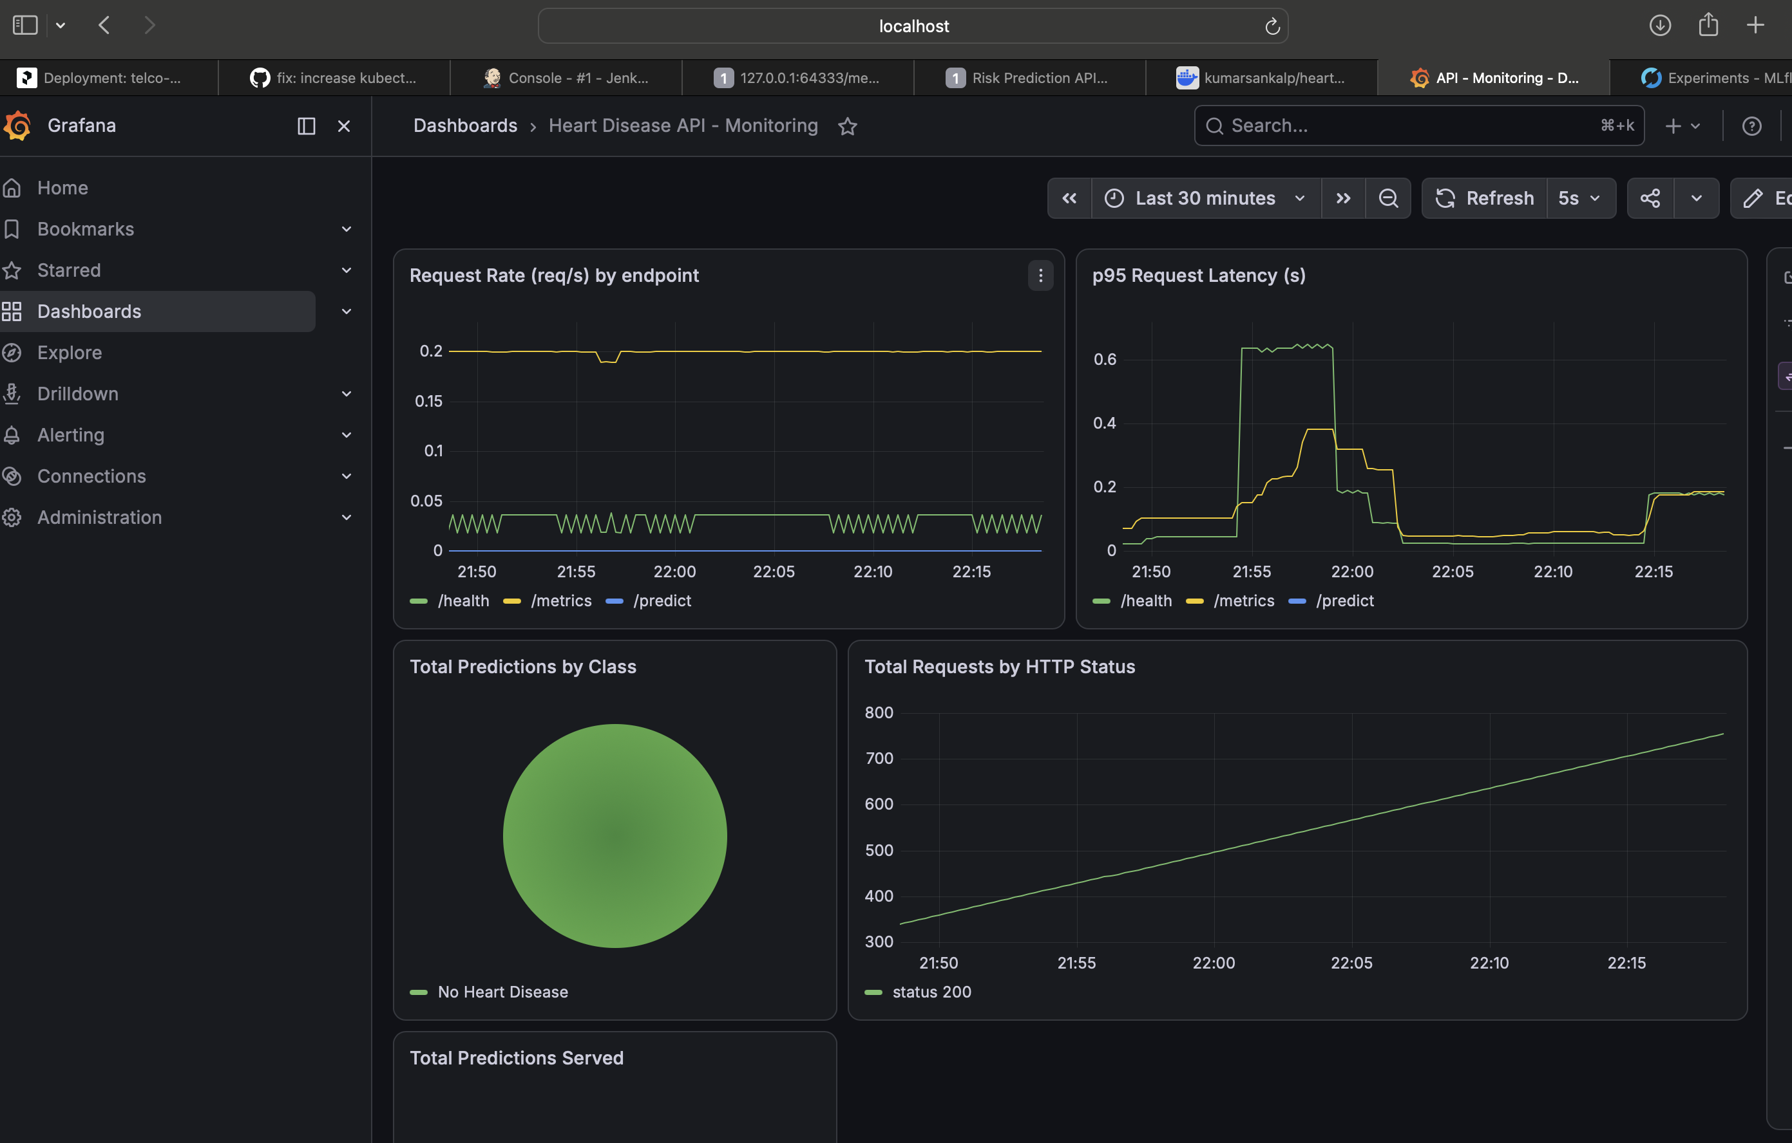
Figure 24 — Grafana: 'Heart Disease API — Monitoring' dashboard with live panels

11. Conclusion & Repository
This assignment implements a full production-style MLOps lifecycle for a healthcare classification problem: reproducible data and preprocessing, tracked experimentation, a well-tested and containerised serving API, automated CI/CD, Kubernetes deployment, and observability. The best model (Logistic Regression) achieves a strong test ROC-AUC of 0.965 with 0.93 recall.
Future work.
- Automated data-drift detection (e.g. Evidently) feeding Grafana alerts.
- Model registry with staged promotion (MLflow Model Registry).
- Push images to a registry and deploy to a managed cloud cluster (AKS/GKE/EKS).
Code repository: https://github.com/kumar-sankalp/MLOPS

