Introduction to Database

Ques:1. Create Database?
Answer:
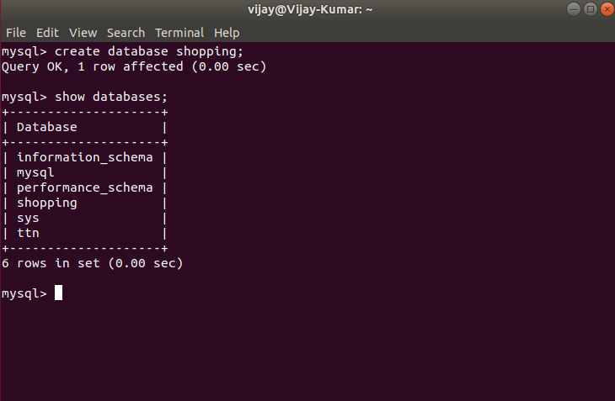
Ques:2. Design Schema?
Answer:
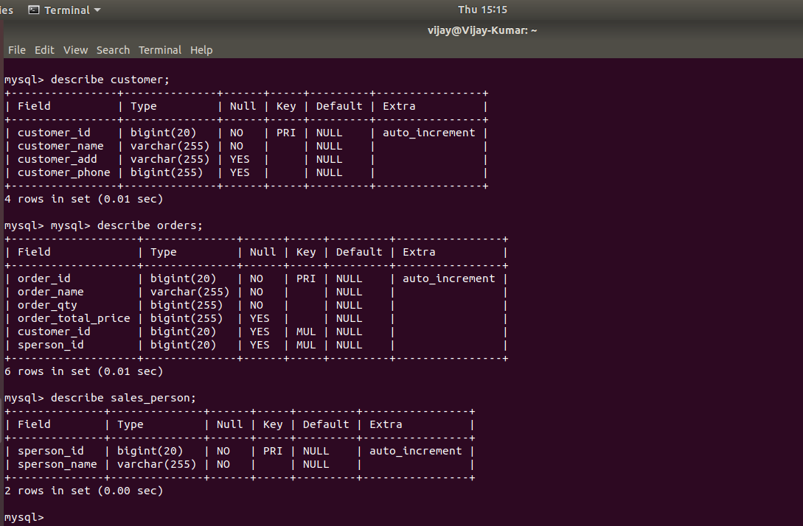

Ques:3. Create tables?
Answer:
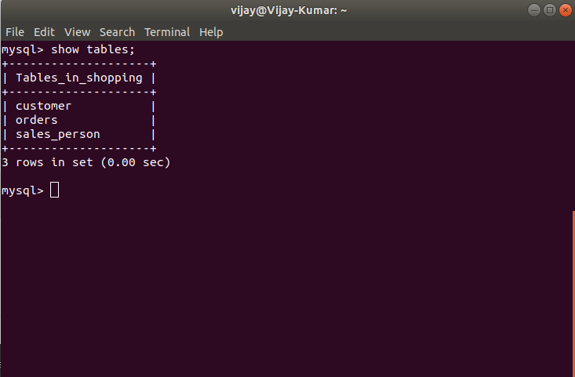

Ques:4. Insert sample data ?
Answer:
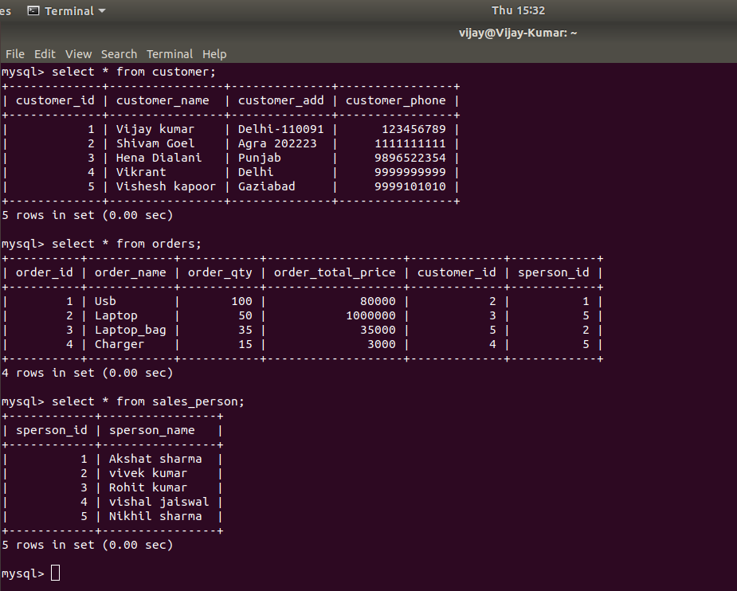

Ques:5. Find the sales person have multiple orders?
Answer:
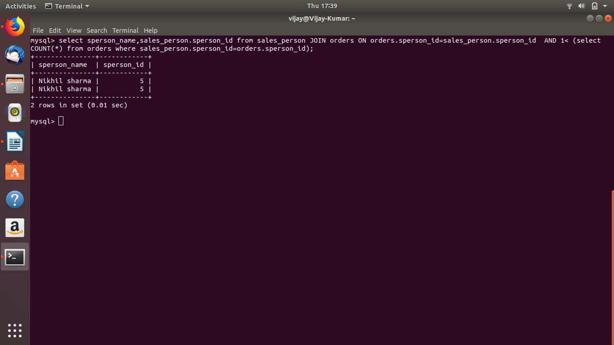

Ques:6. Find the all sales person details along with order details?
Answer:
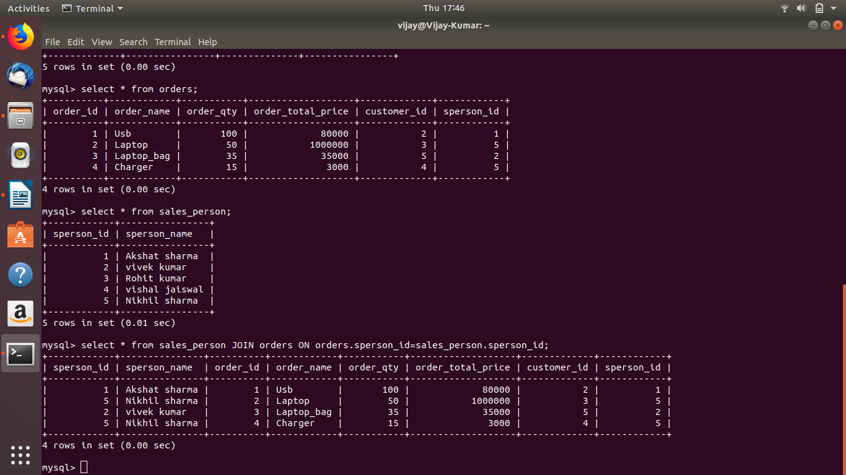

Ques:7. Create index?
Answer: query starts from below the blue line.
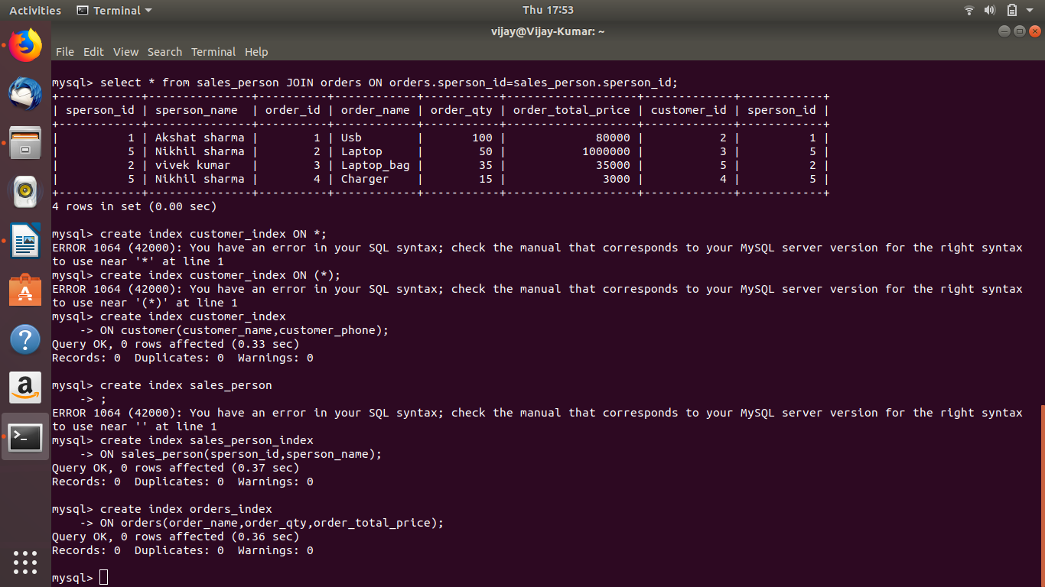

Ques:8. How to show index on a table?
Answer:
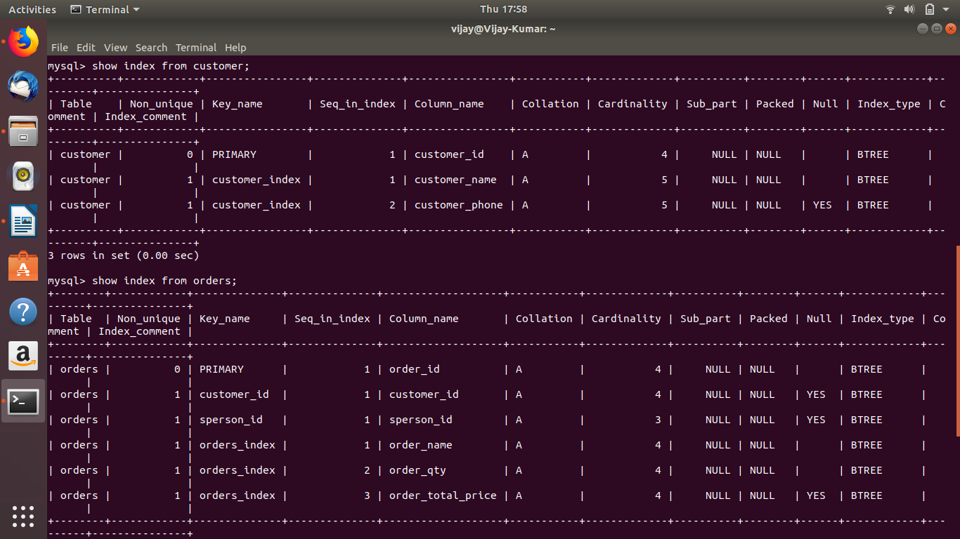

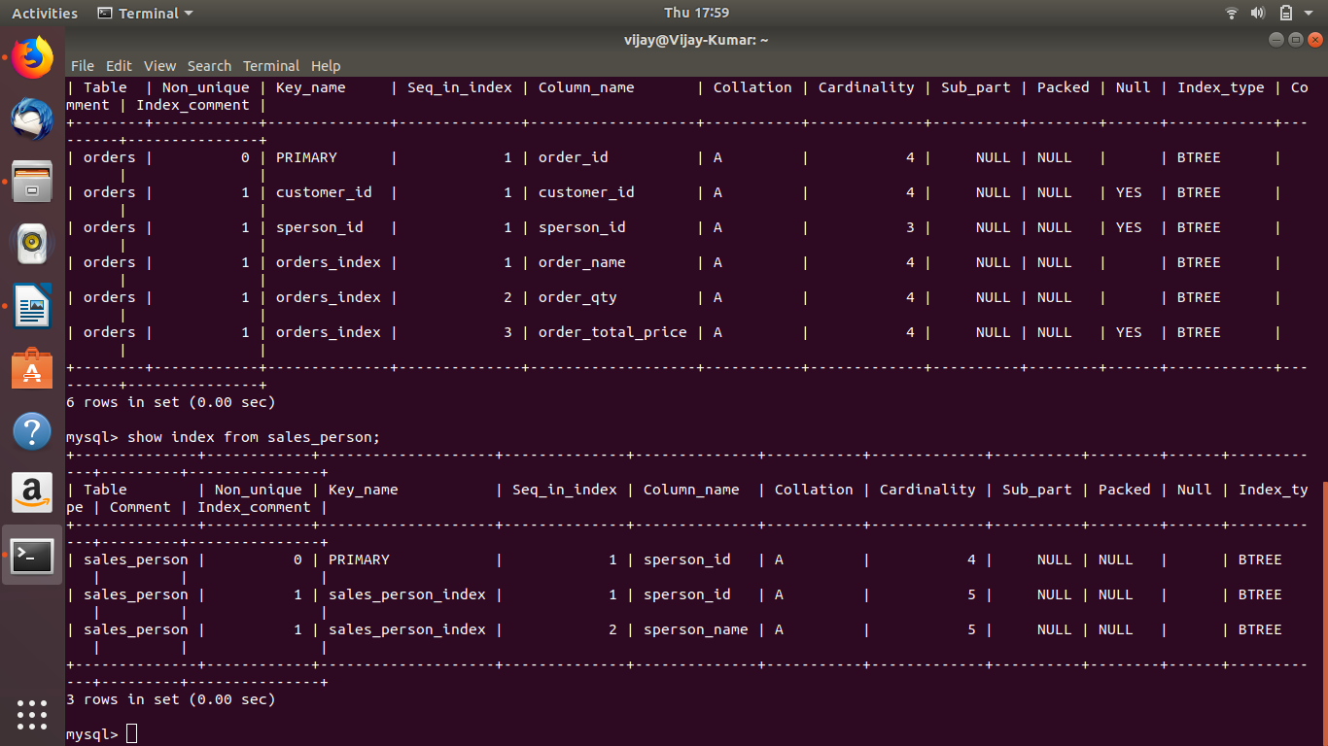
Ques:9. Find the order number, sale person name, along with the customer to whom that order belongs to?
Answer:

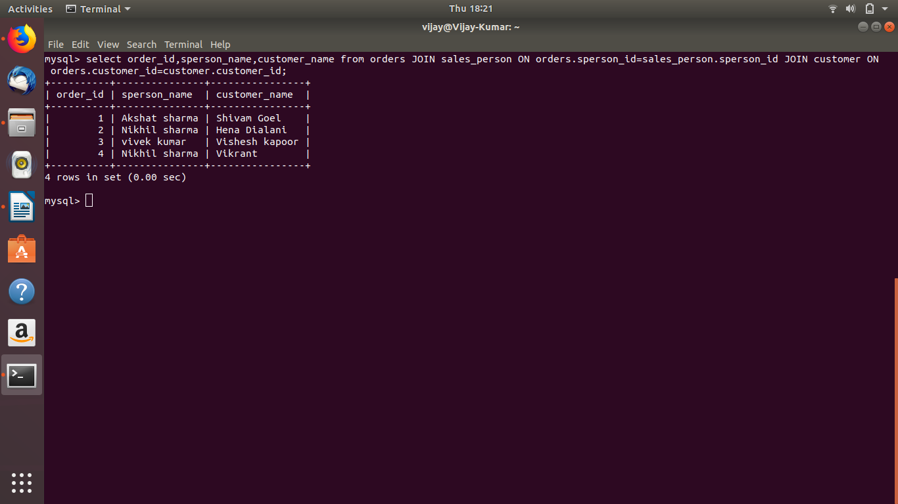

Submitted by
(VIJAY KUMAR)

