Twitter Bootstrap

Ques:11. Create HTML for web-page.jpg (check resources, highest weightage for answers) ?
Answer:
bootstrap.html
<!DOCTYPE html>
<html lang="en">
<head>
<meta charset="UTF-8">
<meta name="viewport" content="width=device-width, initial-scale=1.0">
<link rel="stylesheet" href="https://maxcdn.bootstrapcdn.com/bootstrap/4.4.1/css/bootstrap.min.css">

<!-- jQuery library -->
<script src="https://ajax.googleapis.com/ajax/libs/jquery/3.4.1/jquery.min.js"></script>
<!-- Popper JS -->
<script src="https://cdnjs.cloudflare.com/ajax/libs/popper.js/1.16.0/umd/popper.min.js"></script>
<!-- Latest compiled JavaScript -->
<script src="https://maxcdn.bootstrapcdn.com/bootstrap/4.4.1/js/bootstrap.min.js"></script>
<link rel="stylesheet" type="text/css" href="/Stylesheet/bootstyle.css">
<title>Bootstrap</title>
</head>
<body>
<div class="container-fluid main-container">
<div class="container middle">
<header class="container-fluid header">
<div class="container mycont w-100 px-5 py-4">
<h1>To The New</h1>
<na v class="navbar navbar-expand-lg nav-cust">
<button class="navbar-toggler btn" type="button" data-toggle="collapse" data-target="#navres" aria-controls="navbarNavAltMarkup" aria-expanded="false" aria-label="Toggle navigation">
<span class="navbar-toggler-icon myicon"></span>
</button>
<div class="collapse navbar-collapse" id="navres">
<div class="navbar-nav">
<a class="nav-item nav-link" href="#">Text Link</a>
<a class="nav-item nav-link" href="#">Text Link</a>
<a class="nav-item nav-link" href="#">Text Link</a>
<a class="nav-item nav-link" href="#">Text Link</a>
<a class="nav-item nav-link" href="#">Text Link</a>
<div>
</div>
</nav>
</div>
</header>
<div class="container w-auto mh-100 m-5 px-4">
<div class="row justify-content-between align-items-center imgcon">
<div class="col-md-12 ">
<p class="display-4 text-white text-center">960x360px</p>
</div>
</div>
<div class="row my-3 mypara">
<div class="col-md-12 justify-content-center align-items-center">
<p class="text-secondary pt-3">
VESTIBULUMACCUMSAN EGESTIBULUUEU JUSTO CONVALLIS AUGUE ESTAS AENEAN ELIT INTESQUESED. FACILISPEDE ESTIBULUM NULLA ORNA NISL VELIT ELIT AC ALIQUAT NON TINCIDUNT NAMJUSTO CRAS URNA
</p>
</div>
</div>
<h2 class="text-secondary my-3">Latest From The Gallery</h2>
<div class="row text-white justify-content-center align-self-center">
<div class="col-12 col-md-3">
<div class="card p-2 pb-4 ">
<div class=" w-100 align-items-center py-5" style="background-color: #323232; height:315px">
<h5 class="text-seconday text-center p-5 my-5">215x315px</h5>
</div>
<div class="card-body bg-secondary">
<p class="card-text text-center">Image Caption Here</p>
</div>
</div>
</div>
<div class="col-12 col-md-3">
<div class="card p-2 pb-4 ">
<div class=" w-100 py-5" style="background-color: #323232; height:315px">
<h5 class="text-seconday align-middle text-center py-5 my-5">215x315px</h5>
</div>
<div class="card-body bg-secondary">
<p class="card-text text-center">Image Caption Here</p>
</div>
</div>
</div>
<div class="col-12 col-md-3">
<div class="card p-2 pb-4 ">
<div class=" w-100 py-5 " style="background-color: #323232; height:315px">
<h5 class="text-seconday py-5 my-5 align-middle text-center">215x315px</h5>
</div>
<div class="card-body bg-secondary">
<p class="card-text text-center">Image Caption Here</p>
</div>
</div>
</div>
<div class="col-12 col-md-3">
<div class="card p-2 pb-4 ">
<div class=" w-100 py-5" style="background-color: #323232; height:315px">
<h5 class="text-seconday py-5 my-5 align-middle text-center">215x315px</h5>
</div>
<div class="card-body bg-secondary">
<p class="card-text text-center">Image Caption Here</p>
</div>
</div>
</div>
</div>
</div>
<footer class="container-fluid footer">
<div class="container w-100 d-flex text-white p-3 px-5">
<div class="mr-auto "id="footer-left">Copyright &#169; 2009-2017-All Rights Reserved-To the new</div>
<div class="ml-auto" id="footer-right">Web layout by To the new</div>

</div>
</footer>
</div>
</div>
</body>
</html>

bootstyle.css

*{
margin:0px;
padding:0px;
}
h1{
font-size:26px;

color:#908882;
}
.main-container{
background-color: #363636;
}
.middle{
padding: 0px;
background-color: white;
}
.header{
background-color: #383838;
margin:0px;
}
.footer{
background-color: #222222;
}
.nav-cust{
color : black;
background-color: black;
padding-left:0px;
}
a{
color:#908882;
}
.btn{
border:white 1px solid;
background-color: black;
color : white;
}
.img-container{
margin-top: 20px;
background-color: #323232;
border:1px solid red;
}
.mypara{
background-color:#EBEBEB;
font-weight: bold;
}
.imgcon{
height:360px;
background-color: #323232;
}

OUTPUT:

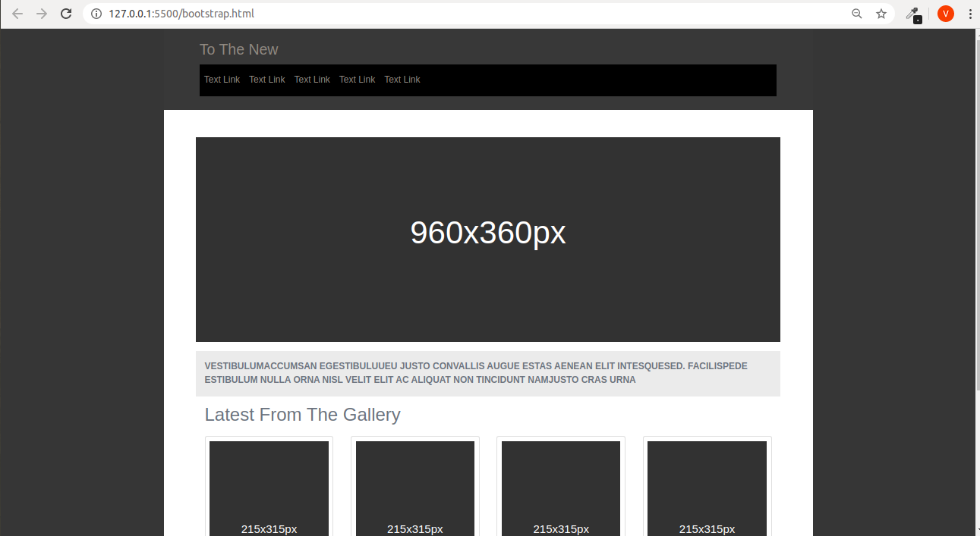

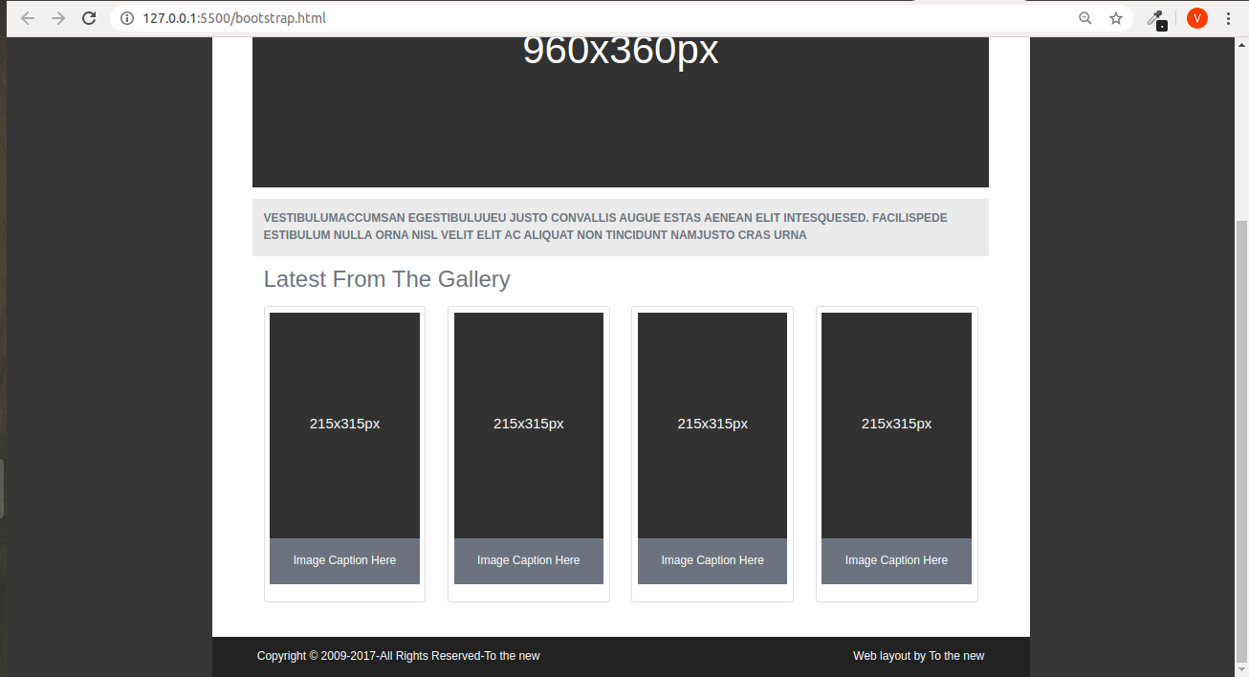

Ques:12. Create HTML for form.png (check resources, highest weightage for answers)?
Answer:

bootstrapform.html

<!DOCTYPE html>
<html lang="en">
<head>
<meta charset="UTF-8">
<meta name="viewport" content="width=device-width, initial-scale=1.0">
<title>Document</title>
<link rel="stylesheet" href="https://maxcdn.bootstrapcdn.com/bootstrap/4.4.1/css/bootstrap.min.css">

<!-- jQuery library -->
<script src="https://ajax.googleapis.com/ajax/libs/jquery/3.4.1/jquery.min.js"></script>
<!-- Popper JS -->
<script src="https://cdnjs.cloudflare.com/ajax/libs/popper.js/1.16.0/umd/popper.min.js"></script>
<!-- Latest compiled JavaScript -->
<script src="https://maxcdn.bootstrapcdn.com/bootstrap/4.4.1/js/bootstrap.min.js"></script>
<title>Bootstrap Form</title>
<style>.custom-file-input:lang(en) ~ .custom-file-label::after { content: "Choose File";}</style>
</head>
<body>
<div class="container-fluid">
<div class="row border-bottom border-secondary" style="color:#36A3A4 ;">
<div class="col-12 col-md-8 ">
<h2 class="pt-3" >TO The New</h1>
</div>
<div class="col-12 col-md-4 ">
<nav class="navbar navbar-expand-lg ">
<button class="navbar-toggler navbar-toggler-right navbar-dark" type="button" data-toggle="collapse" data-target="#navres" aria-controls="navbarNavAltMarkup" aria-expanded="false" aria-label="Toggle navigation">
<span class="navbar-toggler-icon myicon border border-secondary bg-dark"></span>
</button>
<div class="collapse navbar-collapse" id="navres">
<ul class="navbar-nav ml-auto" >
<li class="nav-item">
<a class="nav-link" style="color:#36A3A4" href="#">Home</a>
</li>
<li class="nav-item">
<a class="nav-link" style="color:#36A3A4" href="#">Quick Help</a>
</li>
</ul>
</div>
</nav>
</div>
</div>
</div>
<div class="container my-5 w-50">
<div class="card">
<h4 class="card-header text-white py-4" style="background-color: #BCC3CA;">
<strong>Bug Report</strong>
</h4>
<div class="card-body">
<form class="text-left text-secondary">
<div class="form-group">
<label for="title">Title:*</label>
<input type="text" class="form-control" id="title">
</div>
<div class="form-group">
<label for="description">Description:*</label>
<textarea class="form-control" id="description" rows="3"></textarea>
</div>
<div class="form-group" >
<label for="os">Operating System:</label>
<select class="form-control text-white" id="os" style="background-color: #3CBC9C;">
<option>Window Xp</option>
<option>ubuntu</option>
<option>Mac</option>
<option>Window 10</option>
</select>
</div>
<div class="form-group" >
<label for="products">Products:*</label>
<select class="form-control text-white" id="products" style="background-color: #3CBC9C;">
<option>Formoid</option>
<option>Office</option>
</select>
</div>
<div class="form-group mt-2">
<label for="ver">Version:*</label>
<input type="text" class="form-control w-25 " id="ver">
</div>
<div class="form-group">
<label>License:</label><br>
<div class="custom-control custom-radio custom-control-inline mr-5">
<input type="radio" class="custom-control-input" id="free" name="inlineDefaultRadiosExample">
<label class="custom-control-label" for="free">Free</label>
</div>
<div class="custom-control custom-radio custom-control-inline ml-5">
<input type="radio" class="custom-control-input" id="Business" name="inlineDefaultRadiosExample">
<label class="custom-control-label" for="Business">Business</label>
</div>
</div>
<div class="form-group" >
<label for="severty">Severity:</label>
<select class="form-control text-white" id="severty" style="background-color: #3CBC9C;">
<option>Critical</option>
<option>Moderate</option>
<option>Low</option>
</select>
</div>
<div class="form-group">
<label for="file">Attachments:</label>
<div class="custom-file">
<input type="file" class="custom-file-input" id="file">
<label class="custom-file-label" for="file">No File Selected</label>
</div>
</div>
</form>
</div>
<h5 class="card-footer">
<button class="btn btn-outline-info btn-rounded text-white float-right" style="background-color: #3CBC9C;"type="submit">Send</button>

</h5>

</div>
</div>
</body>
</html>

OUTPUT:
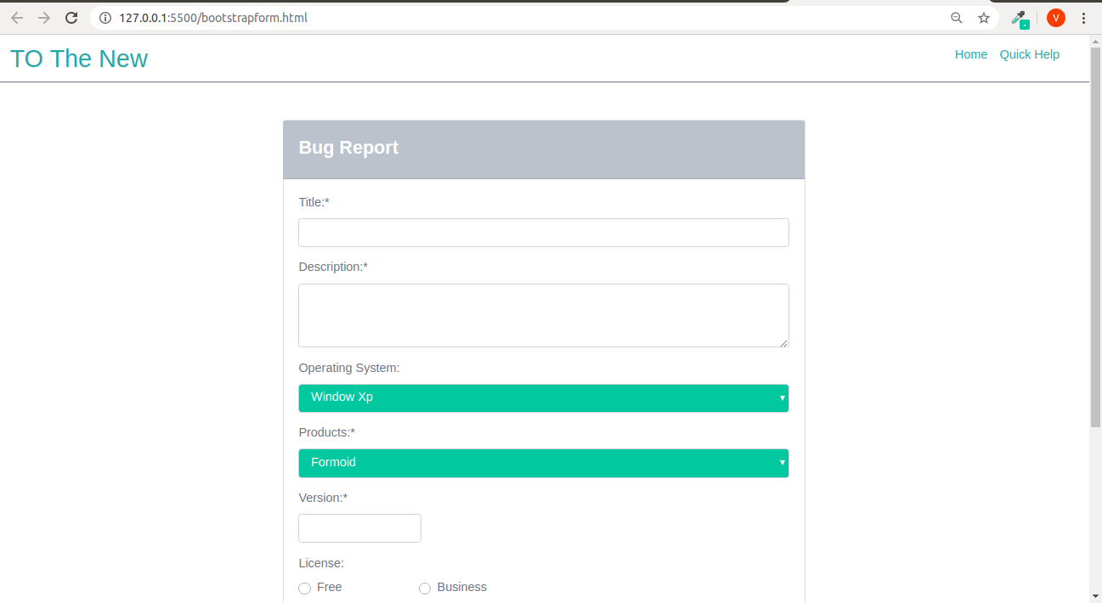

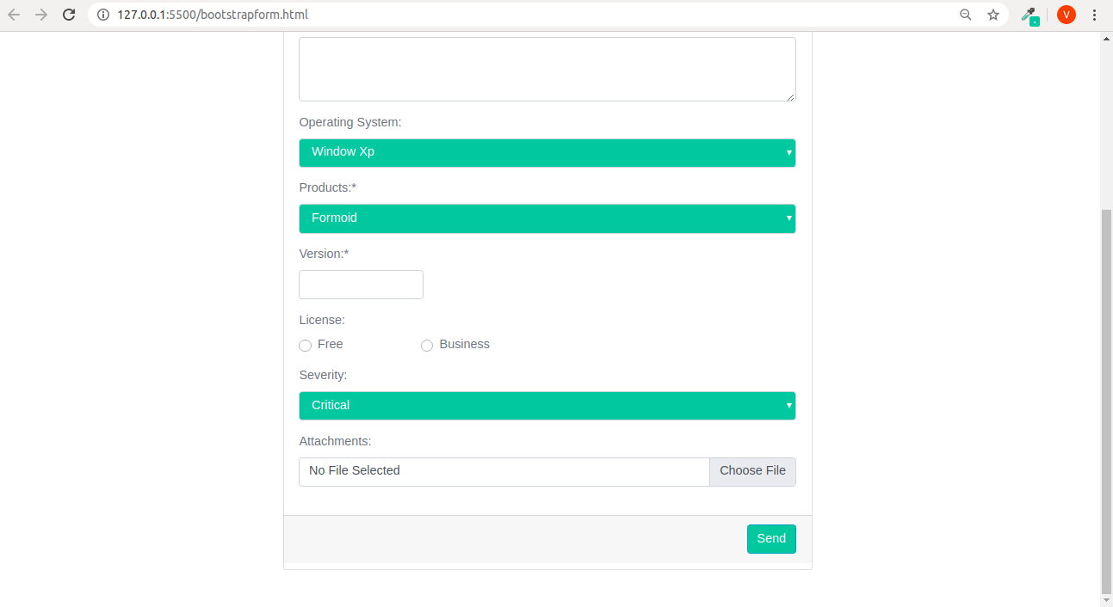

Submitted by
(VIJAY KUMAR)

