# **IMPLEMENTATION OF STATIC ROUTING USING GNS3 SOFTWARE**

**What is GNS3?**

**Graphical Network Simulator-3** (shortened to **GNS3**) is a network software emulator first released in 2008.It is an Open Source Free Software. It allows the combination of virtual and real devices, used to simulate complex networks. It uses dynamips emulation software to simulate Cisco Ios.

GNS3 is used by many large companies including Exxon,Walmart,AT & T and NASA, and is also popular for preparation of network professional certification exams. As of 2015, the software has been downloaded 11 million times.

GNS3 is used by hundreds of thousands of network engineers worldwide to emulate, configure, test and troubleshoot virtual and real networks. GNS3 allows you to run a small topology consisting of only a few devices on your laptop, to those that have many devices hosted on multiple servers or even hosted in the cloud. It is actively developed and supported and has a growing community of over 800,000 members. By joining the GNS3 community you will be joining fellow students, network engineers, architects and others that have downloaded GNS3 over 10 million times to date. GNS3 is used in companies all over the world including Fortune 500 companies.

GNS3 can help you prepare for certification exams such as the Cisco CCNA, but also help you test and verify real world deployments. Jeremy Grossman, the original developer of GNS3 originally created the software to help him study for his CCNP certifications. Because of that original work, you can today use to help you do the same without paying for expensive hardware.

 GNS3 has allowed network engineers to virtualize real hardware devices  for over 10 years. Originally only emulating Cisco devices using software called Dynamips, GNS3 has now evolved and supports many devices from multiple network vendors  including Cisco virtual switches, Cisco ASAs, Brocade vRouters, Cumulus Linux switches, Docker instances, HPE VSRs, multiple Linux appliances and many others.

****

**What is Static Routing?**

**Static routing** is a form of routing that occurs when a router uses a manually-configured routing entry, rather than information from a dynamic routing traffic. In many cases, static routes are manually configured by a [network administrator](https://en.wikipedia.org/wiki/Network_administrator" \o "Network administrator) by adding in entries into a routing table, though this may not always be the case.Unlike dynamic routing, static routes are fixed and do not change if the network is changed or reconfigured. Static routing and dynamic routing are not mutually exclusive. Both dynamic routing and static routing are usually used on a router to maximise routing efficiency and to provide backups in the event that dynamic routing information fails to be exchanged. Static routing can also be used in stub networks, or to provide a gateway of last resort.

## Uses

Static routing may have the following uses:

* Static routing can be used to define an exit point from a router when no other routes are available or necessary. This is called a default route.
* Static routing can be used for small networks that require only one or two routes. This is often more efficient since a link is not being wasted by exchanging dynamic routing information.
* Static routing is often used as a complement to dynamic routing to provide a failsafe backup in the event that a dynamic route is unavailable.
* Static routing is often used to help transfer routing information from one routing protocol to another (routing redistribution).

## Advantages

Static routing, if used without dynamic routing, has the following advantages:[*[citation needed](https://en.wikipedia.org/wiki/Wikipedia:Citation_needed" \o "Wikipedia:Citation needed)*]

* Static routing causes very little load on the [CPU](https://en.wikipedia.org/wiki/CPU" \o "CPU) of the router, and produces no traffic to other routers.
* Static routing leaves the network administrator with full control over the routing behaviour of the network.

## Disadvantages

Static routing can have some potential disadvantages:[[3]](https://en.wikipedia.org/wiki/Static_routing" \l "cite_note-3)

* **Human error:** In many cases, static routes are manually configured. This increases the potential for input mistakes. Administrators can make mistakes and mistype in network information, or configure incorrect routing paths by mistake.
* **Fault tolerance:** Static routing is not fault tolerant. This means that when there is a change in the network or a failure occurs between two statically defined devices, traffic will not be re-routed. As a result, the network is unusable until the failure is repaired or the static route is manually reconfigured by an administrator.
* **Administrative distance:** Static routes typically take precedence over routes configured with a dynamic routing protocol. This means that static routes may prevent [routing protocols](https://en.wikipedia.org/wiki/Routing_protocols" \o "Routing protocols) from working as intended. A solution is to manually modify the [administrative distance](https://en.wikipedia.org/wiki/Administrative_distance" \o "Administrative distance).[[4]](https://en.wikipedia.org/wiki/Static_routing" \l "cite_note-4)
* **Administrative overhead:** Static routes must be configured on each [router](https://en.wikipedia.org/wiki/Router_(computing)" \o "Router (computing)) in the network(s). This configuration can take a long time if there are many routers. It also means that reconfiguration can be slow and inefficient. Dynamic routing on the other hand automatically propagates routing changes, reducing the need for manual reconfiguration.

## Example

To route IP traffic destined for the network *10.10.20.0/24* via the next-hop router with the IPv4 address of *192.168.100.1*, the following configuration commands or steps can be used:-

### Linux

In most Linux distributions, a static route can be added using the [iproute2](https://en.wikipedia.org/wiki/Iproute2" \o "Iproute2) command. The following is typed at a terminal:-

root@router:~# ip route add 10.10.20.0 via 192.168.100.1

### Cisco

Enterprise-level [Cisco routers](https://en.wikipedia.org/wiki/Cisco_Systems" \o "Cisco Systems) are configurable using the Cisco IOS command line, rather than a web management interface.

#### Add a static route

The commands to add a static route are as follows:

**Router>** enable

**Router#** configure terminal

**Router(config)#** interface s0/0/0

**Router(config)#** ip route 10.10.20.0 255.255.255.0 192.168.100.1

Network configurations are not restricted to a single static route per destination:

**Router>** enable

**Router#** configure terminal

**Router(config)#** ip route 197.164.73.0 255.255.255.0 197.164.72.2

**Router(config)#** ip route 197.164.74.0 255.255.255.0 197.164.72.2

#### Add static route by specifying exit interface

Static routes can also be added by specifying the exit interface rather than the "next hop" IP address of the router.

**Router(config)#** ip route 10.10.20.0 255.255.255.0 Serial 0/0/0

#### Configuring administrative distance

The administrative distance can be manually (re)configured so that the static route can be configured as a backup route, to be used only if the dynamic route is unavailable.

**Router(config)#** ip route 10.10.20.0 255.255.255.0 exampleRoute 1 254

Setting the administrative distance to 254 will result in the route being used only as a backup.

Looking into the detailed explanation:-

Routers in our networks discover remote networks in one of two ways;

1. Statically configured routes
2. Dynamic routing protocols

We will learn various concepts on static routes such as how to configure static routes, how the routing table bases its decisions, routing interfaces among other concepts.

## **Introduction**

as you may already know, the work of the router is to forward packets from the source device to the destination device. In between there may be several routers. The router uses a database known as the routing table to forward these packets.

The network above shows a small network consisting of 3 routers and 2 hosts. As discussed earlier, each connection to a router should have its own network segment and this is shown in the diagram.

The network administrator also configured R1’s and R3’s serial interfaces as the DCE and all other configurations are correct.

In this scenario, R1 can ping HOST A, R1 can ping R2 s0/0/0 interface but not interface s0/0/1.

R3 can ping HOST B, R3 can ping R2’s s0/0/1 interface ONLY. HOST A and HOST B cannot communicate. As shown in the exhibit below.

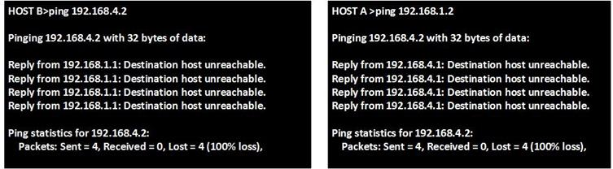

## **Directly connected networks**

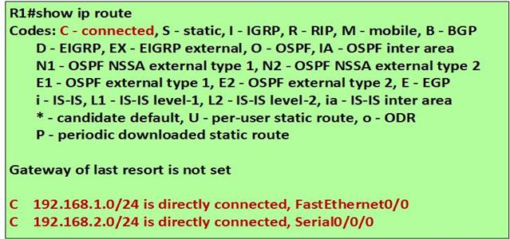

The routing table is the database that contains information about various networks, we have said that these remote networks may either be learnt through routing protocols or manually configured routes.

The output of the “show ip route” command on a router, shows the routes that a particular router can reach. By default, a router will only know of directly connected routes.

Directly connected routes in our scenario, from R1’s perspective are the network connected to HOST A and the network between R1 and R2.

Since no other configuration has been made on these routers, R2 and R3, should only have directly connected routes.

The directly connected networks are the only networks that can be reached by a particular router. In our scenario, this means that;

Host A can ping R1

R1 can ping R2’s s0/0/0 interface but not interface s0/0/1

R2 can ping R1’s s0/0/0 interface but not interface fa0/0 or HOST A

R2 can ping R3’s s0/0/0 interface but not interface fa0/0 or HOST B

R3 can ping R2’s s0/0/1 interface but not interface s0/0/0

HOST B can ping R3.

Neither hosts can ping each other

R1 and R3 cannot ping each other.

The figure shown below shows all the directly connected networks.

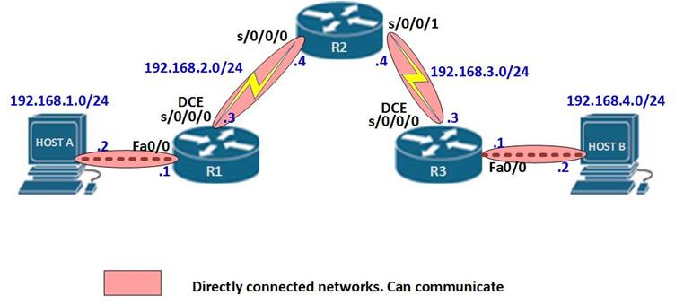

## Static routing

Static routes are one way we can communicate to remote networks. In production networks, static routes are mainly configured when routing from a particular network to a stub network.

**stub networks are** networks that can only be accessed through one point or one interface.

In the above scenario, the 192.168.1.0/24 and 192.168.4.0/24 networks are stub networks. This means that for hosts in these network segments only have one way to communicate with other hosts, which is R1 and R3 for the 192.168.1.0/24 and 192.168.4.0/24 networks respectively.

Understanding stub networks is crucial in understanding static routing.

The command needed to configure a static route is shown below.

**Router(config)# ip route (network-address) (subnet-mask) (next-hop ip address/ exit interface)**

The table below explains the meaning of each of the parameters in the ip route command as well as an example of the command which would be used on R1 to configure a static route to R3’s LAN network (192.168.4.0/24).

|  |  |  |
| --- | --- | --- |
| **Parameter** | **Meaning** | **example** |
| **Ip route** | State that the route being configured is a static route | Ip route |
| **Network-address** | The network address of the destination network. This is the network I am trying to reach. | 192.168.4.0 |
| **Subnet-mask** | The network address of the destination network that I am trying to reach | 255.255.255.0 |
| **Next hop ip address** | This is the ip address of the router that is connecting me to the desired network | 192.168.2.4 |
| **Exit interface** | This is the exit point interface on my router that connects to the router that will take me to the desired network | s0/0/0 |

 Therefore to configure a static route on R1 for network 192.168.4.0/24, the command to be issued on R1 is:

**R1(config)# ip route 192.168.3.0 255.255.255.0 192.168.2.4**

**R1(config)# ip route 192.168.4.0 255.255.255.0 192.168.2.4**

**OR**

**R1(config)# ip route 192.168.3.0 255.255.255.0 s0/0/0**

**R1(config)# ip route 192.168.4.0 255.255.255.0 s0/0/0**

**NOTE:** When configuring static routesyou should only use either the exit interface or the next hop ip address and not both. This will be explained later.

**ROUTING TABLE ON R1:**

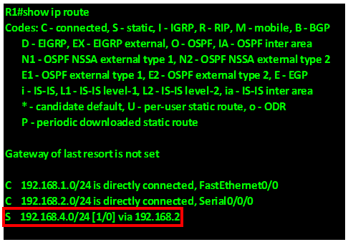

Highlighted in **red** at the bottom of the show ip route output on R1, is the static route that we just added. The “S” at the beginning means that the routing table got this route as a result of a static route configuration.

In the braces, **“1”**, is the administrative distance for static routes, and **“0”** is the metric.

From this we can assume that pings from **HOST A to HOST B** should work. Right?

Let’s try a ping from **HOST A TO HOST B** and see what happens.

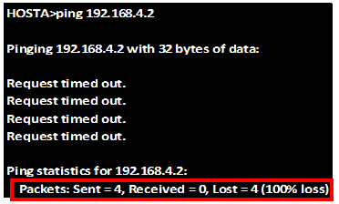

As you can see from the exhibit above, all four pings to **HOST B** are shown as **request timed out.** Further, highlighted in red.at the bottom, no packets were received by **HOST B.** this means that they could not communicate.

In the next section, we will explore why the two hosts could not communicate yet **R1** was correctly configured with a static route.

## Routing table principles

There are three routing table principles that dictate how routers communicate.

### Principle 1:

“**routers forward packets based on information contained in their routing tables ONLY.”**

R1 has 2 routes 192.168.3.0/24 which is the connection between R2 and R3, and 192.168.4.0/24, which is the network on which HOST B is located. Therefore, based on the first principle, R1 will make its forwarding decisions based on this information only. It will not consult R2 or R3.Nor does it know whether or not those routers have routes to other networks. As a network administrator, it is your responsibility to make sure that all the routers in a network know about remote networks.

### Principle 2:

**” Routing information on one router does not mean that other routers in the domain have the same information.”**

R1 doesn’t know about the information in R2’s routing table. The same can be said of R2 and R3. Therefore, the fact that R1 has a path to the networks connected to R2 and R3 does not mean that R2 and R3 have the same information.

For example, can reach the network 192.168.4.0/24 on R3 through R2. R1 does not know whether R2 can reach the network connected to R3. Therefore, we need to configure routes from R2 to the LAN connected to R3.

**Using Principle 2**, we still need to configure the proper routing on the other routers (R2 and R3) to make sure that they have routes to these three networks.

### Principle 3:

“Routes on a router to a remote network do not mean that the remote router has return paths.”

This principle means that when a route is configured on one router, the remote router must be configured with a return route. In our networks, most of the communication is bidirectional, this means that for every message we send, a reply is expected.

If we use the analogy of the post office, it would be like sending a letter without a return address. The recipient cannot reply to a letter without a return address, and the postman would not know where to send the letter.

In our scenario, this means that, when we configure a route to network 192.168.4.0/24 on R1, we need to configure a route on the remote routers that leads to the LANs connected to R1.

Using **Principle 3** as guidance, we will configure proper static routes on the other routers to make sure they have routes back to the 192.16.1.0/24 network.

### Applying the principles:

In this scenario, we need to apply all the three principles on all the routers so that the static routes can work.

**Principle 1**

R1 knows how to get to network 192.168.3.0/24, and network 192.168.4.0/24, however, R2 and R3 do not know how to get there. Therefore, we need to configure a static route on R2 so that it can know how to get to 192.168.4.0/24.

**Principle 2**

We configured a static route on R1, however, this does not mean that R2 knows a path to 192.168.4.0/24 network. Therefore this router needs to know about that network.

**Principle 3**

Even though R1 and R2 have a route to network 192.168.4.0, a ping would still fail because both R2 and R3 would not know how to get to R1. Therefore, we need to configure a route that gets back to network 192.168.1.0/24 on R1.in this case we are using the next-hop ip address on both R2 and R3.

From this. We can now make the necessary configurations on all the routers to make communication between HOST A and HOST B possible.

On router R2:

**R2(config)# ip route 192.168.1.0 255.255.255.0 192.168.2.3**

**R2(config)# ip route 192.168.4.0 255.255.255.0 192.168.3.3**

On router R3:

**R3(config)# ip route 192.168.1.0 255.255.255.0 192.168.3.4**

**R3(config)# ip route 192.168.4.0 255.255.255.0 192.168.3.4**

When all the configurations have been made on all the three routers, communication between HOST A and HOST B should be possible. The figure below shows the routing tables of all the three routers, the static routes have been highlighted in red.

**R1:**

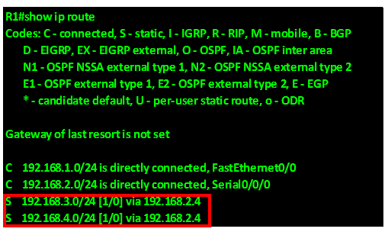

**R2:**

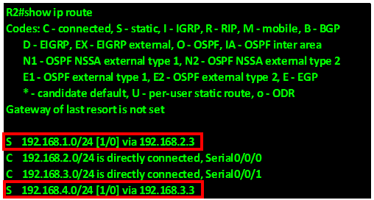

**R3:**

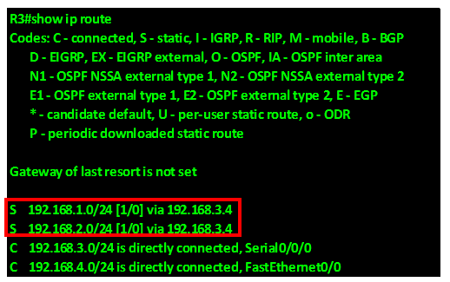

As a result of this output. We should be able to ping from HOST A to HOST B. the output below shows the results of the ping from HOST A to HOST B.

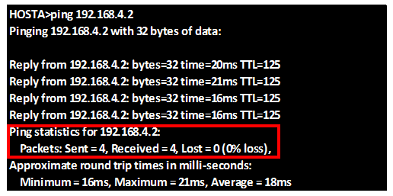

The output shows that there are replies coming from HOST B which has the ip address 192.168.4.2, the highlighted section in red shows that 4 packets were sent and all 4 were received by HOST B, with 0% loss.

Therefore, we have successfully configured static routing on the routers.

## Resolving the next- hop ip address

Suppose we configured R2 with the next-hop ip address not an exit interface, how would the router know which interface to send the packets through?

Refer to the output of the show ip route command on R2, below.

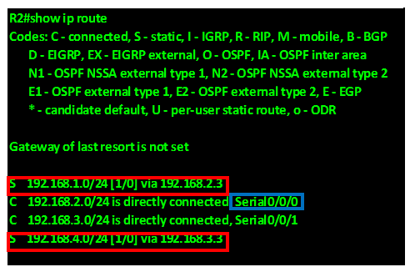

When the router wants to send a packet to the 192.168.1.0 network, it will look at the routing table.

There is a route to that network via 192.168.2.3. Then the router checks to see whether it has an interface that to the 192.168.2.3 network. In this scenario, that would be the network highlighted in blue. The exit interface is serial 0/0/0.

Routes that only have the next-hop ip address and no exit interfaces, must have resolve the next hop ip address using a route on their routing table that connects to the remote network.

In most cases, the route that the next hop is resolved to is usually a directly connected network.

As such, this is usually an issue, since the router has to process a packet twice before it can determine where to forward it. This is known as a recursive lookup.

It is recommended that static routes have an exit interface as opposed to the next hop ip address.

## Summary and default routes

Suppose a router has more than 1 LAN connected to it. It would be more practical to use an address that covers all the LANS, and configure 1 static route. Take this scenario, R1 has 5 LANs connected to it;

Summarizing these routes is shown in the table below.

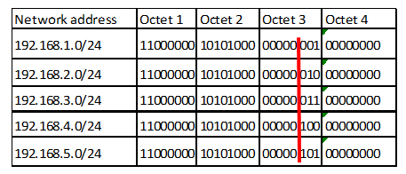

The first 2 octets and the first 5 bits from the left, in the third octet.

Therefore the new summary network address and subnet mask for the 5 networks will be: **192.168.0.0/21** with the subnet mask as **255.255.248.0.**

When configuring a static route to the summary network out serial0/0/0 on R2, the command would be;

**R2(config)# ip route 192.168.0.0 255.255.248.0 s0/0/0**

Refer to the exhibit shown below. Suppose HOST A wants to send an email to a friend or wants to view a website on the internet, how would the router know where to send the packets?

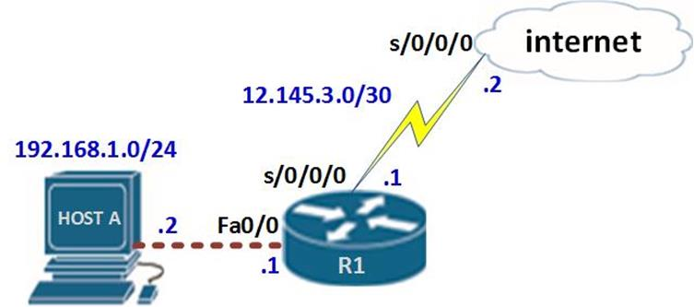

The internet has many ip addresses, and configuring one static route to a specific network would not work. Therefore, a default route is needed.

A default static route is a route that will match all packets. Default static routes are used:

When no other routes in the routing table match the packet’s destination IP address. In other words, when a more specific match does not exist. A common use is when connecting a company’s edge router to the ISP network.

When a router has only one other router to which it is connected. This condition is known as a stub router.

The syntax for configuring a static default route is:

**Router(config)# ip route 0.0.0.0 0.0.0.0 [next-hop ip address/ exit interface]**

A route to this network would tell the router to forward any packet for which it does not have a route to the indicated next-hop ip address or exit interface.

In this scenario, to configure a default static route, the command sequence on R1 would be.

**R1(config)# ip route 0.0.0.0 0.0.0.0 12.145.3.2**

**Or**

**R1(config)# ip route 0.0.0.0 0.0.0.0 s0/0/0.**