ADVANCED PUBLIC DISTRIBUTION SYSTEM

Capstone-I project report submitted
by the student of

Hybrid UG program in Computer Science & Data Analytics

STUDENT NAME: ADITYA KUMAR
ROLL NO. : ua2503cdh368
GROUP NO: 54

INDIAN INSTITUTE OF TECHNOLOGY
PATNA BIHTA - 801106, INDIA

Date: 28/03/2026
DECLARATION

I hereby declare that this submission is my own work and that, to the best of our knowledge and belief, it contains no material previously published or written by another person nor material which to a substantial extent has been accepted for the award of any other degree or diploma of the university or other institute of higher learning, except where due acknowledgment has been made in the text.

Date :- 28/03/2026 Student Name:- ADITYA KUMAR
Roll No. :- ua2503cdh368
Group No. :- 54
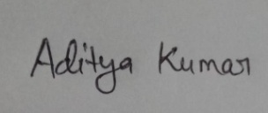
Signature:-

SUMMARY OF THE PROJECT

The Advance Public Distribution System (APDS) is a web-based digital platform designed to improve transparency, efficiency, and accountability in the ration distribution process. The project aims to digitize traditional Public Distribution Systems by providing a structured dashboard for dealers, administrators and beneficiary . It includes key functionalities such as ration distribution management, real-time stock tracking, and monthly analytics.
The project is developed using HTML, CSS, and JavaScript, following a modular and scalable design approach. It emphasizes a clean UI, consistent layout, and ease of navigation. Overall, Advanced PDS serves as digital solution that can reduce manual errors, prevent misuse of resources, and enhance the overall efficiency of government ration distribution systems.

Work Done by Each Member :-
- Adarsh Kumar (ua2504aih12) – Responsible for designing the project home page, including the About Us and Contact sections, as well as implementing the login and registration pages.
- Aditya Kumar (ua2503cdh22) –Worked on the admin portal, the kisan sahyogi portal, the statistics, graphs and data for the complete website.
- Aditya Kumar (ua2503cdh367) –Handled the Beneficiary Module of the project. Developed features such as profile management, ration status tracking, and the complaint registration system.
- Work done by me – Designed the dealer module of the website. Worked on different features like dealer dashboard, start distribution page, view stock page and monthly status page to insure transparency and updated data systems.
CONTENT

- INTRODUCTION

- MY WORK

- PROGRESS OF DEALER MODULE OF APDS WEBSITE

- CONCLUSION

- FUTURE WORK

- REFERNCES
INTRODUCTION
The Advance Public Distribution System (APDS) is a web-based project aimed at modernizing and improving the traditional Public Distribution System used for ration distribution in India. The existing system often suffers from issues such as lack of transparency, inefficient record-keeping, manual errors, and mismanagement of stock. These challenges can lead to improper distribution of essential commodities and reduced trust in the system.
The primary objective of this project is to design a digital platform that ensures efficient, transparent, and accountable delivery of ration to beneficiaries. By leveraging web technologies, the system provides an organized interface for dealers and administrators to manage distribution activities, track stock levels, and monitor monthly performance.
The project is developed as a team effort, where different modules such as Dealer, Beneficiary, and Admin are designed to handle specific functionalities. The Dealer Module, in particular, focuses on day-to-day operations like initiating distribution, checking stock status, and analyzing monthly summaries. The system also incorporates basic data visualization techniques, such as charts and tables, to present information in a more understandable and meaningful way.
Overall, the Advance PDS project aims to simulate a real-world government dashboard system that can reduce manual dependency, minimize errors, and improve the efficiency of the ration distribution process. It also serves as a practical application of concepts from web development and data analytics, making it both technically relevant and socially impactful.
.

WHY (Need for the Project)
The traditional Public Distribution System (PDS) is primarily manual and paper-based, which makes it inefficient and difficult to manage. Due to the lack of proper digital tracking, there is limited transparency in the system, often leading to corruption, resource misuse, and unfair distribution of essential commodities. Stock management is not handled in real-time, resulting in frequent mismatches, shortages, or leakage of goods.
In addition, manual record-keeping increases the chances of human error and data inconsistency. Authorities also face challenges in monitoring dealer activities effectively, as there is no centralized or structured system to track operations. The absence of proper analytics and reporting tools further limits decision-making capabilities. Overall, the current system suffers from inefficiency, lack of accountability, and poor data management.

WHAT (Proposed Solution – Smart PDS)m
To address these issues, the Advanced Public Distribution System (APDS) is proposed as a web-based digital platform designed to modernize and streamline the ration distribution process. The system introduces a centralized interface where dealers and administrators can manage distribution activities, track stock levels in real time, and maintain accurate digital records.
The platform uses a dashboard-based design with structured sections, tables, and visualizations such as graphs to present data in a clear and understandable manner. By reducing manual dependency and automating key processes, the system improves efficiency, transparency, and reliability. The project is developed using a modular approach, including Dealer, Beneficiary, and Admin modules, making it scalable and easy to extend. Overall, Smart PDS aims to create a user-friendly, efficient, and transparent solution for modern ration distribution systems.

MY WORK
As part of the APDS project, I have primarily worked on developing the Dealer Module frontend, focusing on designing a clean and functional user interface using HTML and CSS. I created the Dealer Home Page, which serves as the main dashboard and includes sections such as dealer identity, action buttons, and analytics with graphical representation.
I further developed multiple interconnected pages, including the Start Distribution Page, View Stock Status Page, and Monthly Summary Page, ensuring consistent design and smooth navigation between them. The Start Distribution page includes form-based input fields for beneficiary and ration details, while the Stock Status and Monthly Summary pages display data using structured tables and organized layouts.
I also implemented a card-based design system, used CSS variables for consistent theming, and ensured proper alignment and layout using flexbox. Additionally, I integrated graph visuals (bar and pie charts) to represent data in a more understandable way. Overall, my work contributes to building a structured, scalable, and user-friendly frontend for the dealer-side operations of the Advanced PDS system.

Check Out our Project at:-
HyperLink:- APDS.project
- Progress of Dealer Module of APDS website:-

1. Dealer Home Page
This page serves as the main dashboard for the dealer, displaying profile details, key action buttons, and graphical insights such as distribution trends and stock composition.
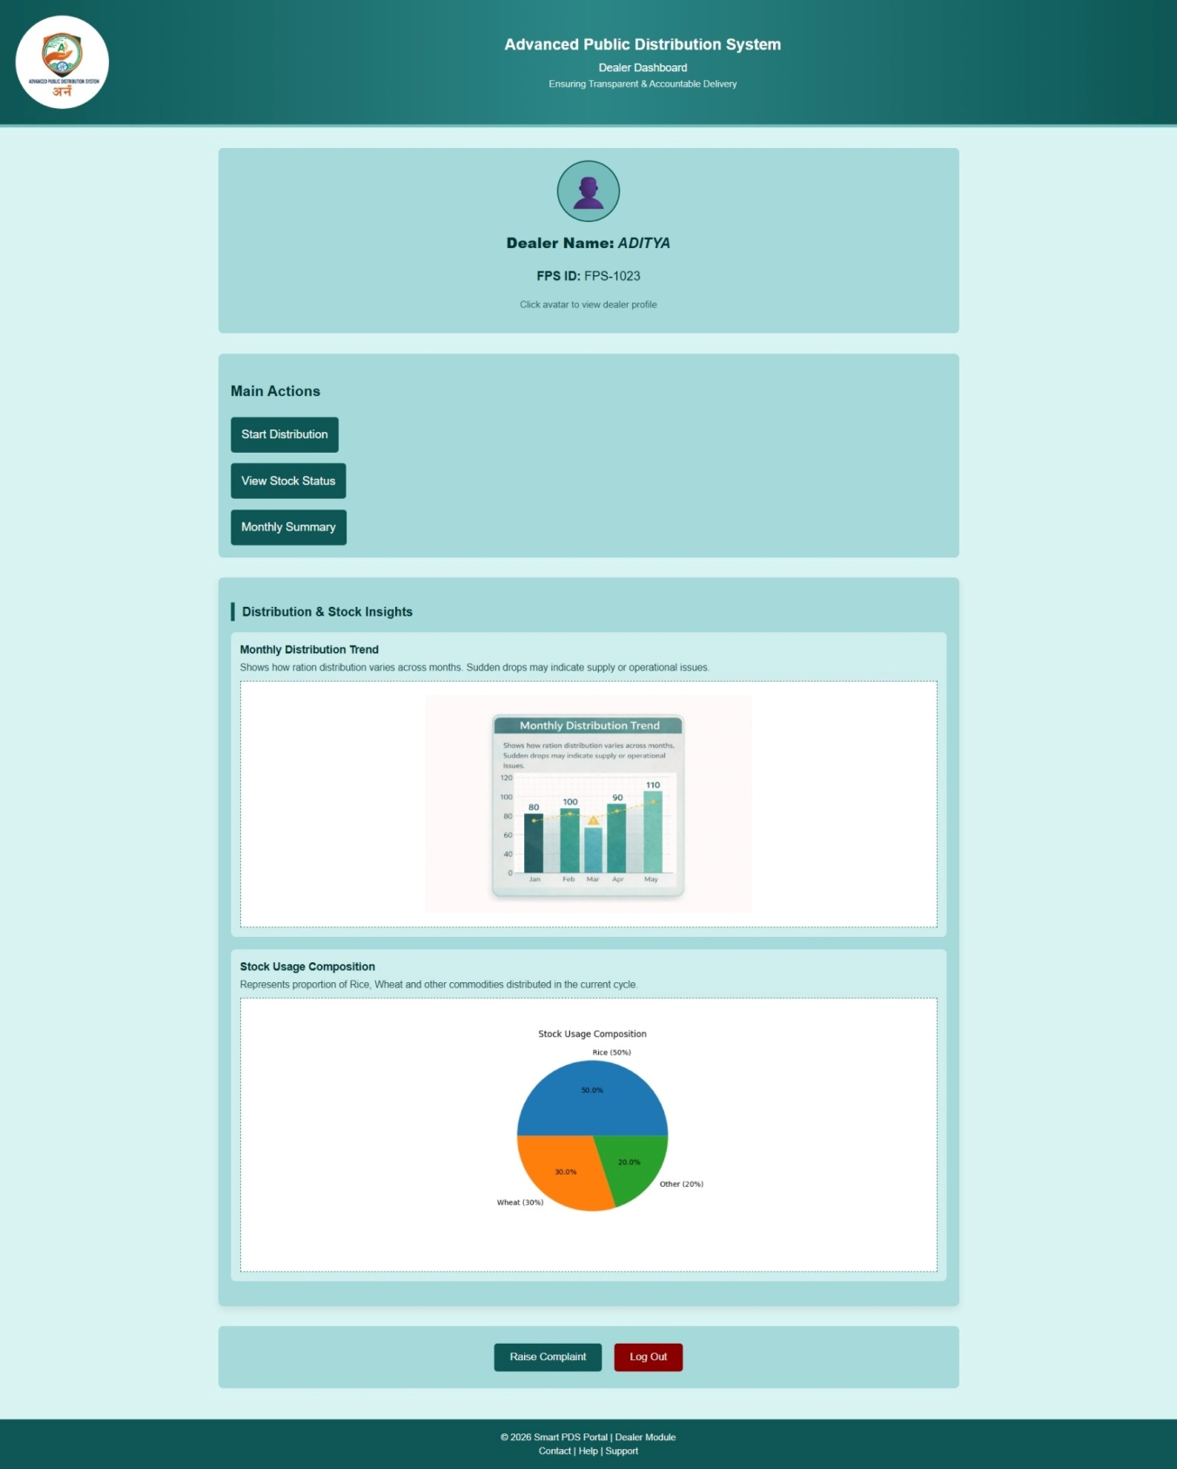

2. Start Distribution Page
This page allows the dealer to initiate ration distribution by entering beneficiary details and specifying the quantity of items to be distributed.
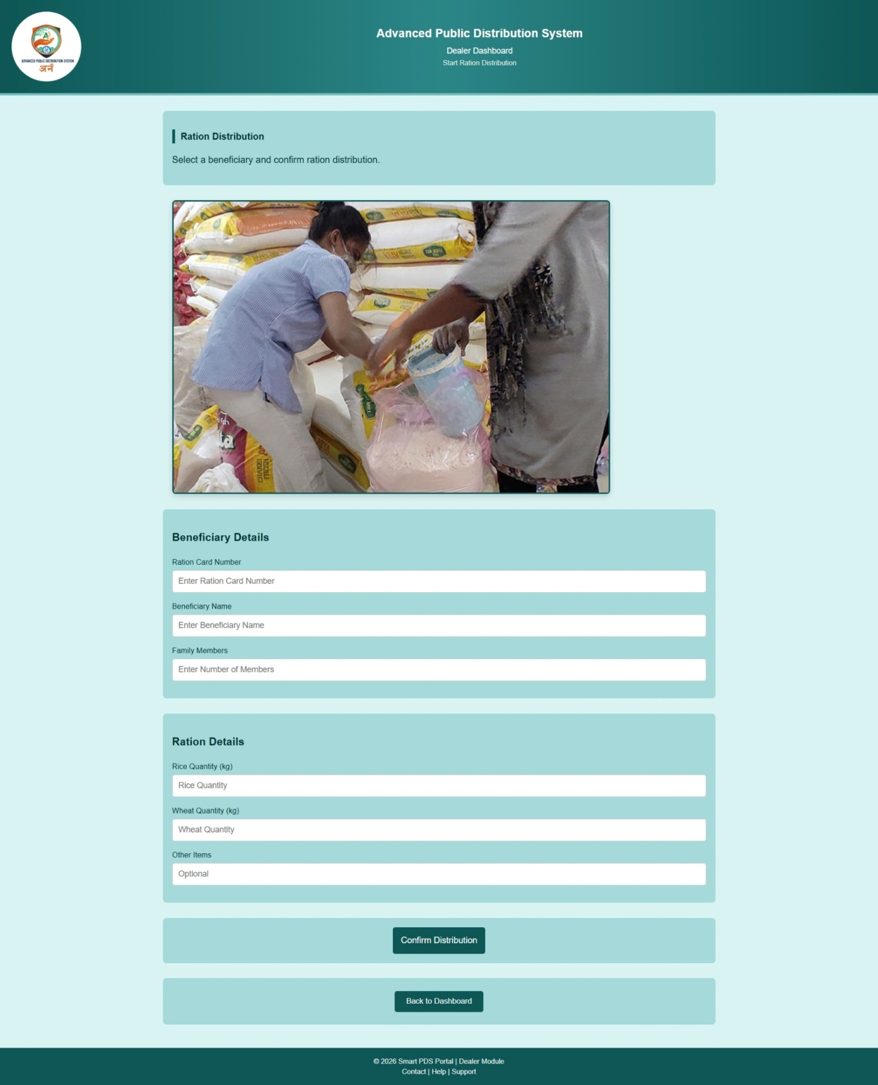

3. View Stock Status Page
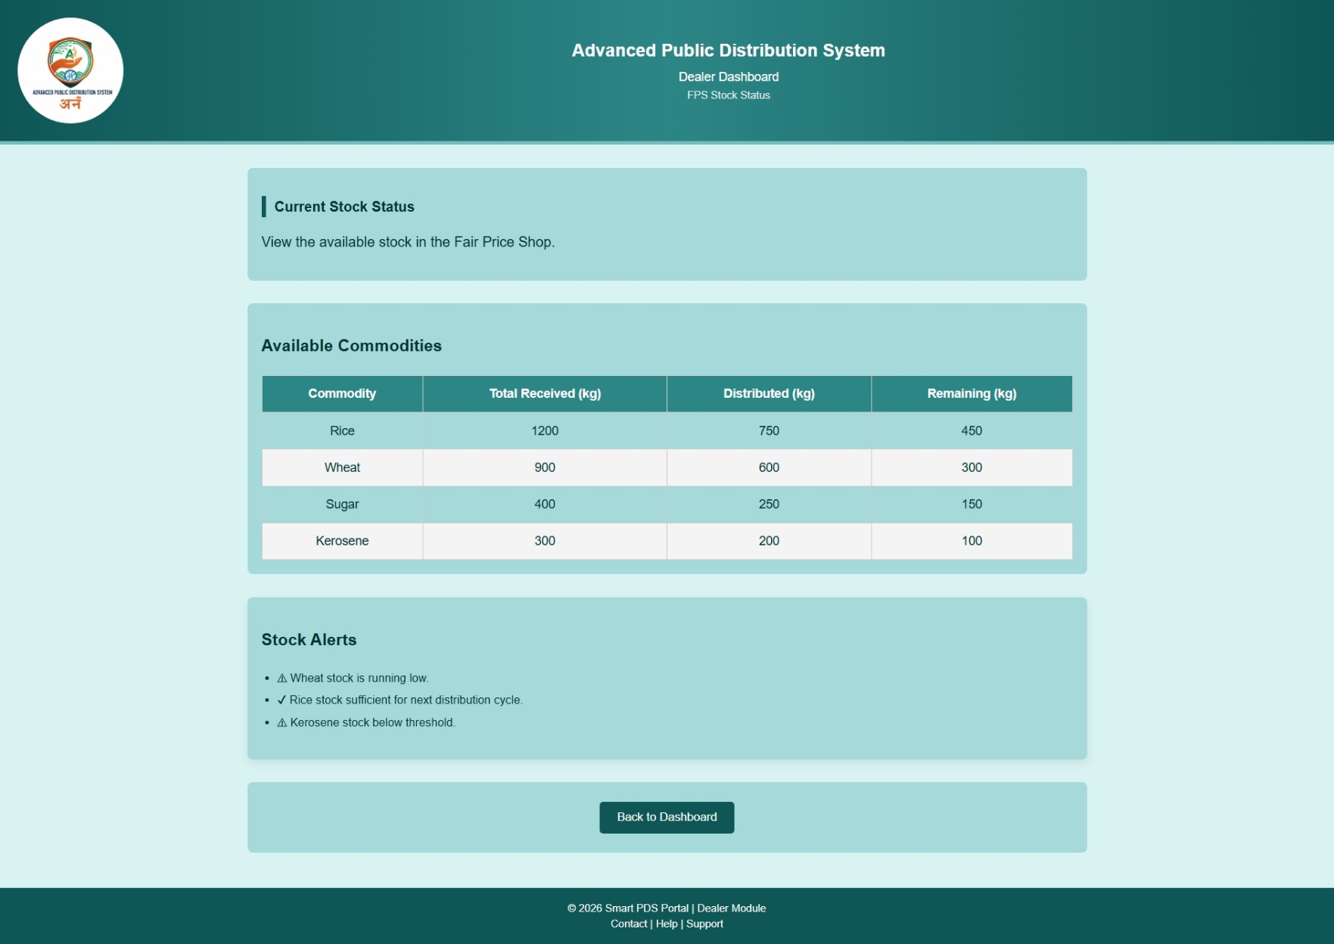
This page displays the current stock details of various commodities in a structured table format, along with alerts for low stock levels.

4. Monthly Summary Page
This page provides a summary of monthly distribution data, including total stock received, distributed, and remaining, along with overall statistics, still some work is unfinished of this page.

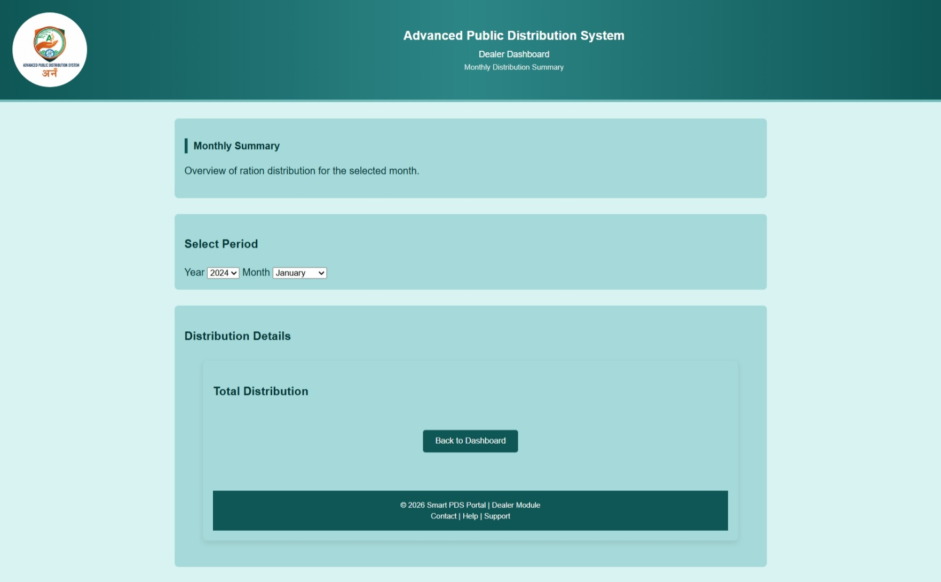

Conclusion

The Advanced Public Distribution System (APDS) project successfully demonstrates a structured and user-friendly approach to digitizing the traditional ration distribution system. Through the development of the Dealer Module, key functionalities such as ration distribution, stock monitoring, and monthly summary analysis have been effectively implemented in the form of a web-based dashboard. The project highlights how digital solutions can improve transparency, reduce manual errors, and enhance overall system efficiency.
By using modern web technologies and a modular design approach, the system provides a strong foundation for building a scalable and practical solution. The current implementation serves as a functional prototype that reflects real-world operations and showcases the potential of integrating technology into public service systems.

Future Work

In future, the project can be enhanced by introducing dynamic data handling using JavaScript and integrating it with a backend database for real-time data storage and retrieval.
Advanced data visualization using libraries like Chart.js can be implemented for better analytics.
Further improvements may include responsive design for mobile compatibility, complaint tracking systems, and notification features. Overall, these enhancements will help transform the project from a prototype into a fully functional, real-world deployable solution.

References

- https://youtu.be/ESnrn1kAD4E?si=UM6BdCRCTtaQFM0Y

- https://youtu.be/HcOc7P5BMi4?si=eCQiQDZelzUHAwUH

- https://epos.bihar.gov.in

- ChatGPT for image generation.

