**Migrate both structure and data** from your **Ascend** database in (localdb)\MSSQLLocalDB to KIRAN\SQLEXPRESS, the best fit is the **Generate Scripts** method with **Structure + Data**. Here's a complete walkthrough tailored to your setup:

**🧩 Method: Migrate_StructureAndData_GenerateScripts**

**🎯 Goal: Transfer full database (Structure + data) from LocalDB to SQL Server Express**

**🧱 Step-by-Step Guide**

**🔹 1. Open SSMS and Connect to (localdb)\MSSQLLocalDB**

* Expand **Databases** → Right-click **Ascend** → Tasks → **Generate Scripts**

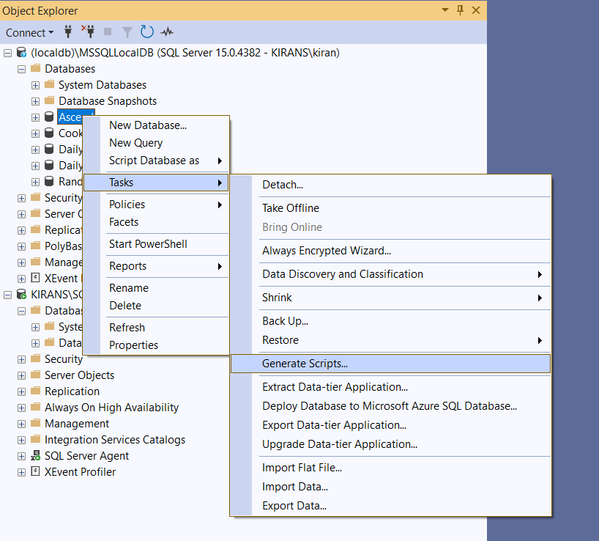

**🔹 2. Launch the Script Wizard**

* Click **Next** on the welcome screen.

**🔹 3. Choose Objects to Script**

* Select **"Script entire database and all database objects"**
* Click **Next**

**🔹 4. Set Scripting Options**

* Choose **Save to file** or **Open in new query window**
* Click **Advanced**
  + Set **Types of data to script** → Structureand Data / Data only / Structure only

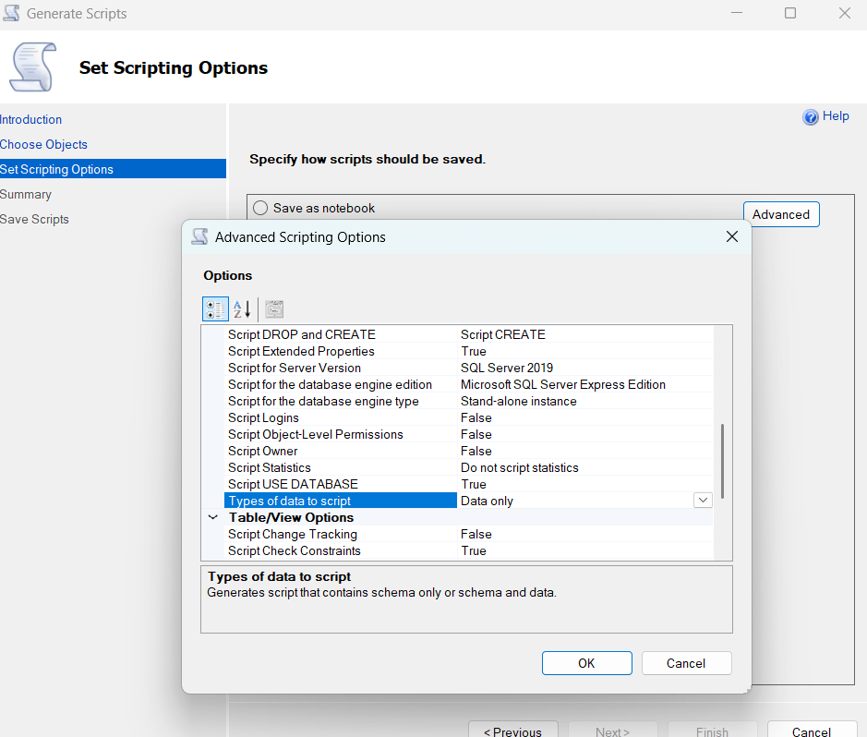

* + Set **Script for Server Version** → SQL Server 2022 (or match your SQLEXPRESS version)
  + Optional: Set **Script DROP and CREATE** → Script DROP and CREATE

**🔹 5. Generate the Script**

* Click **Next** → Review summary → Click **Finish**
* SSMS will generate a full .sql script with:
  + Table definitions
  + Indexes, constraints
  + Insert statements for all data

**🧪 Step 6: Execute Script on KIRAN\SQLEXPRESS**

* Connect to KIRAN\SQLEXPRESS in SSMS
* Open the generated script
* Execute it in a new query window

💡 If the script is large, consider running it in batches or disabling SET XACT_ABORT ON temporarily.

**✅ Result**

Your **Ascend** database will be recreated on KIRAN\SQLEXPRESS with:

* All tables, views, stored procedures
* All data rows
* Same Structure

**🛠️ Optional Enhancements**

* **Verify row counts** between source and destination
* **Script indexes and constraints separately** if needed
* **Use SQL Server Data Tools (SSDT)** for version control