🪟 **SSMS GUI-Based Backup and Restore – User Inter face Procedure**

Use When: You prefer a visual interface or are guiding someone less familiar with T-SQL.

**🔧 Procedure:**

**1.On Source Server**:

- Open SSMS → Right-click database → Tasks → Back Up…

- Choose Full , set destination path, and click OK.

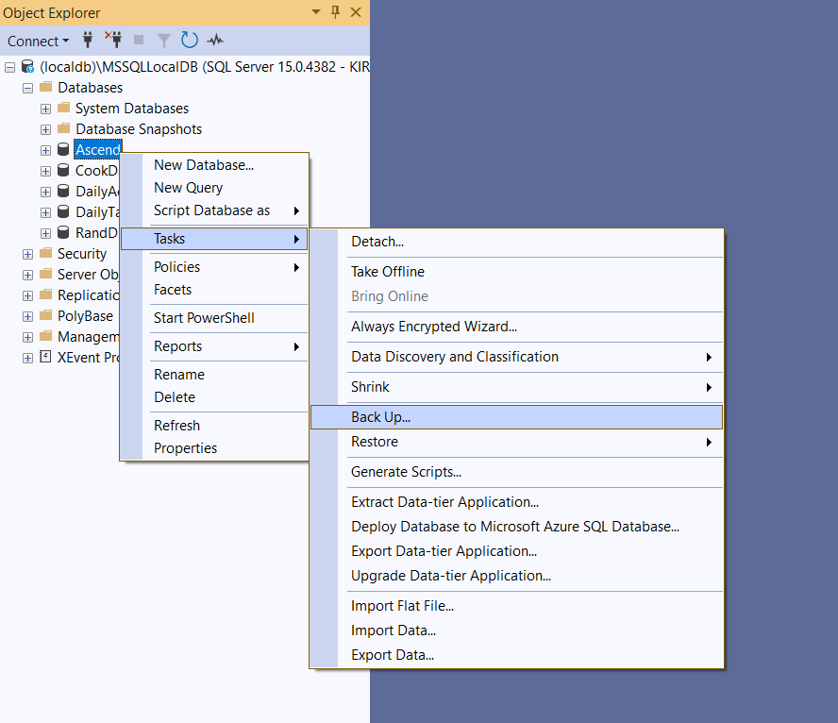

**2. Copy the `.bak` file to the destination server.**

**3. On Destination Server:**

- Right-click Databases → Restore Database…

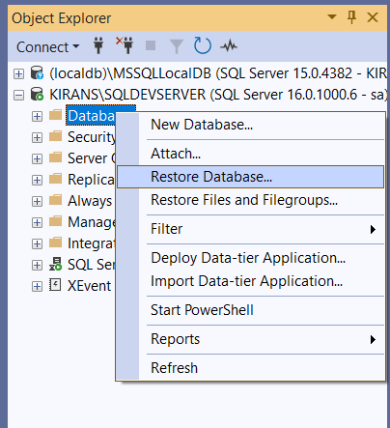

- Choose Device, select the `.bak` file.

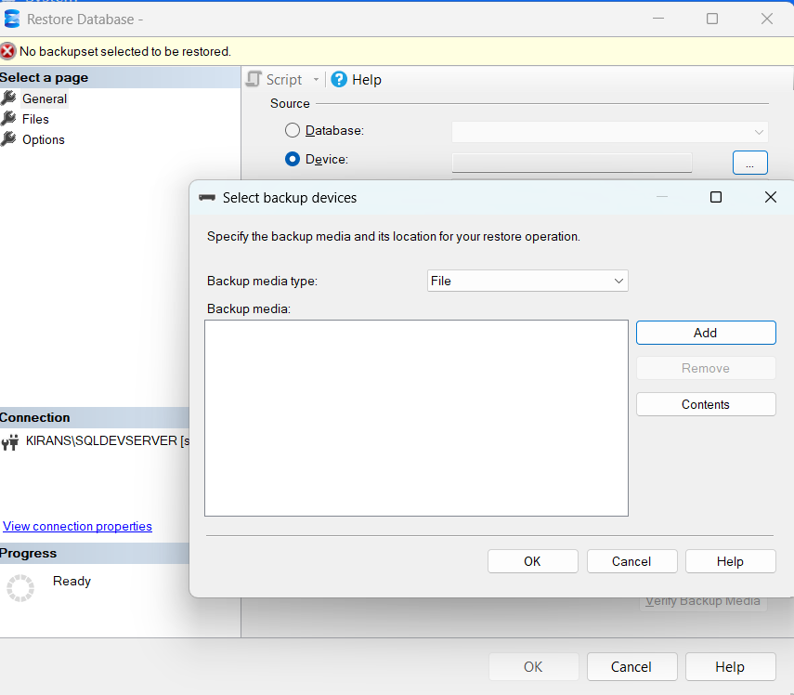

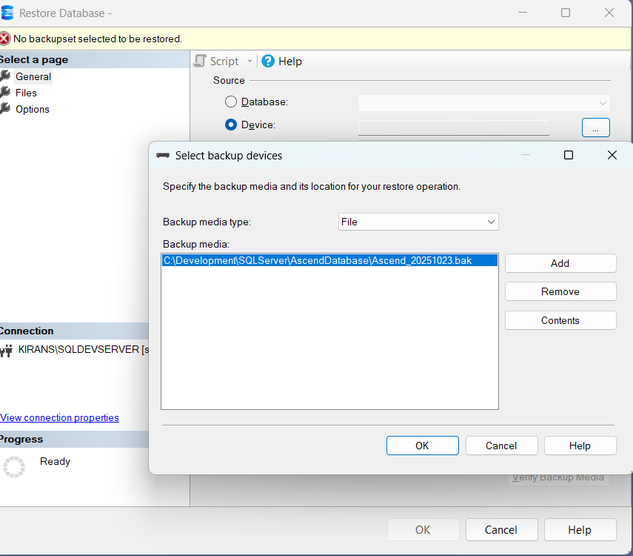

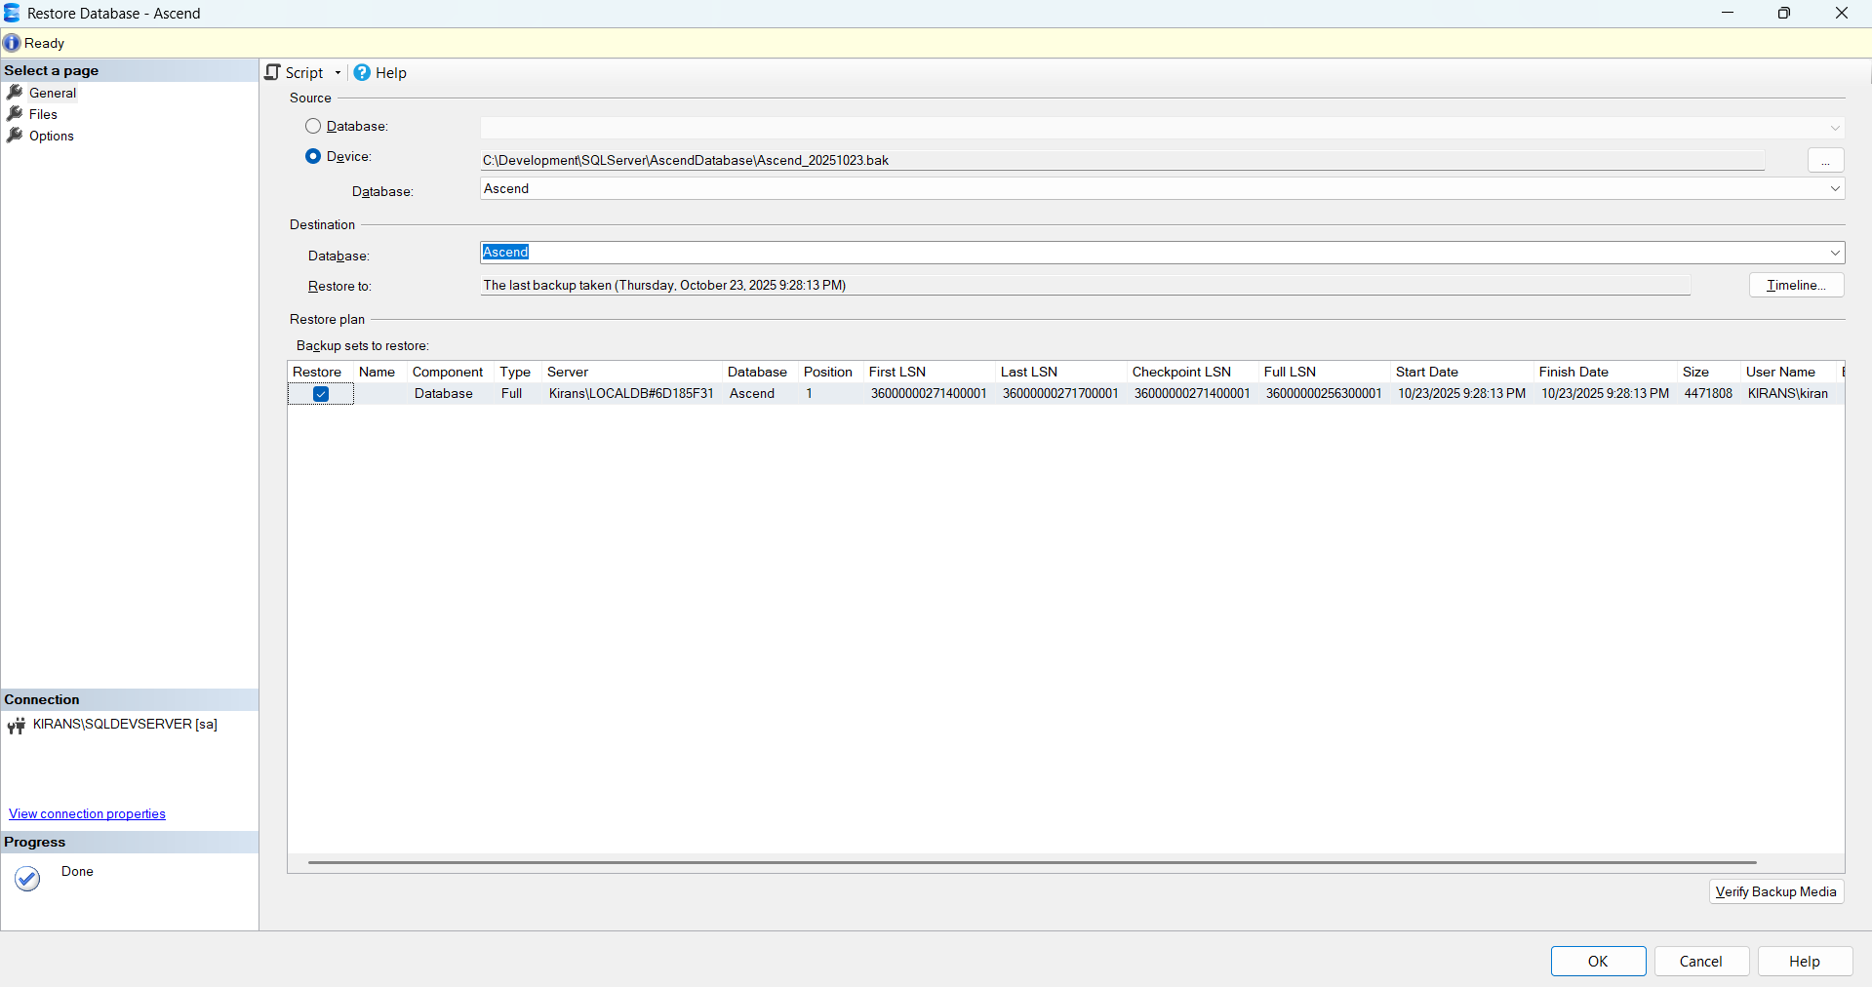

- Under Files, adjust paths for `.mdf` and `.ldf`.

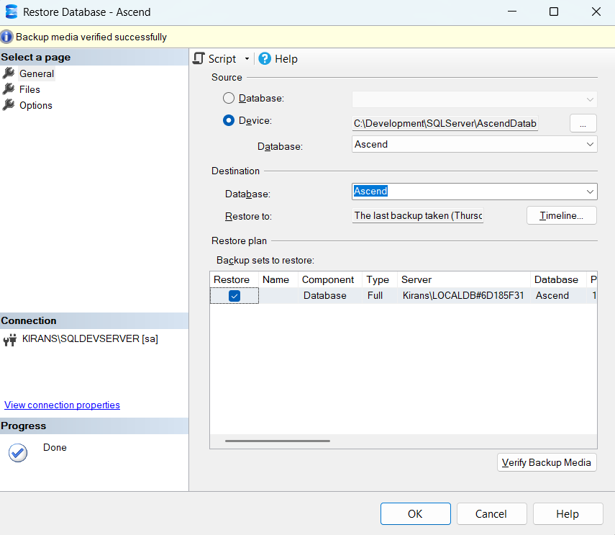

- Click OK to restore.

