**🕒 Procedure: `Schedule_BackupRestore_AgentJob`**

**⏰ SQL Server Agent Job Automation**

Use When: You need scheduled or recurring backups/restores.

**🔧 Procedure:**

1. Create a SQL Server Agent Job:

- Step 1: Backup using T-SQL (same as Method 1).

- Step 2: Use PowerShell or `xp_cmdshell` to copy the file to the destination.

- Step 3: Restore using T-SQL on the destination server.

2. Schedule the job to run daily, weekly, or on-demand.

3. Monitor job history for success/failure logs.

Here's a **step-by-step breakdown** of **Schedule_BackupRestore_AgentJob**, the SQL Server Agent Job method for automating backup and restore across servers. This method is ideal for recurring tasks and production-grade setups.

**🕒 Procedure: Schedule_BackupRestore_AgentJob**

**⏰ SQL Server Agent Job Automation**

**🧱 Step 1: Create the SQL Server Agent Job**

**🔹 1.1 Open SQL Server Management Studio (SSMS)**

* Connect to the **source server**.
* Expand **SQL Server Agent** → Right-click **Jobs** → **New Job…**

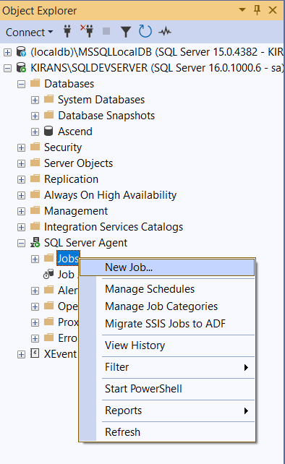

**🔹 1.2 Define Job Properties**

* **Name**: Schedule_BackupRestore_AgentJob_Ascend
* **Owner**: Choose a valid SQL login (e.g., sa)
* **Category**: Leave as [Uncategorized (Local)]
* **Description**: "Automated job to backup and restore Ascend database across servers"

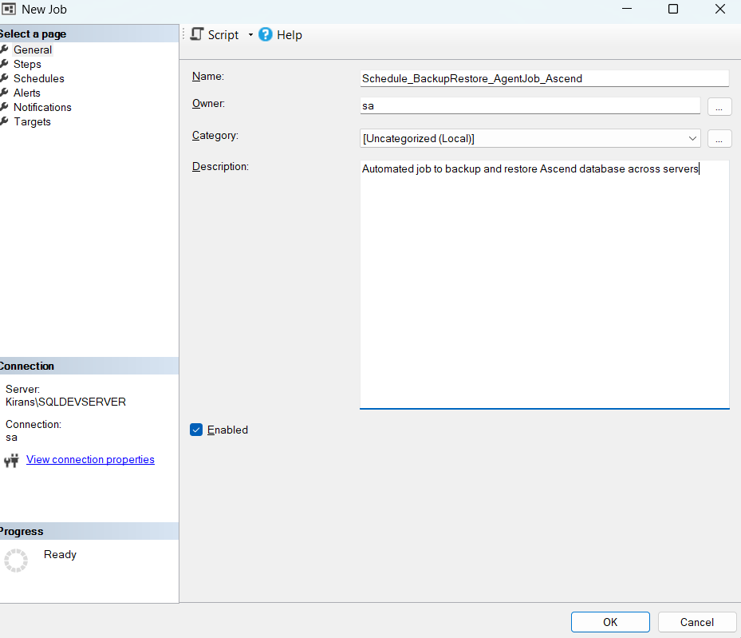

**🧩 Step 2: Add Job Steps**

**🔸 Step 2.1: Backup the Database (T-SQL)**

* **Step Name**: Backup_Ascend
* **Type**: Transact-SQL script (T-SQL)
* **Database**: Ascend
* **Command**:
* DECLARE @BackupPath NVARCHAR(255) = 'C:\Backups\Ascend_20251024.bak';
* BACKUP DATABASE [Ascend]
* TO DISK = @BackupPath
* WITH FORMAT, STATS = 10;

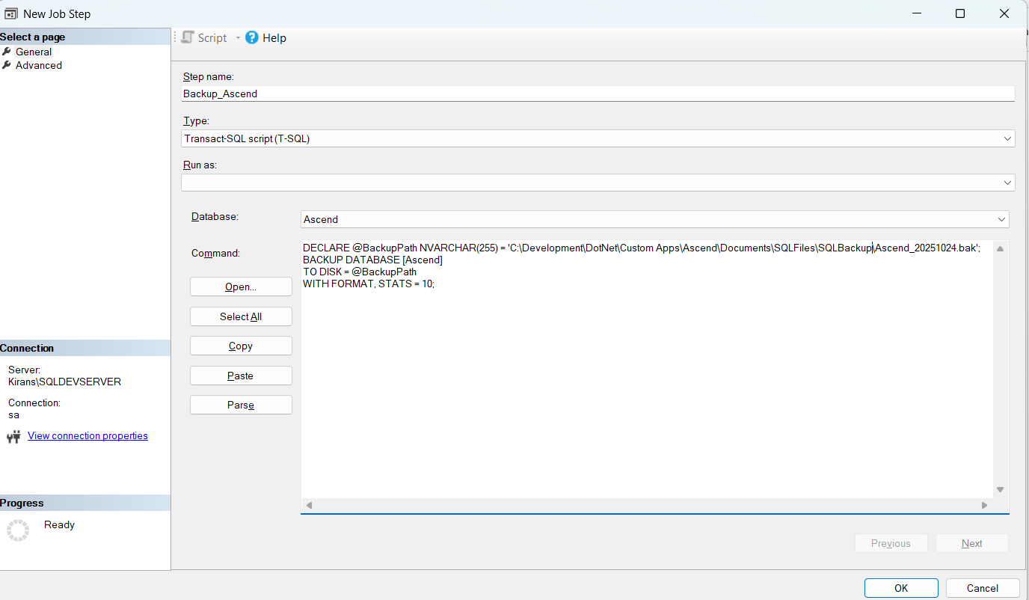

**🔸 Step 2.2: Copy Backup File to Destination Server**

You can use either of the following:

**Option A: PowerShell (Recommended)**

* **Step Name**: Copy_BackupFile
* **Type**: PowerShell
* **Command**:
* Copy-Item -Path "C:\Backups\Ascend_20251024.bak" -Destination "\\DestinationServer\SharedFolder\Ascend_20251024.bak"

**Option B: xp_cmdshell (if enabled)**

* **Step Name**: Copy_BackupFile
* **Type**: T-SQL
* **Command**:
* EXEC xp_cmdshell 'copy "C:\Backups\Ascend_20251024.bak" "\\DestinationServer\SharedFolder\Ascend_20251024.bak"';

⚠️ Ensure xp_cmdshell is enabled and the SQL Server Agent account has file system access.

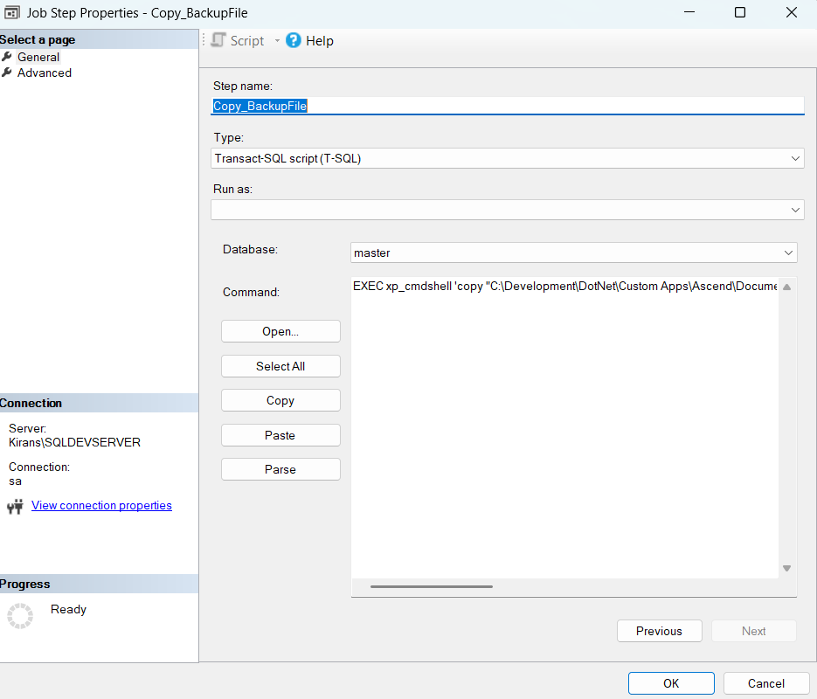

**🔸 Step 2.3: Restore on Destination Server**

* **Step Name**: Restore_Ascend
* **Type**: Transact-SQL script (T-SQL)
* **Database**: master
* **Command**:
* RESTORE DATABASE [Ascend]
* FROM DISK = '\\DestinationServer\SharedFolder\Ascend_20251024.bak'
* WITH
* MOVE 'Ascend' TO 'C:\Data\Ascend_Data.mdf',
* MOVE 'Ascend_Log' TO 'C:\Data\Ascend_Log.ldf',
* RECOVERY, STATS = 5;

💡 This step must be executed on the **destination server**, so you may need to create a **linked server** or a separate job on the destination.

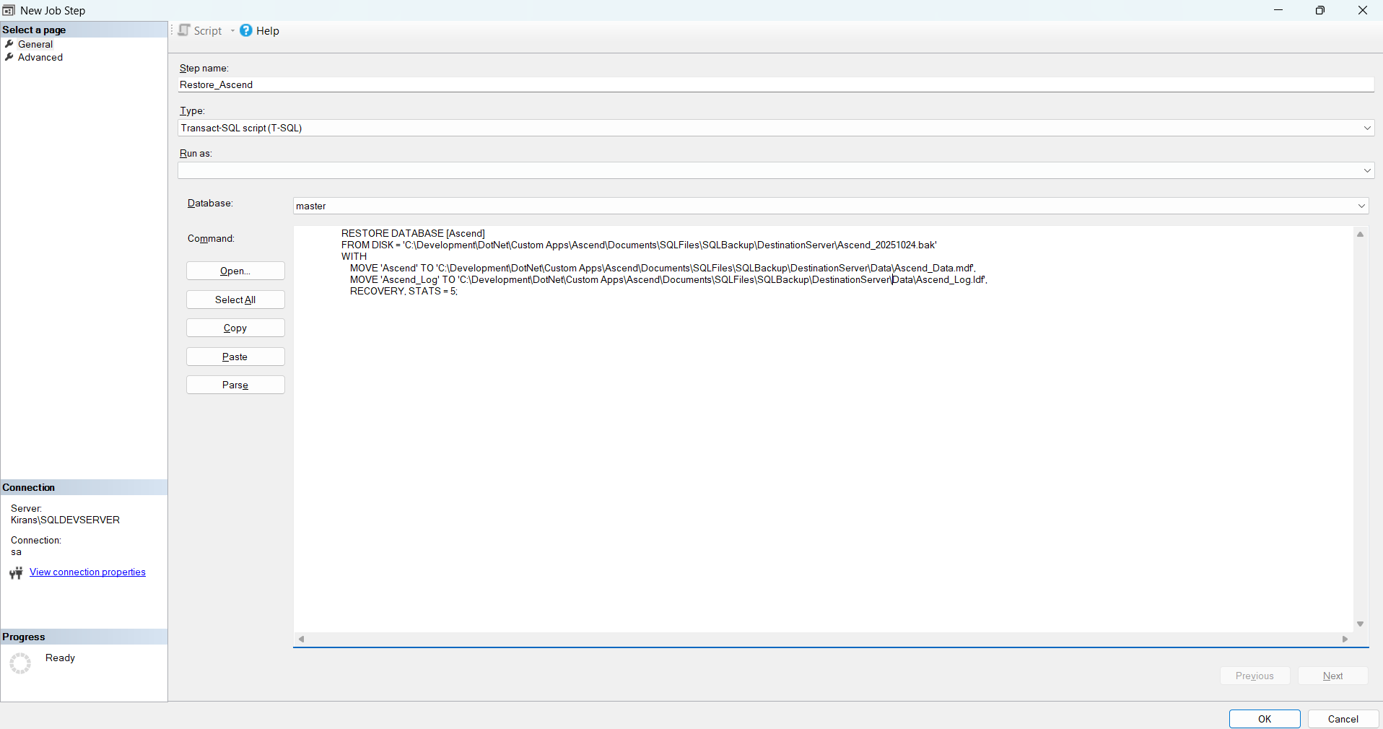

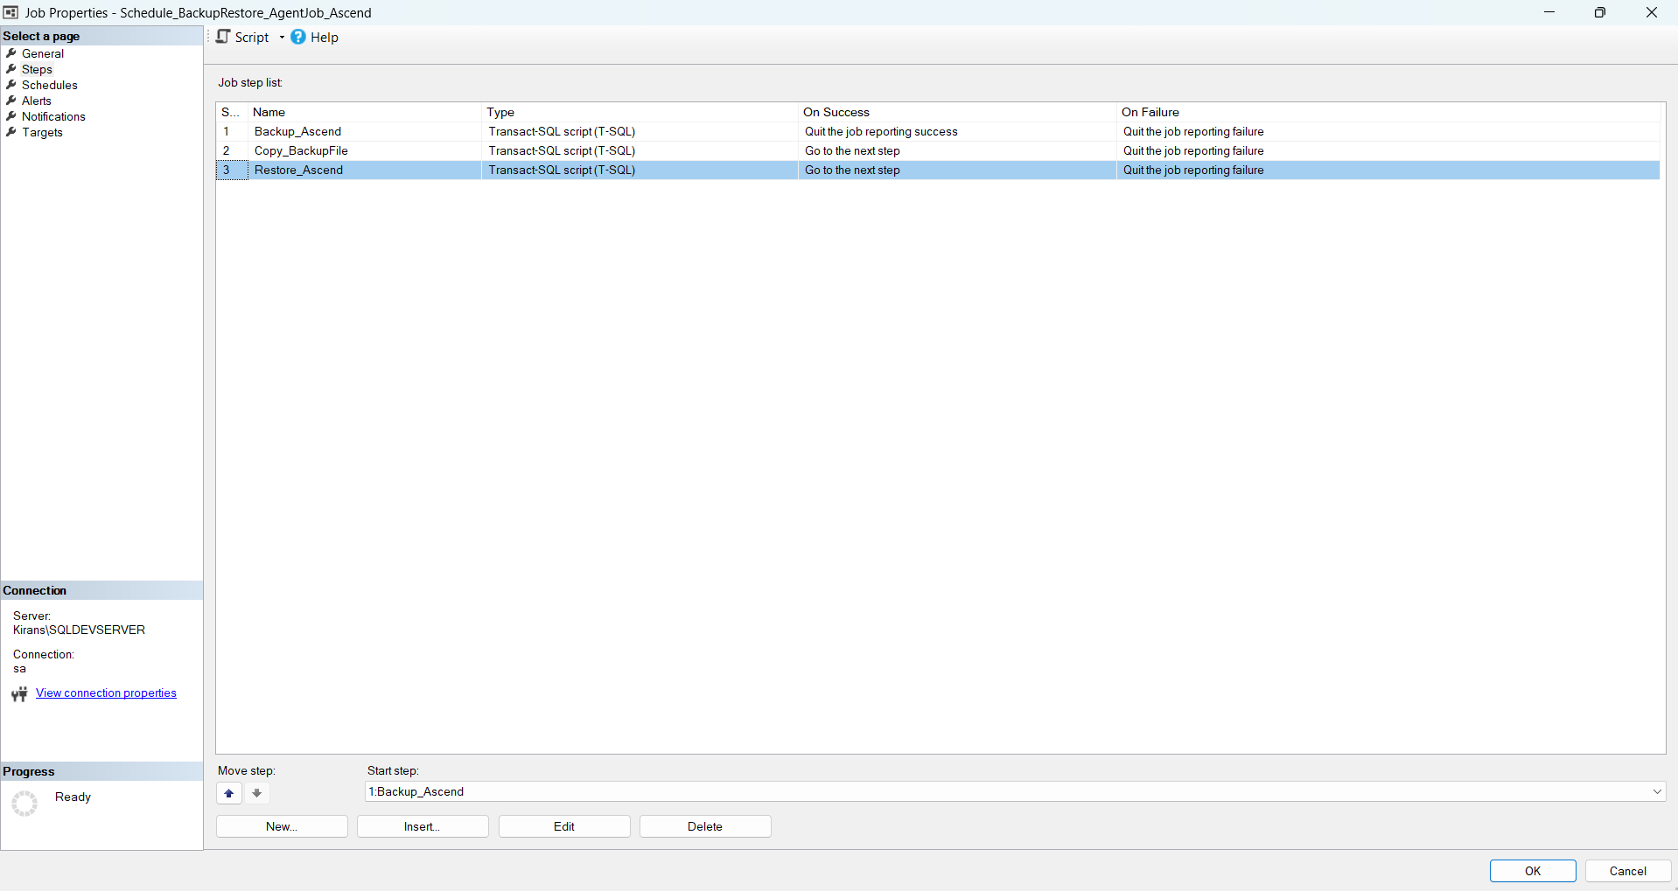

**🕓 Step 3: Schedule the Job**

**🔹 3.1 Go to Schedules tab**

* Click **New…**
* **Name**: DailyBackupRestore
* **Frequency**: Daily / Weekly / Custom
* **Time**: Choose a non-peak hour (e.g., 2:00 AM)

Note : Before executing this job schedule check that any database already exists and should not effect any databases and data

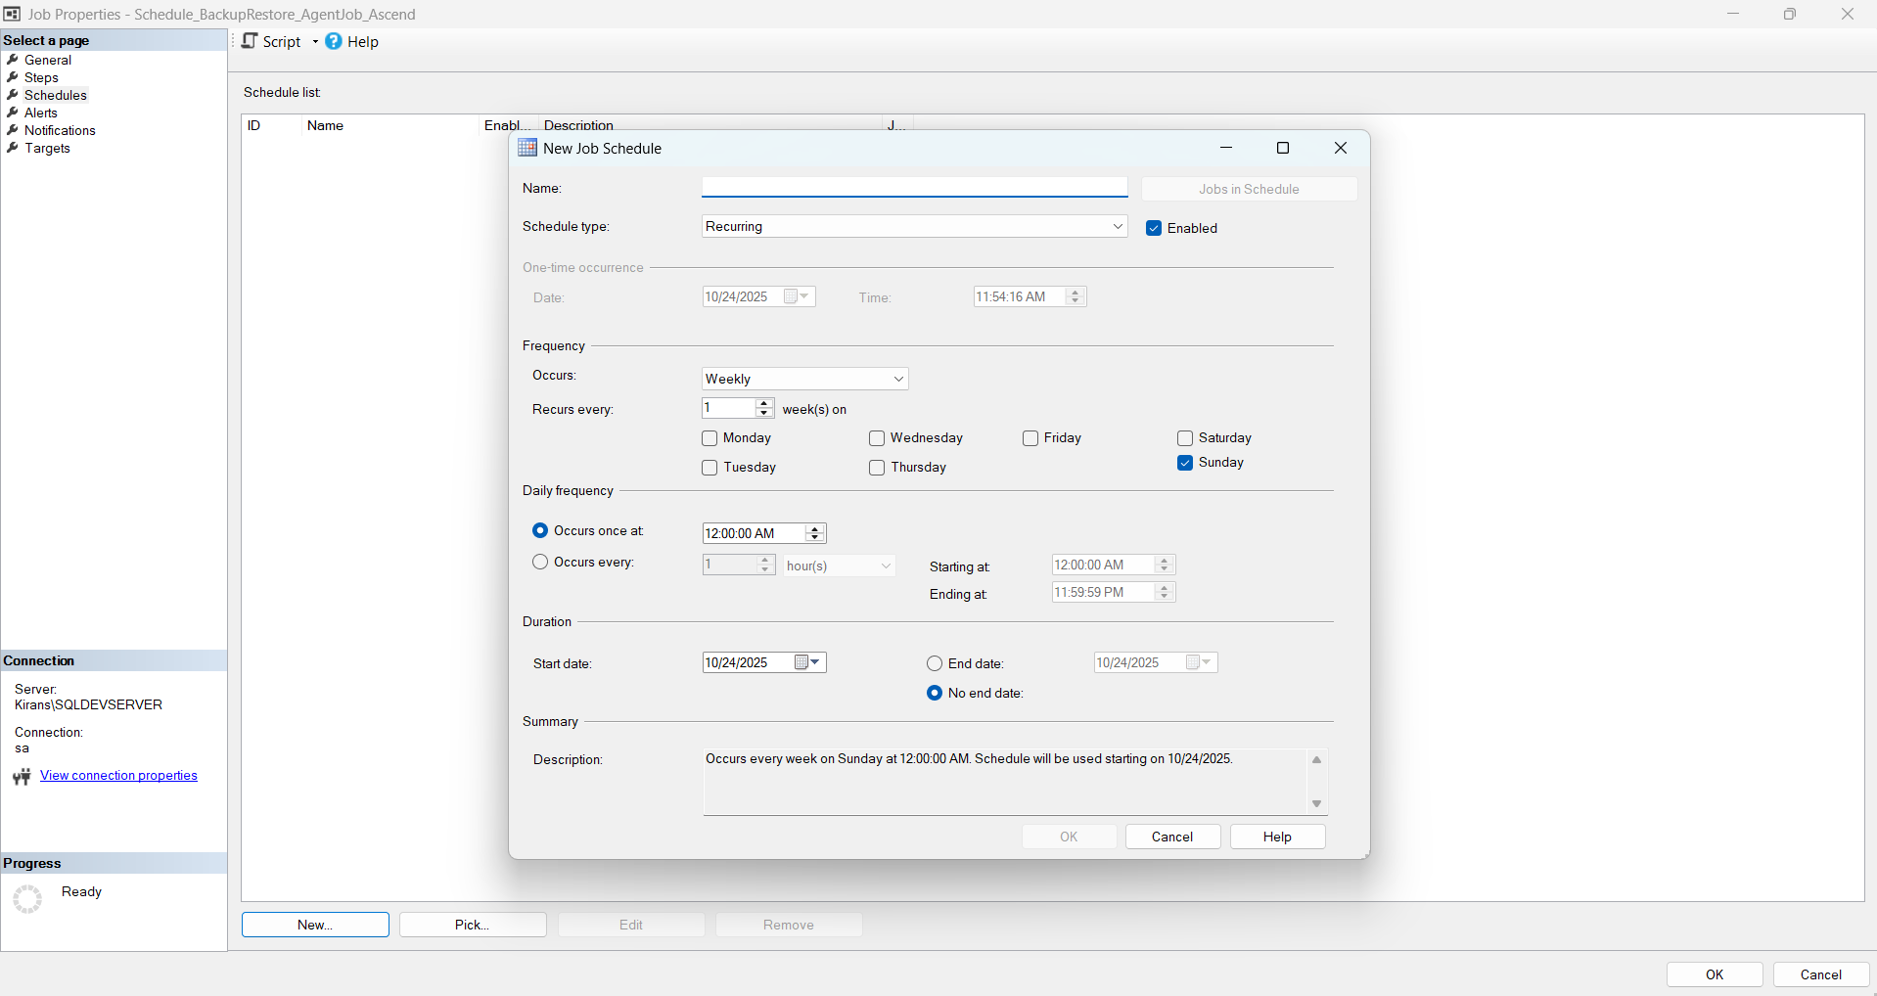

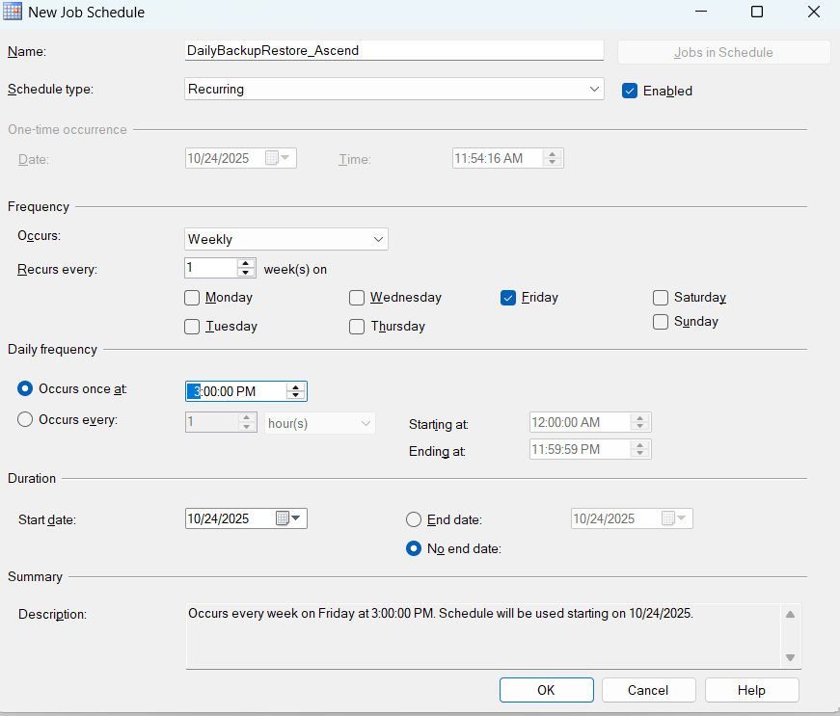

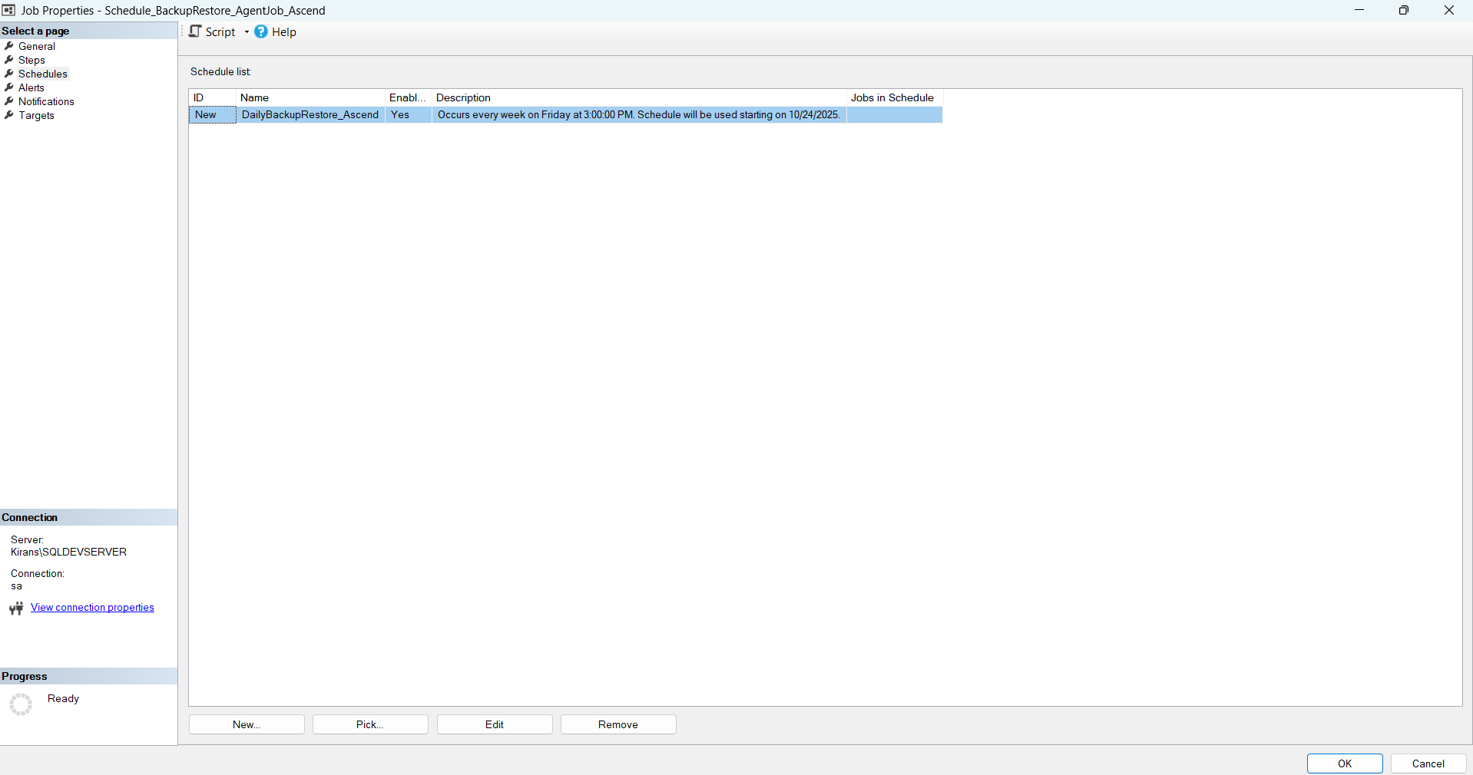

**📊 Step 4: Monitor Job History**

**🔹 4.1 View Job History**

* Right-click the job → **View History**
* Check for:
  + Success/failure of each step
  + Duration and output messages

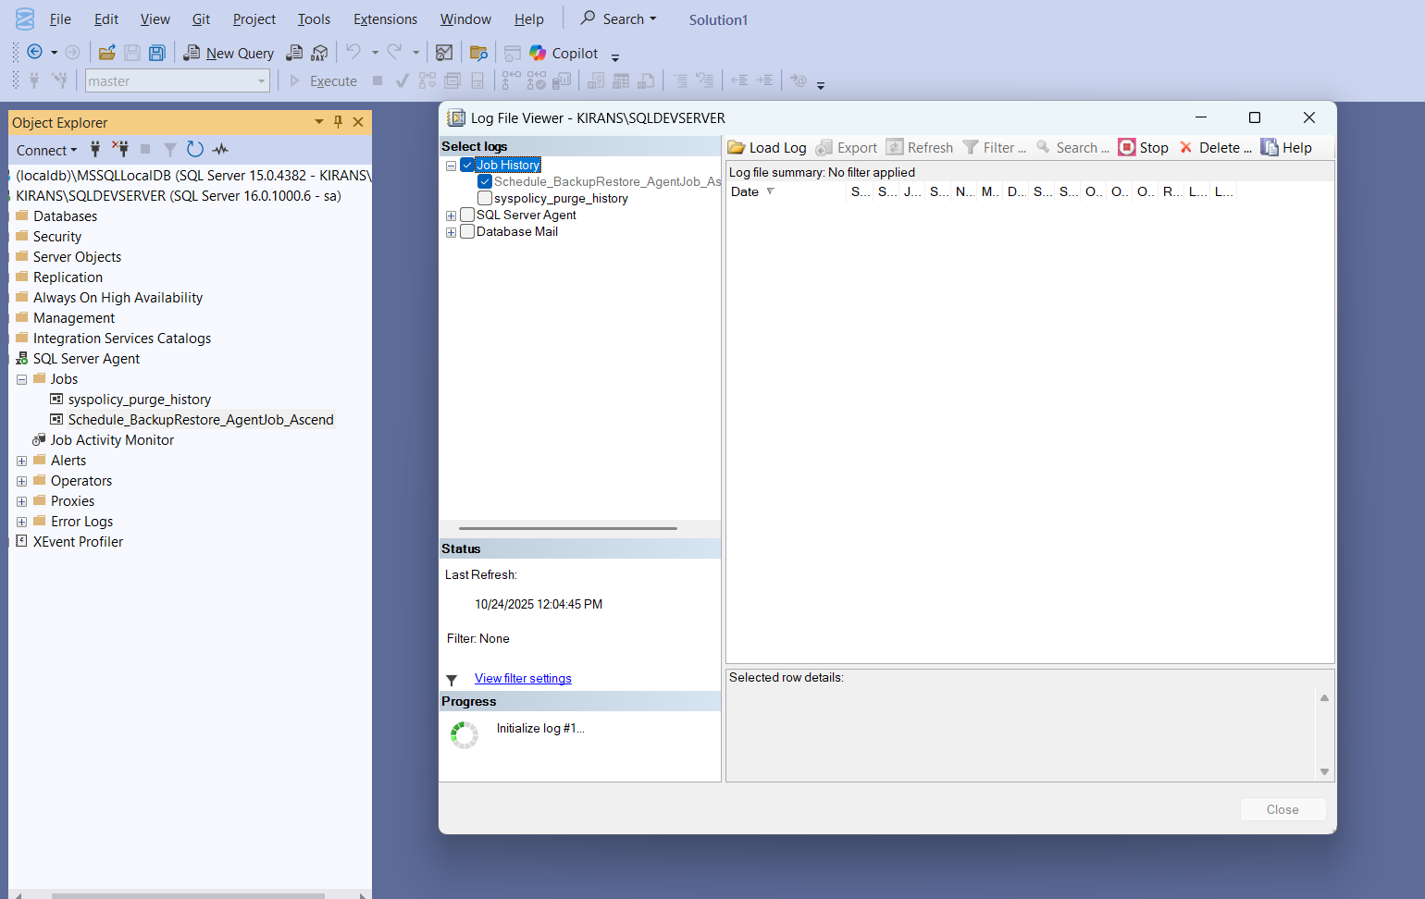

**🔹 4.2 Add Notifications (Optional)**

* Go to **Notifications** tab
* Configure:
  + Email alerts
  + Logging to event viewer
  + SQL alerts on failure

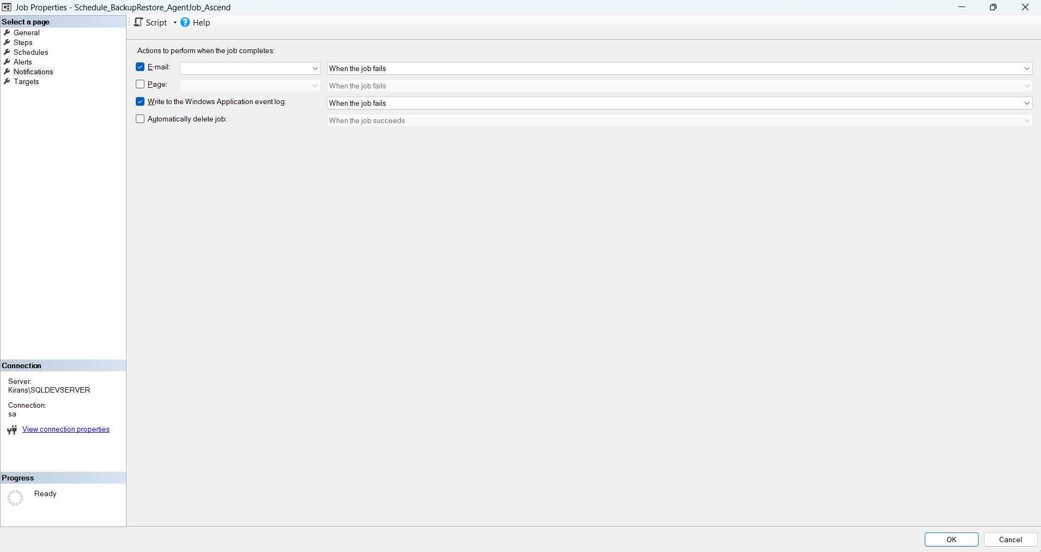

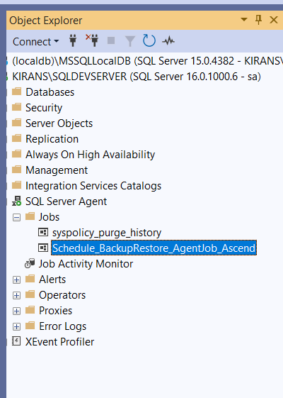

**✅ Summary**

| **Step** | **Action** | **Tool** | **Notes** |
| --- | --- | --- | --- |
| 1 | Create Job | SSMS | Define name, owner |
| 2.1 | Backup | T-SQL | On source server |
| 2.2 | Copy File | PowerShell / xp_cmdshell | Ensure permissions |
| 2.3 | Restore | T-SQL | On destination server |
| 3 | Schedule | SSMS | Daily/Weekly |
| 4 | Monitor | SSMS | View logs, set alerts |