SHRI RAMSWAROOP MEMORIAL UNIVERSITY


Case Study on Improving Student Mental Wellness

SUBMITTED TO: SUBMITTED BY:
Mr. Ujjawal Tomar Name-Ankit Kumar
Amisha Kashyap
Sakshi Jaiswal
Khushi Raj
Awiral Jaiswal
Roll No: 202410702190006
202410702190004
202410702190003
202410702190002
202410702190005

Semester- Ⅲ
Course-BBA(BA)

Agenda/Definition: This project focuses on using IBM MURAL to explore student mental Wellness through empathy mapping. It aims to understand students’ emotions, motivations, and challenges in online learning environments.

Outcomes/Learning: Students learn to apply design thinking through empathy mapping to identify emotional pain points and propose creative wellness solutions.

Required Tool
Tool Name: IBM MURAL
Template Used: empathy map
Working: The process involves the team collaboratively populating the Empathy Map template (Doing–Thinking–Feeling–Saying) on a Mural board.

- Doing: Identify students’ daily online learning activities—logging in, attending lectures, completing tasks.

- Thinking: Capture thoughts that may cause stress or anxiety (e.g., “I’m falling behind,” “This is too much screen time”).

- Feeling: Map emotional states such as frustration, motivation loss, or isolation.

- Saying: Document direct feedback from students about their challenges and expectations.

Introduction
The shift toward digital education has transformed the academic landscape, making online learning a primary mode of instruction across schools and universities. While this transition offers flexibility, accessibility, and personalized learning opportunities, it also presents serious challenges to student mental wellness. Prolonged screen time, social isolation, lack of peer interaction, and constant digital distractions contribute to heightened stress, anxiety, and burnout among students.
This case study applies a psychological and user experience (UX) lens to understand the mental health barriers students face in online learning platforms. The goal is to identify cognitive and emotional friction points that undermine focus, motivation, and overall well-being. By integrating supportive design principles, empathetic communication tools, and wellness-centered learning models, institutions can create a balanced digital ecosystem that promotes both academic success and mental resilience.

Main Objectives
The primary objectives of this study are focused on improving measurable indicators of student well-being and engagement in online learning environments:

- Cognitive Load Reduction: To minimize mental fatigue by simplifying digital interfaces, optimizing content delivery pace, and reducing multitasking pressure during online sessions.

- Emotional Resilience and Engagement: To strengthen emotional connection and motivation by integrating interactive, human-centered features that foster belonging and social support among students.

- Sustained Mental Wellness: To build long-term student well-being through mindfulness integration, flexible scheduling, and access to mental health resources embedded within learning platforms.

Specific goals:
To achieve these objectives, the project will focus on three targeted goals validated by educational psychology research:
- Reduce “Zoom Fatigue”: Introduce dynamic class structures—shorter lectures, regular breaks, and interactive polls—to combat cognitive exhaustion caused by continuous video-based sessions. Encourage camera-optional participation to lower social anxiety.

- Enhance Social Connection: Implement virtual peer groups, discussion boards, and mentorship circles to recreate the sense of community found in traditional classrooms. Emotional belonging is a key factor in reducing stress and dropout rates.

- Integrate Mental Health Support: Embed digital wellness features such as guided meditation breaks, self-assessment check-ins, and instant counseling chatbots into the online learning portal to ensure proactive mental health monitoring.

Problem Definition
Educational institutions face increasing difficulty in sustaining student engagement and motivation in online environments due to the psychological friction of digital learning. The core issue arises from emotional isolation, cognitive overload, and lack of well-being support, which undermine academic performance and student satisfaction.

- Cognitive Overload:
Students experience information fatigue from excessive reading materials, continuous assignments, and multitasking demands. The absence of physical cues and structured learning rhythm intensifies mental strain.

- Emotional Disconnection:
Reduced peer and teacher interaction leads to loneliness and detachment, causing students to disengage from academic and social participation.

- Wellness Neglect:
Institutions often prioritize academic performance metrics over emotional health, resulting in delayed response to stress, anxiety, and burnout.

Why IBM Mural Would Be the best Tool for This Problem

IBM Mural is the most suitable tool for addressing student mental wellness challenges in online learning environments because it enables collaborative empathy-driven analysis, helping educators and students co-create solutions in real time. Its visual and interactive workspace transforms abstract emotional and psychological experiences into actionable insights.

1. Visual Collaboration for Deeper Understanding

Mural’s digital whiteboard allows multiple participants to work together simultaneously, mapping out students’ thoughts, emotions, and challenges through frameworks such as the Empathy Map or Journey Map. This visual approach helps educators clearly identify where students feel overwhelmed, disengaged, or unsupported in the learning process.

2. Empathy-Centered Design Thinking

The platform is built around Design Thinking principles, which prioritize empathy, ideation, and problem-solving. For mental wellness improvement, Mural facilitates understanding of what students are doing, thinking, feeling, and saying — crucial dimensions for designing learning experiences that reduce stress and foster well-being.
3. Real-Time Collaboration Across Roles

Educators, counselors, and students can collaborate live from anywhere, promoting shared understanding and co-creation. This helps break the isolation often felt in online learning, while ensuring that wellness strategies are shaped collectively rather than imposed top-down.
4. Structured Templates for Mental Wellness Analysis

IBM Mural provides customizable templates like:

- Empathy Maps (to identify emotional pain points)

- Journey Maps (to track stress and motivation across the learning cycle)

- Brainstorming Boards (to co-create wellness ideas and support systems)
Steps to create the MURAL are as follows
Step 1: Search IBM MURAL in Browser

Step 2: open IBM MURAL

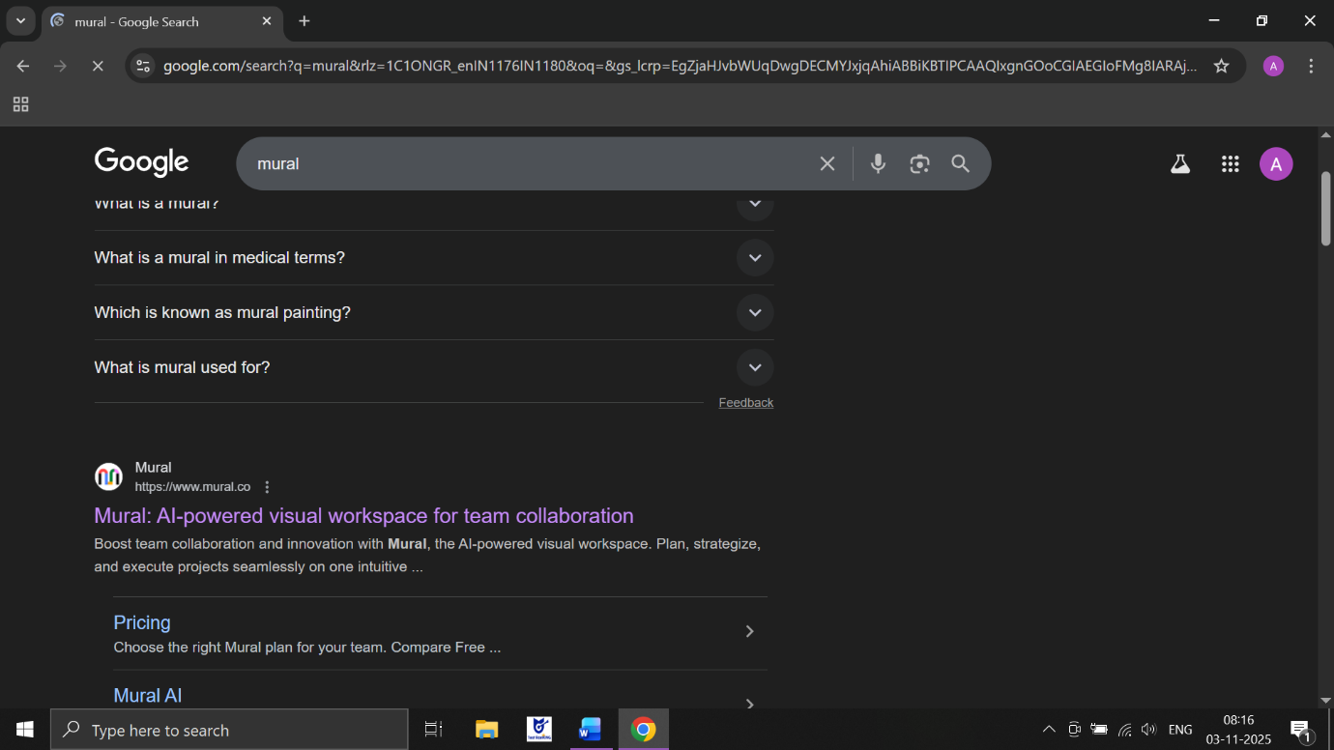
Step 3: log in or sign with the google


Step 4: Now our main page of mural open

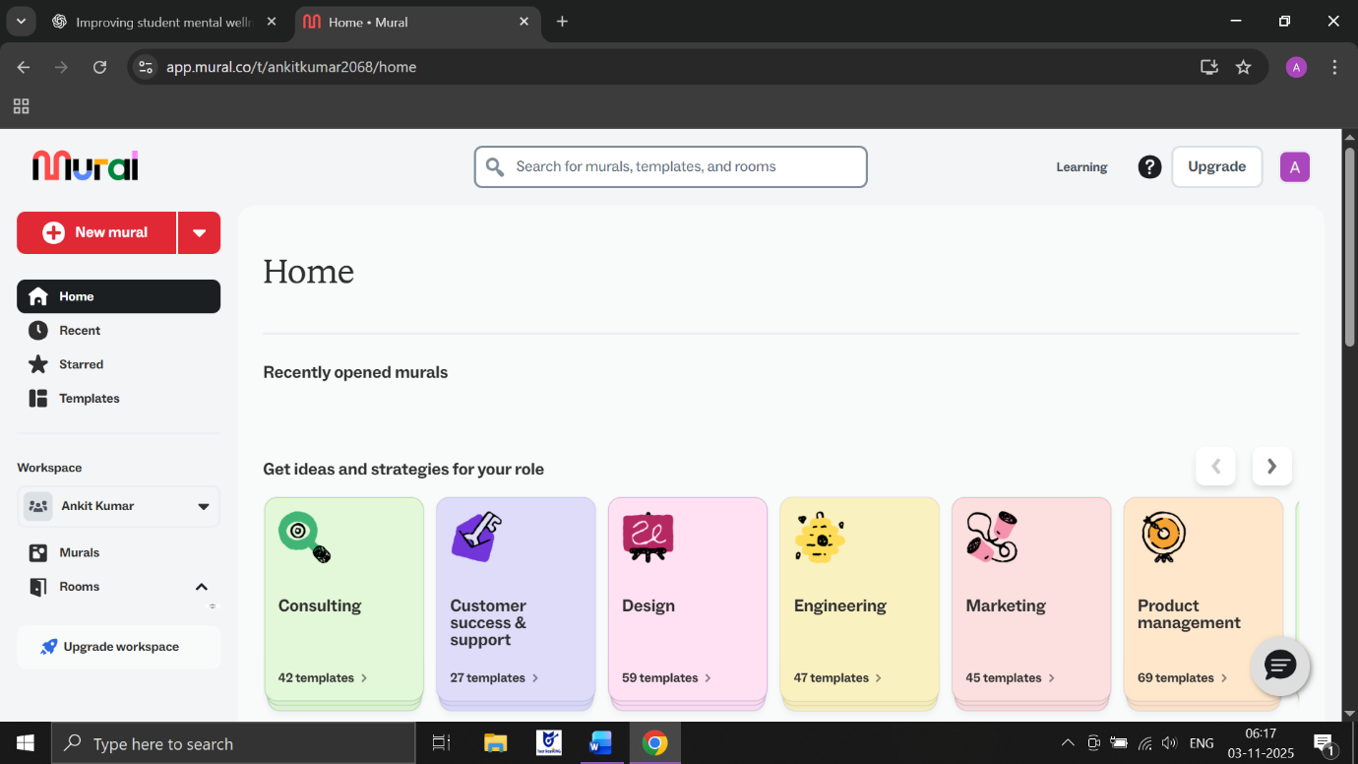

Step 5: Now click on New mural and enter mural name and create mural

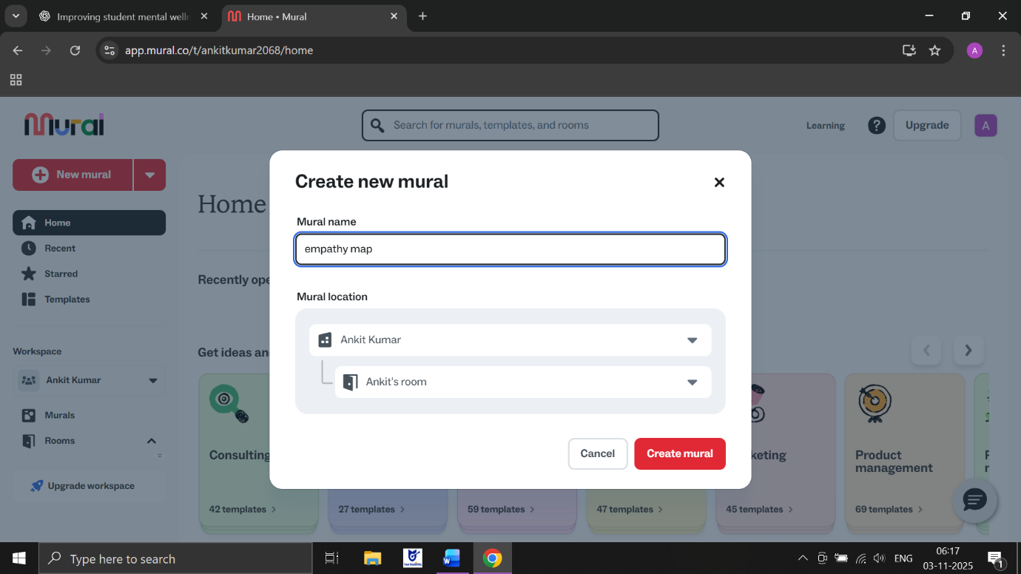

Step 6: Now our mural will open
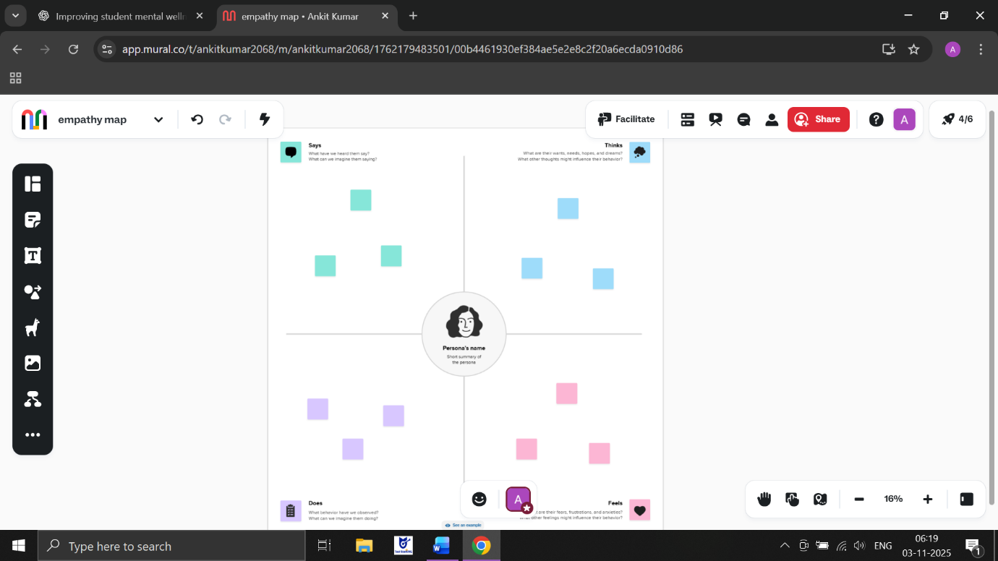

Step 7: Now we enter the data in sticky notes

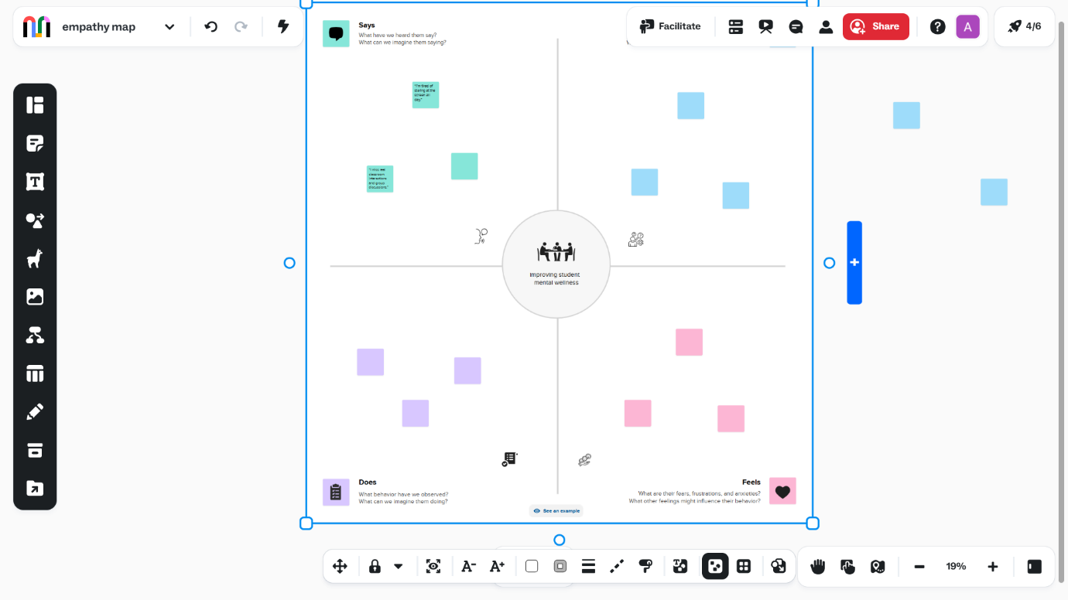

Step 8: Now enter data in SAYS{feedback}
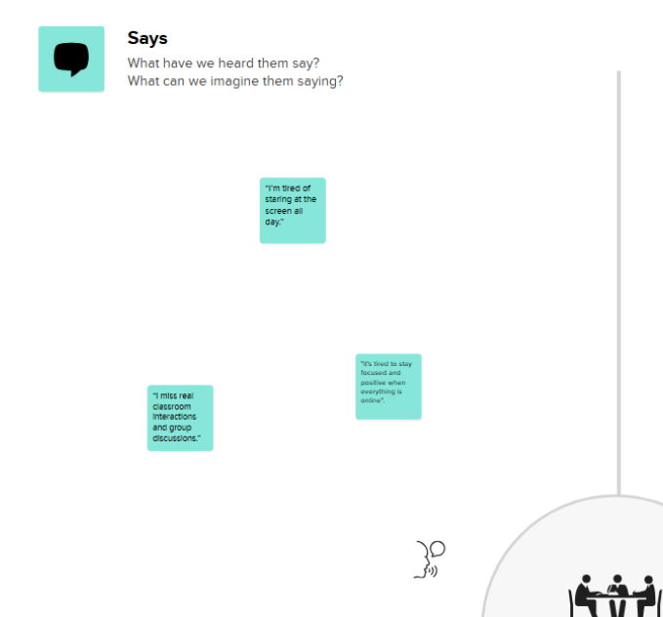
Step 9: Now enter data in THINKS{thoughts}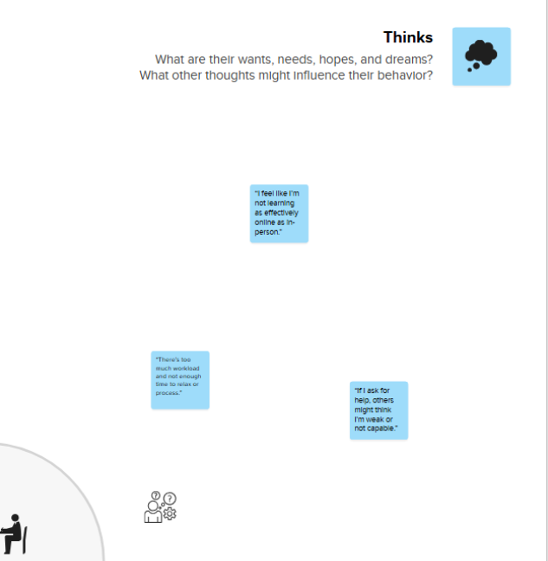

Step 10: Now enter data in DOES{actions}

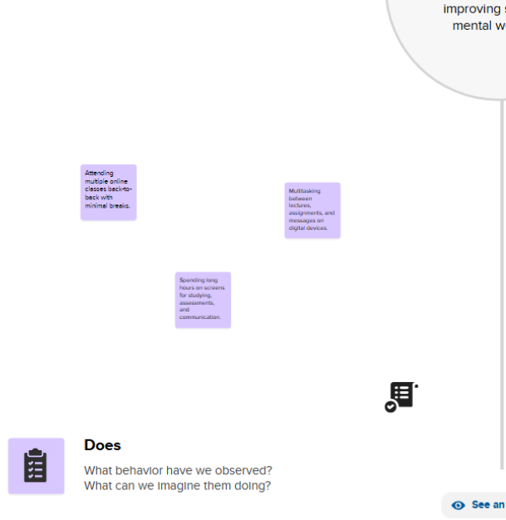

Step 11: Now enter data in FEELING{emotions}

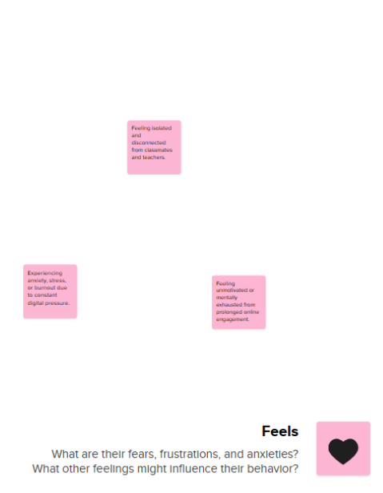

Step 12 : now our final output is ready

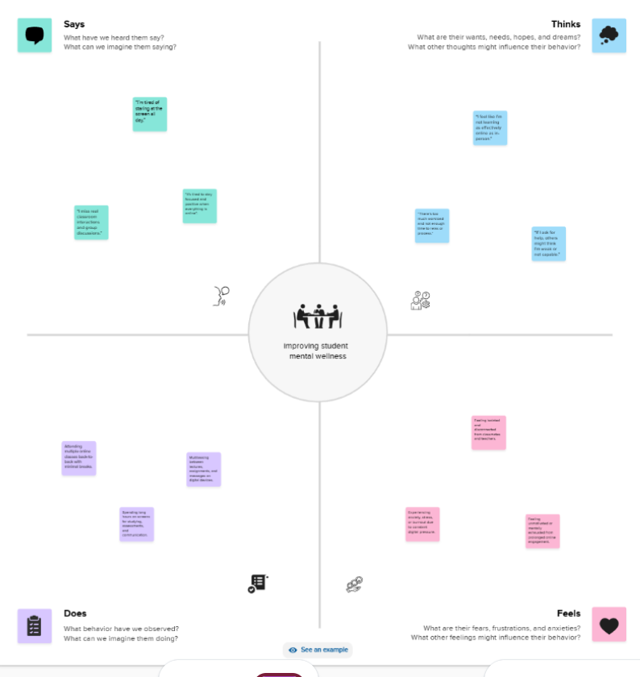

Conclusion
Improving student mental wellness in online learning environments requires a deep understanding of learners’ emotional, cognitive, and behavioral experiences. Through the Empathy Map approach, educators can identify the real challenges students face — such as digital fatigue, social isolation, and motivational decline — and design learning experiences that support both mental health and academic performance.
By using IBM Mural as a collaborative tool, institutions can visualize these pain points, encourage open communication, and co-create wellness-oriented strategies like mindful breaks, peer support sessions, and flexible study models.
In conclusion, prioritizing student mental wellness is not just a supportive practice but a strategic necessity for effective online education. When empathy-driven insights guide the design of digital learning environments, students feel more connected, balanced, and motivated — leading to healthier minds, improved focus, and sustainable academic success.

