|  |  |
| --- | --- |
|  |  |
| Anti-Lock Braking System (ABS) |  |
|  | Anti-lock braking system - Wikipedia |
|  | 17-12-2020Model Based Design |
|  | Omkar Rane 2005203KPIT-Genesis |

# Contents

|  |  |  |
| --- | --- | --- |
| 1. | Introduction to Anti-Lock braking System. | 3 |
| 2 | Model Based Design in Simulink | 6 |
| 3. | Function Callbacks. | 7 |
| 4. | Solver Selection strategy. | 8 |
| 5. | Data Inspector | 10 |
| 6. | MATLAB Function Block. | 11 |
| 7. | Look-up table. | 12 |
| 8. | System test with signal builder. | 13 |
| 9. | Reference | 22 |

1. **Introduction**

**Problem statement:**

ABS System Design (Anti-Lock Braking System Design)

Qn: A 4-wheeled vehicle is to decelerate from a speed of 44 m/s (V0) to standstill without wheel locking. The co-efficient friction between the tyres and road is known. The desired wheel slip is 0.2. Find the vehicle speed and slip over time, and the stopping distance.

Mathematical modeling and simulation bring significant benefits in terms of understanding the braking phenomena and the impact of different parameters on the braking performance of a vehicle. Anti-lock braking systems (ABS) are meant to control the wheel slip in order to maintain the friction coefficient close to the optimal value. Wheel slip is defined as the relative motion between a wheel (tire) and the surface of the road, during vehicle movement.

Wheel slip occurs when the angular speed of the wheel (tire) is greater or less compared to its free-rolling speed. In order to simulate the braking dynamics of a vehicle, we are going to implement simplified mathematical models (quarter-car model) for both vehicle and wheel. Also, a simplified ABS controller is going to be implemented in order to emulate the braking torque in slip conditions.

**1.1 Vehicle model**

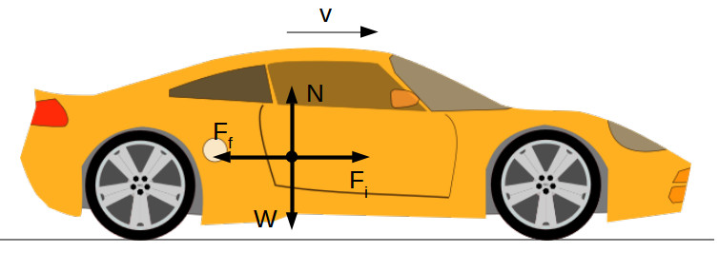

If we consider a vehicle moving in a straight direction under braking conditions, we can write the equations of equilibrium:

for horizontal direction:

Ff=Fi -(1)

where:

Ff [N] – is the friction force between wheel and ground  
Fi[N] – is the inertial force of the vehicle

for vertical direction:

N=W -(2)

where:

N [N] – normal force (road reaction)  
W [N] – vehicle weight

We can write the expressions of the friction force as:

Ff=μ⋅N -(3)

where μ [-] the friction coefficient between wheel and road.

The vehicle’s weight is:

W=mv⋅g -(4)

Replacing (2) and (4) in (3) gives the expression of the friction force as:

Ff=μ⋅mv⋅g -(5)

where:  
mv [kg] – is the total vehicle mass  
g [m/s2] – is the gravitational acceleration

The inertia force is the product between the vehicle mass mv [kg] and vehicle acceleration av [m/s2]:

Fi=mv⋅av=mv⋅ -(6)

where vv [m/s] is the vehicle speed.

From equations (1), (5) and (6) we can extract the expression of the vehicle acceleration:

= (μ⋅mv⋅g) -(7)

Vehicle speed is obtained by integration of equation (7).

**1.2 Wheel model**

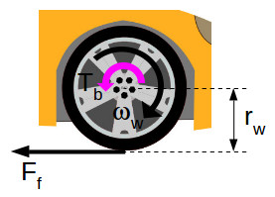

During braking, through the braking system, the driver applies a braking torque Tb [Nm] to the wheels. The friction force Ff [N] between the wheel and road creates an opposite torque with the wheel radius rw [m].

For simplification, we are going to consider that the wheel is rigid and the normal force (road reaction) passes through the wheel hub, therefore doesn’t add an additional torque.

We can write the equation of equilibrium for the wheel as:

Tb–Ff⋅rw–Jw⋅ =0 -(8)

where:

Jw [kg·m2] – is the wheel’s moment of inertia  
ωw [rad/s] – is the angular speed of the wheel

From equation (8) we can extract the expression of the **wheel acceleration**:

= ⋅(Tb–Ff⋅rw) -(9)

**Wheel speed** is obtained by integration of equation (9).

### Wheel slip

The ABS system has to control the wheel slip s [-] around an optimal target. The **wheel slip** is calculated as:

s=1– -(10)

where ωv [rad/s] is the **equivalent angular speed of the vehicle**, equal with:

ωv = -(11)

where vv [m/s] is the vehicle speed.

### Friction coefficient

The friction coefficient between wheel and road depends on several factors, like:

* wheel slip
* vehicle speed
* the type of the road surface
* environmental conditions (humidity, temperature, etc.)

For our simulation purpose, we are going to take into account only the variation of the **friction coefficient**function on the **longitudinal wheel slip**.

1. **Model Based Design in Simulink**

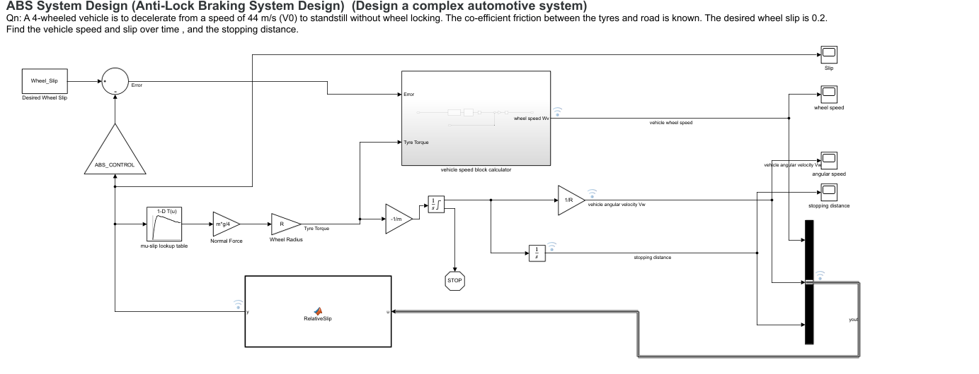

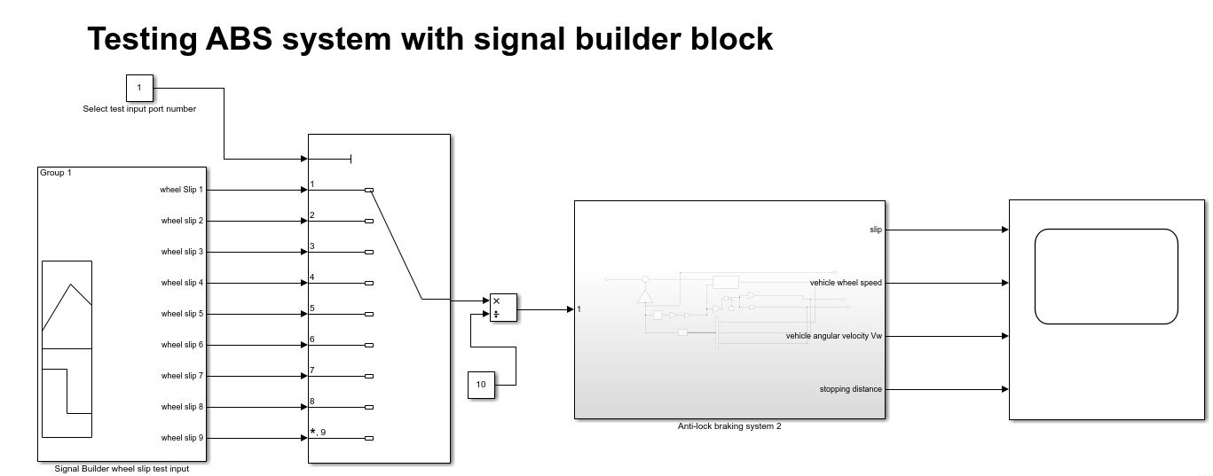

1. **Function Call backs**

To initialize value in workspace before simulating actual model. We are intializing values like vehicle mass,speed,radius of wheel ,moment of inertia,wheel slip.

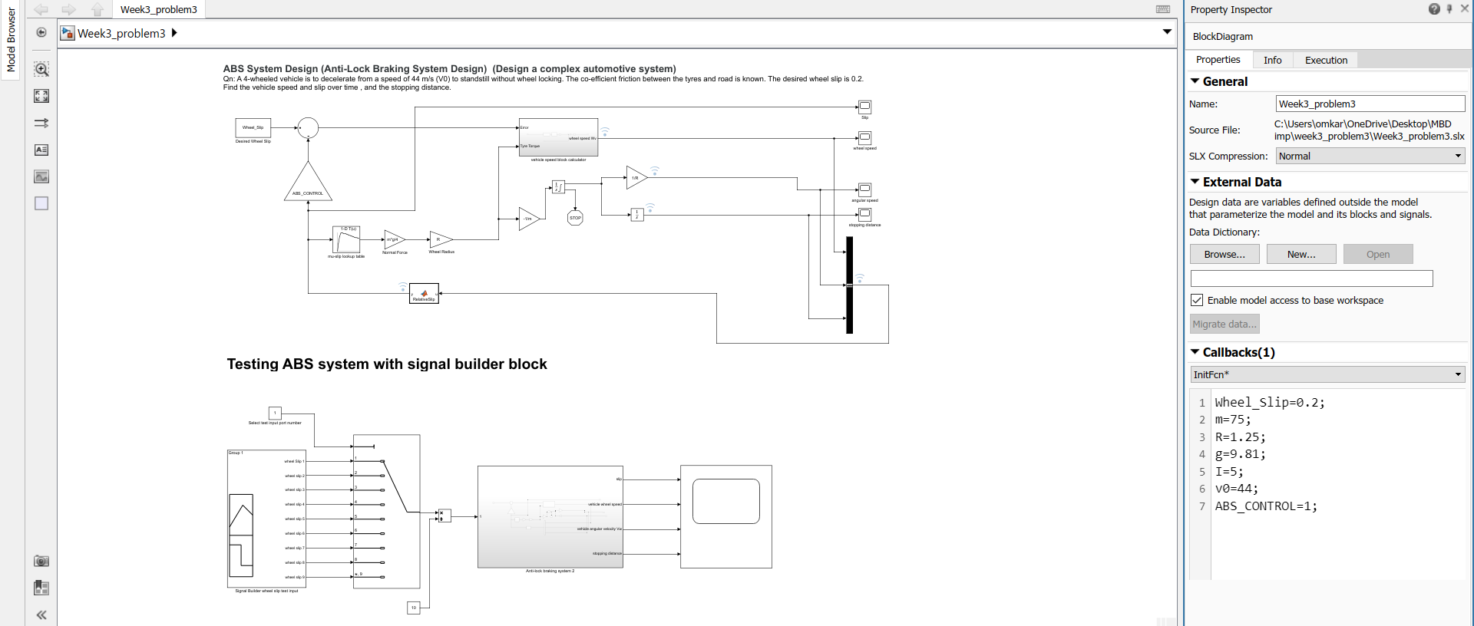



1. **Solver Strategy**

Flowchart to choose solver

Start

Convert to C code?

yes

No

Variable step solver

Fixed step solver

Continuous or discrete?

Continuous or discrete?

Discrete

Continuous

Continuous

Discrete

Variable Step Continuous Solver

Variable step discrete solver

Fixed Step Continuous Solver

Fixed Step Discrete Solver

Is Model Stiff?

Is Model Stiff?

Explicit

(no)

Explicit

(no)

Implicit

(yes)

Implicit(yes)

Explicit Solver:

Ode1

Ode2

Ode3

Ode5

Ode8

Ode1

Explicit Solver:

Ode45

Ode23

Ode115

Implicit Solver:

Ode15s

Ode23s

Ode23t

Implicit Solver:

Ode14x

**Solver strategy of ABS system is as follows:**

1. Based on above mentioned flowchart we are not required to generate any C code at present so I am proceeding with variable step solver.
2. MATLAB solver are numerical solver based on numerical methods.
3. Initially to determine best solver method we can select type as ‘Variable step’ and Solver as ‘Auto’ MATLAB will select best suitable solver as per requirements.
4. Stiffness of model can be determined by amount of time required for calculation. Based on message given by MATLAB whether model is stiff we select solver from above list.
5. In our case model is not stiff so we are selecting ODE45 based on dormand-prince solver selected by auto-solver.

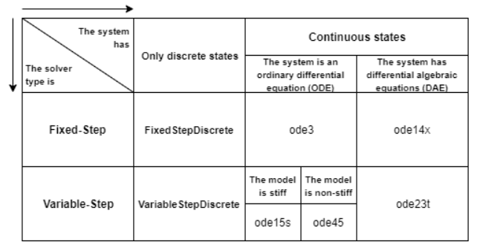

1. **Data Inspector**

Using data inspector we can compare graphs with various conditions and we can archive our results.

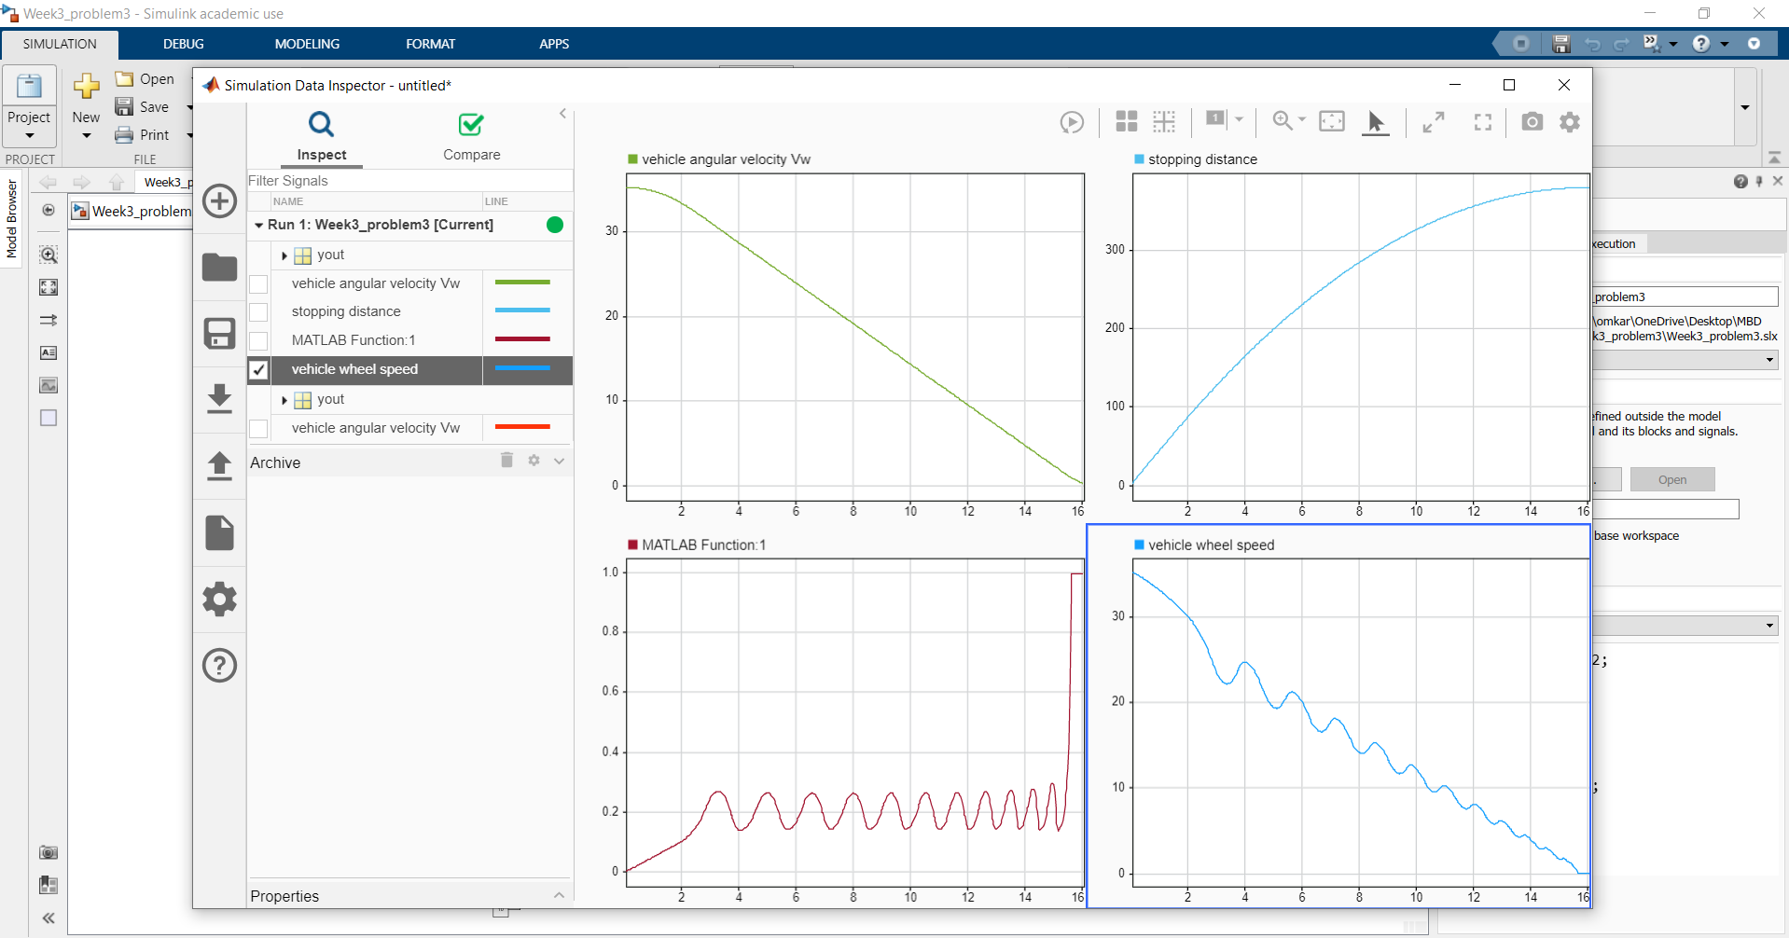

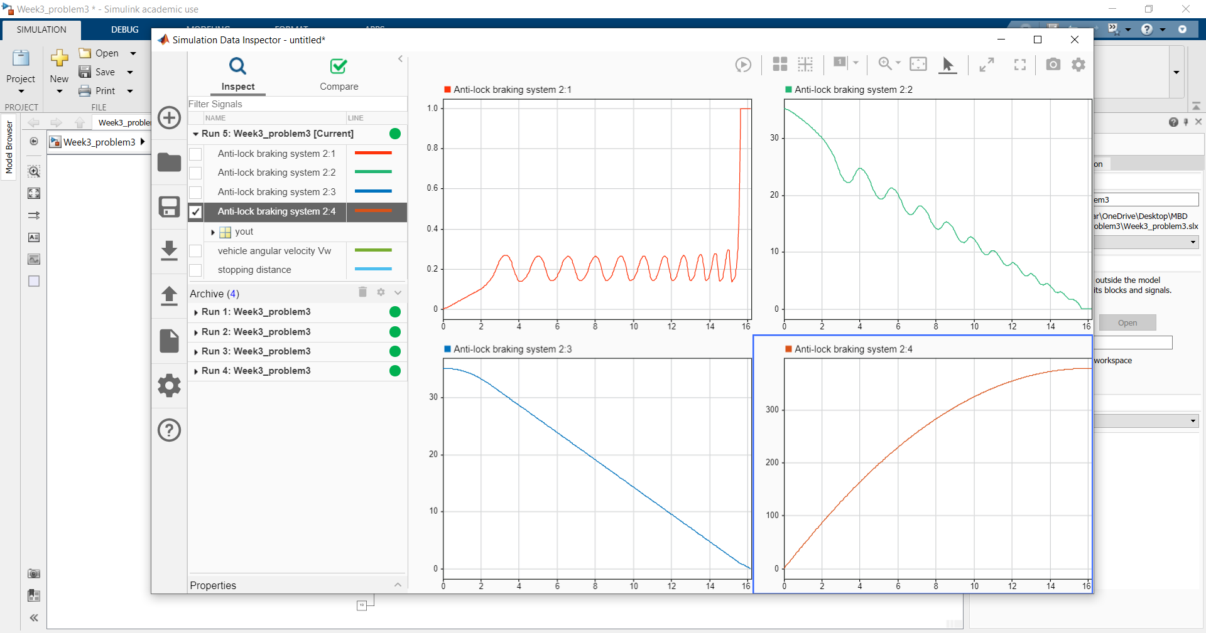

1. **MATLAB Function Block**

In our model we are using matlab function block to calculate relative slip and provide a feedback to the system.

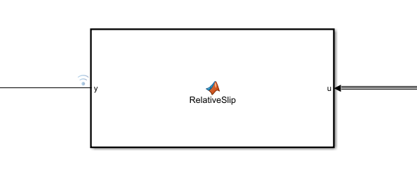

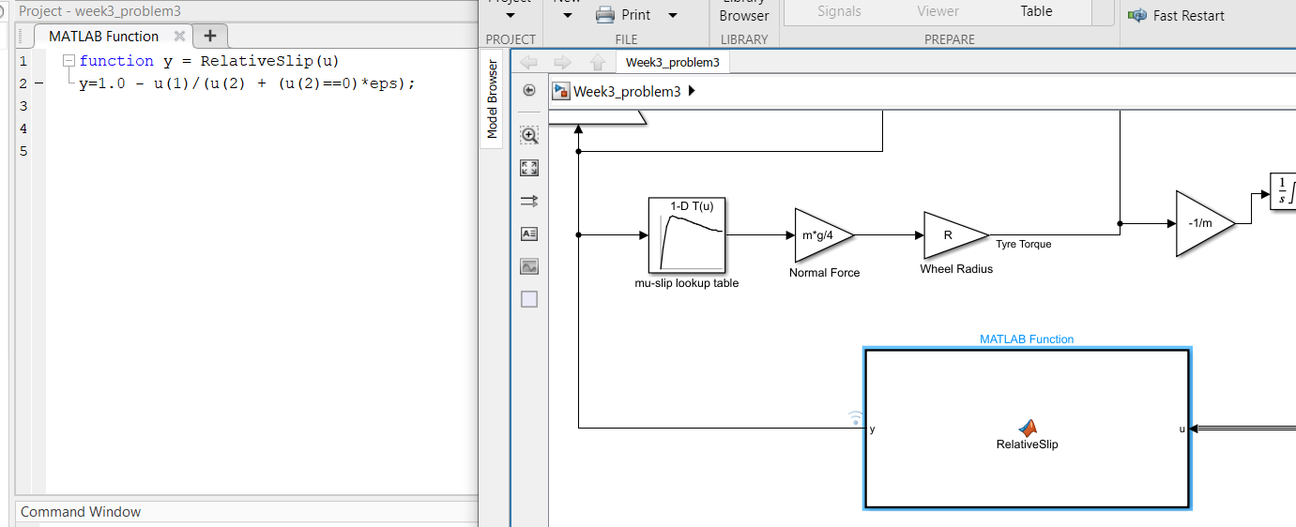

1. **Look-up Table**

1D lookup Table is used to get appropriate value of coefficient friction mapped to desired slip values. It’s a graph of coefficient of friction vs Slip.

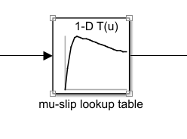

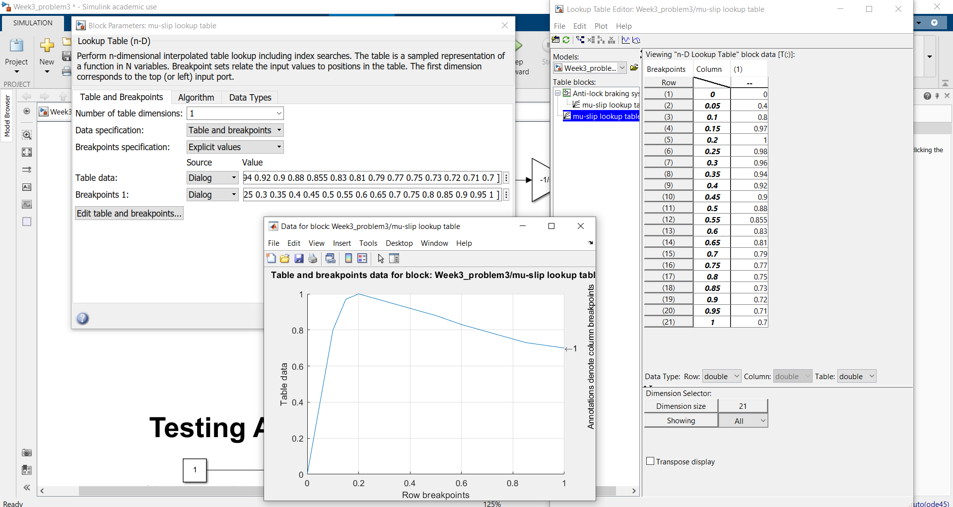

1. **Signal Builder to generate test signals.**

To test various signal input values for wheel slip. We can use signal builder block for generating various test inputs.

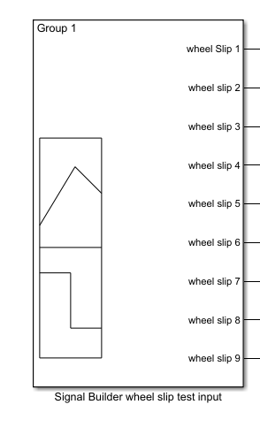

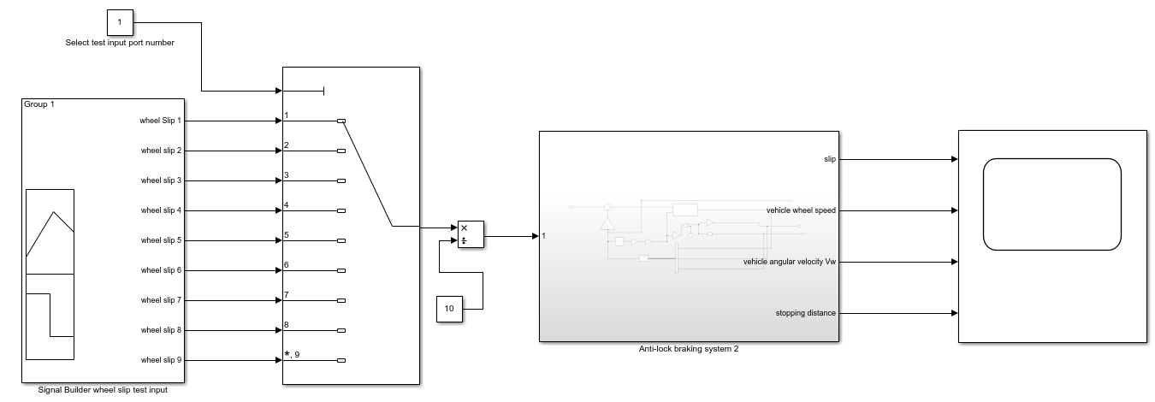

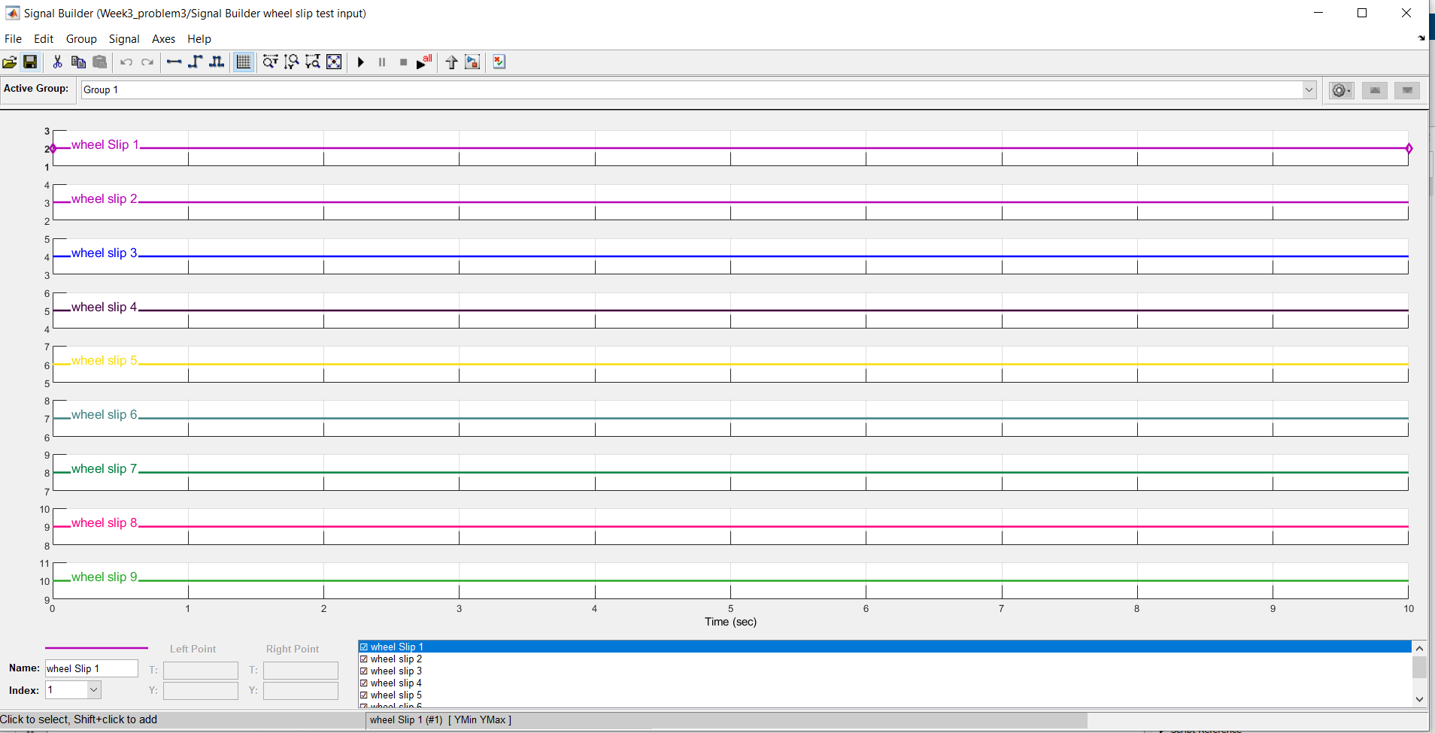

Result:

Wheel slip = 0.2

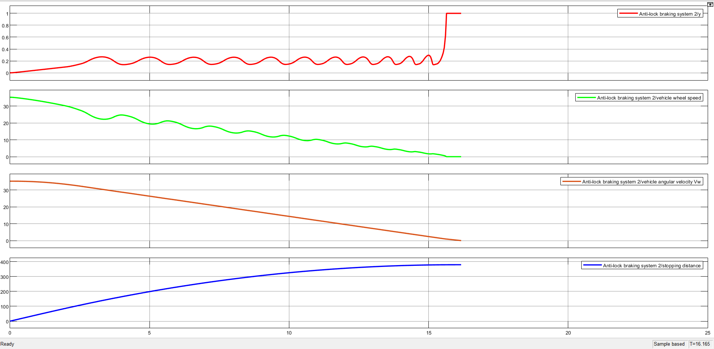

Wheel slip = 0.3

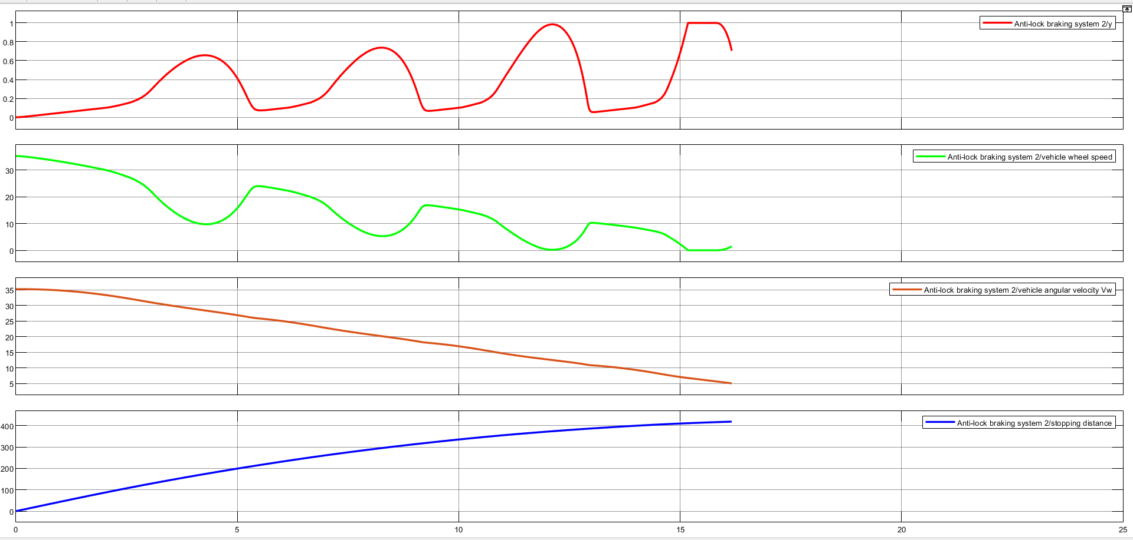

Wheel slip = 0.4

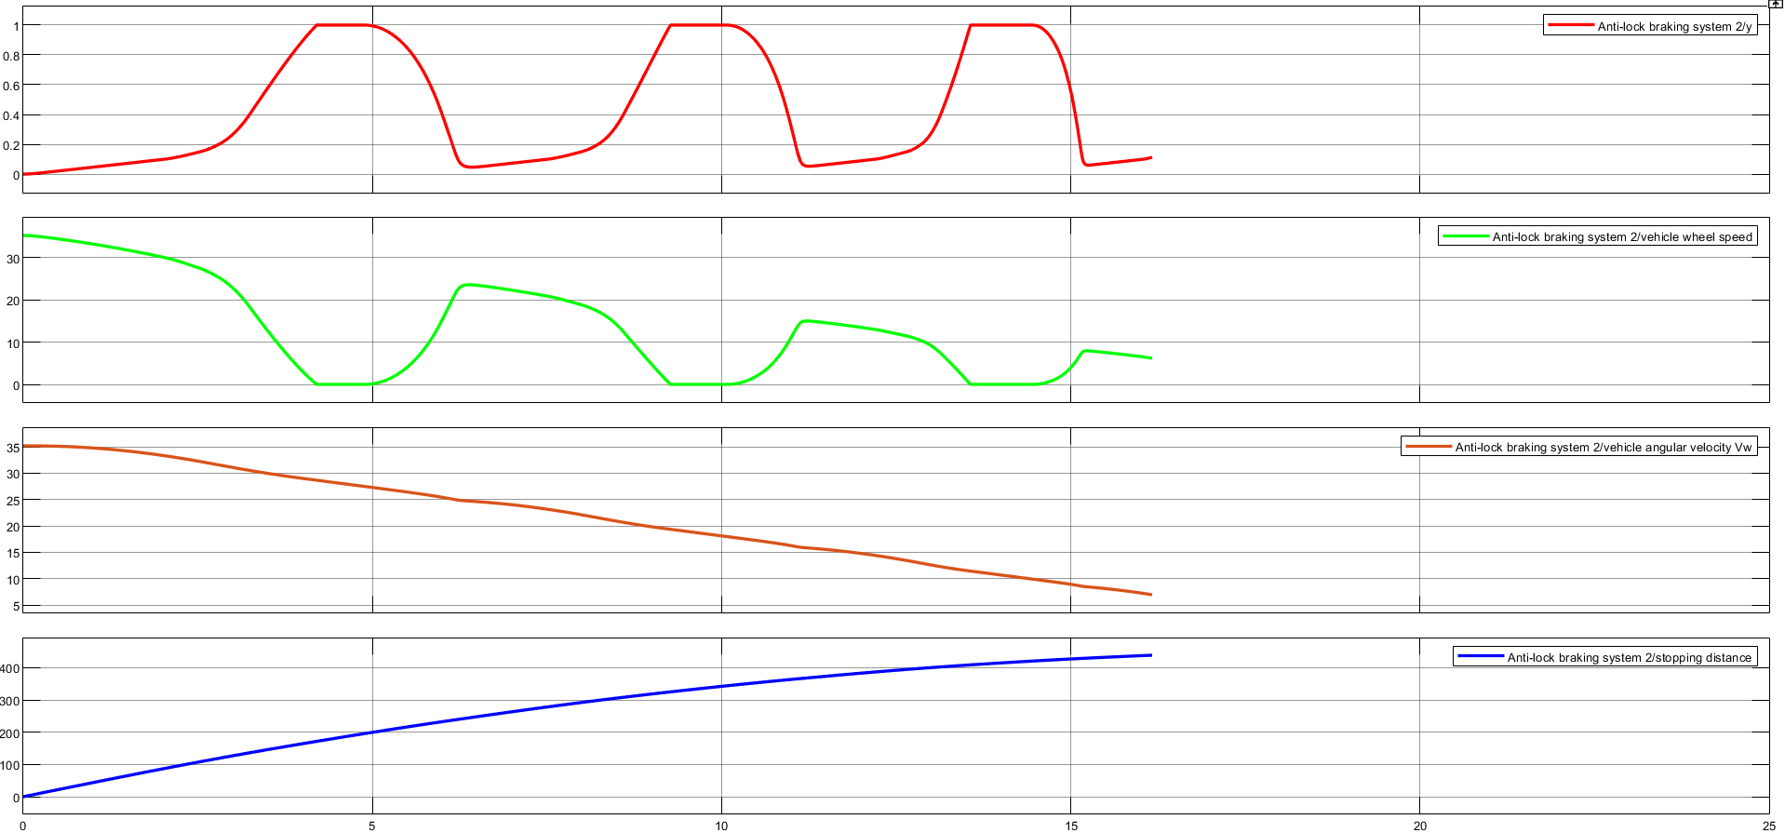

Wheel slip = 0.5

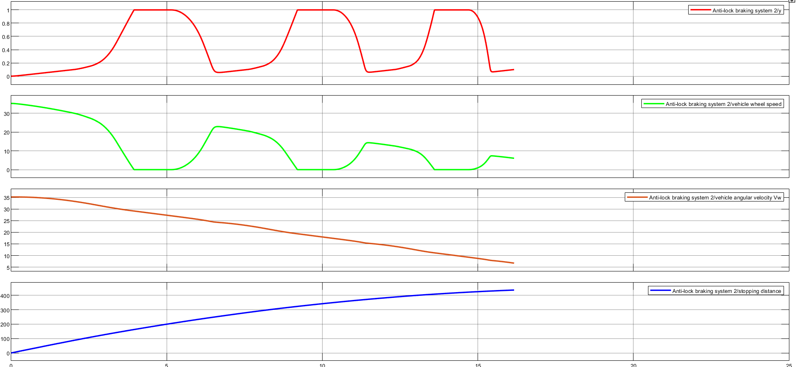

Wheel slip = 1

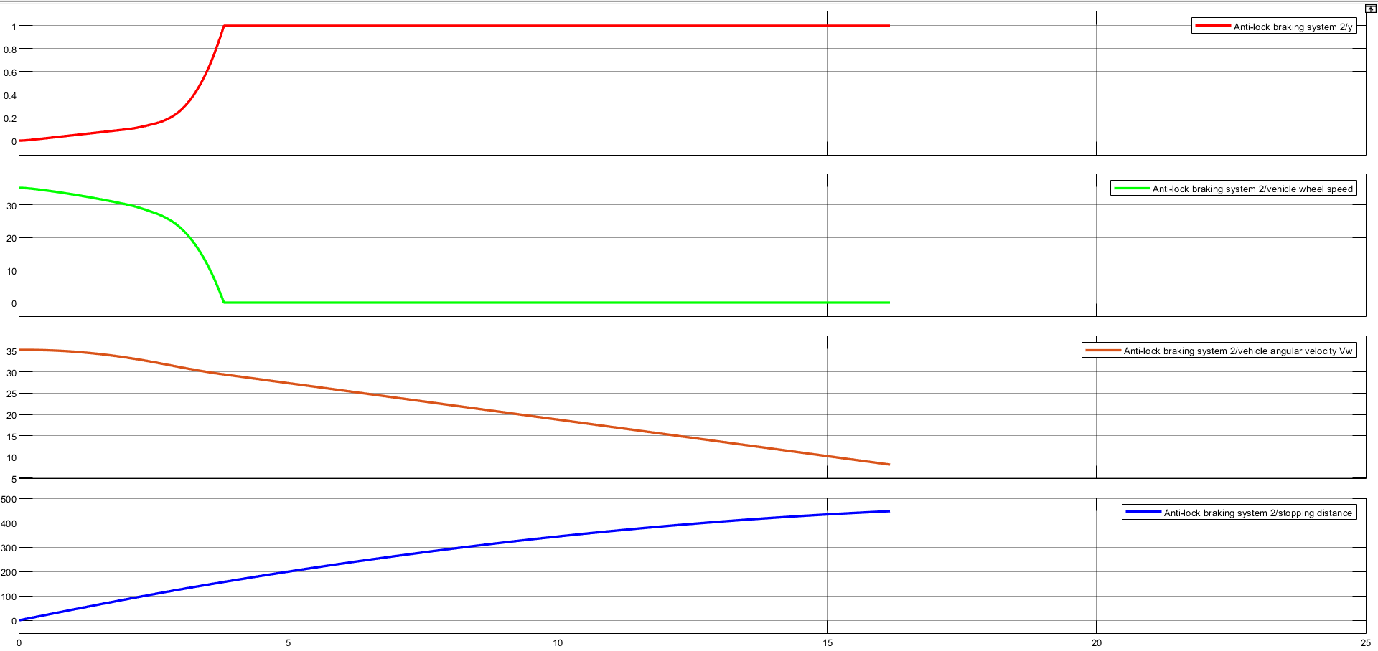

when slip = 1, as the slip plot shows, the tire is skidding so much on the pavement that the friction force has dropped off.

**System Result with ABS :**

ABS_CONTROL=1 this will enable ABS system.

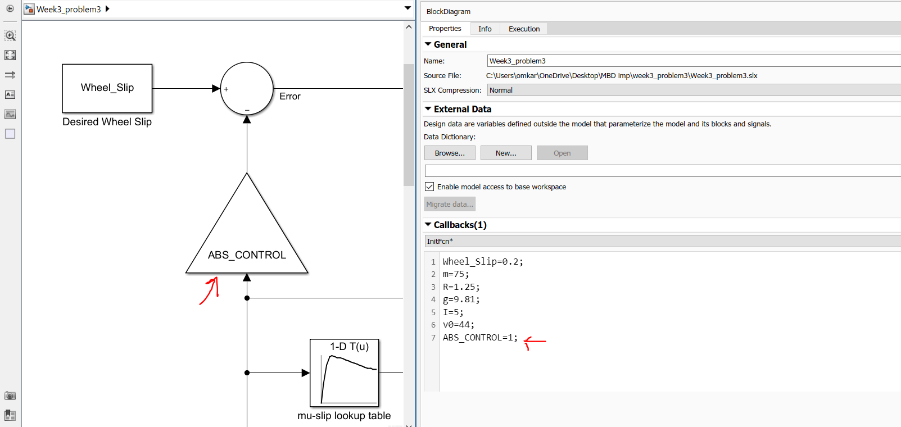

Comparison of vehicle speed and wheel speed with ABS enabled

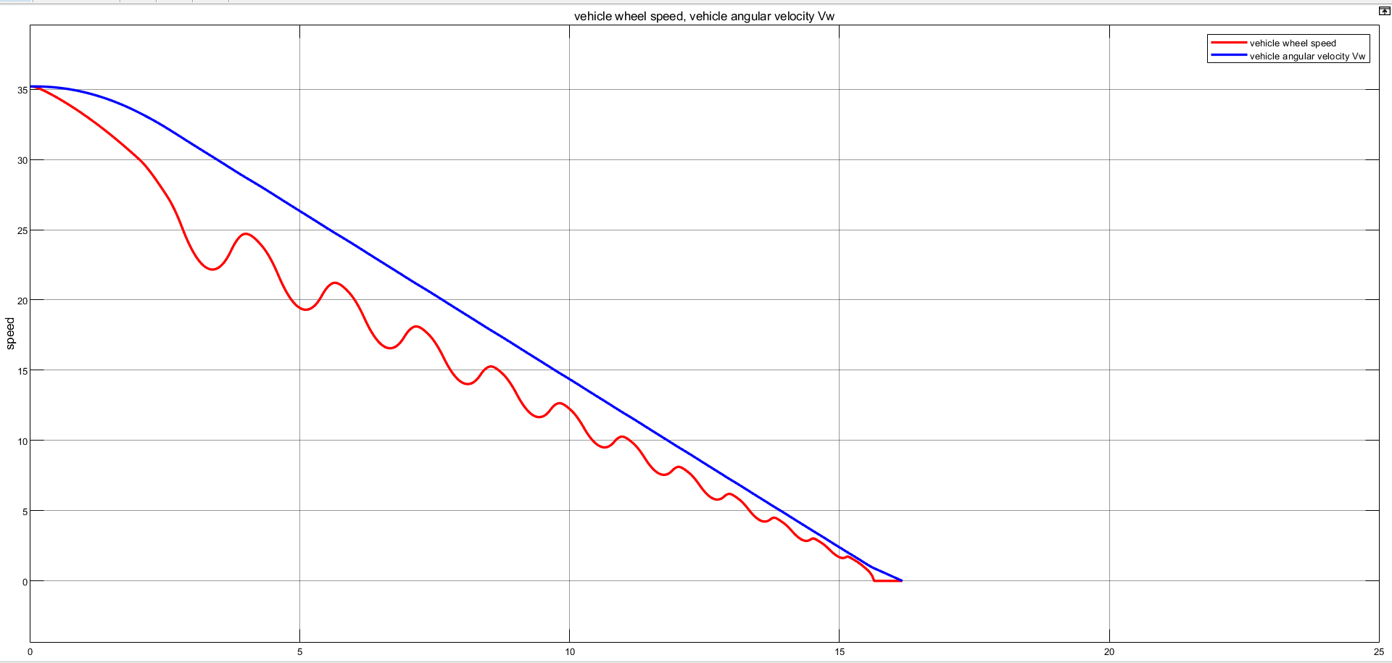

Wheel slip when ABS is enabled.

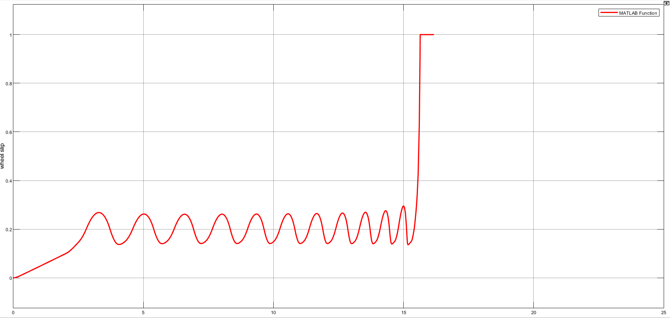

**System Result without ABS :**

ABS_CONTROL=0 this will disable ABS system.

This disconnects the slip feedback from the controller, resulting in maximum braking.

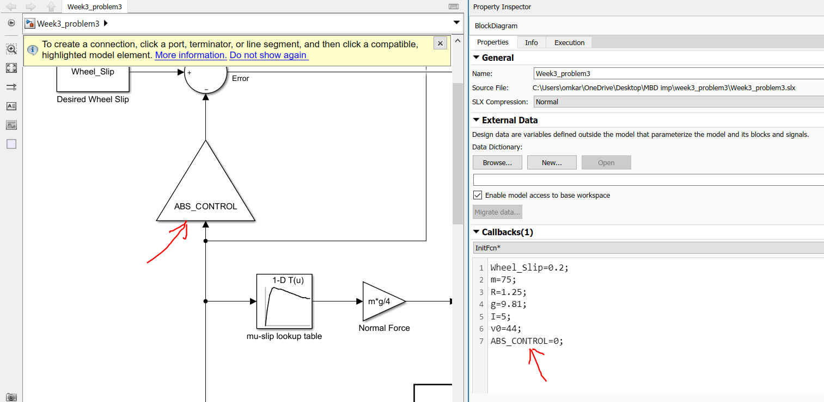

Comparsion of vehicle speed and wheel speed when ABS is disabled.

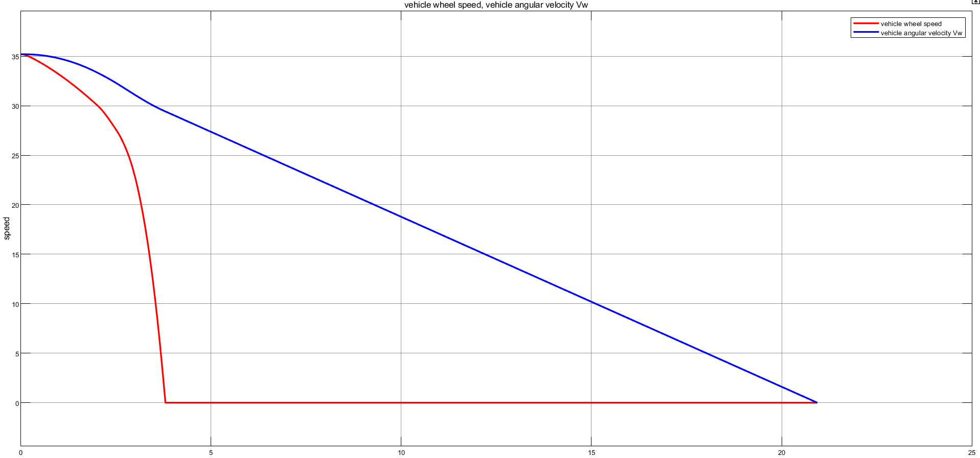

Wheel slip when ABS is disabled.

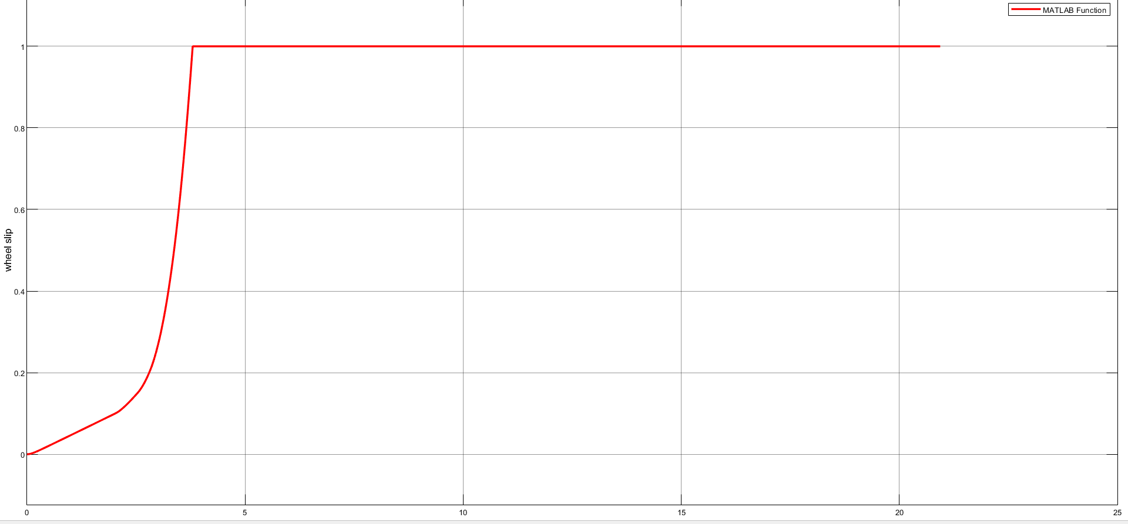

Disabled ABS system

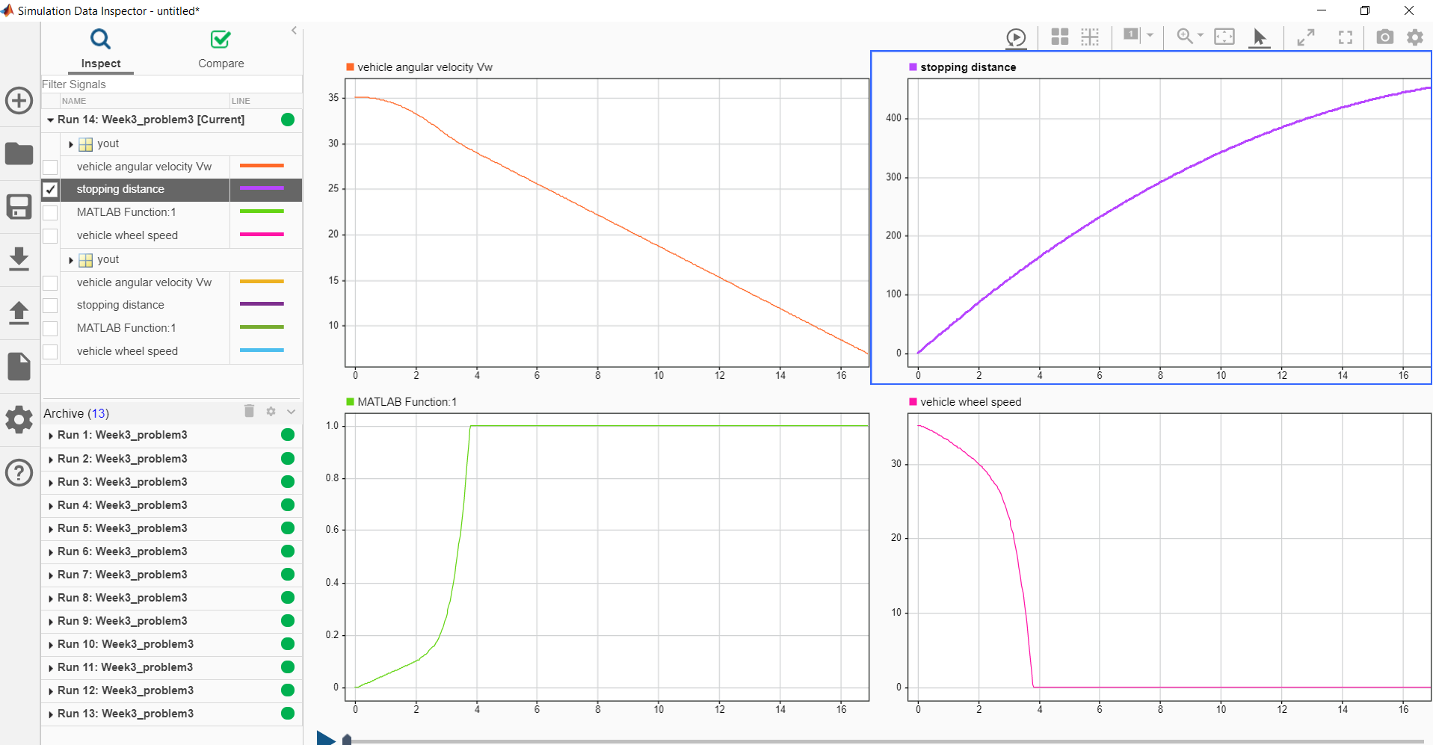

Enabled ABS System

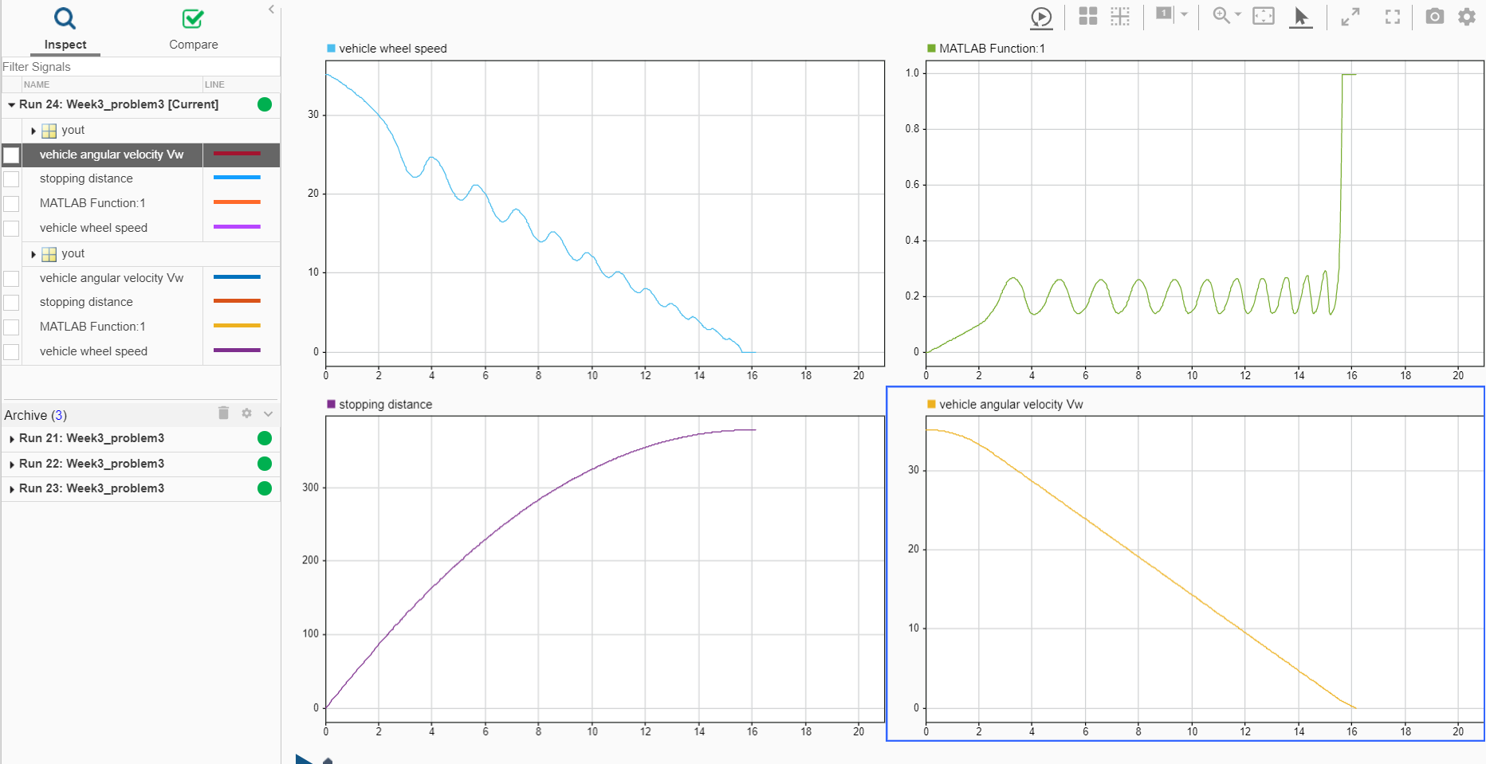

Data inspector comparison for with disabled and enabled ABS system

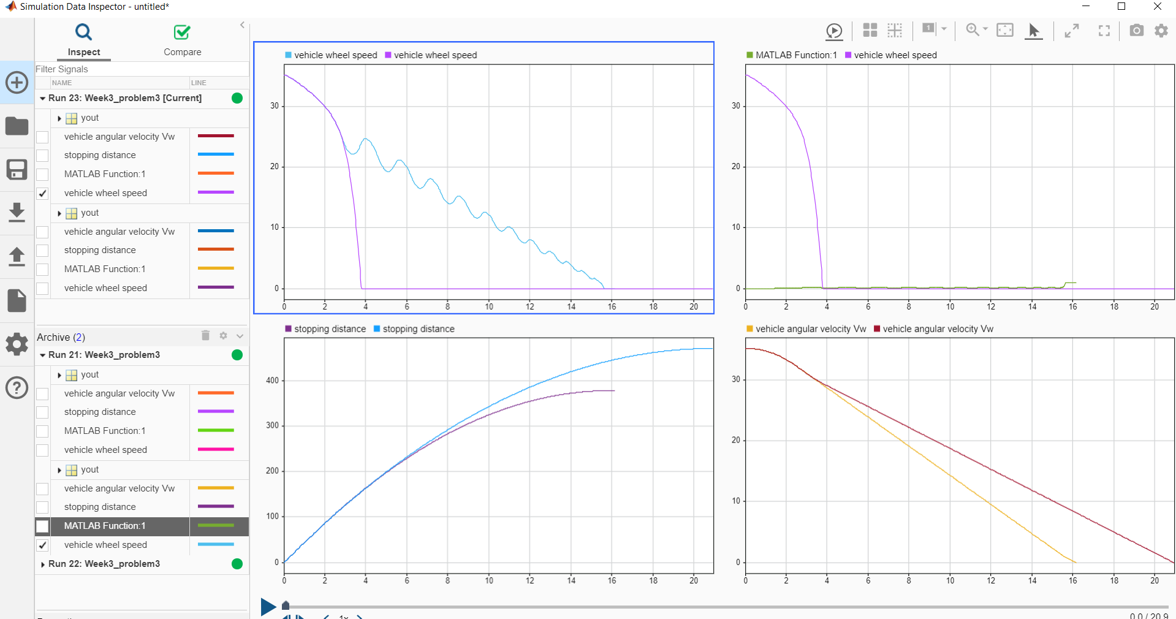

In the plot showing vehicle speed and wheel speed, observe that the wheel locks up in about seven seconds. The braking, from that point on, is applied in a less-than-optimal part of the slip curve. That is, when slip = 1, as the slip plot shows, the tire is skidding so much on the pavement that the friction force has dropped off.

This is, perhaps, more meaningful in terms of the comparison shown below. The distance traveled by the vehicle is plotted for the two cases. Without ABS, the vehicle skids about an extra 100 feet, taking about three seconds longer to come to a stop.

**Conclusion:**

This model shows how you can use Simulink to simulate a braking system under the action of an ABS controller. The controller in this example is idealized, but you can use any proposed control algorithm in its place to evaluate the system's performance. This significantly reduces the time needed to prove new ideas by enabling actual testing early in the development cycle.

For a hardware-in-the-loop braking system simulation, you can remove the 'bang-bang' controller and run the equations of motion on real-time hardware to emulate the wheel and vehicle dynamics. You can do this by generating real-time C code for this model using the Simulink Coder. You can then test an actual ABS controller by interfacing it to the real-time hardware, which runs the generated code. In this scenario, the real-time model would send the wheel speed to the controller, and the controller would send brake action to the mode.

1. **Reference**

|  |  |
| --- | --- |
| [1] | https://in.mathworks.com/help/matlab/math/choose-an-ode-solver.html |
| [2] | https://in.mathworks.com/help/simulink/callback-functions.html |
| [3] | https://in.mathworks.com/help/simulink/what-is-a-matlab-function-block.html |
| [4] | https://in.mathworks.com/help/simulink/ug/choose-a-solver.html |
| [5] | https://in.mathworks.com/help/simulink/ug/use-auto-solver-to-select-a-solver-1.html |
| [6] | https://in.mathworks.com/help/physmod/simscape/ug/setting-up-solvers-for-physical-models.html |
| [7] | https://x-engineer.org/projects/anti-lock-braking-system-abs-modeling-simulation-xcos/ |
| [8] | https://a-lab.ee/edu/sites/default/files/ABS%20System%20Control.pdf |