Main Screen:

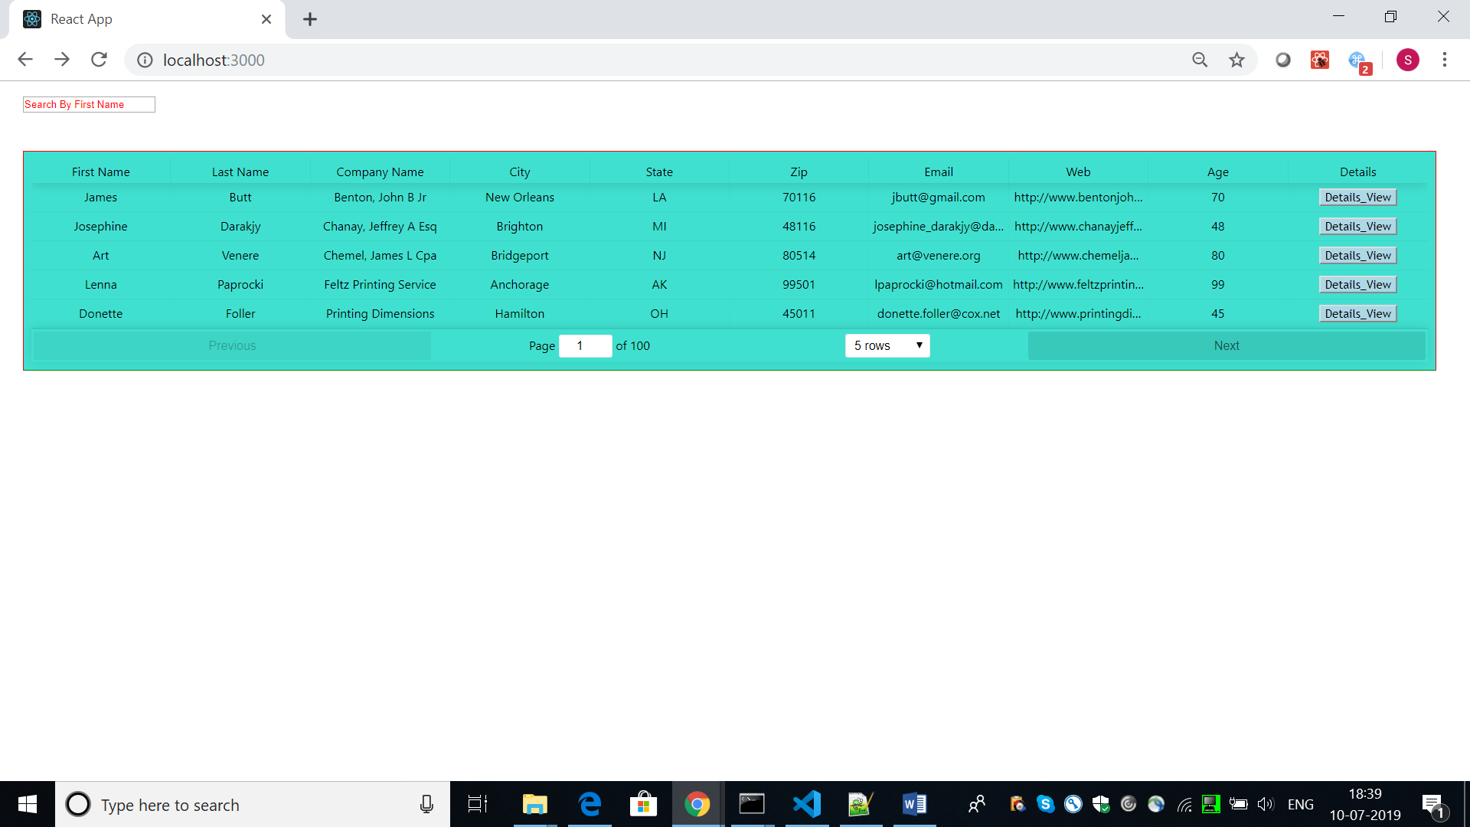

Filtered Data(on the basis of first_name):

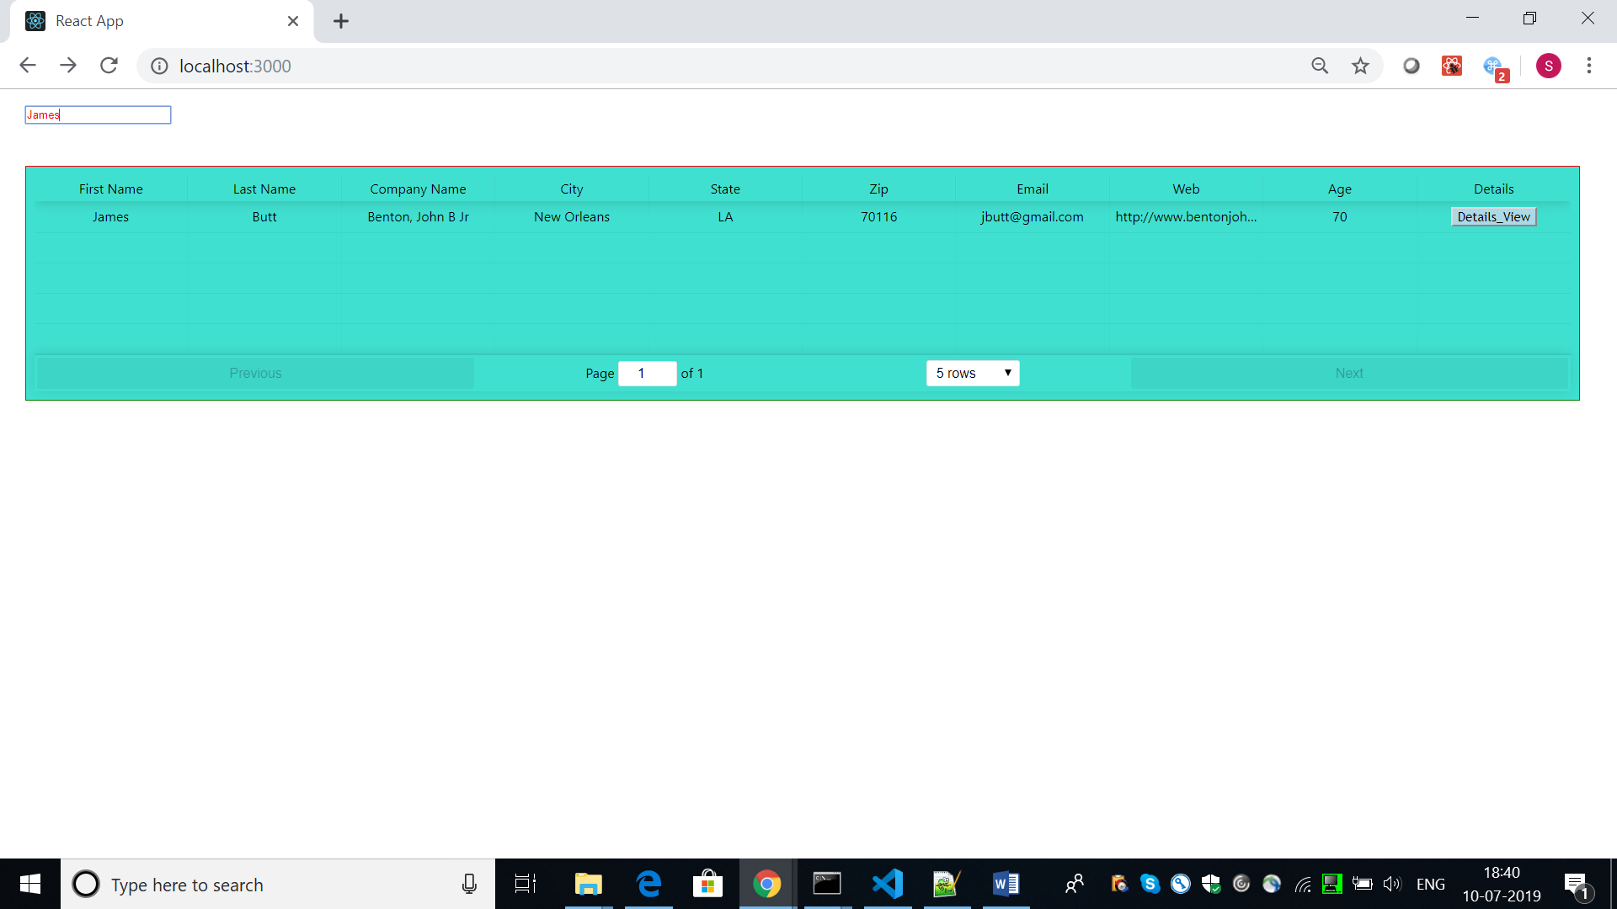

Sorted Data(on the basis of First Name):

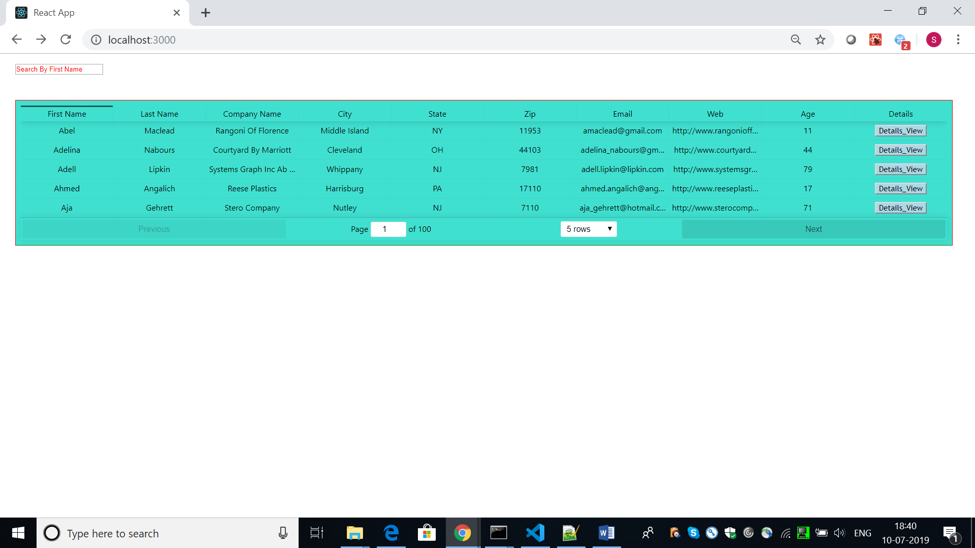

The same has been implemented for all the columns.

Pagination Implemented:

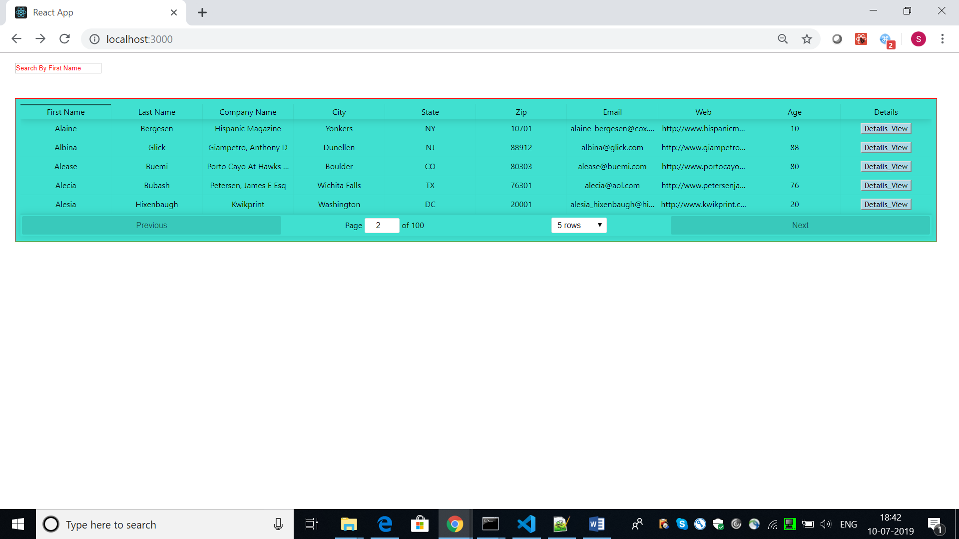

Detailed View (with the changes in the url):

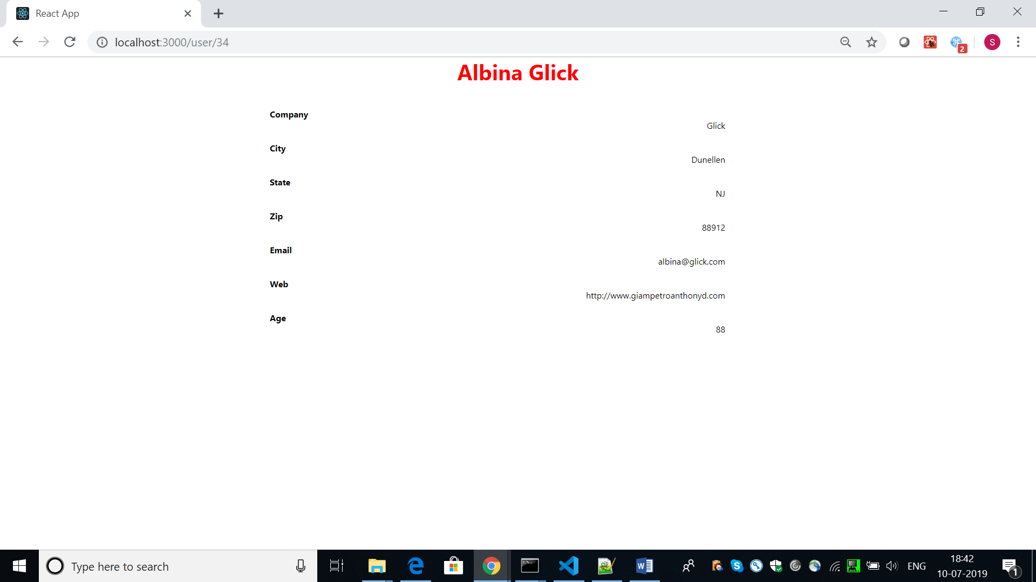

On clicking of back, finally the original screen.

