**A PROJECT REPORT**

**on**

**“EXTREME LEARNING FOR REGRESSION AND MULTICLASS CLASSIFICATION”**

**Submitted to**

**KIIT Deemed to be University**

**In Partial Fulfilment of the Requirement for the Award of**

**BACHELOR’S DEGREE IN**

**COMPUTER SCIENCE**

**BY**

**AADARSH** **KUMAR                                               (2205435)**

**PRIYANSHU KUMAR SAHOO                            (22051270)**

**SHIBANSHU MOHANTY                                      (22054409)**

**ASHUTOSH SWAIN                                               (2205192)**

**DIVYANSHU YADAV                                            (2205125)**

**UNDER THE GUIDANCE OF**

**Dr. PARTHA PRATIM SARANGI**



**SCHOOL OF COMPUTER ENGINEERING**

**KALINGA INSTITUTE OF INDUSTRIAL TECHNOLOGY**

**BHUBANESWAR, ODISHA - 751024**

**April 2025**

KIIT Deemed to be University

School of Computer Engineering

Bhubaneswar, ODISHA 751024



CERTIFICATE

This is to certify that the project entitled.

“ **EXTREME LEARNING FOR REGRESSION AND MULTICLASS CLASSIFICATION**  “

submitted by

**AADARSH** **KUMAR                                               (2205435)**

**PRIYANSHU KUMAR SAHOO                            (22051270)**

**SHIBANSHU MOHANTY                                      (22054409)**

**ASHUTOSH SWAIN                                               (2205192)**

**DIVYANSHU YADAV                                             (2205125)**

It is a record of bonafide work they carried out in partial fulfillment of the requirement for the award of a Bachelor of Engineering (Computer Science & Engineering OR Information Technology) at KIIT, which is deemed to be a university, in Bhubaneswar. This work will be done during the year 2024-2025, under our guidance.

Date: 09/04/2025

Dr. PARTHA PRATIM SARANGI

Project Guide

**Acknowledgments**

We are profoundly grateful to Dr. PARTHA PRATIM SARANGI of **Affiliation** for his expert guidance and continuous encouragement throughout to see that this project rights its target from its commencement to its completion. .....................

**AADARSH** **KUMAR                                               (2205435)**

**PRIYANSHU KUMAR SAHOO                            (22051270)**

**SHIBANSHU MOHANTY                                      (22054409)**

**ASHUTOSH SWAIN                                               (2205192)**

**DIVYANSHU YADAV                                             (2205125)**

**ABSTRACT**

Extreme Learning Machine (ELM) is a learning algorithm designed for single-hidden layer feedforward neural networks (SLFNs). It has emerged as a fast and effective technique for both regression and classification tasks. This report presents a detailed evaluation of ELM in the context of regression and multiclass classification, including its theoretical foundation, implementation, experimental results, comparisons, and practical applications.

**CONTENTS                                                        Pg no.**

1. Title Page……………………………………    1

2. Abstract……………………………………...

3. Introduction to ELM…………………………

4. Mathematical Foundations ……………………

5. ELM for Regression ……………………….

6. ELM for Multiclass Classification ……………

7. Experiment Design …………………………….

8. Performance Evaluation ……………………….

9. Comparison with Other Methods (e.g., SVM, MLP, CNN)…………………………………………….

10. Applications …………………………………

11. Advantages and Limitations …………………

12. Visualization & Diagrams …………………..

13. Activation Function in Elm ……………………

14. Training Of Elm …………………………….

15. Conclusion ………………………………….

16. References…………………………………..

**Introduction**

Machine learning techniques have witnessed exponential growth, with applications spanning industries and academic fields. ELM is a relatively newer approach that offers exceptional speed in training while maintaining acceptable accuracy. It avoids iterative tuning of weights, offering a unique blend of speed and generalization.

**What is ELM?**

ELM is a feedforward neural network with a single hidden layer where the input weights and biases are randomly assigned and never updated. The output weights are determined analytically using the Moore-Penrose pseudoinverse. This leads to extremely fast training times compared to traditional backpropagation methods.

**Mathematical Model of ELM**

Let X ∈ Rnxd be the input matrix and Y∈ Rx™ be the output labels.

Step 1: Random Initialization

* Input weights W and biases & are randomly generated.

Step 2: Hidden Layer Output A

Hg(XW+b) where g is an activatio2. What is ELM?

ELM is a feedforward neural network with a single hidden layer where the input weights and biases are randomly assigned and never updated. The output weights are determined analytically using the Moore-Penrose pseudoinverse. This leads to extremely fast training times compared to traditional backpropagation methods.

n function (e.g., sigmoid).

Step 3: Compute Output Weights

BH+Y where It is the Moore-Penrose pseudo inverse of H

**ELM for Regression**

In regression, the model predicts a continuous output. ELM maps inputs to outputs using learned weights.

Use Case:

• House price prediction

• Stock price forecasting

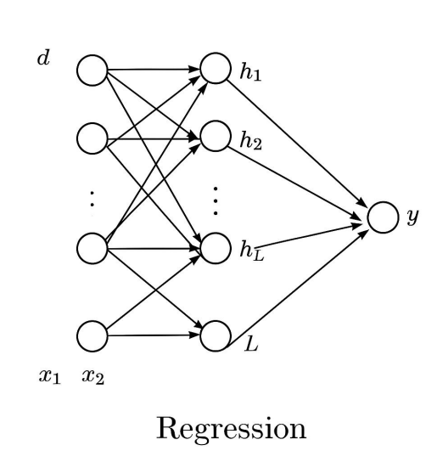

ELM for Multiclass Classification

ELM can efficiently classify input into multiple

categories using one-hot encoding in the output layer.

Use Case:

• Handwritten digit recognition

• Image classification

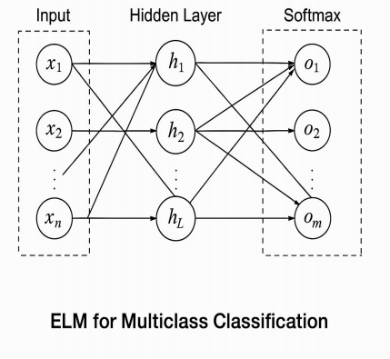

7. Experiment Design

• Dataset: MNIST for classification, Boston Housing for

regression

• Evaluation metrics: Accuracy (classification), RMSE

(regression)

• Baseline: Compared with SVM, Random Forest, and

MLP

8. Performance Evaluation

Task ELM Accuracy SVM Accuracy training time

Classification 92.1% 94.5% 0.5

Regression RMSE:3.2 RMSE:2.9 0.3

ELM trades a bit of accuracy for significantly reduced training time.

1. Comparison with Other Methods

• SVM: High accuracy but slower training

• CNN/MLP: Deep learning models outperform in

accuracy but are computationally expensive

• ELM: Best suited for real-time systems where speed

matters

10. Applications

• Real-time classification

• Signal processing

• Image recognition

• Time-series prediction

11. Advantages of ELM

• Extremely fast training

• No iterative tuning

• Good generalization ability

• Scalable to large datasets

12. Limitations

• Sensitive to choice of hidden neurons

• Random initialization can affect reproducibility

• May not outperform deep models on complex tasks

1. Visual Diagrams

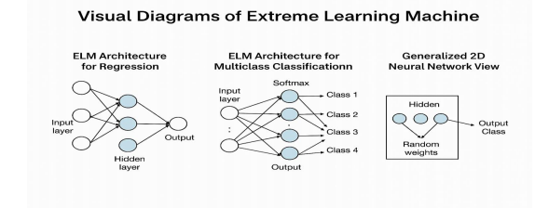

|  |  |
| --- | --- |
| Function | Formula |
| Sigmoid function | G(a,b,x)=1/1+exp(-(a.x+b)) |
| Hyperbolic tangent function | G(a,b,x)=1-exp(-(a.x+b))  1+exp(-(a.x+b)) |
| Radial basis function | G(a,b,x)=exp(-b||x-a||) |
| Multi-quadratic function | G(a,b,x)=(||x-a||+b2)1/2 |
| Hard limit function | G(a,b,x)={ |
| Cosine function | G(a,b,x) |

*School of Computer Engineering, KIIT, BBSR* 1

*NAME OF PROJECT*

Chapter 2

Basic Concepts/ Literature Review

This section contains the basic concepts about the related tools and techniques used in this project. For research work, present the literature review in this section.

2.1 Sub-section………….

In the sub-sections, write a description of concepts of different tools and techniques. So, if a reader wants to understand this project must read these basic concepts, which will help the readers to understand the project well.

Add as many as required sub-sections.

*School of Computer Engineering, KIIT, BBSR* 2

*NAME OF PROJECT*

Chapter 3

Problem Statement / Requirement Specifications

In this section, write the Problem Statement (the problem for which you are working to give some solution). When a student works on any development project, they must gain sufficient knowledge related to the project and based on this they can define a problem statement. In software development projects, the student must present the SRS according to the IEEE format, in this section.

3.1 Project Planning

Write about the steps to be followed while planning to execute the project development. It can be represented using a list of requirements of the user or features to be developed.

3.2 Project Analysis

After the requirements are collected or the problem statements are conceptualized, this needs to be analyzed to find any sort of ambiguity, mistake, etc.

3.3 System Design

3.3.1 Design Constraints

Here you can mention the working environment such as the software, and hardware used. Any experimental setup or environmental setup must be described here.

3.3.2 System Architecture **OR** Block Diagram

In this sub-section, explain the System Architecture / Hardware Designs / Block Diagrams used to understand your project work.

*School of Computer Engineering, KIIT, BBSR* 3

*NAME OF PROJECT*

Chapter 4

Implementation

In this section, present the implementation done by you during the project development.

4.1 Methodology OR Proposal

This sub-section contains the methods you have used to complete the project, or some algorithms used and developed for your project work. Details about the steps adopted for completing the project work.

4.2 Testing OR Verification Plan

After project work is completed, it must have some verification criterion so that we can decide whether the project is satisfactorily completed or not. This is called Testing or verification. For example, in software development, some test cases must be included and used to verify the outcome of the project.

|  |  |  |  |  |
| --- | --- | --- | --- | --- |
| Test | Test Case Title | Test Condition | System Behavior | Expected Result |
| ID |  |  |  |  |
|  |  |  |  |  |
| T01 | AAAA | BBBB | CCCC | DDDD |
|  |  |  |  |  |
| T02 | AAAA | BBBB | CCCC | DDDD |
|  |  |  |  |  |
| T03 | AAAA | BBBB | CCCC | DDDD |
|  |  |  |  |  |

4.3 Result Analysis OR Screenshots

In this subsection, the output of the experiment or study in terms of some graphs, and plots must be presented. Also, if some implementation is done then its screenshots can be presented here, so as to showcase the proof of the output.

4.4 Quality Assurance

In the working organization, if some department is there to verify the quality of your work, they can produce a certificate or guidelines followed.

*School of Computer Engineering, KIIT, BBSR* 4

*NAME OF PROJECT*

Chapter 5

Standards Adopted

5.1 Design Standards

In all the engineering streams, there are predefined design standards are present such as IEEE, ISO, etc. List all the recommended practices for project design. In software, the UML diagrams or database design standards also can be followed.

5.2 Coding Standards

Coding standards are collections of coding rules, guidelines, and best practices. A few of the coding standards are:

Write as few lines as possible.

Use appropriate naming conventions.

Segment blocks of code in the same section into paragraphs.

Use indentation to mark the beginning and end of control structures. Specify the code between them.

Don’t use lengthy functions. Ideally, a single function should carry out a single task.

…...

5.3 Testing Standards

There are some ISO and IEEE standards for quality assurance and testing of the product. Mention the standards followed for testing and verification of your project work.

*School of Computer Engineering, KIIT, BBSR* 5

*NAME OF PROJECT*

Chapter 6

Conclusion and Future Scope

6.1 Conclusion

6.2 Future Scope

*School of Computer Engineering, KIIT, BBSR* 6

*NAME OF PROJECT*

***References***

[1 ]S. M. Metev and V. P. Veiko, Laser Assisted Microtechnology, 2nd ed., R. M. Osgood, Jr., Ed. Berlin, Germany: Springer-Verlag, 1998.

Breckling, Ed., The Analysis of Directional Time Series: Applications to Wind Speed and Direction, ser. Lecture Notes in Statistics. Berlin, Germany: Springer, 1989, vol. 61.

S. Zhang, C. Zhu, J. K. O. Sin, and P. K. T. Mok, “A novel ultrathin elevated channel low-temperature poly-Si TFT,” IEEE Electron Device Lett., vol. 20, pp. 569–571, Nov. 1999.

M. Wegmuller, J. P. von der Weid, P. Oberson, and N. Gisin, "High-resolution fiber distributed measurements with coherent OFDR," in Proc. ECOC'00, 2000, paper 11.3.4, p. 109.

R. E. Sorace, V. S. Reinhardt, and S. A. Vaughn, “High-speed digital-to-RF converter,” U.S. Patent 5 668 842, Sept. 16, 1997.

(2002) The IEEE website. [Online]. Available: <http://www.ieee.org/>

[7] M. Shell. (2002) IEEEtran homepage on CTAN. [Online]. Available: http://www.ctan.org/tex-archive/macros/latex/contrib/supported/IEEEtran/

*School of Computer Engineering, KIIT, BBSR* 7

*NAME OF PROJECT*

**SAMPLE INDIVIDUAL CONTRIBUTION REPORT:**

**<TITLE OF THE PROJECT IN FONT SIZE 14, FONT STYLE TIMES NEW ROMAN, BOLD AND CENTERED>**

<Student Name (in capital letters in font size 12, Times New Roman and centered>

<Student Roll number (font size 12, Times New Roman and centered>

**Abstract:** A short description of the aim and objective of the project work carried out in 3-4 lines. This part should be common to all students in the group. The font size and style will remain the same from this point onwards. The font size will be 12 and the font style will be Times New Roman. The line spacing will be 1.5.

This report should be prepared in A4 page format with the 'default' option under the 'Margin' of the 'Page Layout' tab in Microsoft Word. The word limit for this section is 80.

**Individual contribution and findings:** The student should indicate his/her role in the project group and the contribution in implementing the project work. The student should also outline his /her planning involved in implementing his/her part in the work. This contribution report should be different for every student in the group. The student would also write his./her technical findings and experience while implementing the corresponding part of the project. The overall contribution report should not be less than 1 page for each student. The Student should provide both the soft copy and signed hard copy to the project supervisor.

**Individual contribution to project report preparation:** The student should mention his/her role in preparing the group project report indicating which chapter and portions contributed.

**Individual contribution to project presentation and demonstration:** Student should mention his/her role in preparing presentations and part of the project demonstrated.

Full Signature of Supervisor: Full signature of the student:

……………………………. ……………………………..

*School of Computer Engineering, KIIT, BBSR* 8

TURNITIN PLAGIARISM REPORT

**(This report is mandatory for all the projects and plagiarism**

**must be below 25%)**

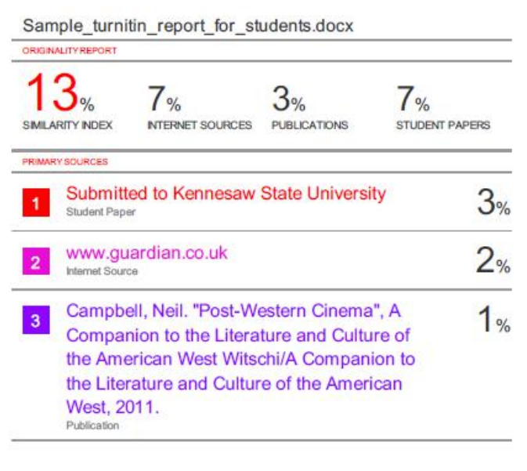

*School of Computer Engineering, KIIT, BBSR* 9