**LockedMe.Com**

# Purpose

The purpose of this document is to define the scope of application called LockedMe.com with its features including searching, sorting, adding, and deleting files from a directory location. This document consists of information pertaining to planning of the application to deployment along with testing.

## Intended Audience and Reading Suggestions

This document is intended to guide users on how to use the digital application. The SRS consists of three parts: Project scope, features, design, and implementation considerations. This helps to walk through the process of using the application for user.

## Project Scope

This project is a digital application called LockedMe.com in which users can perform basic file operations like adding, searching, and sorting files. The objective is to communicate to the user efficiently and produce output in a readable format. The goal of the application is for the user to be able to quickly interpret the content and perform operations with ease. The future scope of the project is to include additional features such as role-based access and approval for performing such operations.

## Product Perspective

This digital application is the parents of the product family and it is a self-contained product. The operations can be performed within this application and no other dependencies are required. The commands to be performed by the user are interlinked with respect to the path specified as the root directory.

## Product Features

1. Set a root directory: To specify a path to perform file operations
2. Display list of files: To display list of files in the chosen file directory
3. Add files: To add or create files to a specified file path
4. Delete files: To delete files with respect to the file path
5. Search: To search for files when keywords are specified
6. History: To display list of commands performed
7. Clear: Clears the command line interface of past actions/commands
8. Main: To go to the main window containing basic details of the application as well as the developer
9. Exit: To exit the application

**Sprint Details**

Sprint 1:

* Welcome screen was developed for the LockedMe.com Project.
* As the user should be provided with Context that lists the options which can be performed by the user such as Add, Delete, Search for files, Sort the files in ascending and descending order, move to the main menu, clear and close the application are displayed.
* User is given access to add a file
* User is given access to delete a file
* An error message will be displayed if the user enters a wrong format or command
* File Not Found message will be displayed if the user tries to access file that doesn’t exists

Sprint 2:

* User is provided with the access to search for the files using the command mentioned.
* User has the access to sort the files in ascending and descending order
* File names should be case sensitive

Sprint 3:

* User gets the expected result upon entering correct command
* User gets error message result upon entering incorrect command or format
* User gets to move to the Main context screen to view the options available
* User can find the history of commands used in the session
* User can close the application when required using the command

Jira Sprint details

Sprint 1:

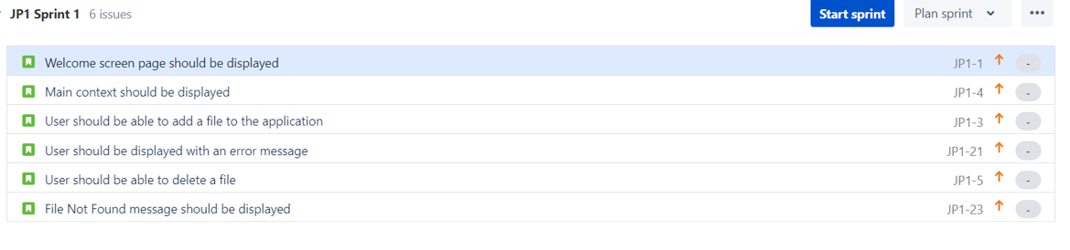



Sprint 2:

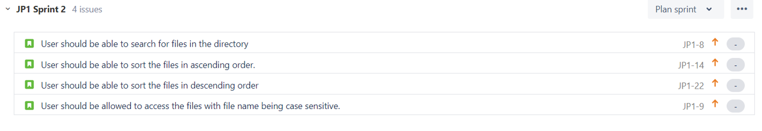

Sprint 3:

