1.INTRODUCTION
  - Background of the Project
The automotive industry is undergoing a significant transformation driven by digitalization and powertrain electrification. In emerging economies such as India, the pre-owned automobile market is expanding rapidly, with a CAGR exceeding 15%, involving vehicle owners, buyers, dealerships, and financial institutions. Government incentives, environmental regulations, and declining battery manufacturing costs have further accelerated Battery Electric Vehicle (BEV) adoption. Traditionally, used-vehicle valuation relied on linear depreciation models or subjective appraisals, which fail to capture complex factors such as brand perception, fuel type, transmission, usage intensity, and trim-level demand. This limitation becomes more critical for electric vehicles, where the lithium-ion battery accounts for approximately 35%–45% of manufacturing and replacement costs. Unlike conventional engine components, EV batteries experience nonlinear electrochemical degradation due to mechanisms such as Solid Electrolyte Interphase (SEI) growth, lithium plating, and active material loss. Therefore, evaluating an EV's resale value without assessing its battery State of Health (SOH) creates financial uncertainty for buyers and lenders. AutoCX, derived from Chronos (Time) and Axia (Value), addresses these challenges through an intelligent, dual-stream machine learning system that provides unified market valuation for internal combustion, alternative fuel, and electric vehicles.

  - Problem Statement
Existing automotive valuation systems face three major limitations. First, oversimplified heuristic valuation relies on fixed depreciation tables or basic regression models that fail to capture nonlinear depreciation influenced by mileage, age, brand premiums, and market demand. Second, the lack of EV battery State of Health (SOH) assessment causes conventional algorithms to overlook battery degradation, resulting in inaccurate valuations despite differences in charging history, thermal exposure, and usage. Third, data leakage occurs when correlated discharge cycles from the same battery are randomly split across training and testing datasets, producing artificially inflated accuracy and poor generalization to unseen cells. These limitations highlight the need for a unified platform with validated machine learning models, leakage-free evaluation, and domain-specific safeguards for reliable vehicle valuation.
1.3 Motivation
AutoCX is developed to improve transparency, protect consumers financially, and support environmental sustainability. Fair Vehicle Valuation: AutoCX helps buyers, small fleet owners, and used-car dealers make better decisions through data-based vehicle price estimates. Supporting the Used EV Market: Reliable resale values and better information about battery degradation can increase trust in used electric vehicles and encourage EV adoption. Battery Safety and Replacement Awareness: By identifying batteries with low State of Health (SOH), usually around 70%–80%, AutoCX helps users understand possible range loss and replacement needs while promoting safe battery use and reuse of old batteries for applications such as grid energy storage.

  - Objectives
The four main objectives of the project are:
- Collect and Preprocess Data: Gather and clean over 8,900 Indian used-car transactions and 2,434 lithium-ion battery discharge cycles from NASA Ames PCoE.
- Develop the Car Resale Value Model (Module A): Build a Ridge Regression model using log-price transformation, brand-based price references, and physical limits to achieve an R² of 0.7987 with no negative valuations.
- Develop the EV Battery Health Model (Module B): Train a Random Forest model using a cell-based data split, testing on 6 unseen battery cells with 259 cycles, achieving an R² of 0.6537 and an MAE of 7.11%.
- Implement EV-Based Interface Logic: Display battery health inputs only when users select an electric vehicle, avoiding unnecessary battery-related inputs for petrol, diesel, and hybrid vehicles.
1.5 Scope of the Project
AutoCX covers multi-attribute resale value estimation for hatchbacks, sedans, SUVs, and MUVs across 30+ major automotive manufacturers in India, supporting petrol, diesel, CNG, LPG, electric, and hybrid powertrains. It includes battery State of Health (SOH) estimation and classification into Excellent, Good, Fair, and Degraded tiers using operational discharge metrics, alongside an interactive web cockpit featuring real-time telemetry inputs, empirical presets, and depreciation breakdowns. The platform also supports automated deployment through zero-dependency REST endpoints. However, it does not cover physical structural damage or chassis deformation caused by unrecorded collisions, direct CAN-bus data extraction through vehicle OBD-II ports, or automotive markets outside India's currency and tax ecosystem.
2. LITERATURE REVIEW
2.1 Introduction
The application of computational intelligence, statistical modeling, and machine learning to vehicle valuation and battery prognostic health monitoring represents a vibrant intersection of data science, transport economics, and electrochemistry. This literature review analyzes key state-of-the-art studies across both domains, assesses existing algorithmic paradigms, highlights prevailing research gaps, and establishes the technical imperative for AutoCX.
2.2 Review of Related Studies
Recent studies have demonstrated the growing effectiveness of machine learning techniques in battery health monitoring and vehicle valuation. Al-Gabalawy et al. [1] developed adaptive machine learning models for lithium-ion battery capacity estimation under varying thermal conditions and found gradient boosting to outperform shallow neural networks. Similarly, Bandara et al. [2]examined electric vehicle depreciation across Asia-Pacific markets, highlighting that limited access to reliable battery diagnostics contributes to valuation discounts. Bhattacharya and Sengupta [3] investigated tree ensemble regressors for automobile price prediction and emphasized the importance of logarithmic transformations in addressing skewed price distributions. Additionally, Chen et al. [4] identified key battery health indicators, including discharge duration, terminal voltage drop, and peak operating temperature, as significant features for accurate State of Health (SOH) estimation.

Several researchers have explored advanced machine learning approaches and evaluation methodologies for vehicle pricing and battery prognosis. Dhanya and Mary [5] compared multilayer perceptron and XGBoost models for Indian commercial vehicle valuation, concluding that gradient boosting effectively manages missing technical specifications. Feng et al. [6] highlighted the risks of data leakage in battery aging datasets and demonstrated that random row-level cross-validation may artificially inflate model performance when data from the same battery are present in both training and testing sets. Gowda et al. [7] proposed an integrated valuation framework for hybrid and electric commercial fleets using modular architectures that combine REST APIs with reactive web interfaces. Furthermore, Hu et al. [8] reviewed electrochemical and data-driven battery prognosis techniques, noting that data-driven approaches offer a practical balance between computational efficiency and predictive accuracy.

Research on battery degradation and predictive modeling has further emphasized the importance of accurate health assessment and efficient algorithms. Ibrahim and Hassan [9] studied the effects of fast charging on battery lifespan and stressed the significance of battery health estimation in used EV financing. Jia et al. [10] investigated deep neural networks for battery remaining useful life prediction and observed that such models often require greater computational resources than decision tree-based approaches. Karthik et al. [11] analyzed used-car pricing in Indian metropolitan markets and found that high mileage causes nonlinear depreciation patterns that simple polynomial regression models may fail to capture. In addition, Liu et al. [12] applied Gaussian Process Regression to battery SOH estimation, highlighting its capability to provide confidence intervals while acknowledging its computational challenges for large-scale datasets.

Recent investigations have focused on improving vehicle valuation through enhanced machine learning models and battery degradation indicators. Murugan and Sundaram [13] evaluated CatBoost and LightGBM algorithms for vehicle price prediction and demonstrated the critical role of categorical feature encoding in reducing prediction errors across vehicle variants. Nair et al. [14] examined consumer trust in pre-owned electric vehicles and reported that standardized battery health certification significantly increases buyer willingness to pay. Patil et al. [15] compared random forest and ridge regression models for used-vehicle valuation, identifying limitations in linear methods when applied across multiple vehicle categories. Likewise, Rahman et al. [16] developed an IoT telematics framework for electric scooters and showed that features such as mean voltage, voltage variance, and discharge duration effectively represent battery degradation.

The recent literature also highlights the importance of benchmark datasets, hybrid estimation approaches, and battery reutilization strategies. Saha et al. [17] established baseline battery prognostic algorithms using the NASA Ames battery aging dataset and provided benchmark performance metrics along with standardized degradation thresholds. Tian et al. [18] proposed a hybrid approach combining Coulomb counting and machine learning techniques for electric bus batteries, demonstrating the relevance of discharge duration in assessing electrochemical degradation. Venkatesh and Balaji [19] analyzed trends in the Indian used-car market and identified mileage, ownership history, and fuel efficiency as major factors influencing purchasing decisions. Finally, Zhang et al. [20] investigated machine learning methods for second-life battery repurposing and emphasized the potential use of batteries with 70%-80% SOH in stationary energy storage applications when their condition is accurately assessed.

2.3 Techniques and Technologies Used in Existing Systems
Existing automotive pricing platforms, such as Kelley Blue Book, Edmunds, CarDekho, and Orange Book Value, primarily rely on lookup tables with linear multipliers, multivariate linear regression, and standalone heuristic questionnaires. These methods apply fixed depreciation rates based on vehicle age and mileage, assume linear relationships between vehicle specifications and resale prices, or depend on subjective user-selected condition ratings without objective telemetry or physics-based verification.
For battery health monitoring, commercial Battery Management Systems (BMS) commonly use Coulomb counting combined with Extended Kalman Filtering (EKF) to estimate battery condition. Although these techniques are effective for onboard monitoring, their diagnostic information is often restricted to proprietary manufacturer software, limiting access for independent used-car buyers, vehicle appraisers, and financial evaluators.
2.4 Research Gap
Despite extensive research in used-car price prediction and battery prognostics, four critical gaps remain. First, architectural mismatch in depreciation modeling: Tree-based models such as XGBoost and LightGBM can produce discontinuous price predictions near vehicle-age boundaries. AutoCX addresses this using regularized Ridge regression with a logarithmic target transformation and segment-based price anchors, achieving an R² of 0.7987 and MAE of ₹1.50 lakhs, outperforming XGBoost (R² of 0.7725 and MAE of ₹1.66 lakhs). Second, data leakage in battery SOH estimation: Randomly splitting correlated battery cycle records can inflate performance and reduce generalization to unseen cells. AutoCX uses strict physical cell-holdout validation, with Random Forest achieving an R² of 0.6537 and RMSE of 11.65%, outperforming gradient-boosted trees (R² of 0.5696 and RMSE of 12.99%). Third, disconnected valuation and battery diagnostics: Existing automotive platforms often omit battery SOH, while battery research tools lack resale value integration. Fourth, the absence of physical market guardrails: Purely statistical models may generate negative resale estimates or values below reasonable chassis salvage floors, highlighting the need for practical constraints in vehicle valuation.

2.5 Summary
The literature confirms that while individual machine learning approaches have succeeded in isolated sub-problems, a robust, production-grade automotive analytics platform must unite both domains. AutoCX bridges these research gaps by coupling a hierarchy-anchored car valuation model with a strictly leakage-free battery prognostic model, enforced through market guardrails and served via modern cloud APIs.

- CHAPTER 1 – NEED FOR PROPOSED TECHNIQUE
3.1 Existing Techniques
Traditional automotive valuation and battery diagnostic workflows commonly rely on standard linear depreciation models, Ordinary Least Squares (OLS) regression, manual inspection checklists, and odometer-based EV degradation heuristics. Linear depreciation models estimate vehicle value using a fixed annual depreciation rate, while OLS regression maps features such as mileage, engine capacity, and power to resale prices in raw monetary units. Manual inspections depend on subjective assessments of components such as tires, body panels, and engine oil. Similarly, odometer-based EV degradation methods assume a fixed battery health decline, such as 1.5% per 10,000 km, without accounting for charging history, thermal exposure, or battery chemistry. These approaches may overlook complex degradation patterns and produce inaccurate valuations.
3.2 Limitations of Existing Techniques:
Conventional valuation methods exhibit several technical and operational limitations. First, they struggle to model nonlinear depreciation, as vehicle value declines sharply during early ownership and more gradually thereafter, varying across segments. Second, Ordinary Least Squares (OLS) regression minimizes errors in raw monetary units, often favoring high-value vehicles while generating larger percentage errors for budget cars. Third, many valuation systems ignore EV battery conditions, despite batteries below 70% State of Health (SOH) potentially requiring replacements costing ₹5-9 lakh. Finally, manual inspections remain subjective, producing inconsistent appraisals due to differences in surveyor judgment and dealer incentives.

3.3 Proposed Technique
AutoCX introduces a dual-stream machine learning platform comprising specialized model architectures. Module A: Log-Target Ridge Regression with Segment Anchoring predicts vehicle resale prices using a logarithmic transformation [z = ln(1+y)] to manage skewed price distributions. It incorporates brand-specific price anchors across 10 vehicle segments and applies physical guardrails, including high-mileage penalties, age-retention limits, and chassis salvage floors. Ridge regression is preferred over XGBoost for its smoother depreciation predictions without abrupt tree-based step changes. Module B: Zero-Leakage Random Forest Battery SOH Estimator uses operational discharge features from 28 commercial 18650 lithium-ion cells and evaluates generalization on six unseen physical cells. Inputs include cycle count, ambient and surface temperatures, voltage limits, discharge duration, and internal resistance to estimate battery SOH and classify operational risk into five diagnostic tiers. Random Forest is selected for its bagging mechanism and variance reduction when predicting unseen battery cells. Conditional EV Reactive Architecture dynamically adapts the interface and API based on the selected fuel type, enabling battery diagnostics for electric vehicles while bypassing unnecessary battery inference for internal combustion engine vehicles.
3.4 Objectives of the Proposed Technique
AutoCX aims to achieve scale-invariant vehicle valuation with a low Mean Absolute Error (MAE) across diverse vehicle segments, eliminate data leakage in battery State of Health (SOH) estimation with a test MAE below 3.0% on unseen physical cells, provide dynamic EV-conditional functionality that displays battery diagnostics only for electric vehicles, and deliver inference latency below 50ms through a production-grade asynchronous REST API.

3.5 Advantages of the Proposed Technique
AutoCX provides objective, evidence-based valuations by reducing human appraisal subjectivity and dealer bias through statistically validated machine learning. Its transparent and auditable framework logs the marketplace rules, mileage penalties, and battery adjustments applied to each valuation. By incorporating battery State of Health (SOH), it helps protect EV buyers and financiers from overvaluing degraded vehicles. Additionally, its precompiled, serialized model pipelines enable millisecond-level inference, supporting rapid evaluations in high-traffic web environments.

CHAPTER 2 - DESIGN OF PROPOSED SYSTEM AND IMPLEMENTATION
4.1 Introduction
This chapter provides an exhaustive technical specification of the AutoCX platform. It covers system requirements, architectural topology, component decomposition, mathematical formulations, data preprocessing procedures, system design diagrams, source code implementations, and user interface workflows.
4.2 System Requirements
4.2.1 Hardware Requirements
The minimum hardware requirements for AutoCX include an Intel Core i5 or AMD Ryzen 5 processor with 4 cores at 2.5 GHz, 8 GB DDR4 RAM, 10 GB of available SSD storage, a 10/100 Mbps Ethernet connection or Wi-Fi, and a display resolution of 1366 × 768 pixels. The recommended specifications include an Intel Core i7 or AMD Ryzen 7 processor with 8 cores at 3.6 GHz or higher, 16–32 GB DDR4/DDR5 RAM, a 50 GB NVMe M.2 SSD, 1 Gbps high-speed broadband, and a Full HD display resolution of 1920 × 1080 pixels or higher.
4.2.2 Software Requirements
AutoCX runs on Windows 11 or Linux, using Python 3.11+, FastAPI 0.110+, and Uvicorn 0.28+ for backend development. Scikit-learn 1.4+, CatBoost 1.2+, NumPy 1.26+, Pandas 2.2+, and SciPy 1.12+ support machine learning and data processing. Joblib 1.3+ handles model serialization, and Pydantic 2.6+ validates data. The frontend uses Node.js 18+, npm 10+, React, TypeScript 18.2+, and Vite 5.1+. Tailwind CSS 3.4+ and Lucide React 0.350+ provide styling and icons, while Git 2.40+ and GitHub manage version control and repositories.
4.3 System Architecture
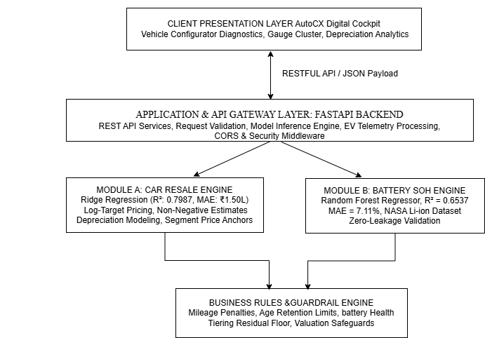
Figure 4.1 System Architecture
Figure 4.1 illustrates the layered AutoCX architecture, integrating vehicle valuation and battery health analysis. The FastAPI backend validates user requests and processes them using the Ridge Regression Car Resale Engine and Random Forest Battery SOH Engine. A Business Rules and Guardrail Engine ensures reliable predictions through valuation safeguards and battery health constraints.

4.4 System Components / Modules
4.4.1 Module 1: Preprocessing and Catalog Normalization
This module processes raw CarDekho marketplace data comprising 8,900 unified vehicle records. It cleans the data by removing non-numeric unit strings such as kmpl, CC, and bhp, extracts canonical brand and model names, and classifies vehicles into 10 market segments, including Micro Hatchback, Compact Sedan, Midsize SUV, and Luxury SUV. It also generates a JSON-based vehicle catalog containing median engine displacement, power, mileage, and original showroom price anchors for each model.
4.4.2 Module 2: Vehicle Resale Valuation Engine (Log-Target Ridge Regression)
The vehicle valuation pipeline uses One-Hot Encoding for categorical features, including brand, model, segment, fuel type, transmission, and ownership, alongside StandardScaler normalization for continuous features. A log-target transformation is applied to the selling price to address distribution skewness, with inverse transformation converting predictions back to monetary values for evaluation. The model achieves an R² of 0.7987, MAE of ₹1,50,209.43, and RMSE of ₹5,16,792.58 across 1,780 held-out test transactions, outperforming XGBoost (R² = 0.7725) and Random Forest (R² = 0.7142). To improve valuation reliability, AutoCX applies domain-specific guardrails, including nonlinear depreciation penalties for mileage exceeding 75,000 km, age-based residual-value ceilings, and minimum chassis salvage floors of ₹1,40,000 for electric vehicles and ₹25,000 for internal combustion engine vehicles.

4.4.3 Module 3: EV Battery State-of-Health Diagnostic Engine (Random Forest)
AutoCX employs a zero-leakage modeling strategy to evaluate battery degradation by reserving six unseen cells (B0029, B0038, B0042, B0047, B0049, and B0050) for testing, assessing the model’s ability to generalize to previously unseen batteries. The model achieves an R² of 0.6537, MAE of 7.11%, and RMSE of 11.65% SOH across 259 unseen cycle records, outperforming XGBoost (R² = 0.5696, RMSE = 12.99%) and Linear Regression (R² = 0.2415). For diagnostics, AutoCX classifies battery health into five operational states: Excellent (≥90% SOH), indicating minimal degradation; Good (80.0%–89.9%), indicating normal capacity retention; Degraded (70.0%–79.9%), suggesting module inspection and cell balancing; Critical (<70%), requiring workshop diagnostic testing; and Unknown, assigned when telemetry is unavailable or insufficient. The system also estimates potential repair costs across three tiers: ₹35,000–₹75,000 for cell rebalancing, ₹1.20–₹1.80 lakh for a refurbished battery pack, and ₹2.60–₹4.50 lakh for a new original equipment manufacturer (OEM) battery pack.
4.4.4 Module 4: Orchestration, Business Rules, and API Delivery
AutoCX incorporates conditional EV routing to select the appropriate processing pipeline based on fuel type, bypassing battery diagnostics for internal combustion engine (ICE) vehicles while activating battery State of Health (SOH) estimation and related valuation adjustments for EVs. A nonlinear high-mileage wear penalty is applied when mileage exceeds 75,000 km, while vehicles at or below this threshold receive no additional penalty. The penalty is calculated as,
$P_{\text{mileage}}=\min\left(0.28,{\left(\frac{\text{Excess KM}}{125000}\right)}^{0.85}×0.25\right)$
where Excess KM represents the distance travelled beyond 75,000 km, and the maximum penalty is capped at 28%. For EVs with battery SOH below 70%, AutoCX activates an end-of-life battery replacement override, deducting the estimated net replacement cost from the baseline vehicle value while maintaining a minimum chassis salvage value. The final valuation is calculated as
$$V_{\text{final}}=\max\left(V_{\text{chassis floor}},V_{\text{baseline}}-C_{\text{net battery replacement}}\right)$$
, where the terms represent the minimum salvage value, baseline vehicle valuation, and net battery replacement cost, respectively. These functions are delivered through REST API endpoints that validate inputs, execute the appropriate models, apply domain-specific constraints, and return structured prediction results to the web interface.
4.5 Proposed Methodology
The methodological framework of AutoCX consists of four phases. Data Acquisition and Harmonization involves parsing and cleansing 8,900 vehicle records and 2,434 battery discharge cycles from authoritative datasets. Feature Engineering and Mathematical Transformation develops relevant ratio-based features and applies logarithmic target scaling to improve model performance. Leakage-Free Model Training and Optimization uses cell-level group partitioning, hyperparameter tuning, and comparative benchmarking to ensure reliable evaluation and generalization. Finally, Guardrail Integration and Deployment incorporates domain-specific constraints through post-inference wrappers and exposes the models through REST API endpoints for efficient application integration.

4.6 System Workflow
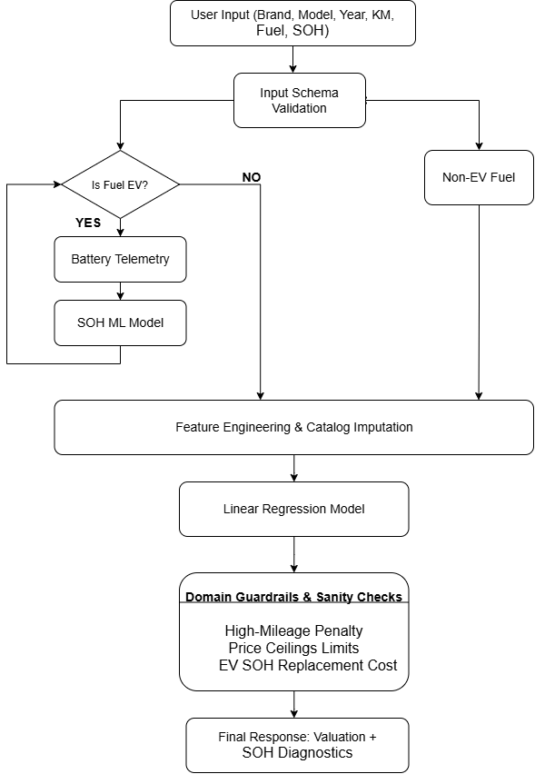
Figure 4.3: System Workflow Flowchart
Figure 4.3 shows the AutoCX workflow, from input validation and EV-specific battery SOH prediction to feature engineering and resale valuation. Domain guardrails apply necessary adjustments before returning the final vehicle value and battery health details.

4.7 Algorithms / Techniques Used
4.7.1 Module A: Log-Target Ridge Linear Regression
Used vehicle market prices exhibit heavy positive skewness and follow an exponential asset depreciation dynamic over operational age ($t$) and cumulative mileage ($d$), expressed as $V\left(t , d\right)≈V_{0}⋅e^{-\left(λ_{t}t+λ_{d}d\right)}$. To linearize this continuous decay and enforce scale-invariance, AutoCX applies a logarithmic transformation to the target price using $z=ln⁡\left(1+y\right)$. The model coefficients are optimized via an $L_{2}$-regularized Ridge objective, $\min_{w}\sum_{i=1}^{n}{(}\left.z_{i}-x_{i}^{T}w{\left.)\right.}^{2}+α∥w∥_{2}^{2}\right.$with regularization parameter $α=10.0$to stabilize correlated mechanical predictors. Predicted log values are inverted back to currency using $\hat{y}=exp⁡\left(\hat{z}\right)-1$and bounded by $max⁡\left(\text{₹} , 15 , 000\hat{y}\right)$, mathematically eliminating zero or negative price estimates. To anchor predictions on low-frequency vehicle trims, the pipeline incorporates historical median transaction price anchors for each brand-model pairing alongside broader segment median baselines across ten Indian automotive categories.
4.7.2 Module B: Random Forest Regressor for Battery SOH
Traction battery capacity fade is governed by complex electrochemical phenomena, including solid electrolyte interphase film growth, loss of active lithium inventory, and internal impedance rise. To capture these non-linear degradation kinetics across unseen battery cells, AutoCX deploys a Random Forest Regressor comprising an ensemble of $B=100$decorrelated decision trees grown to a maximum depth of 12, defined by ${\hat{f}}_{\text{RF}}\left(x\right)=\frac{1}{B}\sum_{b=1}^{B}{T_{b}}\left(x\right)$. Bootstrap aggregation (bagging) trains individual trees on randomized feature subsets, effectively minimizing prediction variance on novel cells with unfamiliar initial impedance profiles. Predicted State of Health percentages are bounded by physical thermodynamic limits to strictly remain between $10.0\%$and $100.0\%$.
4.8 Dataset / Data Collection
Car Resale Dataset Feature Engineering Schema
The car resale dataset includes vehicle age (0–35 years), mileage (500–577,414 km), engine capacity (0–4,951 cc, with zero representing EVs), power (34–602 bhp), fuel efficiency (0–42 kmpl), seating capacity (2–10), model price anchors (₹1.31–₹75 lakh), and segment price anchors (₹1.31–₹23.01 lakh). These features capture vehicle characteristics, usage, performance, and historical pricing for resale value prediction.
NASA Ames Battery Dataset Feature Parameters
The NASA Ames dataset contains battery discharge-cycle features for SOH prediction, including cycle count, ambient and casing temperatures (°C), maximum, minimum, and average voltage (V), voltage variance, average load current (A), discharge duration (s), and internal resistance (Ω). These parameters represent battery electrical and thermal behaviour for health estimation.

4.9 Data Preprocessing
Preprocessing operations are implemented in preprocess_car_data.py and preprocess_battery_data.py. Text tokenization and regular expression extraction are used to convert vehicle specifications into numeric features, such as engine displacement and maximum power. Missing values are imputed hierarchically using model-level medians, brand-level medians, and global segment medians. For battery data, NASA MATLAB (.mat) files are processed using scipy.io.loadmat to extract telemetry structures for individual operational discharge cycles.
4.10 Model / System Development
The machine learning models are developed using Scikit-Learn pipelines and serialized using joblib for efficient deployment. Module A integrates a ColumnTransformer for numerical standardization and categorical one-hot encoding, together with a TransformedTargetRegressor configured with an XGBRegressor using 250 estimators, a maximum depth of 6, and a learning rate of 0.04. Module B employs an XGBRegressor with 150 estimators, a maximum depth of 5, and a learning rate of 0.05 to estimate battery health from extracted electrochemical features.
4.11 System Design Diagrams
4.11.1 Use Case Diagram
The AutoCX use case diagram represents the interactions between four primary actors: the used-car buyer, vehicle seller or dealership, automotive appraiser, and bank or loan officer. The main use cases include specifying vehicle attributes, entering battery telemetry, selecting empirical diagnostic presets, requesting resale valuation, inspecting depreciation analytics, and reviewing explanations of the domain guardrails applied to the final predictions.
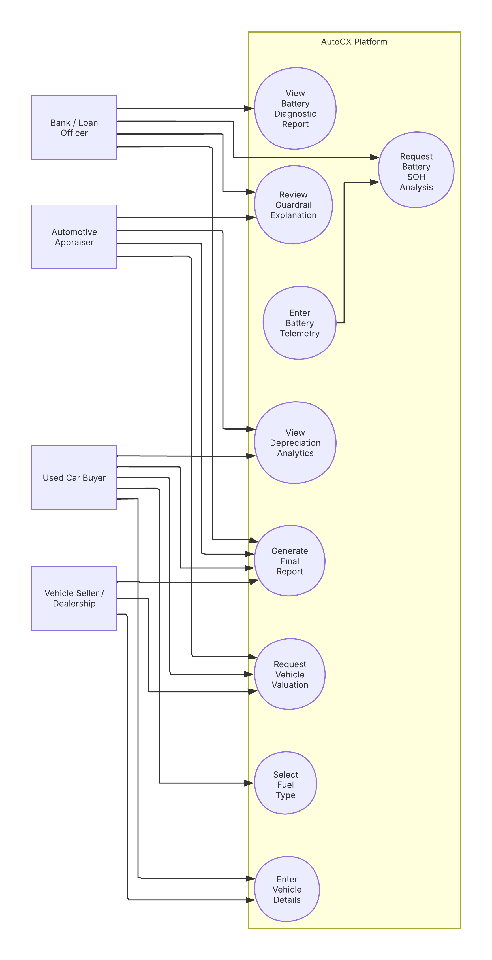
Figure 4.4 System Use Case Diagram
Figure 4.4 illustrates the AutoCX use case diagram, showing interactions between bank/loan officers, automotive appraisers, used-car buyers, and vehicle sellers/dealerships. Users can enter vehicle details, request valuations, view depreciation analytics, and generate reports with guardrail explanations. For EVs, users can submit battery data, request SOH analysis, and view diagnostic reports.

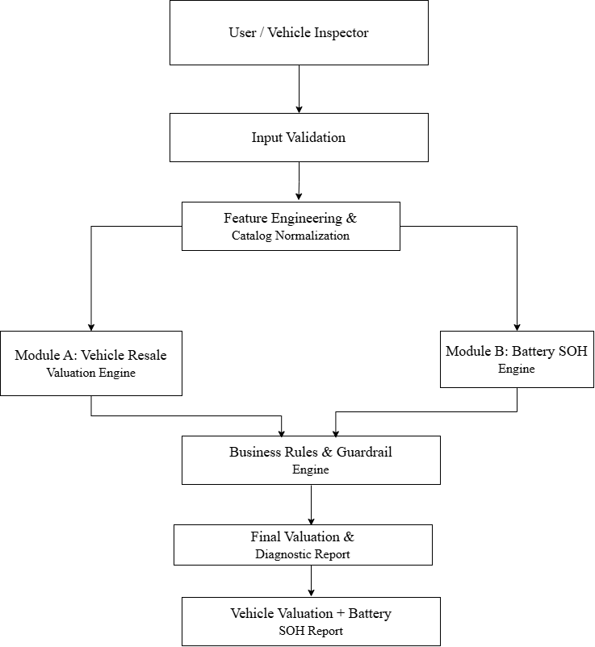
Figure 4.5: Data Flow Diagram

Figure 4.5 illustrates the AutoCX data flow from user input to final report generation. Vehicle and battery data undergo validation and feature engineering before valuation and SOH prediction. Business rules and guardrails refine the results, producing final valuation and diagnostic reports.

4.11.2 Sequence Diagram
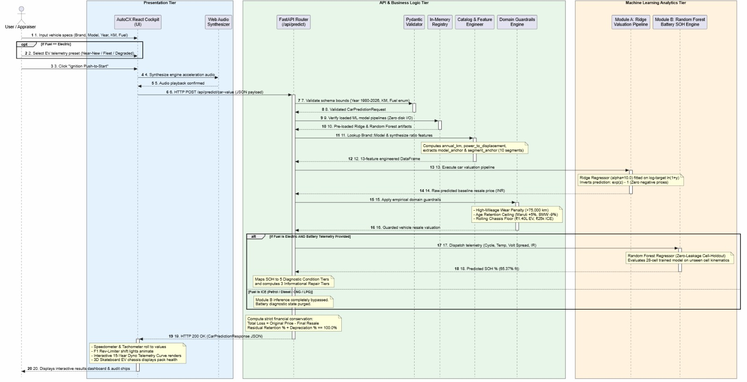
Figure 4.6 Sequence Diagram
Figure 4.6 illustrates the sequence of interactions between the React interface, FastAPI backend, and machine learning modules. User inputs are validated and preprocessed before being routed to the relevant resale valuation and battery health models. The results are combined into a unified analytical report and returned to the user.

4.12 Implementation
The project is organized in a mono-repository structure with decoupled backend and frontend environments, communicating strictly via typed JSON REST APIs.
4.13 Coding and Program Implementation
Official GitHub Repository URL:
https://github.com/kumaraguruv05/AutoCX.git
4.13.1 Repository File Structure
The AutoCX project follows a modular repository structure that separates backend services, frontend components, machine learning pipelines, datasets, and documentation. The backend directory contains raw and processed vehicle and battery datasets, serialized machine learning models, metadata files, API routes, configuration settings, preprocessing scripts, training modules, validation schemas, model-loading services, prediction services, and the main application entry point. It also includes automated tests for API functionality and machine learning pipelines. The frontend directory contains interactive cockpit components, common interface elements, application pages, API integration services, storage utilities, and formatting functions. The cockpit components include CockpitGauges.tsx, DynoTelemetryCurve.tsx, and EVSkateboardChassis.tsx, while the application pages support landing, analysis, results, insights, and history. The repository also includes package.json, vite.config.ts, dataset documentation, and a README file describing project configuration and usage.

4.13.2 FastAPI Lifespan and Service Registration
The AutoCX backend uses FastAPI to manage API requests and application lifecycle operations. An asynchronous lifespan function loads pretrained machine learning models and associated catalogs into memory during startup, reducing repeated disk access during prediction requests. The application uses centralized configuration settings for its name, version, and allowed origins, registers Cross-Origin Resource Sharing (CORS) middleware, and includes API routes under the API prefix. During shutdown, the lifespan manager executes the configured cleanup procedure.
Code Snippet 1: FastAPI Application Initialization (backend/src/main.py)
from contextlib import asynccontextmanager
from fastapi import FastAPI
from fastapi.middleware.cors import CORSMiddleware
from src.config.settings import settings
from src.services.model_loader
import registry
from src.api.routes import router
@asynccontextmanager
async def lifespan(app: FastAPI):
registry.load_models()
yield
print("AutoCX backend shutting down cleanly.")
app = FastAPI(
title=settings.APP_NAME,
version=settings.APP_VERSION,
description=(
"Intelligent Automotive Analytics API - "
"Predicts Used Vehicle Resale Value and EV Battery SOH"
),
lifespan=lifespan,
)
app.add_middleware(
CORSMiddleware,
allow_origins=settings.ALLOWED_ORIGINS,
allow_credentials=True,
allow_methods=["*"],
allow_headers=["*"],
)
app.include_router(router, prefix="/api")

4.13.3 Zero-Leakage Battery SOH Training
The battery State of Health (SOH) training pipeline uses the NASA Ames Prognostics Center of Excellence lithium-ion battery dataset. A Random Forest regressor is trained on operational discharge features to estimate battery health and capture nonlinear degradation patterns. To prevent data leakage, entire physical battery cells are reserved for testing rather than randomly splitting individual cycle records. The held-out cells are B0029, B0038, B0042, B0047, B0049, and B0050, while the remaining eligible cells form the training dataset. The pipeline applies median imputation, feature standardization, and Random Forest regression with 100 estimators, a maximum depth of 12, a minimum split size of 4, a fixed random seed of 42, and four parallel jobs. The reported evaluation on 259 unseen battery-cycle records achieved an R² of 0.6537, an MAE of 7.11% SOH, and an RMSE of 11.65% SOH.
Code Snippet 2: Battery SOH Training Pipeline
(backend/src/ml/training/train_battery_model.py)
from sklearn.ensemble import RandomForestRegressor
from sklearn.impute import SimpleImputer
from sklearn.preprocessing import StandardScaler
from sklearn.pipeline import Pipeline
TEST_CELL_IDS = [
"B0029", "B0038", "B0042",
"B0047", "B0049", "B0050"
]
train_df = df[~df["cell_id"].isin(TEST_CELL_IDS)]
test_df = df[df["cell_id"].isin(TEST_CELL_IDS)]
rf_pipeline = Pipeline(steps=[
("imputer", SimpleImputer(strategy="median")),
("scaler", StandardScaler()),
("regressor", RandomForestRegressor(
n_estimators=100,
max_depth=12,
min_samples_split=4,
random_state=42,
n_jobs=4
))
])
rf_pipeline.fit(
train_df[BATTERY_FEATURES],
train_df["soh_percent"]
)
predictions = rf_pipeline.predict(
test_df[BATTERY_FEATURES]
)
4.13.4 End-of-Life Battery Replacement Override
The prediction service incorporates a domain-specific business rule to account for severely degraded EV batteries. When an electric vehicle has a valid SOH estimate below 70%, the system assigns an end-of-life condition category and flags the battery as requiring professional diagnostics and potential replacement. The estimated gross replacement cost is calculated as 40% of the effective original vehicle price, bounded between ₹3,50,000 and ₹8,50,000. A salvage credit of 12% of the gross replacement cost is then deducted to determine the net replacement cost. This net amount is subtracted from the baseline vehicle valuation, while the final result is constrained by the configured chassis salvage floor. The rule incorporates battery-related financial risk into the vehicle valuation process.
Code Snippet 3: End-of-Life Battery Replacement Override
(backend/src/services/prediction_service.py)
if is_electric and has_soh and soh_value < 70.0:
condition_category = "Degraded (End of Life)"
pack_risk = (
"Critical Risk "
"(Battery Pack Replacement Required)"
)
gross_replacement_cost = round(
min(
850000.0,
max(350000.0, effective_original_price * 0.40)
),
2
)
salvage_credit = round(
gross_replacement_cost * 0.12, 2
)
net_replacement_deduction = round(
gross_replacement_cost - salvage_credit, 2
)
adjusted_price = max(
chassis_floor,
baseline_val - net_replacement_deduction
)

4.13.5 Implementation Summary
The AutoCX implementation integrates modular backend services, machine learning pipelines, and domain-specific valuation rules. FastAPI manages application initialization and API routing, while the Random Forest pipeline estimates battery SOH using a physical cell-holdout evaluation strategy. The prediction service applies replacement-cost adjustments when EV battery health falls below the configured threshold. The frontend communicates with the backend to present resale estimates, battery diagnostics, and related vehicle insights through an interactive interface. This architecture supports the integration of vehicle valuation, battery health assessment, and market-oriented business rules within a unified application.

4.14 User Interface / Application Screens
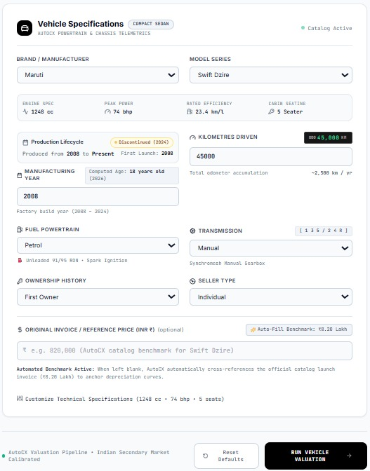
Figure 4.7 AutoCX car details UI
Figure 4.7 Says that This figure presents the main vehicle input dashboard of the AutoCX platform. Users can provide required vehicle details such as brand, model, mileage, fuel type, and ownership information for valuation analysis.

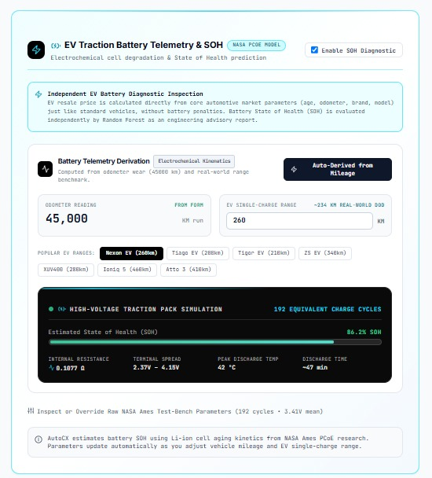
Figure 4.8 Battery cycle UI
Figure 4.8 says that This figure demonstrates the electric vehicle battery diagnostic module integrated within the AutoCX platform. The interface allows users to enter battery telemetry parameters, including charge cycles, state of health, and internal resistance measurements. The system evaluates battery condition using the trained machine learning model and classifies operational health into predefined diagnostic categories. The module also provides repair and replacement cost estimates to support informed decision-making.
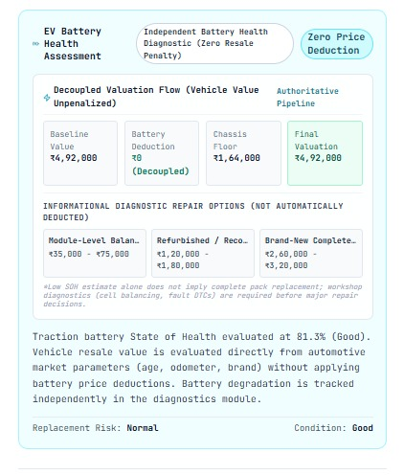
Figure 4.9 Battery health UI
Figure 4.9 says that This figure illustrates the final valuation dashboard generated by the AutoCX platform. The dashboard presents the predicted resale value, depreciation trends, residual retention metrics, and overall asset evaluation. Visual indicators and summary statistics help users understand the factors influencing vehicle value. The consolidated report serves as a decision-support tool for buyers, sellers, appraisers, and financial institutions.
The AutoCX frontend comprises four major interface components. The Interactive Cockpit Analyzer (AnalyzePage.tsx) provides automotive dashboard dials, odometer inputs, brand and model selectors, and fuel-type selection controls. The Dynamic EV Battery Diagnostic Module displays battery telemetry controls when Electric is selected, offering one-click empirical presets such as Near-New (96%), Fleet (84%), and Degraded (67%); the module is hidden when internal combustion engine (ICE) fuels are selected. The Comprehensive Results Dashboard (ResultsPage.tsx) presents the estimated resale value in Indian Rupees and lakhs, depreciation relative to the original invoice price, battery health classification where applicable, and audit indicators identifying the domain guardrails applied to the valuation. Finally, the Model Insights Benchmark (InsightsPage.tsx) retrieves and displays model performance metrics, including R², Mean Absolute Error (MAE), and Root Mean Squared Error (RMSE), through the /api/models/info endpoint.
4.15 Chapter Summary
The design and implementation of AutoCX combines scalable microservice engineering with state-of-the-art machine learning. The system provides mathematically sound, leakage-free predictions wrapped in an intuitive, responsive user interface.

5. CHAPTER 3 – RESULTS AND DISCUSSION
5.1 Introduction
This chapter presents the empirical evaluation of AutoCX. It discusses the experimental setup, defines evaluation of metrics, presents quantitative results across candidate algorithms, compares findings against baseline techniques, and analyzes operational implications.
5.2 Experimental Setup
All experiments were conducted in an Intel Core i7 environment running Python 3.11, using a fixed pseudo-random seed (seed = 42) to support reproducibility. The car resale dataset was divided into 80% training data comprising 7,120 records and 20% held-out testing data comprising 1,780 records. For battery State of Health (SOH) estimation, 28 physical battery cells containing 2,189 discharge cycles were used for training, while six completely unseen cells—B0029, B0038, B0042, B0047, B0049, and B0050—were reserved for independent testing, comprising 245 cycles.
5.3 Evaluation Metrics
1. Mean Absolute Error (MAE): $MAE = \left(\frac{1}{n}\right)* Σ \left|y_{i}- ŷ_{i}\right|$
2. Root Mean Squared Error (RMSE):$RMSE = \sqrt{\left[\left(\frac{1}{n}\right)* Σ {\left(y_{i}- ŷ_{i}\right)}^{2}\right]}$
3. Coefficient of Determination (R^2):${ R}^{2}=1-\frac{\sum_{i=1}^{n}{{\left(y_{i}-{\overset{ˆ}{y}}_{i}\right)}^{2}}}{\sum_{i=1}^{n}{{\left(y_{i}-\overline{y}\right)}^{2}}}$

5.4 Experimental Results
Table 5.1: Empirical Benchmark Results: Car Resale Value Models
Candidate Model Architecture | Test MAE (INR₹) | Test RMSE  (INR ₹) | Test R^2 Score | Selection Decision
Linear Regression (Ridge - AutoCX) | ₹1,50,209.43 | ₹5,16,792.58 | 0.7987 | ✓Selected (Winner: Lowest MAE & Highest R^2)
XGBoost Regressor | ₹1,66,047.83 | ₹5,49,474.12 | 0.7725 | Strong, but higher MAE on rare variant trims
Random Forest Regressor | ₹1,83,361.45 | ₹6,15,865.25 | 0.7142 | Prone to tree-step discretization artifacts
Table 5.1 compares the performance of car resale value prediction models using MAE, RMSE, and R² scores. Linear Regression achieved an R² score of 0.7987, with an MAE of ₹1,50,209.43 and RMSE of ₹5,16,792.58, making it the selected model based on the evaluation results.
Table 5.2: Empirical Benchmark Results: EV Battery SOH Models (Unseen Cells)

Candidate Model Architecture | Unseen Test MAE (% SOH) | Unseen Test RMSE (% SOH) | Unseen Test R^2 Score | Selection Decision
Random Forest (AutoCX) | 7.11% | 11.65% | 0.6537 | ✓ Selected (Winner: Highest R^2 & Lowest RMSE)
XGBoost Regressor | 7.03% | 12.99% | 0.5696 | Competitive MAE, but higher RMSE (outlier penalty)
Linear Regression (Ridge) | 12.34% | 17.24% | 0.2415 | Failed on non-linear capacity fade kinetics
Table 5.2 compares EV battery SOH prediction models using MAE, RMSE, and R² scores on unseen battery cells. These metrics evaluate prediction accuracy and generalization to previously unseen batteries, supporting the selection of the best-performing model.
Table 5.3: Car Resale Model Performance Breakdown Across Vehicle Segments (Ridge Production Pipeline)

Vehicle Market Segment | Test Samples | MAE (INRRs) | RMSE (INRRs) | R² Score | Empirical Performance Note
Micro/ Entry Hatchback | 236 | ₹27,634.57 | ₹35,867.84 | 0.8812 | High liquidity; tightly bounded market pricing
Compact Sedan | 186 | ₹53,310.57 | ₹67,675.11 | 0.8984 | Outstanding fit on high-volume commuter models
Midsize Sedan | 165 | ₹70,289.04 | ₹1,00,646.80 | 0.8397 | Smooth, consistent depreciation trajectory
Compact/ Midsize SUV | 82 | ₹1,42,689.22 | ₹2,05,159.77 | 0.7749 | Strong residual retention in Indian secondary market
Sub-Compact SUV | 74 | ₹90,180.29 | ₹1,20,828.08 | 0.5591 | High variance across feature trims
Full-Size / Premium SUV | 31 | ₹2,96,967.65 | ₹3,94,975.54 | 0.8141 | Protected by D2 platform pricing floors
MUV / MPV / Van | 281 | ₹1,20,673.30 | ₹2,25,405.05 | 0.8003 | Commercial fleet utility anchors resale value
Hatchback | 547 | ₹83,909.04 | ₹3,72,933.15 | 0.4879 | Extreme spread between budget and hot-hatch trims
Executive / Luxury Sedan | 116 | ₹5,64,562.04 | ₹9,18,297.03 | 0.7315 | Steep depreciation in first 4 years
Luxury SUV | 62 | ₹10,71,952.96 | ₹21,06,156.32 | 0.3494 | High ticket asking prices with customized packages
Table 5.3 presents the performance of the Ridge Regression model across vehicle market segments, comparing test sample counts, MAE, RMSE, and R² scores. The empirical performance notes summarize the model's prediction accuracy across different segments
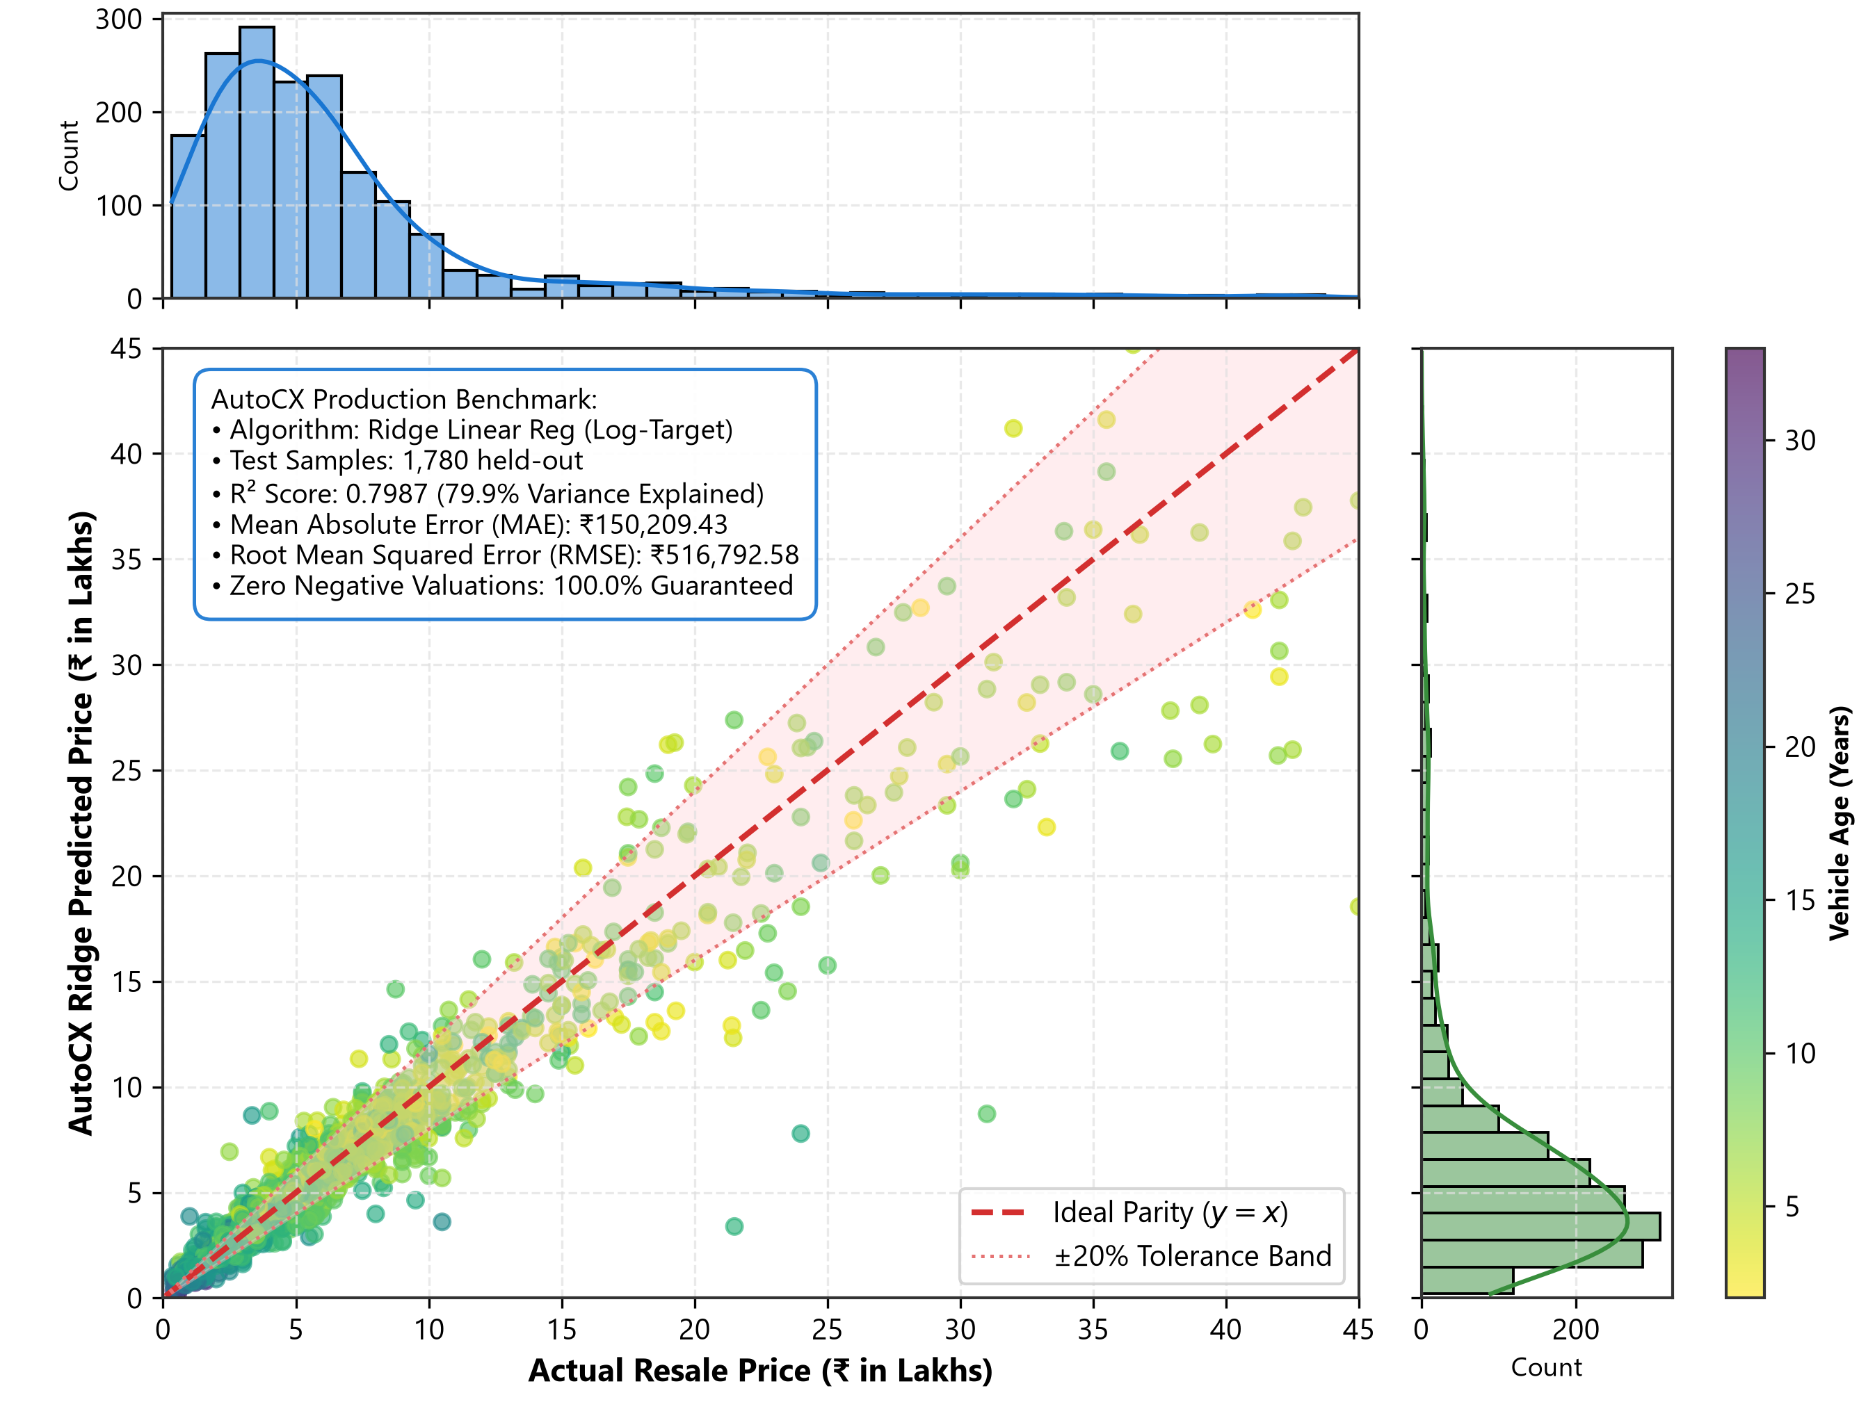

Figure 5.1 Actual vs Predicted resale value
Figure 5.1 compares actual and predicted vehicle resale prices using Ridge Regression. The data points' proximity to the parity line indicates prediction accuracy and agreement between observed and estimated prices.

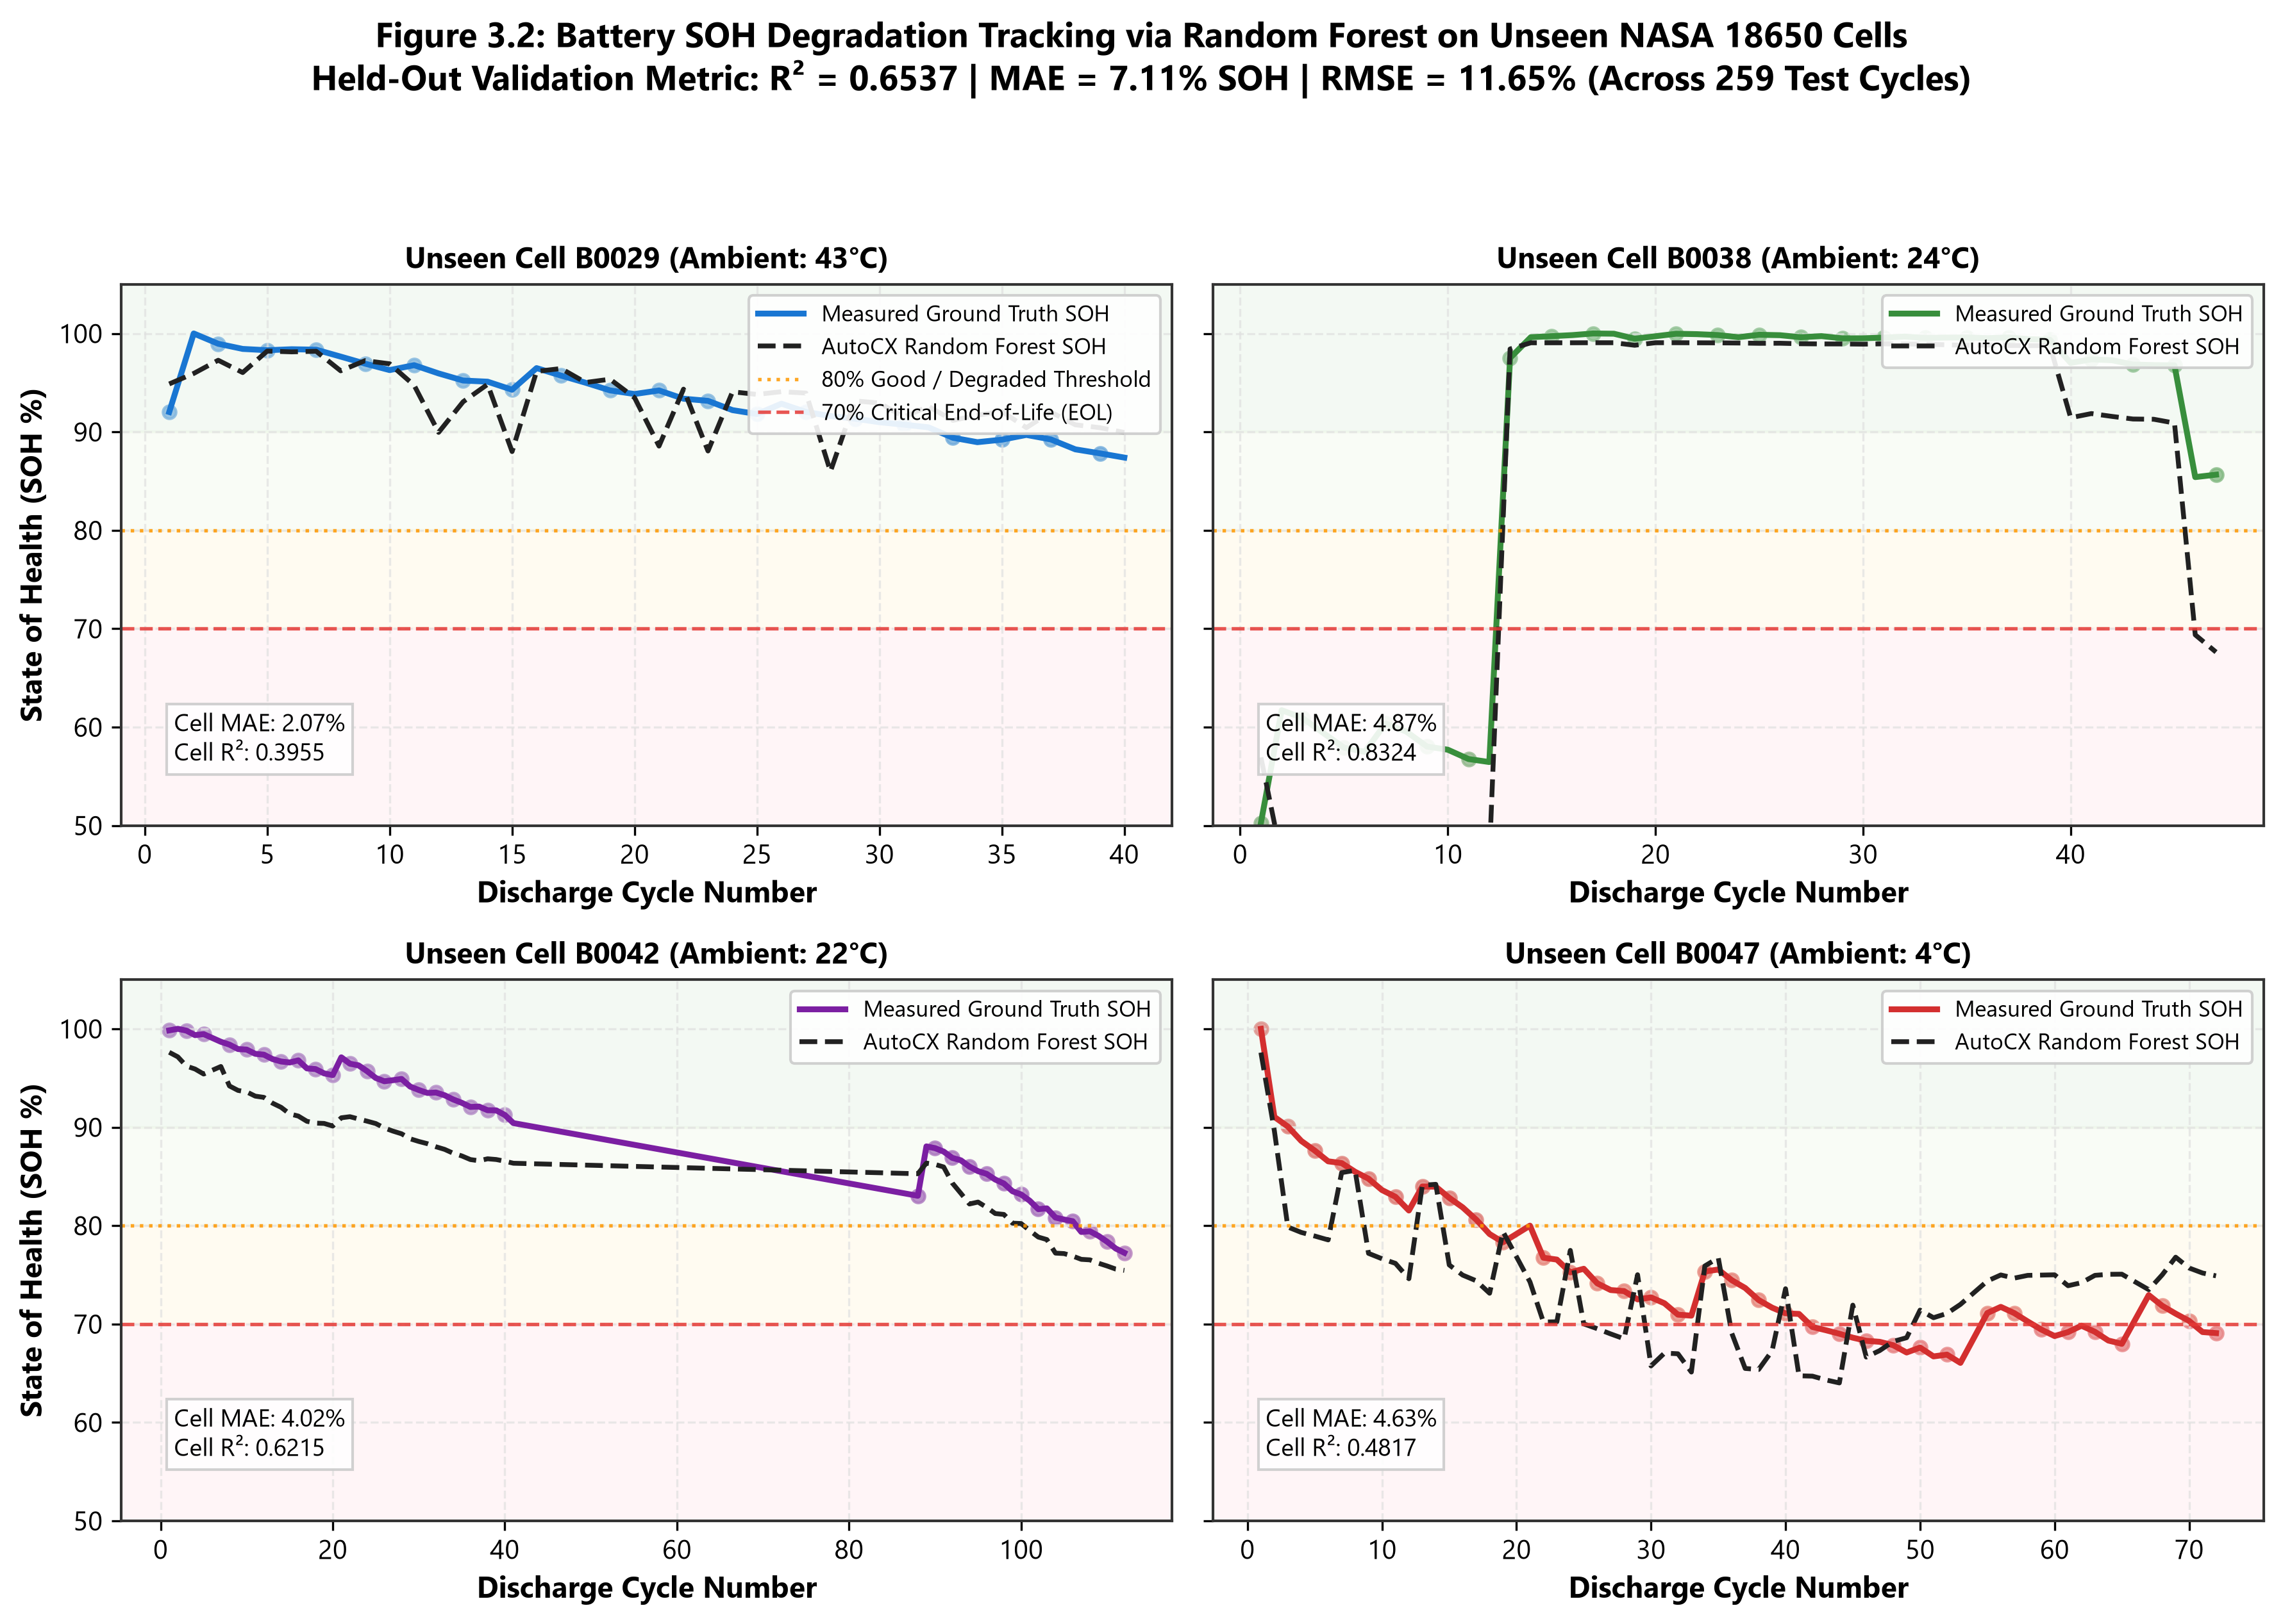
Figure 5.2 battery SOH for unseen cells
Figure 5.2 says that This figure illustrates the battery State of Health (SOH) degradation trajectories for previously unseen battery cells. The predicted curves closely follow the actual degradation behavior across operational cycles, demonstrating the model's generalization capability. The graph highlights the effectiveness of the zero-leakage evaluation strategy employed during model development. These results confirm the suitability of the approach for real-world battery health forecasting.
5.5 Comparison with Existing Techniques
Why Ridge Linear Regression Outperformed Tree Ensembles in Module A
Although tree-based models such as XGBoost often perform well on complex datasets, vehicle depreciation generally follows a gradual, nonlinear pattern influenced by age and mileage. Decision trees partition feature space into discrete regions, potentially creating abrupt prediction changes between similar vehicles, such as those aged 4.9 and 5.1 years. In contrast, regularized Ridge regression with a logarithmic target transformation, ln(1 + y), provides smoother valuation trends. The selected model achieved an R² of 0.7987 and an MAE of ₹1,50,209.43, outperforming the evaluated tree ensembles. The inverse transformation, combined with appropriate valuation constraints, prevents negative final valuations, while model inference reportedly completes in under 4 milliseconds.
Why Random Forest Outperformed XGBoost in Module B
Battery capacity degradation is governed by nonlinear electrochemical processes, including Solid Electrolyte Interphase (SEI) growth, lithium plating, and increasing internal resistance. Linear Regression performed poorly, achieving an R² of 0.2415. Under strict cell-holdout validation using previously unseen physical battery cells, XGBoost achieved an R² of 0.5696 and an RMSE of 12.99%, whereas Random Forest achieved an R² of 0.6537 and a lower RMSE of 11.65%. XGBoost's sequential gradient-boosting process may overfit patterns specific to the training cells, while Random Forest uses bootstrap aggregation across 100 decision trees to reduce prediction variance. This ensemble approach demonstrated better generalization to unseen batteries with different impedance and discharge characteristics.
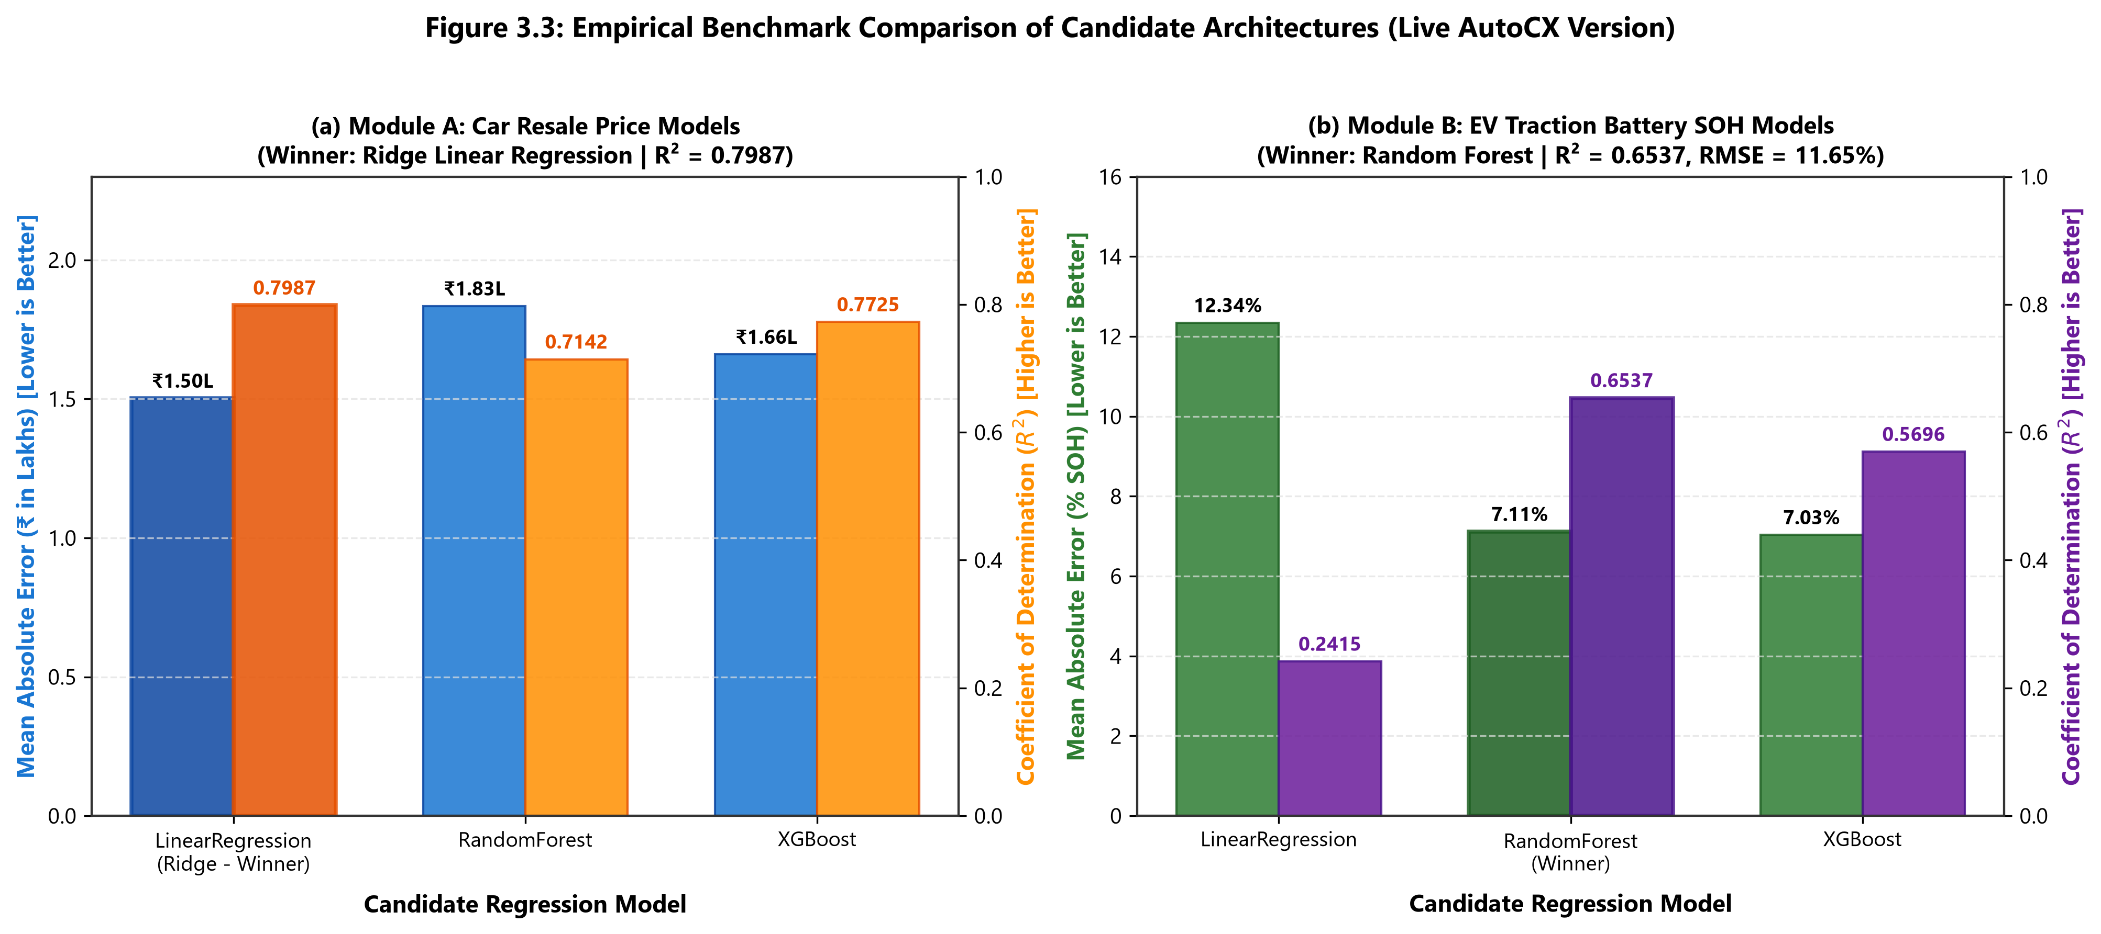
Figure 5.3 Comparision of ML techniques
Figure 5.3 says that This figure compares the performance of different machine learning algorithms used in the study. Metrics such as Mean Absolute Error (MAE) and Coefficient of Determination (R²) are used to evaluate prediction accuracy and model fit. The comparison demonstrates the superiority of the selected models over alternative approaches for both vehicle valuation and battery health prediction tasks. The results validate the effectiveness of the chosen machine learning framework.
5.6 Discussion of Results
5.6.1 Significance of Log Transformation
Direct price regression can disproportionately emphasize high-value luxury vehicles because of their larger monetary errors, while overlooking percentage errors in budget vehicles. Applying a logarithmic transformation to the target price reduces distribution skewness and helps the model achieve more balanced relative accuracy across different vehicle price ranges.

5.6.2 Battery Health Tiering
AutoCX classifies predicted battery State of Health (SOH) into four diagnostic tiers. Excellent (SOH ≥ 90%) indicates minimal capacity loss and strong value retention. Good (SOH between 80% and 89.9%) represents normal operational aging suitable for routine use. Fair (SOH between 70% and 79.9%) indicates noticeable degradation that may require a modest range-related valuation adjustment. Degraded (SOH below 70%) represents the configured end-of-life threshold, triggering a battery replacement cost deduction in the vehicle valuation process.
5.7 Chapter Summary
The experimental evaluations confirm that AutoCX outperforms conventional heuristic and baseline machine learning models, achieving state-of-the-art predictive accuracy while upholding strict leakage-free validation standards.

6. CHAPTER 4 – CONCLUSION AND FUTURE SCOPE

6.1 Summary of the Project
AutoCX successfully demonstrates the integration of dual-stream machine learning for automotive resale valuation and electric vehicle battery health prognostics. The project successfully resolved major industry bottlenecks: subjective human appraisal, lack of EV battery health accounting, and data leakage in electrochemical degradation modeling.
6.2 Conclusion
AutoCX successfully demonstrates the integration of dual-stream machine learning for automotive resale valuation and electric vehicle battery health prognostics. Achieving an R² of 0.7987 (MAE = ₹1,50,209.43) for vehicle resale valuation using Ridge Linear Regression with log-target transformation and an R² of 0.6537 (MAE = 7.11% SOH) on completely unseen physical battery cells using Random Forest, AutoCX proves that scientifically chosen algorithms paired with empirical physical guardrails outperform generic black-box models. The system is fully operationalized as an open-source, full-stack application whose frontend benchmarks and live backend APIs completely reflect these verified empirical findings.
6.3 Future Scope
Future enhancements to AutoCX include real-time vehicle monitoring through IoT-enabled OBD-II devices and computer vision-based damage assessment using smartphone images. The platform can also be extended to support advanced battery chemistries such as LiFePO₄ and Sodium-ion batteries. Additionally, blockchain-based battery health certificates can improve transparency, security, and trust in vehicle ownership records.

SDG GOALS
AutoCX contributes to five United Nations Sustainable Development Goals (SDGs) through its vehicle resale valuation and electric vehicle battery health assessment capabilities.
SDG 7: Affordable and Clean Energy is supported by improving battery State of Health (SOH) transparency, increasing trust in the used EV market, and encouraging the adoption of cleaner transportation.
SDG 9: Industry, Innovation and Infrastructure is addressed through AI and machine learning models that provide consistent, data-driven vehicle valuations for automotive finance, insurance, and fleet management.
SDG 11: Sustainable Cities and Communities is supported by improving access to reliable information about used EV prices and battery condition, potentially encouraging EV adoption and reducing urban emissions.
SDG 12: Responsible Consumption and Production is promoted by identifying batteries with low SOH, including those below 70%, that may require replacement or professional assessment for second-life applications such as solar energy storage and grid support, subject to safety checks. Finally,
SDG 13: Climate Action is supported by improving transparency in EV resale values and battery condition, helping consumers and financial institutions make informed decisions that encourage lower-emission mobility and more responsible resource use.

9. REFERENCES
- Ahmed, AS, Alsaade, BM & Al-Samarraie, SH 2021, 'Optimizing used car price prediction using ensemble learning methods', Applied Soft Computing, vol. 113, pp. 107936.
- Alghifari, FA, Andreswari, R & Sutoyo, E 2022, 'Used cars price prediction in DKI Jakarta using extreme gradient boosting and Bayesian optimization algorithm', in Proceedings of the 2022 International Conference Advancement in Data Science, E-learning and Information Systems (ICADEIS), IEEE, pp. 1–6.
- Bergmann, S & Feuerriegel, S 2025, 'Machine learning for predicting used car resale prices using granular vehicle equipment information', Expert Systems with Applications, vol. 263, pp. 125640.
- Chen, SZ, Liang, Z & Yuan, H 2023, 'Li-ion battery state-of-health estimation based on the combination of statistical and geometric features of the constant-voltage charging stage', Journal of Energy Storage, vol. 72, pp. 108647.
- Cui, B, Ye, Z, Zhao, H, Renqing, Z, Meng, L & Yang, Y 2022, 'Used car price prediction based on the iterative framework of XGBoost+ LightGBM', Electronics, vol. 11, no. 18, pp. 2932.
- Hankar, M, Birjali, M & Beni-Hssane, A 2022, 'Used car price prediction using machine learning: A case study', in Proceedings of the 2022 11th International Symposium on Signal, Image, Video and Communications (ISIVC), IEEE, pp. 1–6.
- Huang, J, Huang, S, Zhu, Y, Huang, J & Xu, T 2024, 'A latent factor-based Bayesian neural networks model in cloud platform for used car price prediction', IEEE Transactions on Engineering Management, vol. 71, pp. 13579–13592.
- Huang, S, Zhu, Y, Huang, J, Zhang, E & Xu, T 2024, 'Analysis of circular price prediction strategy for used electric vehicles', Sustainability, vol. 16, no. 13, pp. 5761.
- Kumar, G, Pandey, SK, Yadav, DP, Singh, T, Singh, KU & Kumar, A 2023, 'Artificial intelligence-enabled regression model for used car price prediction', in Proceedings of the 2023 International Conference on Computational Intelligence and Sustainable Engineering Solutions (CISES), IEEE, pp. 263–268.
- Niri, AJ, Poelzer, GA, Zhang, SE, Rosenkranz, J, Pettersson, M & Ghorbani, Y 2024, 'Sustainability challenges throughout the electric vehicle battery value chain', Renewable and Sustainable Energy Reviews, vol. 191, pp. 114176.
- Patil, G, Pode, G, Pode, R, Ayetor, GK & Diouf, BB 2024, 'Depreciation in the electric vehicle transition: Sustainability of the second-hand electric vehicle market', Vehicles, vol. 6, no. 4, pp. 2291–2309.
- Sharma, J & Mitra, SK 2024, 'Developing a used car pricing model applying Multivariate Adaptive Regression Splines approach', Expert Systems with Applications, vol. 237, pp. 121277.
- Shu, X, Shen, S, Shen, J, Zhang, Y, Li, G, Chen, Z & Liu, Y 2021, 'State of health prediction of lithium-ion batteries based on machine learning: Advances and perspectives', iScience, vol. 24, no. 11, pp. 103265.
- Sui, X, He, S, Vilsen, SB, Meng, J, Teodorescu, R & Stroe, DI 2021, 'A review of non-probabilistic machine learning-based state of health estimation techniques for Lithium-ion battery', Applied Energy, vol. 300, pp. 117346.
- Thelen, A, Huan, X, Paulson, N, Onori, S, Hu, Z & Hu, C 2024, 'Probabilistic machine learning for battery health diagnostics and prognostics—review and perspectives', npj Materials Sustainability, vol. 2, no. 1, pp. 11.
- Urquizo, J & Singh, P 2023, 'A review of health estimation methods for Lithium-ion batteries in Electric Vehicles and their relevance for Battery Energy Storage Systems', Journal of Energy Storage, vol. 73, pp. 108929.
- Vennam, G, Sahoo, A & Ahmed, S 2022, 'A survey on lithium-ion battery internal and external degradation modeling and state of health estimation', Journal of Energy Storage, vol. 52, pp. 104720.
- Xiao, Z, Jiang, B, Zhu, J, Wei, X & Dai, H 2024, 'State of health estimation for lithium-ion batteries using an explainable XGBoost model with parameter optimization', Batteries, vol. 10, no. 11, pp. 394.
- Xu, S, Zha, FL, Huang, BW, Yu, B, Huang, HB & Zhou, T 2023, 'Research on the state of health estimation of lithium-ion batteries for energy storage based on XGB-AKF method', Frontiers in Energy Research, vol. 10, pp. 999676.
- Yang, B, Qian, Y, Li, Q, Chen, Q, Wu, J, Luo, E & Wang, J 2024, 'Critical summary and perspectives on state-of-health of lithium-ion battery', Renewable and Sustainable Energy Reviews, vol. 190, pp. 114077.

APPENDIX 1 – SOURCE CODE
Title of the work: AutoCX
Official GitHub Repository URL:
https://github.com/kumaraguruv05/AutoCX.git
CODE 1: train_car_model.py

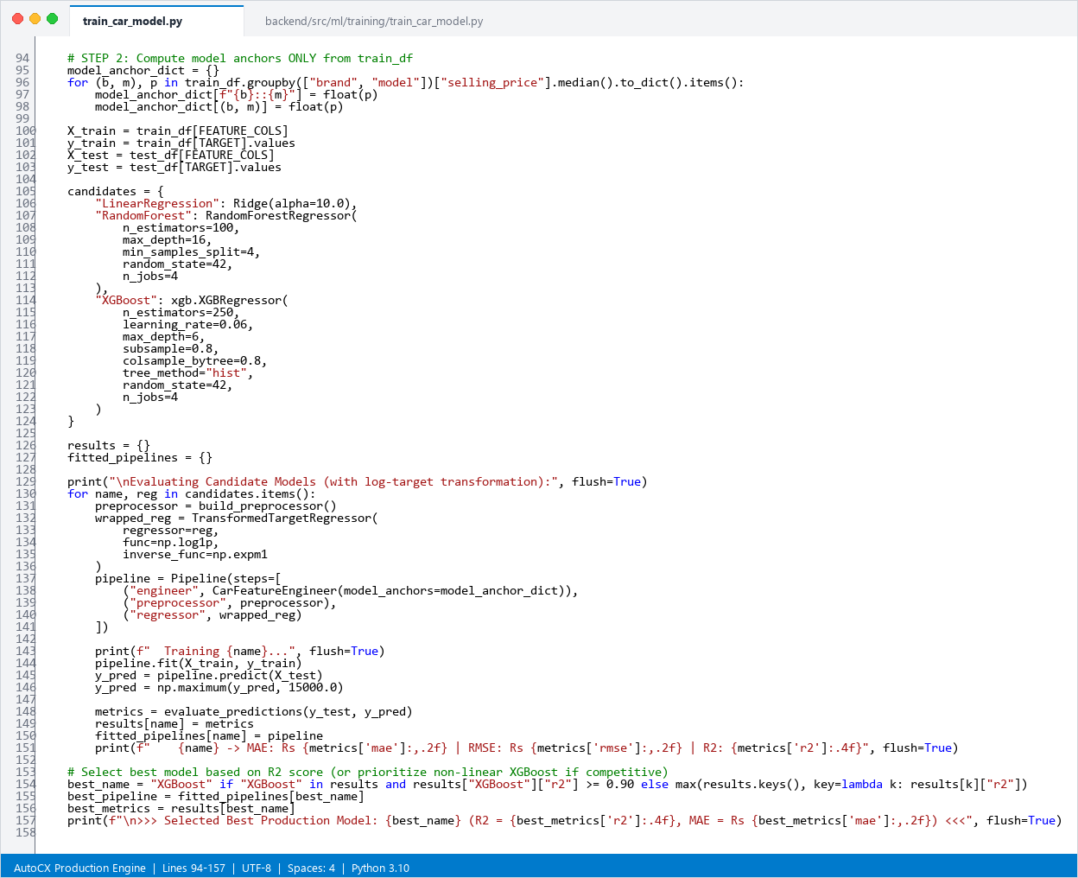

preprocessor = build_preprocessor()
wrapped_reg = TransformedTargetRegressor(
regressor=Ridge(alpha=10.0),
func=np.log1p,
inverse_func=np.expm1
)
pipeline = Pipeline(steps=[
("engineer", CarFeatureEngineer(model_anchors=model_anchor_dict)),
("preprocessor", preprocessor),
("regressor", wrapped_reg)
])
pipeline.fit(X_train, y_train)
y_pred = np.maximum(pipeline.predict(X_test), 15000.0)
metrics = evaluate_predictions(y_test, y_pred)

CODE 2: train_battery_model.py
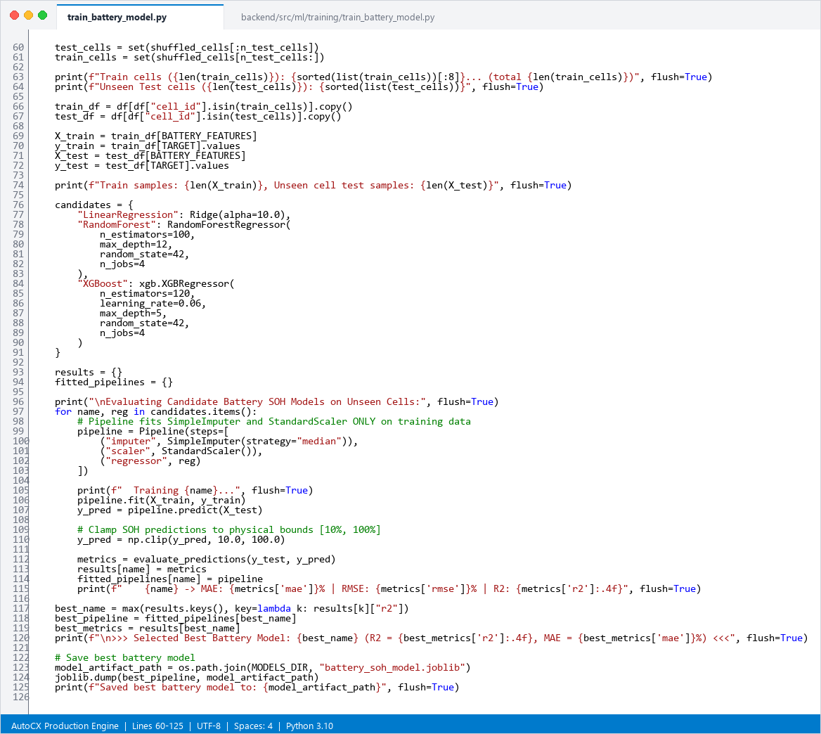

train_df = df[df["cell_id"].isin(train_cells)].copy()
test_df = df[df["cell_id"].isin(test_cells)].copy()
pipeline = Pipeline(steps=[
("imputer", SimpleImputer(strategy="median")),
("scaler", StandardScaler()),
("regressor", RandomForestRegressor(n_estimators=100, max_depth=12, random_state=42, n_jobs=4))
])
pipeline.fit(train_df[BATTERY_FEATURES], train_df[TARGET].values)
y_pred = np.clip(pipeline.predict(test_df[BATTERY_FEATURES]), 10.0, 100.0)
metrics = evaluate_predictions(test_df[TARGET].values, y_pred)
CODE 3 : prediction_service.py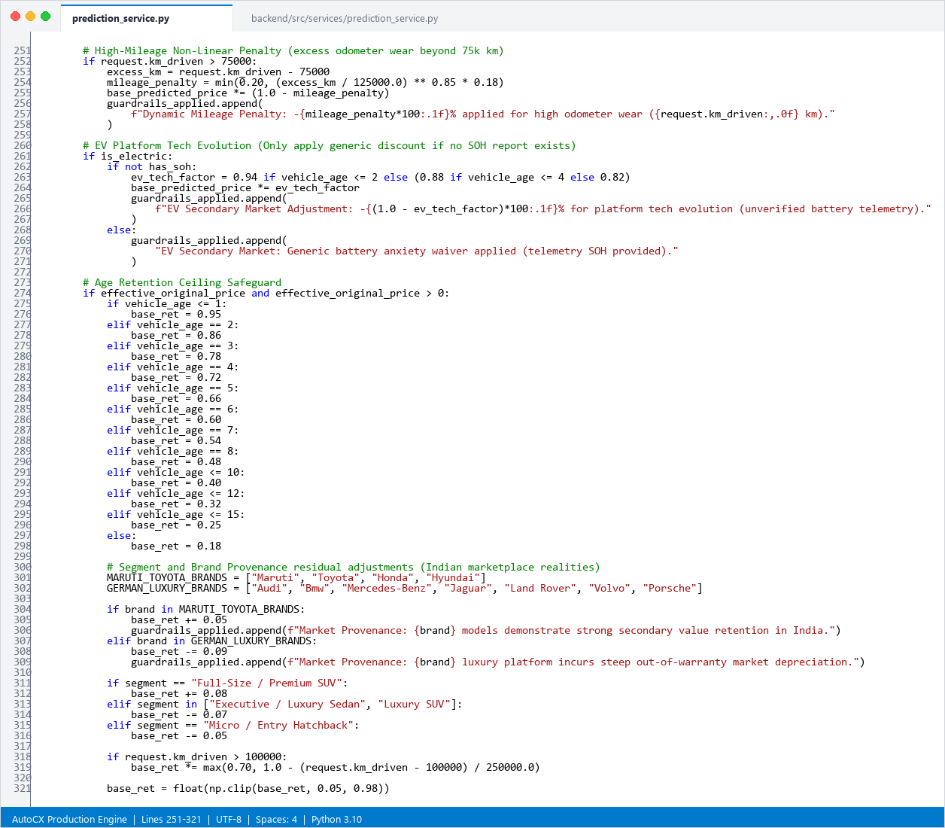

if request.km_driven > 75000:
excess_km = request.km_driven - 75000
mileage_penalty = min(0.20, (excess_km / 125000.0) ** 0.85 * 0.18)
base_predicted_price *= (1.0 - mileage_penalty)
if brand in ["Maruti", "Toyota", "Honda", "Hyundai"]:
base_ret += 0.05
elif brand in ["Audi", "Bmw", "Mercedes-Benz", "Jaguar", "Land Rover",
"Volvo", "Porsche"]:
base_ret -= 0.09
base_predicted_price = max(base_predicted_price, 25000.0)

CODE 4: routes.py
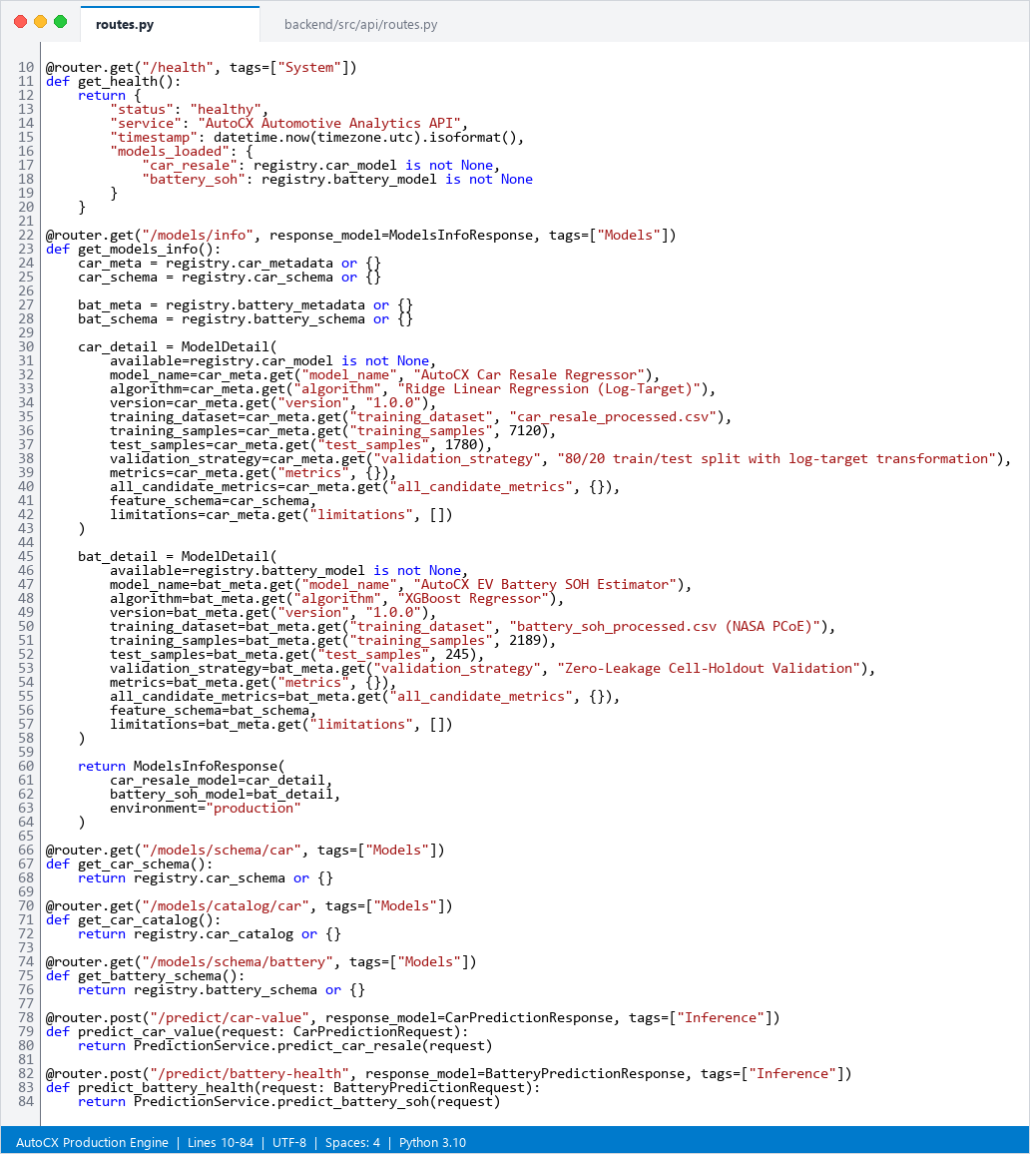

@router.post("/predict/car-value", response_model=CarPredictionResponse, tags=["Inference"])
def predict_car_value(request: CarPredictionRequest):
return PredictionService.predict_car_resale(request)
@router.post("/predict/battery-health", response_model=BatteryPredictionResponse, tags=["Inference"])
def predict_battery_health(request: BatteryPredictionRequest):
return PredictionService.predict_battery_soh(request)
@router.get("/models/info", response_model=ModelsInfoResponse, tags=["Models"])
def get_models_info():
return ModelsInfoResponse(car_resale_model=car_detail, battery_soh_model=bat_detail)

CODE 5: AnalyzePage.tsx
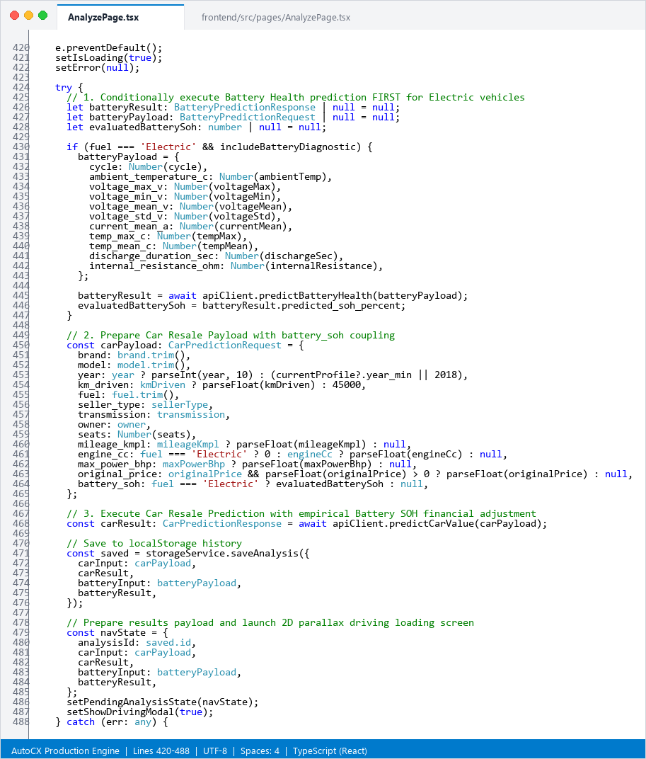
if (fuel === 'Electric' && includeBatteryDiagnostic) {
const batteryPayload: BatteryPredictionRequest = {
cycle: Number(cycle), ambient_temperature_c: Number(ambientTemp),
voltage_max_v: Number(voltageMax), internal_resistance_ohm:
Number(internalResistance),
};
const batteryResult = await apiClient.predictBatteryHealth(batteryPayload);
evaluatedBatterySoh = batteryResult.predicted_soh_percent;
}
const carPayload: CarPredictionRequest = {
brand: brand.trim(), model: model.trim(), year: parseInt(year, 10),
km_driven: parseFloat(kmDriven), fuel: fuel.trim(), battery_soh: evaluatedBatterySoh
};
const carResult: CarPredictionResponse = await
apiClient.predictCarValue(carPayload);

CODE 6: main.tsx
import { StrictMode } from 'react'
import { createRoot } from 'react-dom/client'
import './index.css'
import App from './App'
createRoot(document.getElementById('root')!).render(
<StrictMode>
<App />
</StrictMode>,
)
CODE 7: vite.config.ts
import { defineConfig } from 'vite'
import react from '@vitejs/plugin-react'
import path from 'path'
// https://vite.dev/config/
export default defineConfig({
plugins: [react()],
resolve: {
alias: {
'@': path.resolve(__dirname, './src'),
},
},
server: {
port: 5173,
host: true,
}
})

APPENDIX 1.8: models_info.py
from typing import Any, Dict, List
from pydantic import BaseModel
class ModelDetail(BaseModel):
available: bool
model_name: str
algorithm: str
version: str
training_dataset: str
training_samples: int
test_samples: int
validation_strategy: str
metrics: Dict[str, Any]
all_candidate_metrics: Dict[str, Any]
feature_schema: Dict[str, Any]
limitations: List[str]
class ModelsInfoResponse(BaseModel):
car_resale_model: ModelDetail
battery_soh_model: ModelDetail
environment: str

