1. **SQL query to find employee name starts with 'A'**

select * from Employee where name like 'A%'; (where A case sensetive)

2. **SQL query to find 2nd highest salary**

select max(sal) from Employee where sal < (select max(sal) from employee);

3. **SQL query to list employees in ascending/desending order by salary.**

select * from employee order by sal;

select * from employee order by sal desc;

4. **SQL query to find max salary from each department.**

select deptname, max(sal) from employee group by deptname;

5. **UNION V/S JOIN operation in SQL**

UNION combines results from two select statements and removes duplicates.

JOIN combines results from two or more tables based on a related column.

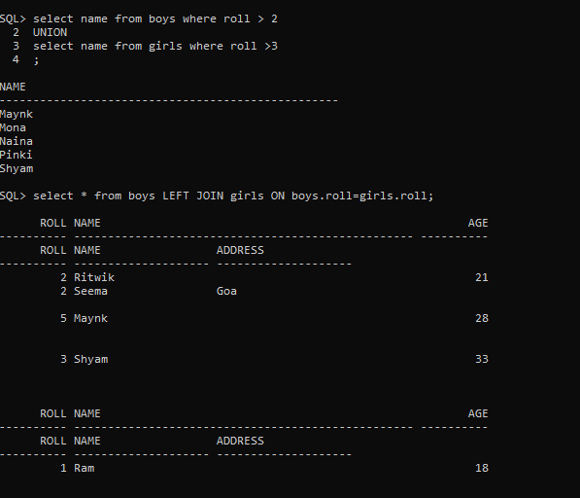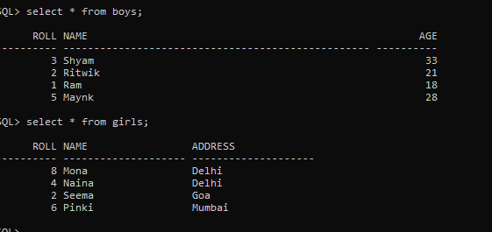

6. **SQL query to count the number of occurrences of each value in column.**

select name, count(*) from girls group by name;

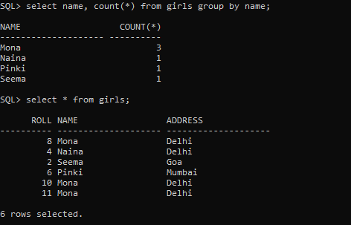

7. **Query to find nth highest salary from an employee table.**

SELECT DISTINCT sal FROM employee x WHERE = (SELECT COUNT(DISTINCT sal) FROM employee WHERE sal>=x.sal);

8. **How do you prevent SQL injection in your Java applications?**

Use PreparedStatement and Parameterized queries to ensure input values are treated as data, not executable code.

9. **Explain the purpose of the EXISTS keyword in SQL?**

EXISTS is used in a subquery to check whether a specified condition is true for at least one row, and returns a Boolean value.

10. **Query to find employees who have joined in the last 30 days.**

SELECT * FROM Employee WHERE JOIN_DATE >= CURRENT_DATE - INTERVAL 30 DAY;

11**. What is a self-join? Provide an example.**

A self-join occurs when a table is joined with itself.

Example: select e1.ename, e1.sal from employee e1 join employee e2 on e1.empno = e2.empno;

12. **Query to calculate the total number of orders for each customer.**

SELECT customer_id, COUNT(order_id) AS total_orders FROM Orders GROUP BY customer_id;

13. **SQL query to find total number of dept from each department.**

select deptname, count(deptname) from employee group by deptname;

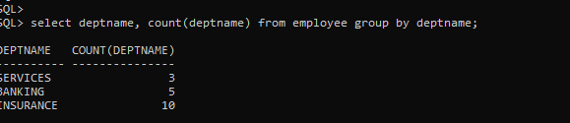

14. **Explain the differences between INNER JOIN, LEFT JOIN, and RIGHT JOIN.**

INNER JOIN returns common rows,

LEFT JOIN returns all rows from the left table and matching rows from the right table,

RIGHT JOIN returns all rows from the right table and matching rows from the left table.