WEEK 7 PRACTICAL
QUESTION 1
Write a program that prints the addresses of code, global, static, heap, and stack
variables. Analyze the Linux process address space layout and explain each memory segment.
Aim
To write a C program that displays the memory addresses of variables belonging to the code, global, static, heap, and stack segments and understand the Linux process address-space layout.
Program
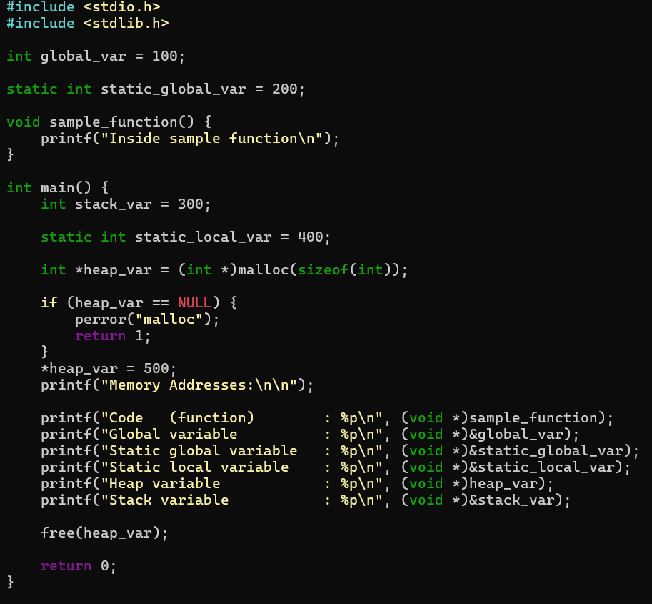

Output

The exact addresses will be different on every execution because of Linux memory-layout randomization.
Memory Addresses:
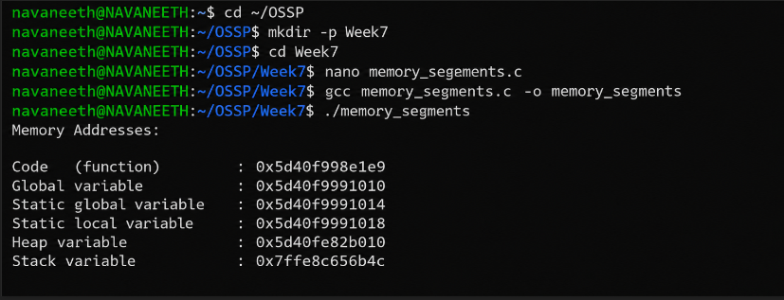

Observation
The program displays the addresses of variables located in different parts of the process address space.

Memory Segment | Example | Purpose
Code / Text | sample_function | Contains executable program instructions
Global / Data | global_var | Stores initialized global variables
Static | static_global_var, static_local_var | Static variables have program-long lifetime and are typically stored in the data or BSS segment depending on initialization.
Heap | heap_var | Used for dynamically allocated memory using malloc()
Stack | stack_var | Stores local variables and function-call information

The addresses demonstrate that different types of data are maintained in different regions of the Linux process address space.
Result
The program was successfully implemented to print the addresses of code, global, static, heap, and stack variables. The Linux process memory layout was analyzed based on the addresses obtained.

QUESTION 2

Make use of the /proc/maps file and memory analysis tools to study the memory organization of a running process. Prepare a report explaining virtual memory mappings.
Aim
To study the memory organization of a running Linux process using the /proc/<PID>/maps file and memory-analysis commands, and understand virtual memory mappings.
Program

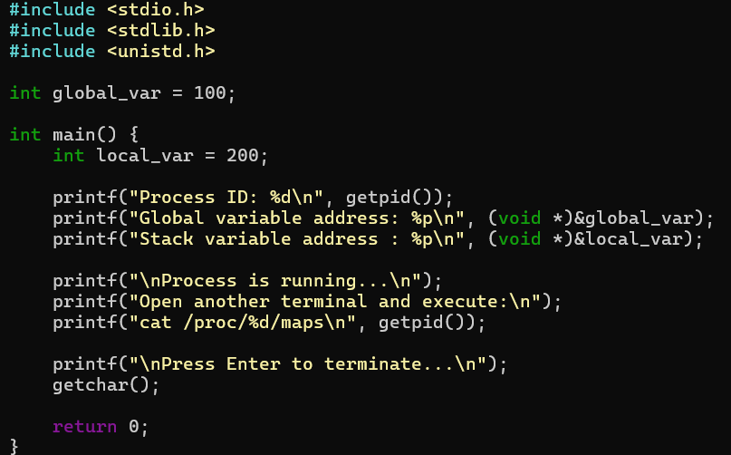

Output
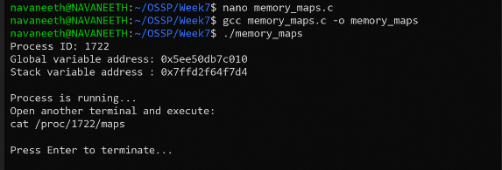

Useful Memory Analysis Commands

To examine the process mappings: cat /proc/1722/maps
Sample /proc/1722/maps Output
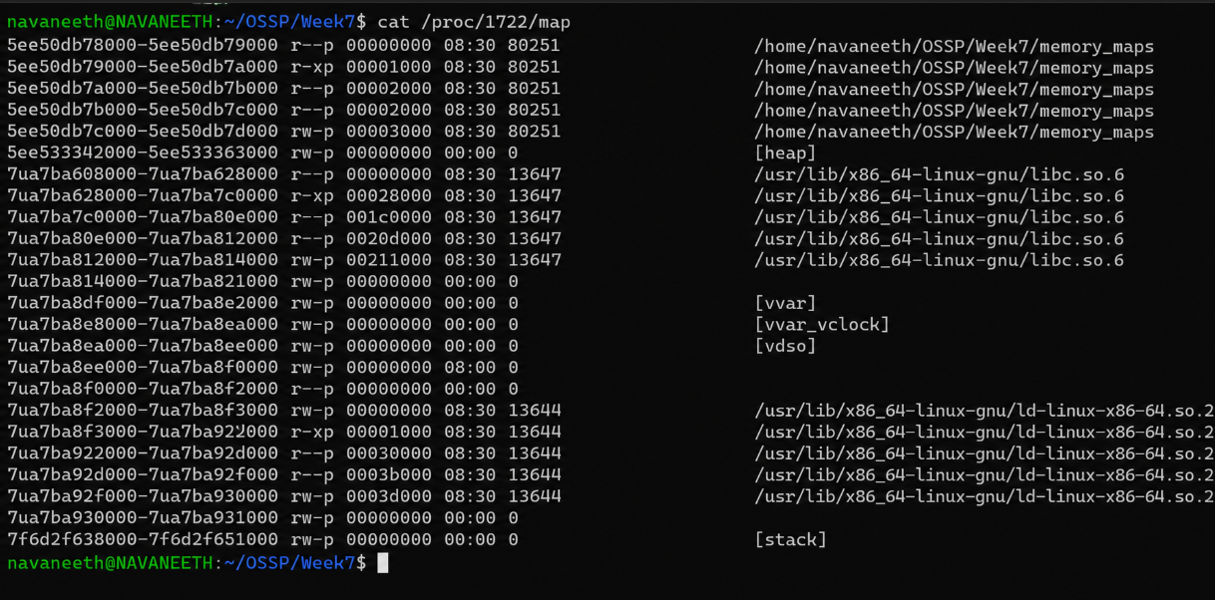
To view memory statistics: cat /proc/1722/status
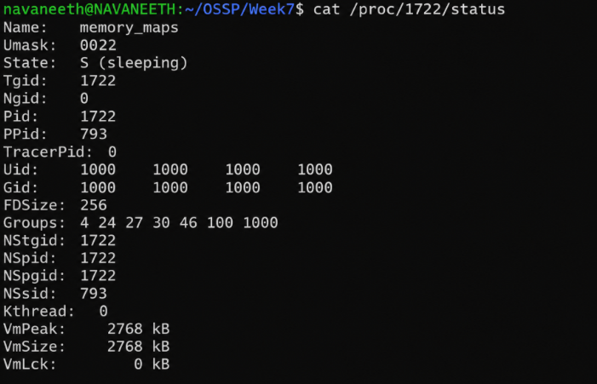

To view detailed memory information: cat /proc/1722/smaps

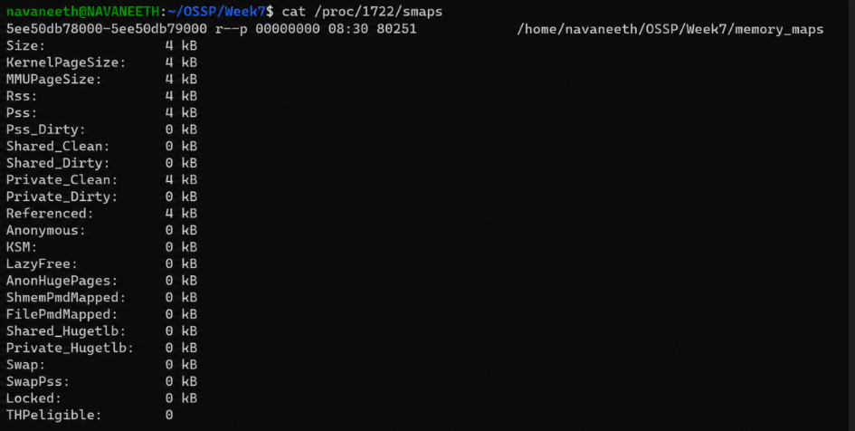

You can also use:
pmap 1722
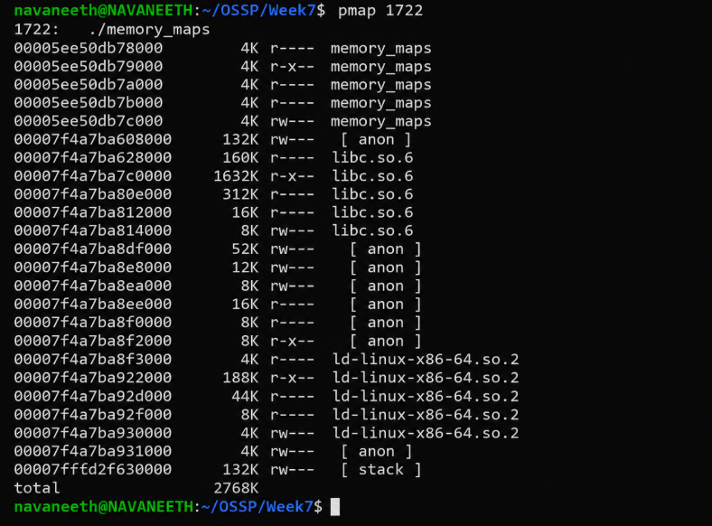
Observation
The /proc/<PID>/maps file shows the virtual memory regions assigned to a running process.
Common mappings include:
- Executable/text region — contains the program's machine instructions.
- Read-only region — contains read-only data and other protected mappina region — contains initialized and writable program data.

Heap — used for dynamically allocated memory.
- Shared libraries — libraries such as the C library are mapped into the process's virtual address space.
- Stack — contains local variables and function-call information.
- VDSO/VVAR — special kernel-provided mappings used for certain system operations and timing-related functionality.
The permissions shown in /proc/<PID>/maps describe what operations are allowed: r = read
w = write
x = execute
p = private mapping s = shared mapping Result
The memory organization of a running Linux process was successfully studied using
/proc/<PID>/maps, /proc/<PID>/status, /proc/<PID>/smaps, and pmap. The experiment demonstrated how virtual memory mappings divide a process's address space into code, data, heap, stack, libraries, and other regions.

