Application is very simple to use.

Application: -

1. As per JSON two users are added, only those two users can login.
2. Login ID is ID which is given in the JSON of that user and password is 123.

3. To run the application:-

* Open the project folder (In which manage.py file is present).
* In the address bar of the folder type cmd and press enter to open the command prompt as shown in the figure below:-

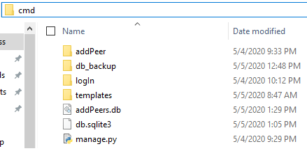

* Once command Prompt is open type “python manage.py runserver ” to run the project.

1. After executing the command in command prompt the host url will come. Copy and paste the url into the browser:-

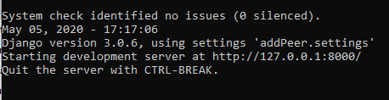

1. 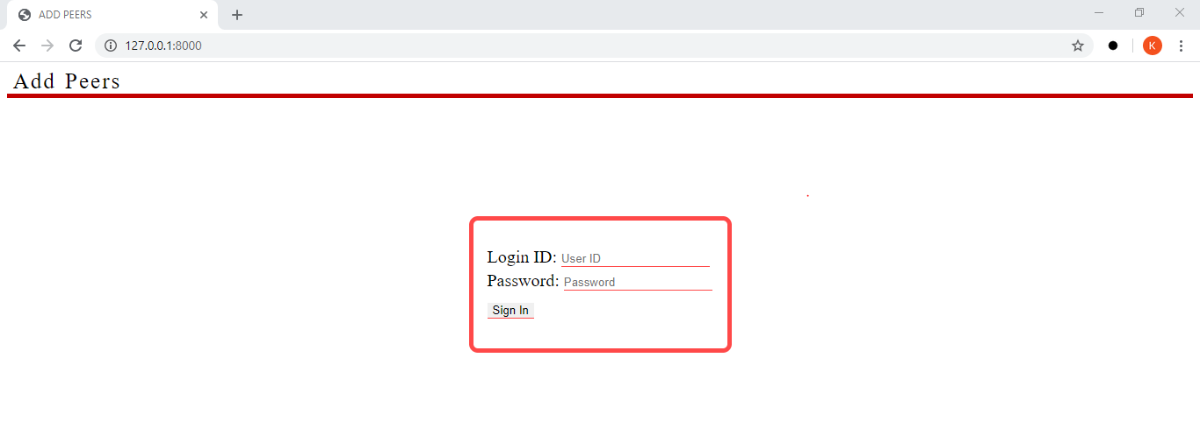Open screen will be like this:-
2. Now user can put ID and pass to login.
3. 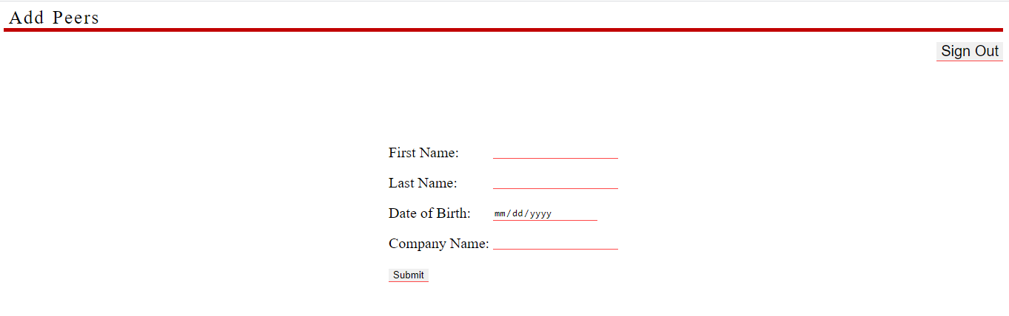After login “Dummy Activity’ will come (To add peers):-
4. User can add one by one as many peers he wants.
5. With the use of “Sign Out” button user can logout of the application any time.

API: -

1. Postman can be use to trigger the API.

2. No input is needed to get the output.

3. Before using the API user first need to Run the application as mentioned above but not need to login in the application.

4. Open “Postman” application.

5. In the address bar of post ma paste the url of the application which appeared in the command prompt followed by “/returnData” and make method as post as shown in the figure: -

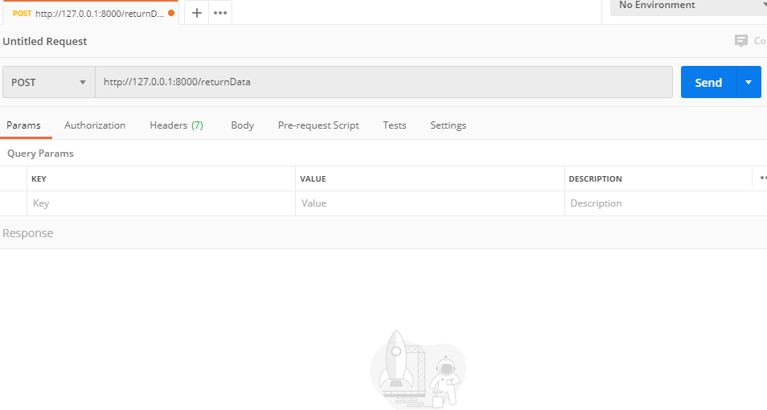

6. Click on send button. The output will appear. Which will contain “Activity Model”.

