**Problem Statement** – **Battle Ship Game**

1. **Application is Up And Running**

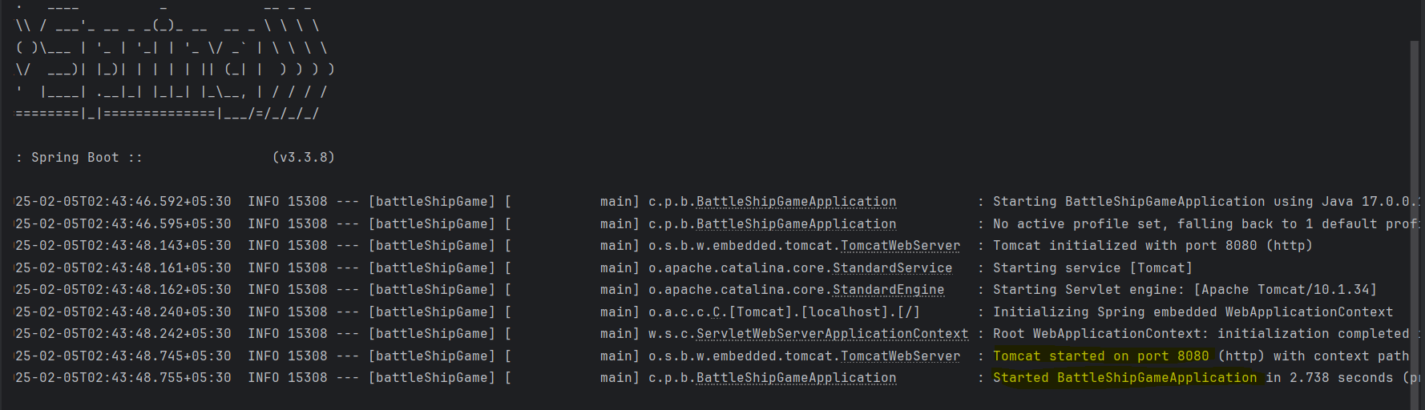

1. 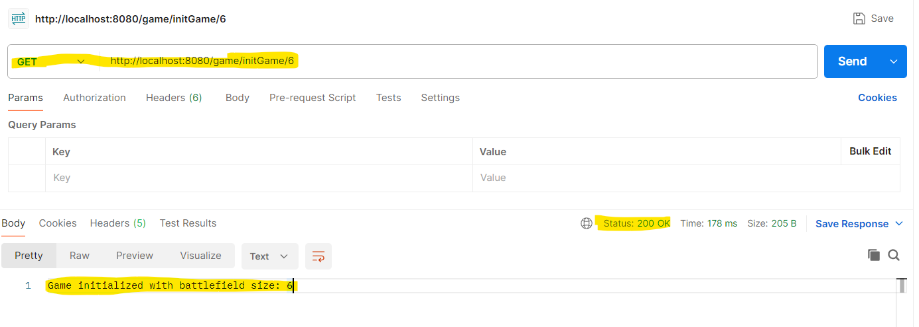**/initGame/6 API**

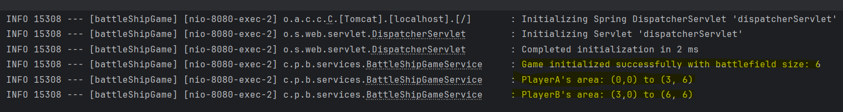

<http://localhost:8080/game/initGame/6>

1. **/addShip(id, size, x position PlayerA, y position PlayerA, x position PlayerB, y position PlayerB) API**

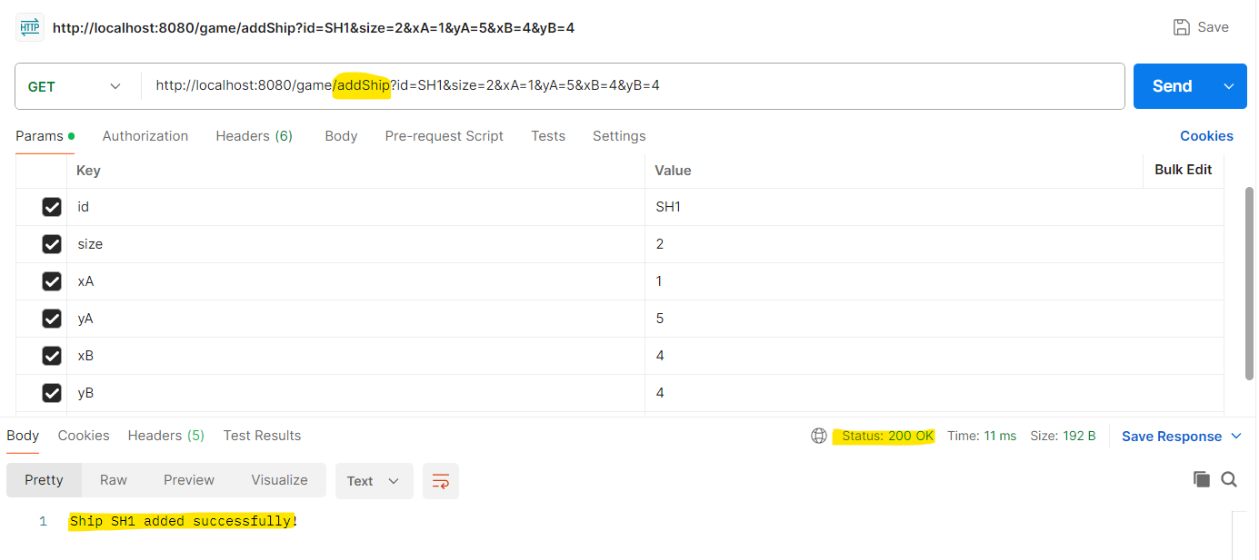

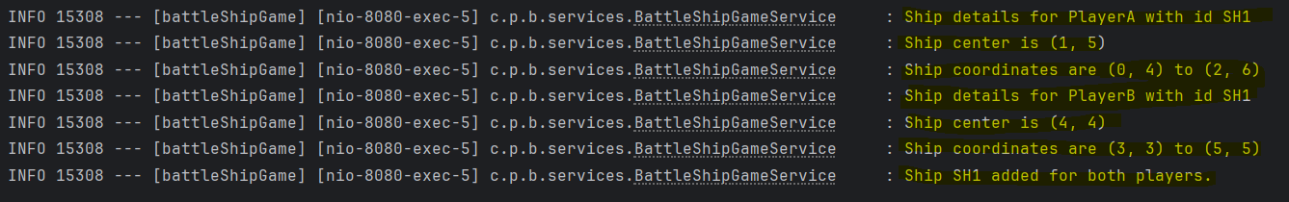

<http://localhost:8080/game/addShip?id=SH1&size=2&xA=1&yA=5&xB=4&yB=4>

1. **/viewBattleField – Optional API\*\*\***

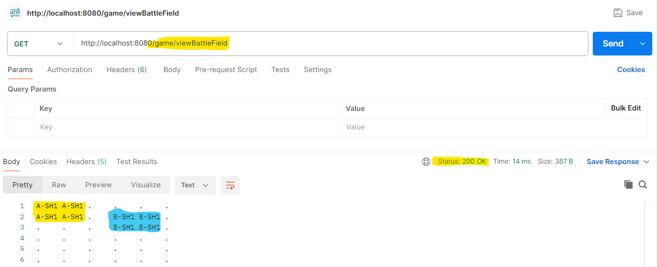

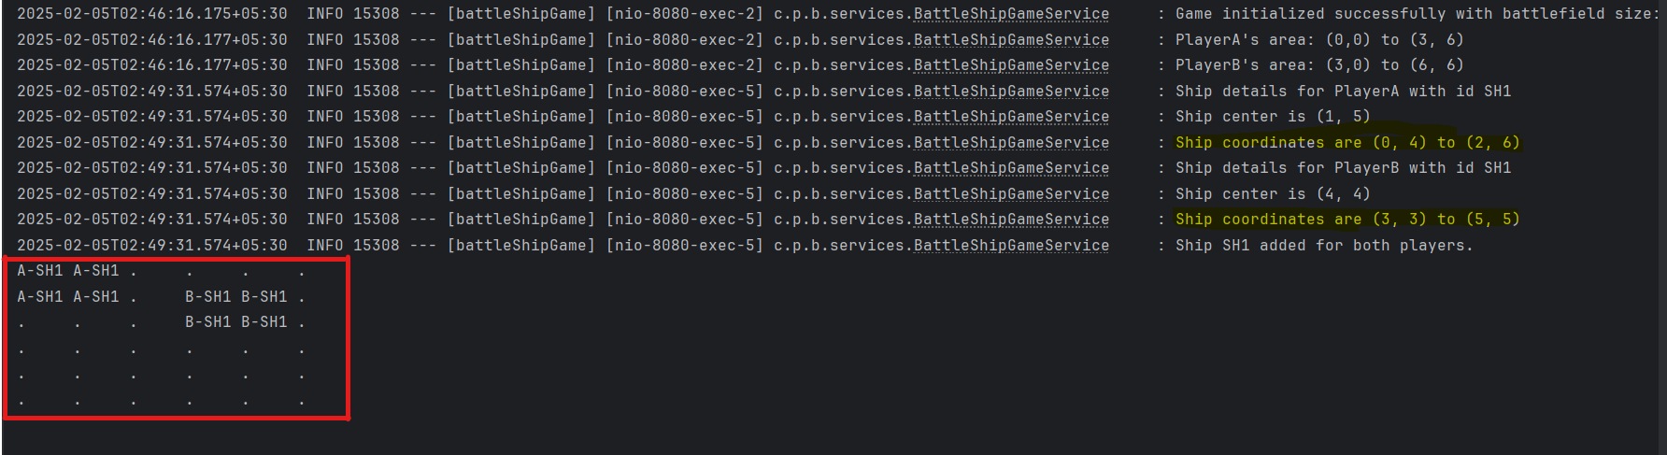

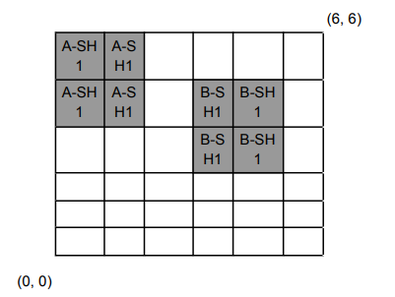

<http://localhost:8080/game/viewBattleField>

1. **/startGame - API**  
     
   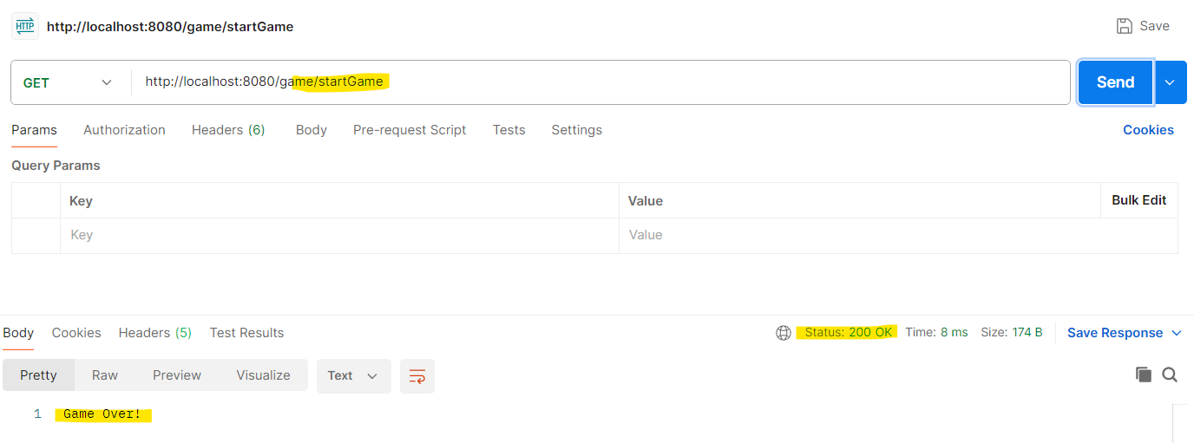

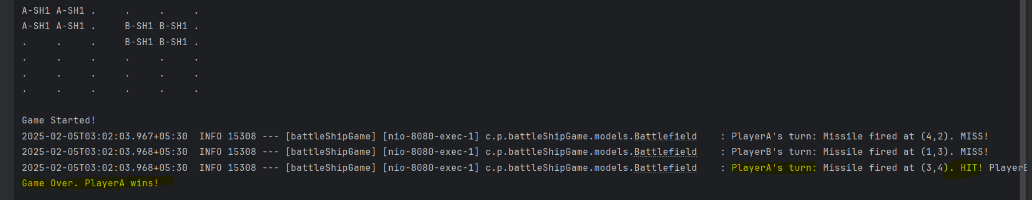  
  
<http://localhost:8080/game/startGame>

**Logs Details -**   
Game Started!  
PlayerA's turn: Missile fired at (4,2). MISS!

PlayerB's turn: Missile fired at (1,3). MISS!

PlayerA's turn: Missile fired at (3,4). HIT! PlayerB's ship with id SH1 destroyed.

Game Over. PlayerA wins!

After this checking the Ship is destroyed or not. By using viewBattleField API -   
As Player B Ship destroyed, so entry also not showing in Battle Field grid -   
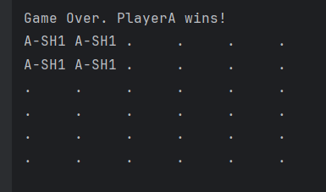

**Added 8 JUnit test cases for testing point of view, working as expected. Please find evidences below -**

