1. Use Case Diagram

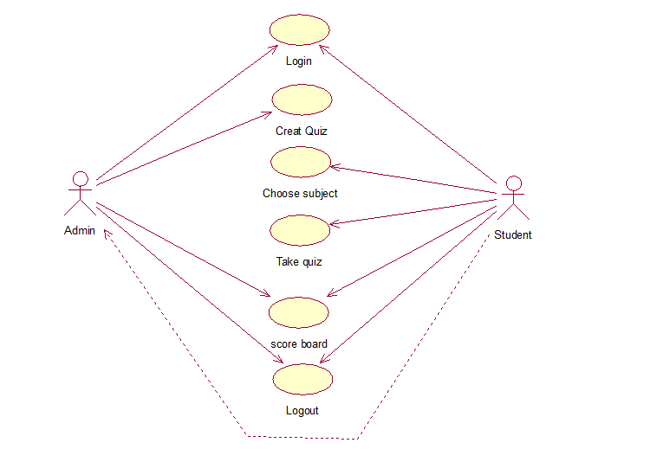

2.1 Login Activity Diagram

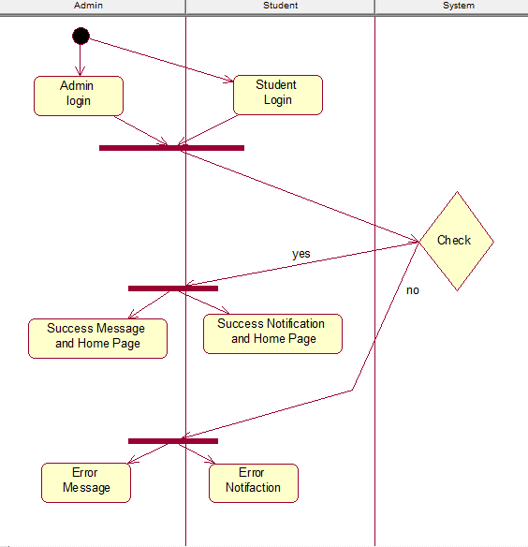

2.2 Create Quiz Activity Diagram

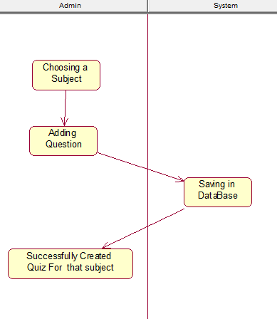

2.3 Choose Subject Activity Diagram

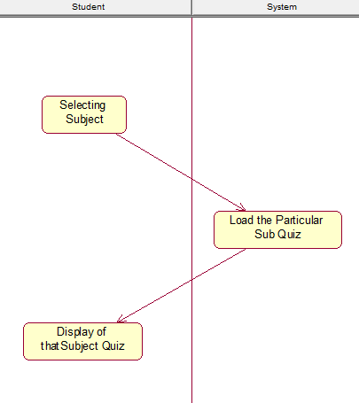

2.4 Take Quiz Activity Diagram

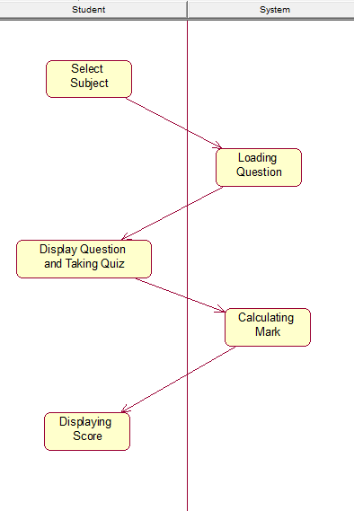

2.5 Score Board Activity Diagram

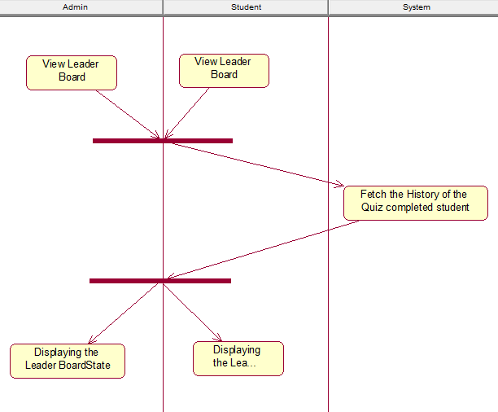

2.6 Logout Activity Diagram

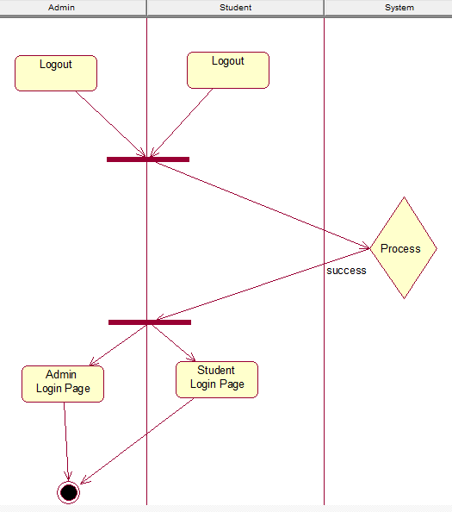

3.1 Login Class Diagram

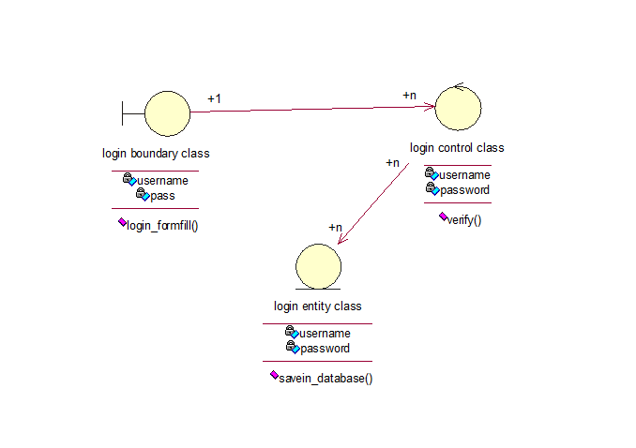3.2 Create Quiz Class Diagram

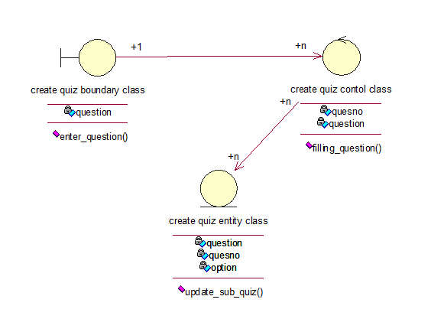

3.3 Choose Subject Class Diagram

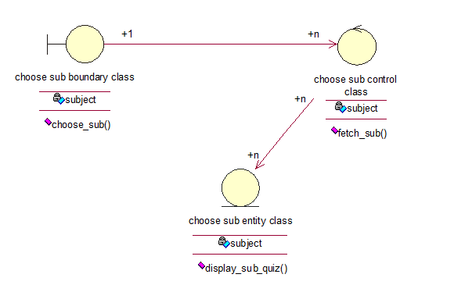

3.4 Take Quiz Class Diagram

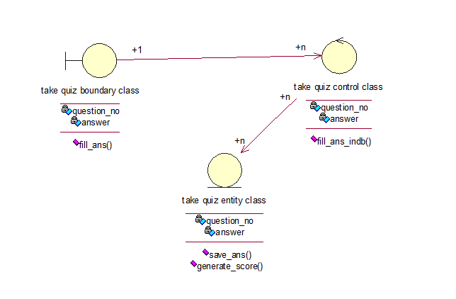

3.5 Score Board Class Diagram

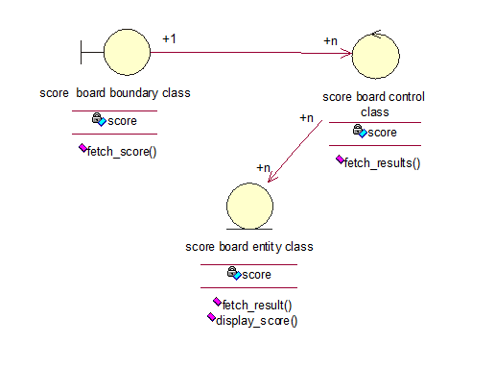

3.6 Logout Class Diagram

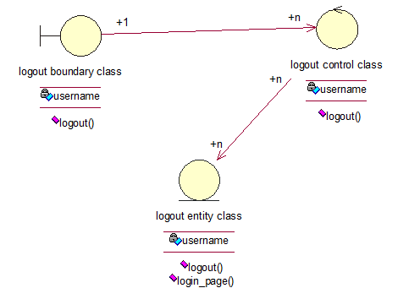

4. Sequence Diagram

5. Collaboration Diagram

6.Component Diagram Main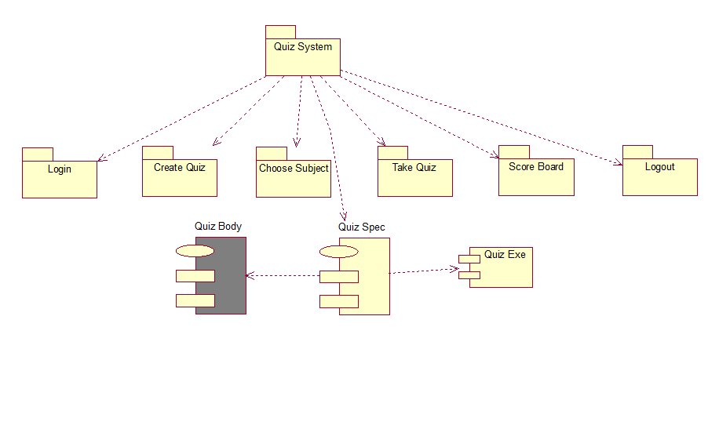  
6.1 Component Diagram Login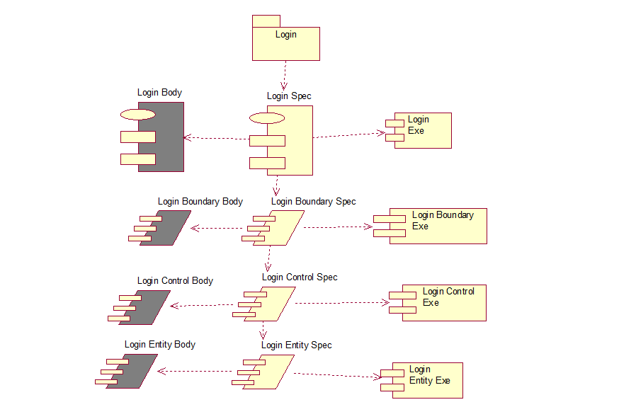

6.2 Component Diagram Create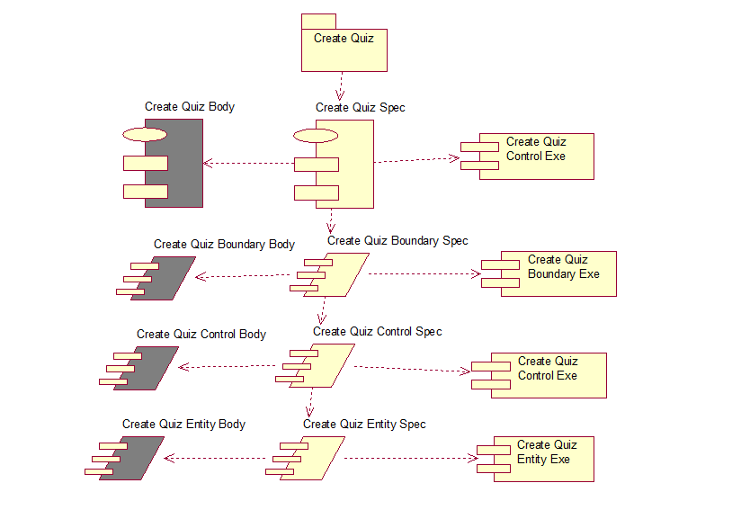

6.3 Component Diagram Choose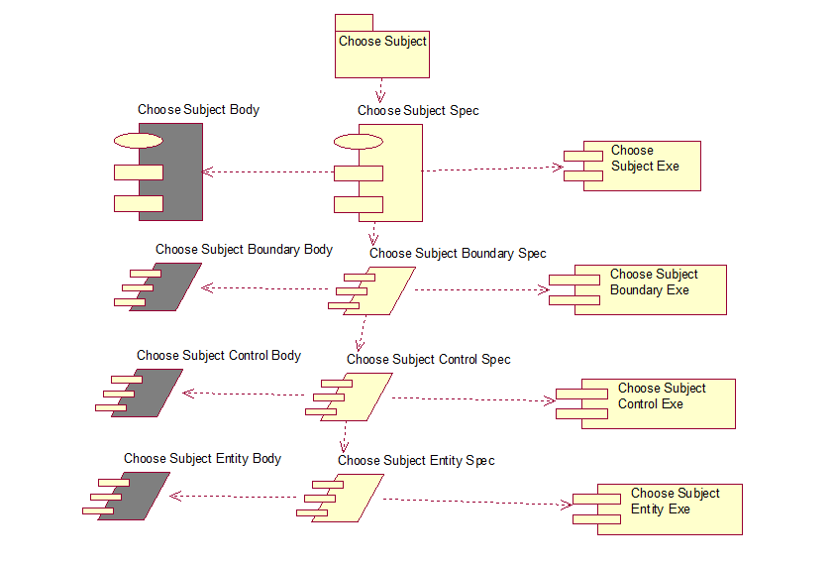

6.4 Component Diagram Take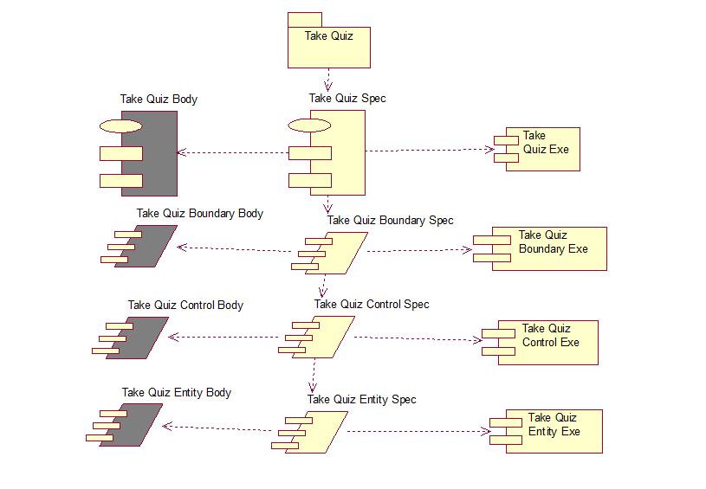

6.5 Component Diagram Score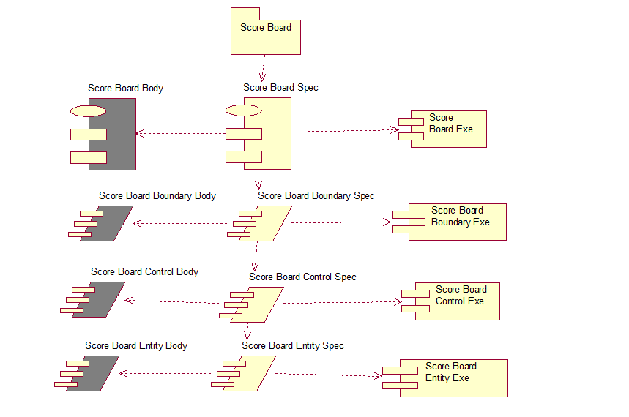

6.6 Component Diagram Logout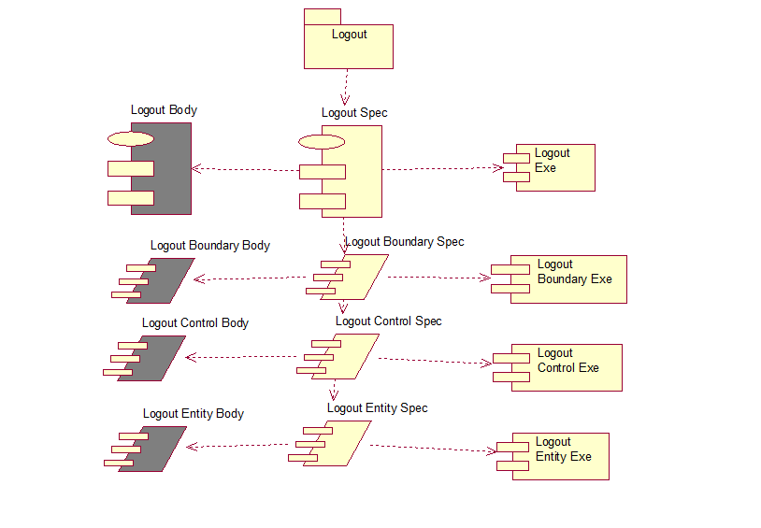

7. Deployment Diagram

