Course: INTERNET PROGRAMMING
Code: CSA4303
Name: Kumaran M
Reg.No: 192525022
LAB EXPERIMENTS

Ex-01:
Aim:
To design and develop a Library Management System website to manage books, student accounts, book issue and return, fines, and study materials.
Algorithm:
- Start the program.
- Create the website using HTML, CSS, and JavaScript.
- Provide student registration and login facilities.
- Allow users to search books and view borrowing history.
- Allow the librarian to add, update, and delete books.
- Manage book issue, return, fine calculation, and study materials.
- Display the results and stop the program.
Code:
<!DOCTYPE html>
<html lang="en">
<head>
<meta charset="UTF-8">
<meta name="viewport" content="width=device-width, initial-scale=1.0">
<title>Library Management System</title>
<link rel="stylesheet" href="style.css">
</head>
<body>
<header class="header">
<h2>📚 Smart Library</h2>
<div class="user-info">Library Management Portal</div>
</header>
<div class="layout">
<aside class="sidebar">
<h3>Navigation</h3>
<a href="#home">🏠 Dashboard</a>
<a href="#books">📚 Search Books</a>
<a href="#history">📖 Borrow History</a>
<a href="#fines">💰 Check Fine</a>
<a href="#materials">📄 Study Materials</a>
<a href="#profile">👤 My Profile</a>
<a href="#admin">⚙ Admin Panel</a>
<a href="#contact">✉ Contact</a>
</aside>
<main class="content">
<section id="home">
<h1>Library Dashboard</h1>
<p>Welcome to your digital library management system.</p>
<div class="stats">
<div class="stat-card">
<h3>1,250</h3>
<p>Total Books</p>
</div>
<div class="stat-card">
<h3>320</h3>
<p>Books Issued</p>
</div>
<div class="stat-card">
<h3>85</h3>
<p>Study Materials</p>
</div>
<div class="stat-card">
<h3>12</h3>
<p>Pending Returns</p>
</div>
</div>
</section>
<section id="books" class="panel">
<h2>Search Books</h2>
<input type="search" placeholder="Enter book title or author">
<select>
<option>All Categories</option>
<option>Computer Science</option>
<option>Mathematics</option>
<option>Science</option>
</select>
<button type="button">Search</button>
<div class="book-grid">
<article class="book-card">
<div class="book-icon">📘</div>
<h3>Python Programming</h3>
<p>Author: John Smith</p>
<p>Category: Computer Science</p>
<span class="available">Available</span>
</article>
<article class="book-card">
<div class="book-icon">📗</div>
<h3>Database Systems</h3>
<p>Author: R. Kumar</p>
<p>Category: Computer Science</p>
<span class="issued">Currently Issued</span>
</article>
<article class="book-card">
<div class="book-icon">📙</div>
<h3>Data Structures</h3>
<p>Author: Mark Allen</p>
<p>Category: Computer Science</p>
<span class="available">Available</span>
</article>
</div>
</section>
<section id="history" class="panel">
<h2>My Borrow History</h2>
<div class="table-wrap">
<table>
<tr>
<th>Book Name</th>
<th>Issue Date</th>
<th>Expected Return</th>
<th>Status</th>
</tr>
<tr>
<td>Python Programming</td>
<td>01-10-2026</td>
<td>15-10-2026</td>
<td><span class="available">Issued</span></td>
</tr>
<tr>
<td>Database Systems</td>
<td>15-09-2026</td>
<td>29-09-2026</td>
<td><span class="issued">Overdue</span></td>
</tr>
</table>
</div>
</section>
<section id="fines" class="panel">
<h2>Check Fine</h2>
<div class="fine-box">
<p>Outstanding Library Fine</p>
<h2>₹20.00</h2>
<p>Sample fine amount for overdue books.</p>
<button type="button">View Fine Details</button>
</div>
</section>
<section id="materials" class="panel">
<h2>Study Materials</h2>
<div class="filters">
<select>
<option>Select Year</option>
<option>First Year</option>
<option>Second Year</option>
<option>Third Year</option>
<option>Final Year</option>
</select>
<select>
<option>Select Semester</option>
<option>Semester 1</option>
<option>Semester 2</option>
<option>Semester 3</option>
<option>Semester 4</option>
<option>Semester 5</option>
<option>Semester 6</option>
<option>Semester 7</option>
<option>Semester 8</option>
</select>
</div>
<div class="material">
<div>
<strong>Data Structures Notes</strong>
<p>Second Year • Semester 3 • PDF</p>
</div>
<a class="download" href="#">Download</a>
</div>
<div class="material">
<div>
<strong>Computer Networks Notes</strong>
<p>Third Year • Semester 5 • PDF</p>
</div>
<a class="download" href="#">Download</a>
</div>
</section>
<section id="profile" class="panel">
<h2>My Profile</h2>
<div class="profile">
<div class="avatar">👤</div>
<div>
<h3>Student Name</h3>
<p>Student ID: STU001</p>
<p>Email: student@example.com</p>
<p>Department: Computer Science</p>
</div>
</div>
</section>
<section id="admin" class="panel">
<h2>Librarian Admin Panel</h2>
<p>Manage books, student borrowing, fines, and study materials.</p>

<div class="admin-grid">
<div class="admin-card">
<h3>📚 Book Inventory</h3>
<p>Add, update, or delete books.</p>
<input type="text" placeholder="Book title">
<input type="text" placeholder="Author name">
<button type="button">Add Book</button>
<button type="button" class="secondary">Update Book</button>
<button type="button" class="danger">Delete Book</button>
</div>
<div class="admin-card">
<h3>📖 Issue & Return</h3>
<input type="text" placeholder="Student ID">
<input type="text" placeholder="Book ID">
<label>Expected Return Date</label>
<input type="date">
<button type="button">Issue Book</button>
<button type="button" class="secondary">Mark Returned</button>
</div>
<div class="admin-card">
<h3>💰 Fine Management</h3>
<input type="text" placeholder="Student ID">
<input type="number" placeholder="Fine amount (₹)">
<button type="button">Update Fine</button>
</div>

<div class="admin-card">
<h3>📄 Study Materials</h3>
<input type="text" placeholder="Material title">
<select>
<option>Select Year</option>
<option>First Year</option>
<option>Second Year</option>
<option>Third Year</option>
<option>Final Year</option>
</select>
<select>
<option>Select Semester</option>
<option>Semester 1</option>
<option>Semester 2</option>
<option>Semester 3</option>
<option>Semester 4</option>
<option>Semester 5</option>
<option>Semester 6</option>
<option>Semester 7</option>
<option>Semester 8</option>
</select>
<input type="file" accept=".pdf">
<button type="button">Upload Material</button>
<button type="button" class="secondary">View Materials</button>
</div>
</div>
</section>
<section id="login" class="panel">
<h2>Student / Admin Login</h2>
<form>
<input type="email" placeholder="Email address" required>
<input type="password" placeholder="Password" required>
<select>
<option>Login as Student</option>
<option>Login as Librarian Admin</option>
</select>
<button type="button">Login</button>
<p>New student? <a href="#register">Register here</a></p>
</form>
</section>
<section id="register" class="panel">
<h2>Student Registration</h2>
<form>
<input type="text" placeholder="Full name" required>
<input type="email" placeholder="Email address" required>
<input type="text" placeholder="Student ID" required>
<input type="password" placeholder="Create password" required>
<button type="button">Register</button>
</form>
</section>
<section id="contact" class="panel">
<h2>Contact Library</h2>
<form>
<input type="text" placeholder="Your name" required>
<input type="email" placeholder="Your email" required>
<textarea placeholder="Write your message..." rows="4" required></textarea>
<button type="button">Send Message</button>
</form>
</section>
<footer>
<p>© 2026 Smart Library Management System | College Library</p>
</footer>
</main>
</div>
</body>
</html>
Output:
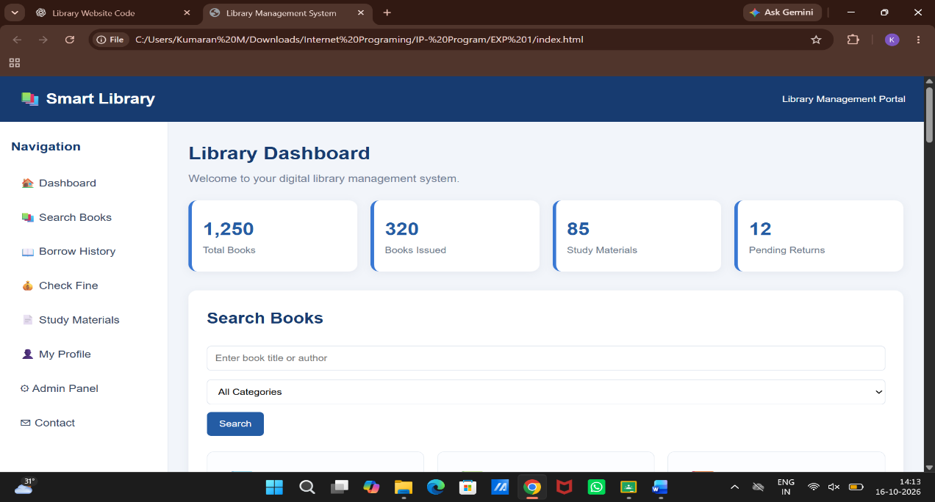

Result:
Thus, the Library Management System website was developed successfully to manage books, student records, borrowing, returns, fines, and study materials efficiently.

