Course: INTERNET PROGRAMMING
Code: CSA4303
Name: Kumaran M
Reg.No: 192525022
LAB EXPERIMENTS

Ex-11:
Aim:
To develop a Home Finder website that helps users search, save, and book houses or lands based on location, budget, and property type.
Algorithm:
- Start the program.
- Provide buyer registration and login.
- Display property details, images, and prices.
- Allow users to search by location, budget, and property type.
- Save search criteria and favorite properties.
- Display property locations on Google Maps.
- Enable agent search, viewing schedules, and advertisements.
- Store customer details and display results.

Code:
* {
box-sizing: border-box;
margin: 0;
padding: 0;
}
html {
scroll-behavior: smooth;
}

body {
font-family: Arial, sans-serif;
background: #f7f8fc;
color: #27324a;
line-height: 1.6;
}
header {
background: white;
padding: 18px 7%;
display: flex;
justify-content: space-between;
align-items: center;
gap: 18px;
flex-wrap: wrap;
box-shadow: 0 2px 12px #0000000c;
}
.logo {
font-size: 24px;
font-weight: bold;
color: #4f46e5;
}
nav {
display: flex;
flex-wrap: wrap;
gap: 18px;
}
nav a {
text-decoration: none;
color: #27324a;
font-weight: bold;
}
nav a:hover {
color: #4f46e5;
}
.hero {
min-height: 340px;
display: flex;
align-items: center;
padding: 50px 8%;
color: white;
background: linear-gradient(120deg, #3730a3, #818cf8);
}
.hero-content {
max-width: 620px;
}
.hero h1 {
font-size: clamp(32px, 5vw, 48px);
line-height: 1.2;
margin-bottom: 15px;
}
.hero p {
font-size: 18px;
margin-bottom: 25px;
}
.button,
button {
display: inline-block;
border: none;
border-radius: 8px;
background: #4f46e5;
color: white;
padding: 11px 17px;
cursor: pointer;
font-size: 14px;
font-weight: bold;
text-decoration: none;
}
.hero .button {
background: white;
color: #4338ca;
}
button:hover,
.button:hover {
opacity: 0.88;
}
button.secondary {
background: #e5e7eb;
color: #27324a;
}
.search-section,
.section {
margin: 30px auto;
width: 86%;
max-width: 1200px;
}
.search-section {
background: white;
padding: 25px;
border-radius: 14px;
box-shadow: 0 5px 20px #0000000a;
}
h2 {
margin-bottom: 15px;
color: #3730a3;
}
h3 {
margin: 15px 0 8px;
}

.search-grid {
display: grid;
grid-template-columns: repeat(3, minmax(0, 1fr));
gap: 12px;
}
input,
select {
width: 100%;
min-width: 0;
padding: 12px;
border: 1px solid #d5d9e5;
border-radius: 7px;
background: white;
font-size: 14px;
}
input:focus,
select:focus {
outline: 2px solid #a5b4fc;
border-color: #6366f1;
}
.saved-searches {
display: flex;
flex-wrap: wrap;
gap: 8px;
}

.saved-searches button {
background: #eef2ff;
color: #3730a3;
}
.subtitle,
.note {
color: #697386;
margin-bottom: 18px;
font-size: 14px;
}
.property-grid {
display: grid;
grid-template-columns: repeat(3, minmax(0, 1fr));
gap: 20px;
}
.property-card,
.agent-card,
.ad-card {
background: white;
border-radius: 12px;
overflow: hidden;
box-shadow: 0 5px 18px #0000000c;
}
.property-card img {
width: 100%;
height: 190px;
object-fit: cover;
background: #e5e7eb;
}
.card-content {
padding: 17px;
}
.card-content h3 {
margin: 0 0 8px;
}
.price {
font-size: 20px;
font-weight: bold;
color: #4f46e5;
margin: 8px 0;
}
.card-content p {
margin: 5px 0;
overflow-wrap: anywhere;
}
.card-actions {
display: flex;
flex-wrap: wrap;
gap: 8px;
margin-top: 14px;
}
.card-actions button {
flex: 1;
}
.card-actions .map-button {
background: #0f766e;
}
.favorites-section {
background: #f0f2ff;
padding: 22px;
border-radius: 14px;
}
.agent-grid,
.ad-grid {
display: grid;
grid-template-columns: repeat(3, minmax(0, 1fr));
gap: 18px;
}
.agent-card,
.ad-card {
padding: 20px;
}

.agent-card p,
.ad-card p {
margin: 8px 0;
}
.agent-card a,
.ad-card a {
color: #4f46e5;
font-weight: bold;
}
.wide-input {
margin-bottom: 18px;
}
.calculator,
.login-box {
max-width: 520px;
background: white;
padding: 22px;
border-radius: 12px;
box-shadow: 0 5px 18px #0000000c;
}
.calculator input,
.login-box input {
margin-bottom: 12px;
}

.calculator button,
.login-box button {
margin: 3px 5px 3px 0;
}
#loginMessage,
#searchMessage,
#mortgageResult {
margin-top: 10px;
color: #0f766e;
font-weight: bold;
}
#viewingList .viewing-item {
background: white;
padding: 15px;
margin: 10px 0;
border-radius: 8px;
border-left: 4px solid #6366f1;
}
footer {
background: #252b46;
color: white;
text-align: center;
padding: 22px;
margin-top: 40px;
}

@media (max-width: 850px) {
.property-grid,
.agent-grid,
.ad-grid {
grid-template-columns: repeat(2, minmax(0, 1fr));
}
.search-grid {
grid-template-columns: repeat(2, minmax(0, 1fr));
}
.search-section,
.section {
width: 92%;
}
}
@media (max-width: 550px) {
header {
padding: 16px 5%;
}
nav {
gap: 12px;
}
.property-grid,
.agent-grid,
.ad-grid,
.search-grid {
grid-template-columns: 1fr;
}
.hero {
padding: 45px 6%;
}
}

Output:
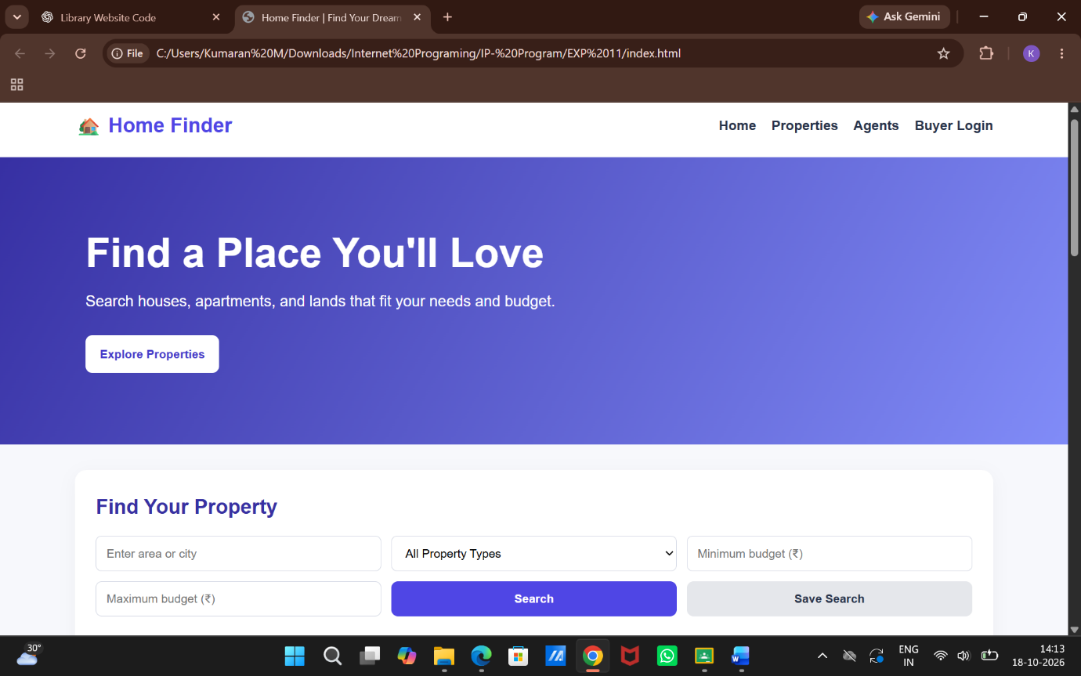

Result:
Thus, the Home Finder website was developed successfully with property search, saved criteria, map locations, agent search, and customer record management.

