Course: INTERNET PROGRAMMING
Code: CSA4303
Name: Kumaran M
Reg.No: 192525022
LAB EXPERIMENTS

Ex-12:
Aim
To develop an InsureEasy Insurance Management System that manages agents, customers, insurance policies, premium payments, and SMS reminders.
Algorithm
- Start the program.
- Provide login facilities for admin, agents, and users.
- Allow agents to register and admin to approve agent accounts.
- Enable agents to add customers and manage customer details.
- Allow agents and users to manage insurance policy details.
- Send SMS alerts for premium due dates and renewals.
- Enable the admin to view agent details and manage records.
- Display the details and stop the program.

Code:
* {
box-sizing: border-box;
margin: 0;
padding: 0;
}
html {
scroll-behavior: smooth;
}

body {
font-family: Arial, sans-serif;
background: #f4f7fb;
color: #25324a;
line-height: 1.6;
}
header {
background: white;
padding: 18px 7%;
display: flex;
justify-content: space-between;
align-items: center;
gap: 15px;
flex-wrap: wrap;
box-shadow: 0 3px 12px #0000000d;
}
.logo {
color: #176b87;
font-size: 25px;
font-weight: bold;
}
nav {
display: flex;
flex-wrap: wrap;
gap: 18px;
}
nav a {
text-decoration: none;
color: #25324a;
font-weight: bold;
}
nav a:hover {
color: #1593a5;
}
.hero {
text-align: center;
padding: 65px 20px;
color: white;
background: linear-gradient(120deg, #155e75, #22a6a1);
}
.hero h1 {
font-size: clamp(30px, 5vw, 44px);
margin-bottom: 12px;
}
.hero p {
margin-bottom: 24px;
}
.hero-button {
display: inline-block;
background: white;
color: #155e75;
padding: 11px 20px;
border-radius: 7px;
text-decoration: none;
font-weight: bold;
}
.section {
width: 88%;
max-width: 1150px;
margin: 35px auto;
}
h2 {
color: #155e75;
margin-bottom: 17px;
}
h3 {
margin-bottom: 9px;
}
.policy-grid {
display: grid;
grid-template-columns: repeat(3, minmax(0, 1fr));
gap: 20px;
}

.policy-card {
background: white;
border-radius: 12px;
padding: 25px;
border-top: 4px solid #22a6a1;
box-shadow: 0 5px 18px #0000000b;
}
.policy-card p {
margin-top: 10px;
}
.panel,
.dashboard {
background: white;
padding: 25px;
border-radius: 12px;
box-shadow: 0 5px 18px #0000000b;
}
form {
display: grid;
gap: 10px;
max-width: 550px;
}
label {
font-weight: bold;
margin-top: 5px;
}
input,
select,
textarea {
width: 100%;
padding: 12px;
border: 1px solid #d2dbe5;
border-radius: 7px;
font: inherit;
background: white;
}
input:focus,
select:focus,
textarea:focus {
outline: 2px solid #9bd8dc;
border-color: #1593a5;
}
button {
border: none;
background: #087f8c;
color: white;
padding: 11px 16px;
border-radius: 7px;
font-weight: bold;
cursor: pointer;
margin: 4px 4px 4px 0;
}
button:hover {
opacity: 0.88;
}
button.secondary {
background: #e5eaf0;
color: #25324a;
}
button.danger {
background: #b42335;
}
button.approve {
background: #17834d;
}
.hint,
.note {
color: #65748b;
font-size: 14px;
margin: 8px 0 15px;
}
#loginMessage,
#agentMessage,
.message {
color: #087f62;
margin-top: 12px;
font-weight: bold;
}
.dashboard-heading {
display: flex;
justify-content: space-between;
align-items: center;
gap: 15px;
margin-bottom: 20px;
}
.stats {
display: grid;
grid-template-columns: repeat(4, minmax(0, 1fr));
gap: 14px;
margin-bottom: 25px;
}
.stat-card {
background: #eaf7f8;
padding: 17px;
border-radius: 10px;
}
.stat-card strong {
display: block;
font-size: 25px;
color: #155e75;
}
.dashboard-block {
border-top: 1px solid #e4e9ef;
padding-top: 22px;
margin-top: 22px;
}
.table-wrap {
overflow-x: auto;
margin-top: 12px;
}
table {
width: 100%;
border-collapse: collapse;
min-width: 650px;
}
th,
td {
padding: 11px;
border-bottom: 1px solid #e3e8ef;
text-align: left;
}
th {
background: #eaf7f8;
}
.badge {
display: inline-block;
padding: 4px 9px;
border-radius: 20px;
background: #fff1ce;
color: #875d00;
font-size: 12px;
font-weight: bold;
}
.badge.approved,
.badge.paid {
background: #d9f7e6;
color: #146c3d;
}
.badge.pending,
.badge.unpaid {
background: #fff1ce;
color: #875d00;
}
.badge.rejected {
background: #ffe1e1;
color: #a32222;
}

.inline-form {
display: grid;
grid-template-columns: repeat(2, minmax(0, 1fr));
gap: 12px;
max-width: 750px;
}
.inline-form .full {
grid-column: 1 / -1;
}
.record-card {
border: 1px solid #e1e7ee;
border-radius: 9px;
padding: 15px;
margin: 12px 0;
}
.record-card p {
margin: 5px 0;
}
.empty {
padding: 16px;
background: #f4f7fb;
border-radius: 8px;
color: #65748b;
}

footer {
text-align: center;
background: #183447;
color: white;
padding: 25px 15px;
margin-top: 45px;
}
footer .hint {
color: #d0dce5;
}
[hidden] {
display: none !important;
}
@media (max-width: 800px) {
.policy-grid {
grid-template-columns: 1fr;
}
.stats {
grid-template-columns: repeat(2, minmax(0, 1fr));
}
.section {
width: 92%;
}
}
@media (max-width: 520px) {
header {
padding: 15px 5%;
}
nav {
gap: 10px;
}
.stats,
.inline-form {
grid-template-columns: 1fr;
}
.inline-form .full {
grid-column: auto;
}
.panel,
.dashboard {
padding: 17px;
}
}

Output:
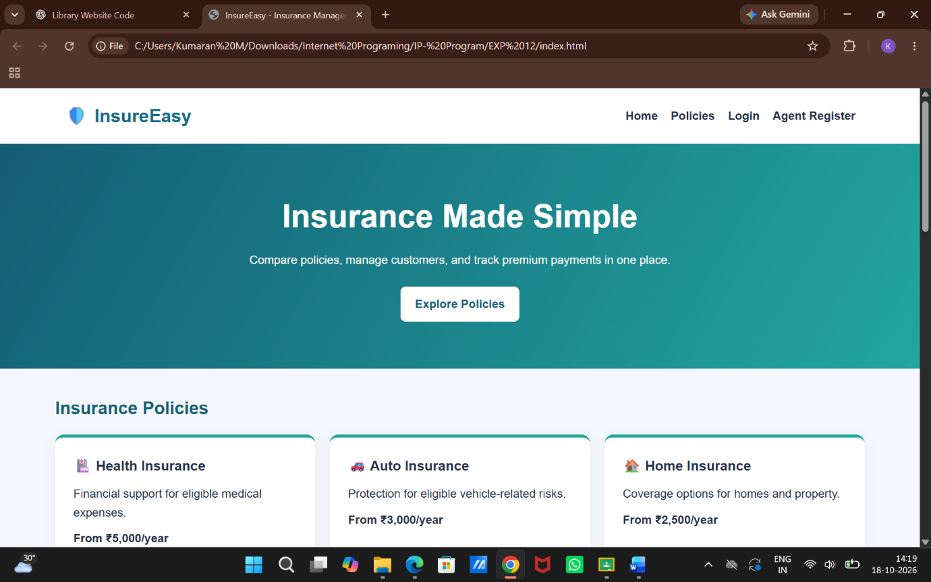

Result:
Thus, the InsureEasy system was developed successfully to manage insurance policies, agents, customers, and premium reminder alerts.

