Course: INTERNET PROGRAMMING
Code: CSA4303
Name: Kumaran M
Reg.No: 192525022
LAB EXPERIMENTS

Ex-13:
Aim:
To develop a BlossomGifts website that allows customers to browse, order, and track flowers and gifts online.
Algorithm:
- Start the program.
- Provide user registration and login.
- Display product categories and subcategories.
- Allow users to search items and check availability.
- Enable users to add, edit, or remove items from the cart.
- Allow checkout, payment, and order tracking.
- Enable the admin to manage products, prices, and customer details.
- Display order details and stop the program.

Code:
* {
box-sizing: border-box;
margin: 0;
padding: 0;
}
html {
scroll-behavior: smooth;
}

body {
font-family: Arial, sans-serif;
background: #fff8fa;
color: #44323b;
line-height: 1.6;
}
header {
background: white;
padding: 16px 6%;
display: flex;
align-items: center;
justify-content: space-between;
gap: 15px;
flex-wrap: wrap;
box-shadow: 0 3px 14px #6d31410d;
position: sticky;
top: 0;
z-index: 5;
}
.logo {
font-size: 24px;
font-weight: bold;
color: #c13e70;
text-decoration: none;
}

nav {
display: flex;
gap: 15px;
flex-wrap: wrap;
}
nav a {
color: #543743;
text-decoration: none;
font-weight: bold;
font-size: 14px;
}
nav a:hover {
color: #c13e70;
}
.hero {
min-height: 340px;
display: flex;
align-items: center;
padding: 55px 9%;
color: white;
background: linear-gradient(115deg, #9c315b, #e77da0);
}
.hero h1 {
font-size: clamp(32px, 5vw, 48px);
line-height: 1.2;
max-width: 600px;
margin: 10px 0;
}
.hero p {
margin: 12px 0 22px;
}
.eyebrow {
font-weight: bold;
letter-spacing: 2px;
}
.button,
button {
border: none;
border-radius: 8px;
padding: 11px 16px;
background: #c13e70;
color: white;
font-weight: bold;
font-size: 14px;
cursor: pointer;
text-decoration: none;
display: inline-block;
}
.hero .button {
background: white;
color: #a82d5d;
}
button:hover,
.button:hover {
opacity: 0.86;
}
button.secondary {
background: #eee4e8;
color: #543743;
}
button.danger {
background: #b42335;
}
.section {
width: 88%;
max-width: 1200px;
margin: 36px auto;
}
h2 {
color: #a82d5d;
margin-bottom: 18px;
}
h3 {
margin-bottom: 10px;
}
.category-grid {
display: grid;
grid-template-columns: repeat(6, minmax(0, 1fr));
gap: 14px;
}
.category-card {
min-height: 105px;
background: white;
color: #a82d5d;
border: 1px solid #f4d9e3;
font-size: 27px;
display: flex;
flex-direction: column;
align-items: center;
justify-content: center;
gap: 5px;
}
.category-card span {
font-size: 14px;
}
.shop-section {
background: #fff0f5;
padding: 25px;
border-radius: 15px;
}
.filters {
display: grid;
grid-template-columns: 2fr 1fr 1fr 1fr;
gap: 12px;
margin-bottom: 22px;
}
input,
select,
textarea {
width: 100%;
min-width: 0;
padding: 11px;
border: 1px solid #e1cbd4;
border-radius: 7px;
background: white;
color: #44323b;
font: inherit;
}
input:focus,
select:focus,
textarea:focus {
outline: 2px solid #f3b6cc;
border-color: #c13e70;
}

.product-grid {
display: grid;
grid-template-columns: repeat(3, minmax(0, 1fr));
gap: 20px;
}
.product-card {
background: white;
border-radius: 12px;
overflow: hidden;
box-shadow: 0 5px 18px #7b33420e;
border: 1px solid #f3e4e9;
}
.product-card img {
width: 100%;
height: 205px;
object-fit: cover;
background: #f5e8ed;
}
.product-info {
padding: 16px;
}
.product-info h3 {
margin-bottom: 5px;
}

.subcategory {
display: inline-block;
background: #ffedf3;
color: #a82d5d;
border-radius: 20px;
padding: 3px 9px;
font-size: 12px;
margin: 5px 0;
}
.product-price {
color: #b12e61;
font-size: 21px;
font-weight: bold;
margin: 8px 0;
}
.product-info p {
margin: 5px 0;
}
.product-actions {
display: flex;
gap: 8px;
margin-top: 13px;
}
.product-actions button {
flex: 1;
}
.cart-section,
.panel {
background: white;
padding: 25px;
border-radius: 13px;
box-shadow: 0 4px 18px #7b33420c;
}
.cart-item {
display: grid;
grid-template-columns: 2fr auto auto auto;
align-items: center;
gap: 12px;
border-bottom: 1px solid #f0dfe6;
padding: 14px 0;
}
.quantity-controls {
display: flex;
align-items: center;
gap: 7px;
}
.quantity-controls button {
padding: 5px 10px;
}

.cart-total {
text-align: right;
margin-top: 20px;
}
.cart-total h3 {
color: #a82d5d;
margin-top: 8px;
}
.hint {
color: #806c76;
font-size: 13px;
margin: 9px 0 15px;
}
.account-grid {
display: grid;
grid-template-columns: repeat(2, minmax(0, 1fr));
gap: 25px;
}
.account-grid form,
.checkout-grid,
.admin-form {
display: grid;
gap: 10px;
}

label {
display: block;
font-weight: bold;
font-size: 14px;
}
label input,
label select,
label textarea {
display: block;
margin-top: 5px;
font-weight: normal;
}
#accountMessage,
#checkoutMessage,
#adminMessage {
margin-top: 12px;
color: #168052;
font-weight: bold;
}
.checkout-grid {
grid-template-columns: repeat(2, minmax(0, 1fr));
gap: 15px;
}
.full {
grid-column: 1 / -1;
}
.order-card {
background: white;
border: 1px solid #f0dfe6;
border-left: 4px solid #c13e70;
border-radius: 9px;
padding: 17px;
margin: 12px 0;
overflow-wrap: anywhere;
}
.order-card p {
margin: 5px 0;
}
.order-card button {
margin-top: 8px;
}
.status {
display: inline-block;
padding: 3px 9px;
border-radius: 20px;
background: #fff0d3;
color: #805500;
font-size: 12px;
font-weight: bold;
}
.status.delivered {
background: #dff7e7;
color: #176c3d;
}
.status.cancelled {
background: #ffe3e3;
color: #a32222;
}
.admin-heading {
margin: 25px 0 15px;
}
.admin-form {
grid-template-columns: repeat(2, minmax(0, 1fr));
padding: 18px;
border-radius: 10px;
background: #fff4f7;
margin-bottom: 25px;
}
.table-wrap {
overflow-x: auto;
margin: 12px 0 25px;
}

table {
width: 100%;
min-width: 650px;
border-collapse: collapse;
}
th,
td {
text-align: left;
padding: 11px;
border-bottom: 1px solid #f0dfe6;
}
th {
background: #fff0f5;
color: #893052;
}
.empty {
background: #fff4f7;
padding: 16px;
border-radius: 8px;
color: #806c76;
}
footer {
background: #71304b;
color: white;
text-align: center;
padding: 25px 15px;
margin-top: 45px;
}
[hidden] {
display: none !important;
}
@media (max-width: 850px) {
.category-grid {
grid-template-columns: repeat(3, minmax(0, 1fr));
}
.product-grid {
grid-template-columns: repeat(2, minmax(0, 1fr));
}
.filters {
grid-template-columns: repeat(2, minmax(0, 1fr));
}
.cart-item {
grid-template-columns: 1fr 1fr;
}
}
@media (max-width: 560px) {
header {
position: static;
}
nav {
gap: 10px;
}
.section {
width: 92%;
}
.category-grid,
.product-grid,
.account-grid,
.checkout-grid,
.admin-form,
.filters {
grid-template-columns: 1fr;
}
.full {
grid-column: auto;
}
.shop-section,
.panel,
.cart-section {
padding: 17px;
}
}

Output:
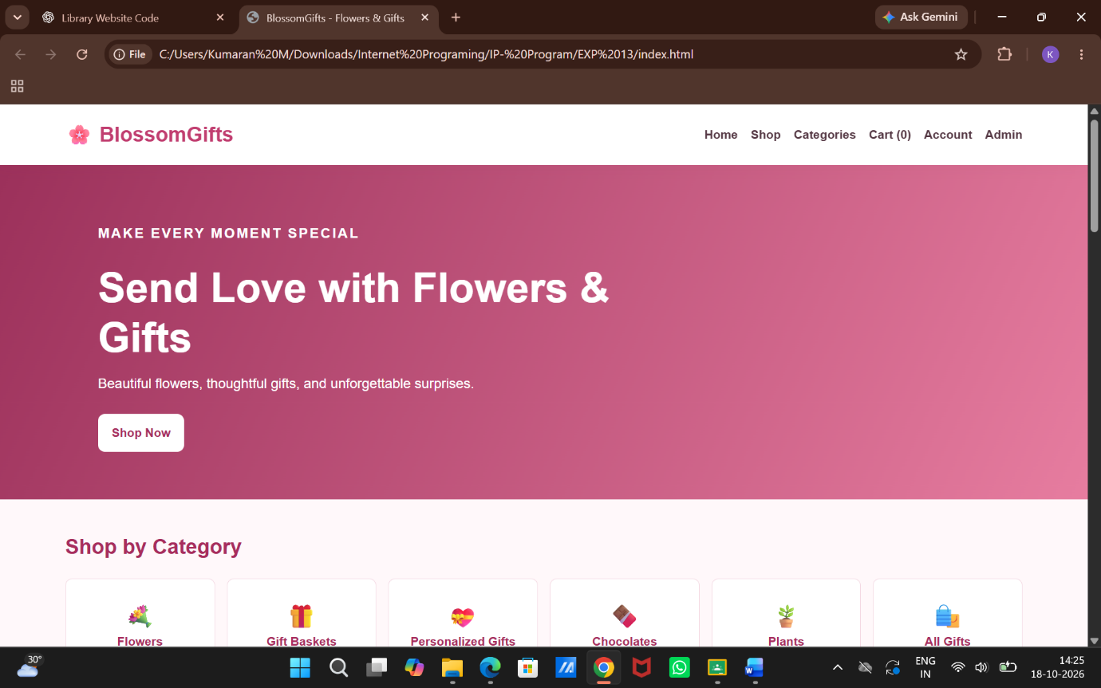

Result:
Thus, the BlossomGifts website was developed successfully with product browsing, shopping cart, online ordering, order tracking, and admin management features.

