Course: INTERNET PROGRAMMING
Code: CSA4303
Name: Kumaran M
Reg.No: 192525022
LAB EXPERIMENTS

Ex-15:
Aim:
To develop an EasyToll website that allows users to pay toll charges in advance, purchase toll passes, and avoid waiting in queues.
Algorithm:
- Start the program.
- Provide registration and login for users and admin.
- Allow users to add money to their eWallet.
- Enable users to buy eTickets and apply for or renew toll passes.
- Generate a QR code for the toll ticket or pass.
- Allow toll gate staff to scan and verify QR codes and toll details.
- Enable the admin to manage users, toll details, and pass approvals.
- Display payment details and stop the program.

Code:
body {
font-family: Arial, sans-serif;
margin: 0;
background: #f2f6f3;
color: #26352b;
}
header {
background: #218c5a;
color: white;
text-align: center;
padding: 22px;
}
header h1 {
margin: 0;
}
nav {
background: #174d35;
padding: 12px;
text-align: center;
}
nav button {
margin: 5px;
background: white;
color: #174d35;
}
main {
max-width: 900px;
margin: 25px auto;
padding: 15px;
}
.section {
background: white;
padding: 22px;
margin-bottom: 20px;
border-radius: 10px;
box-shadow: 0 2px 8px #cccccc;
}
input, select {
padding: 10px;
margin: 6px 3px;
border: 1px solid #bbb;
border-radius: 5px;
max-width: 100%;
box-sizing: border-box;
}
button {
padding: 10px 14px;
background: #218c5a;
color: white;
border: none;
border-radius: 5px;
cursor: pointer;
}
button:hover {
background: #146b40;
}
li, .product, .order {
background: #eef7f0;
padding: 12px;
margin: 10px 0;
border-radius: 6px;
overflow-wrap: anywhere;
}
li button, .product button, .order button {
margin: 5px;
}
footer {
background: #174d35;
color: white;
text-align: center;
padding: 15px;
margin-top: 30px;
}
[hidden] {
display: none !important;
}
@media (max-width: 600px) {
main {
margin: 10px;
padding: 5px;
}

nav button {
width: 95%;
}
input, select {
width: 95%;
}
}

Output:
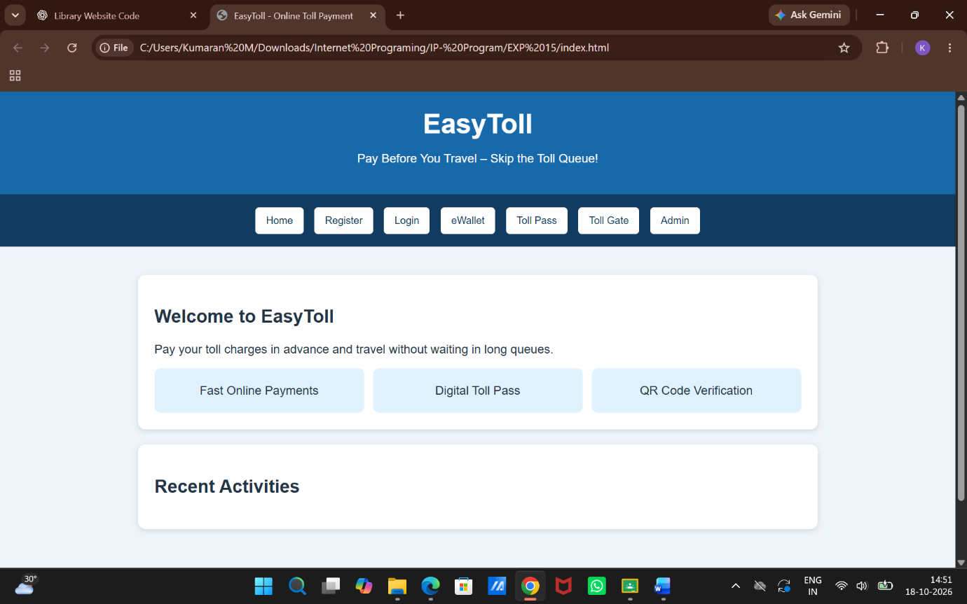

Result:
Thus, the EasyToll website was developed successfully with advance toll payments, eWallet, toll pass management, QR code generation, and toll verification features.

