Course: INTERNET PROGRAMMING
Code: CSA4303
Name: Kumaran M
Reg.No: 192525022
LAB EXPERIMENTS

Ex-16:
Aim:
To develop a ComplainEase website that allows users to register complaints, track their status, and receive updates from officers.
Algorithm:
- Start the program.
- Provide registration and login for users, officers, and admin.
- Allow users to submit complaints and mark locations on Google Maps.
- Enable users to view complaint status and provide feedback.
- Allow officers to view complaints and update their status.
- Enable officers to upload proof of completed work.
- Allow the admin to manage accounts, passwords, officers, and website features.
- Display complaint details and stop the program.

Code:
* {
margin: 0;
padding: 0;
box-sizing: border-box;
}
html {
scroll-behavior: smooth;
}
body {
font-family: Arial, sans-serif;
background-color: #f1f5f9;
color: #1e293b;
line-height: 1.6;
}
header {
background: #164e63;
color: white;
text-align: center;
padding: 30px 15px;
}
header h1 {
font-size: 36px;
margin-bottom: 5px;
}
nav {
background: #0e7490;
padding: 15px;
text-align: center;
position: sticky;
top: 0;
}
nav a {
color: white;
text-decoration: none;
margin: 8px;
font-weight: bold;
display: inline-block;
}
nav a:hover {
color: #facc15;
}
main {
width: 90%;
max-width: 1000px;
margin: 25px auto;
}
.hero {
background: #cffafe;
padding: 40px 20px;
text-align: center;
border-radius: 10px;
margin-bottom: 25px;
}
.hero h2 {
color: #155e75;
font-size: 28px;
margin-bottom: 10px;
}
.card {
background: white;
padding: 25px;
margin-bottom: 25px;
border-radius: 10px;
box-shadow: 0 3px 10px #00000012;
}
.card h2 {
color: #0e7490;
margin-bottom: 18px;
border-bottom: 2px solid #cffafe;
padding-bottom: 8px;
}
.card h3 {
margin: 15px 0;
color: #155e75;
}
label {
display: block;
font-weight: bold;
margin-top: 12px;
}
input, select, textarea {
width: 100%;
padding: 12px;
margin-top: 6px;
border: 1px solid #cbd5e1;
border-radius: 5px;
font-size: 15px;
}
textarea {
resize: vertical;
}
button, .btn {
display: inline-block;
background: #0891b2;
color: white;
border: none;
padding: 11px 18px;
margin-top: 15px;
border-radius: 5px;
text-decoration: none;
cursor: pointer;
font-size: 15px;
}
button:hover, .btn:hover {
background: #155e75;
}

ul {
padding-left: 25px;
}
footer {
background: #164e63;
color: white;
text-align: center;
padding: 18px;
}
@media (max-width: 600px) {
header h1 {
font-size: 28px;
}
nav a {
margin: 5px;
font-size: 14px;
}
main {
width: 94%;
}
.card {
padding: 16px;
}
}

Output:
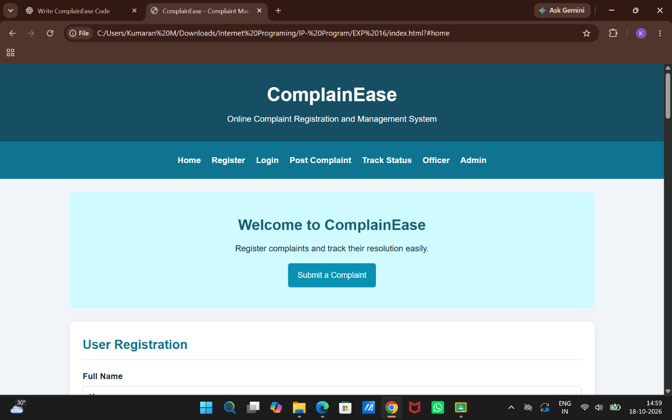

Result:
Thus, the ComplainEase website was developed successfully with complaint registration, location marking, status tracking, officer management, and administrator control.

