Course: INTERNET PROGRAMMING
Code: CSA4303
Name: Kumaran M
Reg.No: 192525022
LAB EXPERIMENTS

Ex-02:
Aim:
To design and develop a responsive Hotel Room Booking website that allows users to search room availability, book rooms, manage reservations, and enables administrators to manage room details and bookings.
Algorithm:
- Start the program.
- Design the website using HTML, CSS, and JavaScript.
- Provide user registration and login facilities.
- Allow users to search rooms by destination, dates, and guests.
- Check room availability and confirm bookings.
- Allow users to modify or cancel bookings at least three days before arrival.
- Allow the administrator to manage room prices, quantities, bookings, and hotel information.
- Display booking details and stop the program.

Code:
* {
margin: 0;
padding: 0;
box-sizing: border-box;
}
html {
scroll-behavior: smooth;
scroll-padding-top: 90px;
}
body {
font-family: Arial, sans-serif;
line-height: 1.6;
color: #263238;
background: #f7f8fa;
}
header {
background: #173d35;
color: white;
padding: 18px 5%;
display: flex;
justify-content: space-between;
align-items: center;
flex-wrap: wrap;
gap: 15px;
position: sticky;
top: 0;
z-index: 10;
}
header h2 {
color: #f5d28a;
}
nav {
display: flex;
flex-wrap: wrap;
gap: 15px;
}

nav a,
footer a {
color: white;
text-decoration: none;
}
nav a:hover,
footer a:hover {
color: #f5d28a;
}
.hero {
min-height: 420px;
padding: 70px 5%;
display: flex;
align-items: center;
justify-content: center;
text-align: center;
color: white;
background: linear-gradient(135deg, #173d35, #4b7867);
}
.hero h1 {
font-size: clamp(30px, 5vw, 48px);
margin-bottom: 10px;
}
.hero p {
margin-bottom: 25px;
}
.hero form {
display: flex;
flex-wrap: wrap;
gap: 10px;
justify-content: center;
background: white;
padding: 15px;
border-radius: 10px;

input,
select,
textarea {
width: 100%;
padding: 12px;
margin: 7px 0;
border: 1px solid #d6dedb;
border-radius: 6px;
font: inherit;
background: white;
}
.hero input,
.hero select {
width: 180px;
}

button,
.btn {
display: inline-block;
padding: 11px 17px;
background: #b98237;
color: white;
border: none;
border-radius: 6px;
cursor: pointer;
text-decoration: none;
font-size: 14px;
text-align: center;
}
button:hover,
.btn:hover {
background: #926126;
}
.section {
padding: 55px 6%;
scroll-margin-top: 80px;
}
.section h2 {
color: #173d35;
margin-bottom: 10px;
font-size: 28px;
}
.subtitle {
color: #718078;
margin-bottom: 25px;
}
.light {
background: #eaf0ed;
}
.room-grid {
display: grid;
grid-template-columns: repeat(4, minmax(0, 1fr));
gap: 20px;
margin-top: 25px;
}
.room-card {
background: white;
border-radius: 12px;
overflow: hidden;
box-shadow: 0 4px 15px #173d3512;
}
.room-image {
height: 150px;
display: grid;
place-items: center;
font-size: 65px;
}
.standard {
background: #e2eee8;
}
.deluxe {
background: #f4e8d5;
}
.suite {
background: #e1e7f2;
}
.family {
background: #f4e3df;
}
.room-info {
padding: 18px;
}
.room-info h3 {
color: #173d35;
margin-bottom: 8px;
}
.room-info p {
font-size: 13px;
color: #68766e;
margin: 10px 0;
}
.price {
color: #ad752d !important;
margin: 12px 0 !important;
}
.available {
display: block;
font-size: 12px;
color: #397354;
margin: 10px 0;
}
.form-card {
max-width: 650px;
margin: 20px auto 0;
background: white;
padding: 25px;
border-radius: 12px;
box-shadow: 0 4px 15px #173d3510;
}
.form-card label {
display: block;
font-weight: bold;
margin-top: 10px;
font-size: 14px;
}
.form-card button {
margin-top: 12px;
}
.note {
color: #718078;
font-size: 12px;
margin-top: 15px;
}
.table-wrap {
overflow-x: auto;
background: white;
border-radius: 8px;
}
table {
width: 100%;
border-collapse: collapse;
min-width: 650px;
}
th,
td {
padding: 14px;
text-align: left;
border-bottom: 1px solid #e5eae7;
font-size: 14px;
}
th {
background: #173d35;
color: white;
}
.cancel {
background: #c74646;
}
.edit {
background: #426d98;
}
.account-grid,
.admin-grid {
display: grid;
grid-template-columns: repeat(2, minmax(0, 1fr));
gap: 20px;
align-items: start;
}
.account-grid .form-card {
width: 100%;
}

.admin-card {
background: white;
padding: 22px;
border-radius: 10px;
border: 1px solid #dfe7e2;
}
.admin-card h3 {
color: #173d35;
margin-bottom: 12px;
}
.admin-card label {
display: block;
font-size: 13px;
font-weight: bold;
margin-top: 8px;
}
details {
background: white;
padding: 18px;
margin: 12px 0;
border-radius: 8px;
border: 1px solid #dfe7e2;
}
summary {
cursor: pointer;
font-weight: bold;
color: #173d35;
}
details p {
margin-top: 12px;
color: #68766e;
}
footer {
background: #173d35;
color: white;
text-align: center;
padding: 25px 15px;
}
footer p {
margin: 8px 0;
}
/* Tablet */
@media (max-width: 1050px) {
.room-grid {
grid-template-columns: repeat(2, minmax(0, 1fr));
}
header {
justify-content: center;
}
}
/* Mobile */
@media (max-width: 650px) {
header {
position: static;
}
nav {
justify-content: center;
gap: 12px;
}
nav a {
font-size: 13px;
}
.hero {
padding: 45px 15px;
}
.hero form {
flex-direction: column;
}
.hero input,
.hero select {
width: 100%;
}
.section {
padding: 35px 16px;
}
.room-grid,
.account-grid,
.admin-grid {
grid-template-columns: 1fr;
}
.form-card {
padding: 18px;
}
}

Output: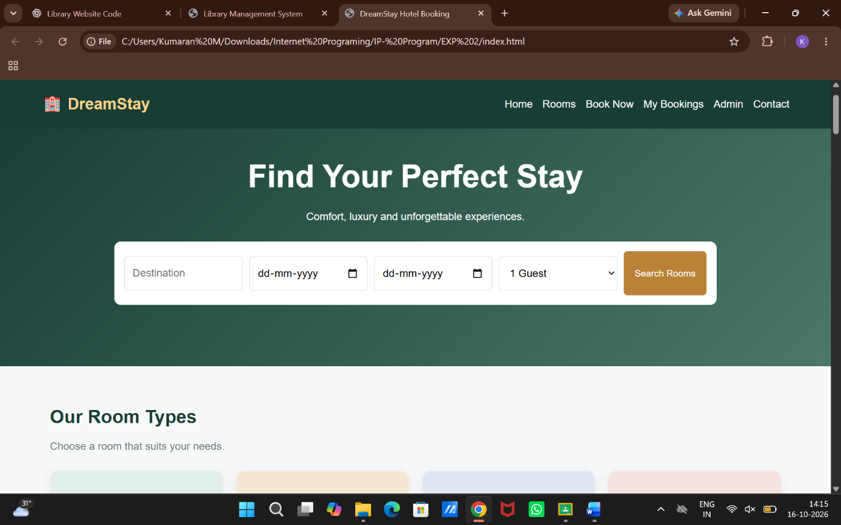

Result:
Thus, the Hotel Room Booking website was developed successfully with room searching, availability checking, booking management, user accounts, and administrator facilities.

