Course: INTERNET PROGRAMMING
Code: CSA4303
Name: Kumaran M
Reg.No: 192525022
LAB EXPERIMENTS

Ex-03:
Aim:
To design and develop an Online Bus Ticket Booking System that allows users to register, search buses, book seats, cancel tickets, and enables administrators to manage bus information and generate reports.
Algorithm:
- Start the program.
- Design the website using HTML, CSS, and JavaScript.
- Provide user registration, login, and password management.
- Allow users to search buses by route, date, and time.
- Display available seats and allow users to book tickets.
- Enable users to cancel tickets and post comments.
- Allow the admin to manage buses, categories, users, news, and reports.
- Display booking details and stop the program.

Code:
* {
margin: 0;
padding: 0;
box-sizing: border-box;
}
html {
scroll-behavior: smooth;
scroll-padding-top: 100px;
}
body {
font-family: Arial, sans-serif;
background: #f4f7fb;
color: #263449;
line-height: 1.6;
}
header {
background: #12345a;
color: white;
padding: 18px 5%;
display: flex;
justify-content: space-between;
align-items: center;
flex-wrap: wrap;
gap: 15px;
position: sticky;
top: 0;
z-index: 10;
}
header h2 {
color: #ffc857;
}
nav {
display: flex;
flex-wrap: wrap;
gap: 15px;
}
nav a {
color: white;
text-decoration: none;
font-size: 14px;
}
nav a:hover {
color: #ffc857;
}
.hero {
background: linear-gradient(135deg, #12345a, #2877a8);
color: white;
text-align: center;
padding: 75px 5%;
}
.hero h1 {
font-size: clamp(28px, 5vw, 45px);
margin-bottom: 10px;
}
.hero p {
margin-bottom: 25px;
}
.search-form {
background: white;
padding: 15px;
border-radius: 10px;
display: flex;
flex-wrap: wrap;
gap: 10px;
justify-content: center;
max-width: 950px;
margin: auto;
}
input,
select,
textarea {
width: 100%;
padding: 11px;
margin: 7px 0;
border: 1px solid #d5deea;
border-radius: 6px;
font: inherit;
background: white;
}
.search-form input {
width: 200px;
}

button,
.btn {
display: inline-block;
background: #1479b8;
color: white;
border: none;
padding: 11px 17px;
border-radius: 6px;
cursor: pointer;
text-decoration: none;
font-size: 14px;
text-align: center;
}
button:hover,
.btn:hover {
background: #0c527e;

.section {
padding: 45px 6%;
scroll-margin-top: 90px;
}
.section h2 {
color: #12345a;
margin-bottom: 10px;
}

.subtitle {
color: #718096;
margin-bottom: 25px;
}
.light {
background: #eaf0f7;
}
.bus-grid {
display: grid;
grid-template-columns: repeat(3, minmax(0, 1fr));
gap: 22px;
margin-top: 25px;
}
.bus-card {
background: white;
padding: 24px;
border-radius: 12px;
box-shadow: 0 4px 14px #12345a12;
border: 1px solid #e2e8f0;
}
.bus-icon {
font-size: 45px;
margin-bottom: 10px;
}

.bus-card h3 {
color: #12345a;
margin-bottom: 10px;

.bus-card p {
color: #64748b;
font-size: 14px;
margin: 7px 0;
}
.price {
color: #d18b19 !important;
margin: 15px 0 !important;
}
.form-card {
max-width: 620px;
margin: 20px auto;
background: white;
padding: 25px;
border-radius: 12px;
box-shadow: 0 4px 15px #12345a10;
}
.form-card h3 {
color: #12345a;
margin-bottom: 12px;
}
.form-card label,
.admin-card label {
display: block;
font-size: 14px;
font-weight: bold;
margin-top: 10px;
}
.form-card button {
margin-top: 12px;
}
.note {
font-size: 12px;
color: #718096;
margin-top: 12px;
}
.table-wrap {
overflow-x: auto;
background: white;
border-radius: 8px;
}
table {
width: 100%;
border-collapse: collapse;
min-width: 750px;
}
th,
td {
text-align: left;
padding: 13px;
border-bottom: 1px solid #e2e8f0;
font-size: 13px;

th {
background: #12345a;
color: white;
}
.cancel {
background: #d94343;
}
.cancel:hover {
background: #ad2929;
}
.edit {
background: #64748b;
}
.account-grid,
.admin-grid {
display: grid;
grid-template-columns: repeat(2, minmax(0, 1fr));
gap: 20px;
align-items: start;
}
.account-grid .form-card {
width: 100%;
}
.admin-card {
background: white;
padding: 22px;
border: 1px solid #e0e7ef;
border-radius: 10px;
}
.admin-card h3 {
color: #12345a;
margin-bottom: 12px;
}
.comment-card {
background: white;
padding: 20px;
border-radius: 10px;
margin-top: 20px;
}

.comment-card p {
margin-top: 10px;
}
footer {
background: #12345a;
color: white;
text-align: center;
padding: 25px;
font-size: 14px;
}
/* Tablet */
@media (max-width: 950px) {
.bus-grid {
grid-template-columns: repeat(2, minmax(0, 1fr));
}
header {
justify-content: center;
}
}
/* Mobile */
@media (max-width: 600px) {
header {
position: static;
padding: 15px;

nav {
justify-content: center;
gap: 12px;
}
nav a {
font-size: 13px;
}
.hero {
padding: 45px 15px;
}
.search-form {
flex-direction: column;
}
.search-form input {
width: 100%;
}
.section {
padding: 30px 15px;
}
.bus-grid,
.account-grid,
.admin-grid {
grid-template-columns: 1fr;
}
.form-card {
padding: 18px;
}
}

Output:
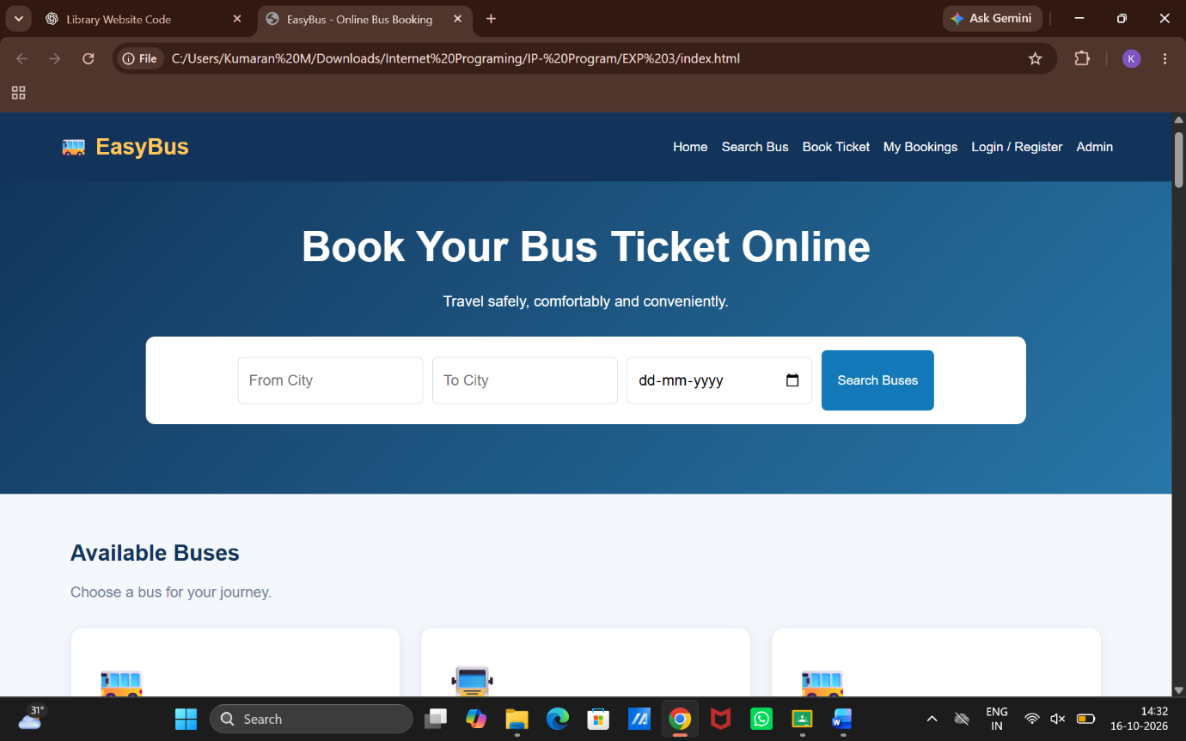

Result:
Thus, the Online Bus Ticket Booking System was developed successfully with user registration, bus searching, seat booking, ticket cancellation, comments, and administrator management features.

