Course: INTERNET PROGRAMMING
Code: CSA4303
Name: Kumaran M
Reg.No: 192525022
LAB EXPERIMENTS

Ex-04:
Aim:
To design and develop an Online Train Reservation System that allows passengers to search trains, check seat availability, book and cancel tickets, check PNR status, and manage refunds.
Algorithm:
- Start the program.
- Allow passengers to register and log in with valid credentials.
- Enter journey details, passenger information, and travel class.
- Display available trains, fares, and seat availability.
- Select a train and complete the payment process.
- Generate the ticket and PNR number after successful payment.
- Allow passengers to check PNR status, cancel tickets, and request refunds.
- Allow the admin to manage train details, fares, reservations, and refunds.

Code:
* {
box-sizing: border-box;
}
body {
margin: 0;
font-family: Arial, sans-serif;
background: #f2f6fc;
color: #222;
}
header {
background: #12345a;
color: white;
text-align: center;
padding: 20px;
}
header h1 {
margin-top: 0;
}
nav a {
color: white;
text-decoration: none;
margin: 10px;
font-weight: bold;
}
nav a:hover {
color: #ffd166;
}
.hero {
background: #2463a6;
color: white;
text-align: center;
padding: 45px 15px;
}
.container {
background: white;
width: 85%;
max-width: 850px;
margin: 25px auto;
padding: 25px;
border-radius: 10px;
box-shadow: 0 3px 10px #00000015;
}
h2 {
color: #12345a;
}
form {
display: flex;
flex-direction: column;
gap: 10px;
}
label {
font-weight: bold;
}
input, select {
padding: 12px;
border: 1px solid #bbb;
border-radius: 5px;
width: 100%;
}
button, .button {
display: inline-block;
background: #2463a6;
color: white;
padding: 12px;
border: none;
border-radius: 5px;
text-decoration: none;
text-align: center;
cursor: pointer;
font-size: 15px;
}
button:hover, .button:hover {
background: #12345a;
}
.train {
background: #f6f9ff;
border: 1px solid #d5e2f3;
border-radius: 8px;
padding: 18px;
margin-bottom: 15px;
}

.train h3 {
color: #2463a6;
}
footer {
background: #12345a;
color: white;
text-align: center;
padding: 18px;
}
@media (max-width: 600px) {
header h1 {
font-size: 23px;
}
nav a {
display: inline-block;
margin: 7px;
font-size: 13px;
}
.container {
width: 92%;
padding: 18px;
}
}

Output:
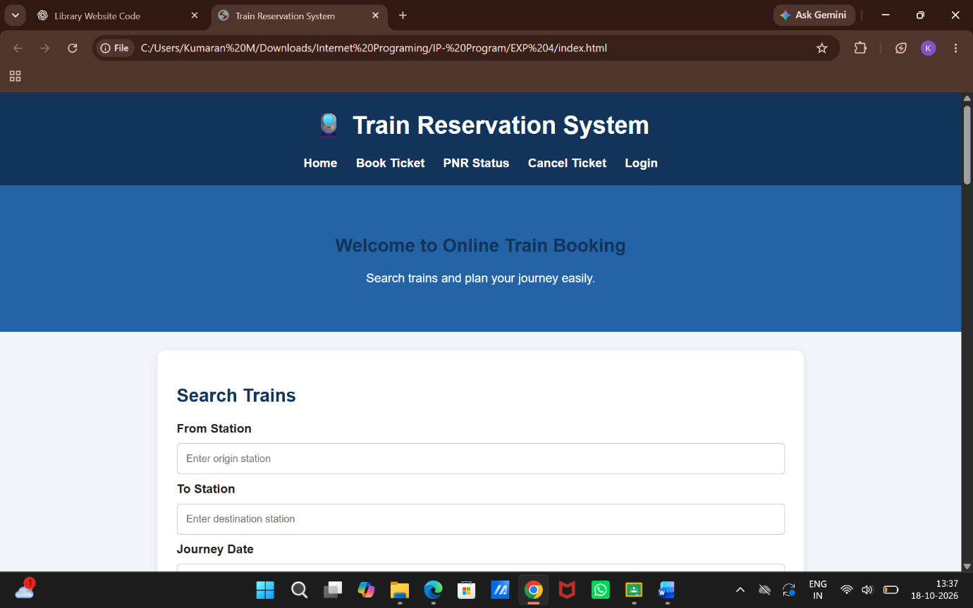

Result:
Thus, the Online Train Reservation System was designed successfully to manage train searches, seat availability, ticket booking, PNR status, cancellations, and refunds efficiently.

