Course: INTERNET PROGRAMMING
Code: CSA4303
Name: Kumaran M
Reg.No: 192525022
LAB EXPERIMENTS

Ex-05:
Aim:
To design and develop an Online Flight Reservation System that allows users to search flights, book and cancel tickets, make payments, view booking status, and print e-tickets.
Algorithm:
- Start the program.
- Provide user registration, login, and forgot password facilities.
- Enter the destination, travel date, and travel class.
- Display available flights, fares, and seat availability.
- Select a flight, enter passenger details, and complete payment.
- Generate the ticket and allow users to view, print, or cancel tickets.
- Allow users to submit feedback and check booking status.
- Enable the admin to manage flights, users, and reports.

Code:
body {
margin: 0;
font-family: Arial, sans-serif;
background: #f0f5fb;
color: #222;
}
header {
background: #12345a;
color: white;
text-align: center;
padding: 20px;
}
nav {
margin-top: 15px;
}
nav a {
color: white;
text-decoration: none;
margin: 10px;
font-weight: bold;
}
nav a:hover {
color: #ffd166;
}
.hero {
background: #2874b5;
color: white;
text-align: center;
padding: 50px 15px;
}
.container {
width: 85%;
max-width: 850px;
margin: 25px auto;
padding: 25px;
background: white;
border-radius: 10px;
box-shadow: 0 3px 10px #00000015;
}
h2 {
color: #12345a;
}
form {
display: flex;
flex-direction: column;
gap: 10px;
}
label {
font-weight: bold;
}
input, select, textarea {
padding: 12px;
border: 1px solid #bbb;
border-radius: 5px;
width: 100%;
box-sizing: border-box;
}

button, .btn {
background: #2874b5;
color: white;
padding: 12px;
border: none;
border-radius: 5px;
cursor: pointer;
text-decoration: none;
text-align: center;
display: inline-block;
margin-top: 5px;
}
button:hover, .btn:hover {
background: #12345a;
}
.flight {
border: 1px solid #d5e2f3;
background: #f7faff;
padding: 18px;
border-radius: 8px;
margin-bottom: 15px;
}
.flight h3 {
color: #2874b5;
}

.container a:not(.btn) {
color: #2874b5;
}
footer {
background: #12345a;
color: white;
text-align: center;
padding: 20px;
}
@media (max-width: 600px) {
header h1 {
font-size: 22px;
}
nav a {
display: inline-block;
margin: 7px;
font-size: 13px;
}
.container {
width: 90%;
padding: 18px;
box-sizing: border-box;
}
}
@media print {
header, footer, form, button, .hero, nav {
display: none;
}
body {
background: white;
}
.container {
box-shadow: none;
width: 100%;
}
}

Output:
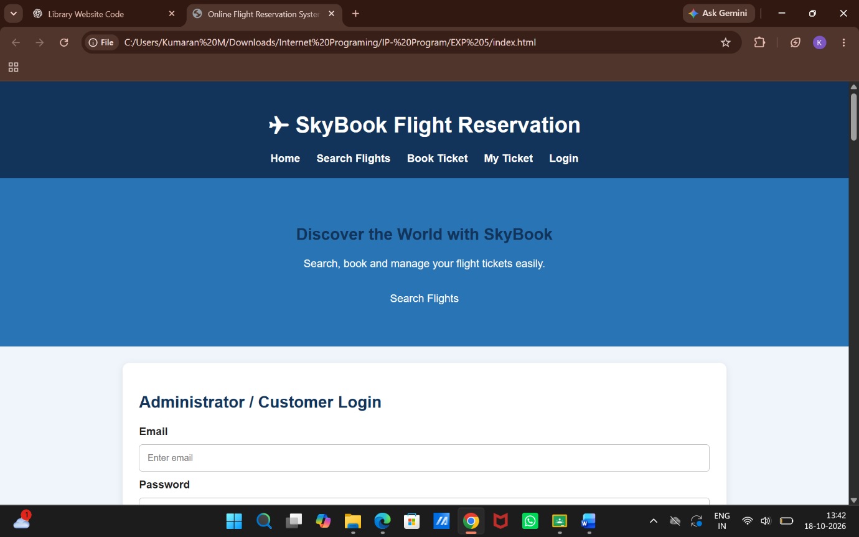

Result:
Thus, the Online Flight Reservation System was developed successfully with flight searching, ticket booking, payment, cancellation, booking status, e-ticket printing, and administration features.

